“Metal-electrode stabilization treatment time drastically reduced from 12 hours to 8 minutes” GIST develops technology to dramatically improve the safety and durability of next-generation high-energy lithium metal batteries

- Professor KwangSup Eom's team from the School of Materials Science and Engineering formed a nanowire-shaped precursor on the copper current collector of the existing lithium metal anode using an electrochemical deposition method... Implementing a lithium metal battery with twice the energy density and lifespan

- "Resolving the obstacle to commercializing lithium metal batteries (chronic dendrite crystal problem) in a quick and simple way" Expected to be used in electric vehicles, etc... Published in the international academic journal 《Chemical Engineering Journal》



▲ (From left) Professor KwangSup Eom and doctoral student Changhyeon Lee

As electric vehicle sales continue to increase worldwide, interest in next-generation secondary batteries with larger capacities and faster charge/discharge speeds than commercial lithium-ion batteries is growing significantly.

Graphite, the anode material of existing lithium-ion batteries, has almost reached its theoretical capacity limit, and in order to dramatically improve energy density, the development of new anode materials with much larger capacities is necessary.

* anode material: It plays an important role in the charging speed and lifespan of the battery by storing and releasing lithium ions from the anode and allowing current to flow.

Lithium metal batteries, which replace the cathode material with lithium metal, can theoretically implement cathode capacity 10 times higher than lithium ion batteries, and are attracting attention as a next-generation battery technology that can practically improve the energy density of a secondary battery full cell* by more than double.

However, safety and durability issues, such as swelling of the battery and increase in internal pressure due to lithium dendrite crystal growth during charging and discharging of lithium metal batteries, are hindering commercialization.

* full cell: A type of battery in which the positive and negative electrodes participate in electrochemical reactions simultaneously. It is mainly used to evaluate the overall performance of a battery because it can directly measure the characteristics and performance of the battery.

* lithium dendrite: It is caused by the breakdown of the solid electrolyte interface (SEI) that accumulates on the surface of the negative electrode during the lithium battery charging and discharging process. It increases the internal resistance, causes the temperature to rise, the energy capacity to decrease, and causes the battery to age when charged.

The Gwangju Institute of Science and Technology (GIST, President Kichul Lim) announced that a research team led by KwangSup Eom from the School of Materials Science and Engineering has developed a technology to solve the chronic dendrite crystal problem of high-energy lithium metal batteries and dramatically improve charge/discharge durability by forming a nanowire-shaped composite on the cathode in just 8 minutes using the electrochemical deposition method* and implementing a multi-inorganic solid electrolyte interface (SEI)* layer.

In general, chemical vapor deposition (CVD)* or physical vapor deposition (PVD)* using plasma are mainly used to deposit an artificial SEI layer on the cathode surface. However, these methods are not only expensive, but also have the limitation that the uniform deposition method* requires a processing time of at least 1 hour and at most 12 hours or more.

* chemical vapor deposition (CVD): A process that converts solid materials into a gaseous state and deposits them on a surface. It is mainly used in various fields such as semiconductor manufacturing, coating, and nanotechnology.

* physical vapor deposition (PVD): A method of forming a thin film on a substrate by converting solid or liquid materials into vapor using heat or kinetic energy in a vacuum.

* uniform precipitation: Instead of adding a precipitant from the outside to create a precipitate, a method of slowly creating a precipitant in a reaction solution through a reaction such as hydrolysis and precipitating it.

Conventional untreated solid electrolyte interfaces generally have limitations such as weak mechanical strength and slow lithium ion diffusion rates. To solve these problems, various studies have been conducted to form artificial solid electrolyte interfaces, but most of them focus on the formation of a single-component SEI layer.

On the other hand, multicomponent inorganic solid electrolyte interfaces consist of three main components: lithium chloride (LiCl), Li₂S₂/Li₂S_{x}, and Li_{x}N, and each component interacts to produce a synergistic effect.

* solid electrolyte interphase (SEI): When the battery is first charged, lithium ions in the battery move to the cathode, and during this process, substances in the electrolyte are electrolyzed for the first time, resulting in a solid film formed on the surface of the cathode material as a result of a chemical reaction. In other words, an organic/inorganic film formed at the interface between the electrolyte and the electrode. It prevents electrolyte decomposition and maintains ion conductivity by preventing direct contact between the electrolyte and the inside of the electrode.

* cathodic electrochemical deposition (CELD): This is a method of depositing metals or metal compounds on the surface of the electrode using an electrochemical reaction.

The research team presented a method to suppress the formation of lithium dendrites, a chronic problem in lithium metal batteries, and dramatically improve charge/discharge performance and stability by applying copper-thiourea nanowire composites (CTC NWs, [Cu(SCN₂H₄)_{n}]Cl)* to a copper current collector using an electrochemical deposition method in just 8 minutes.

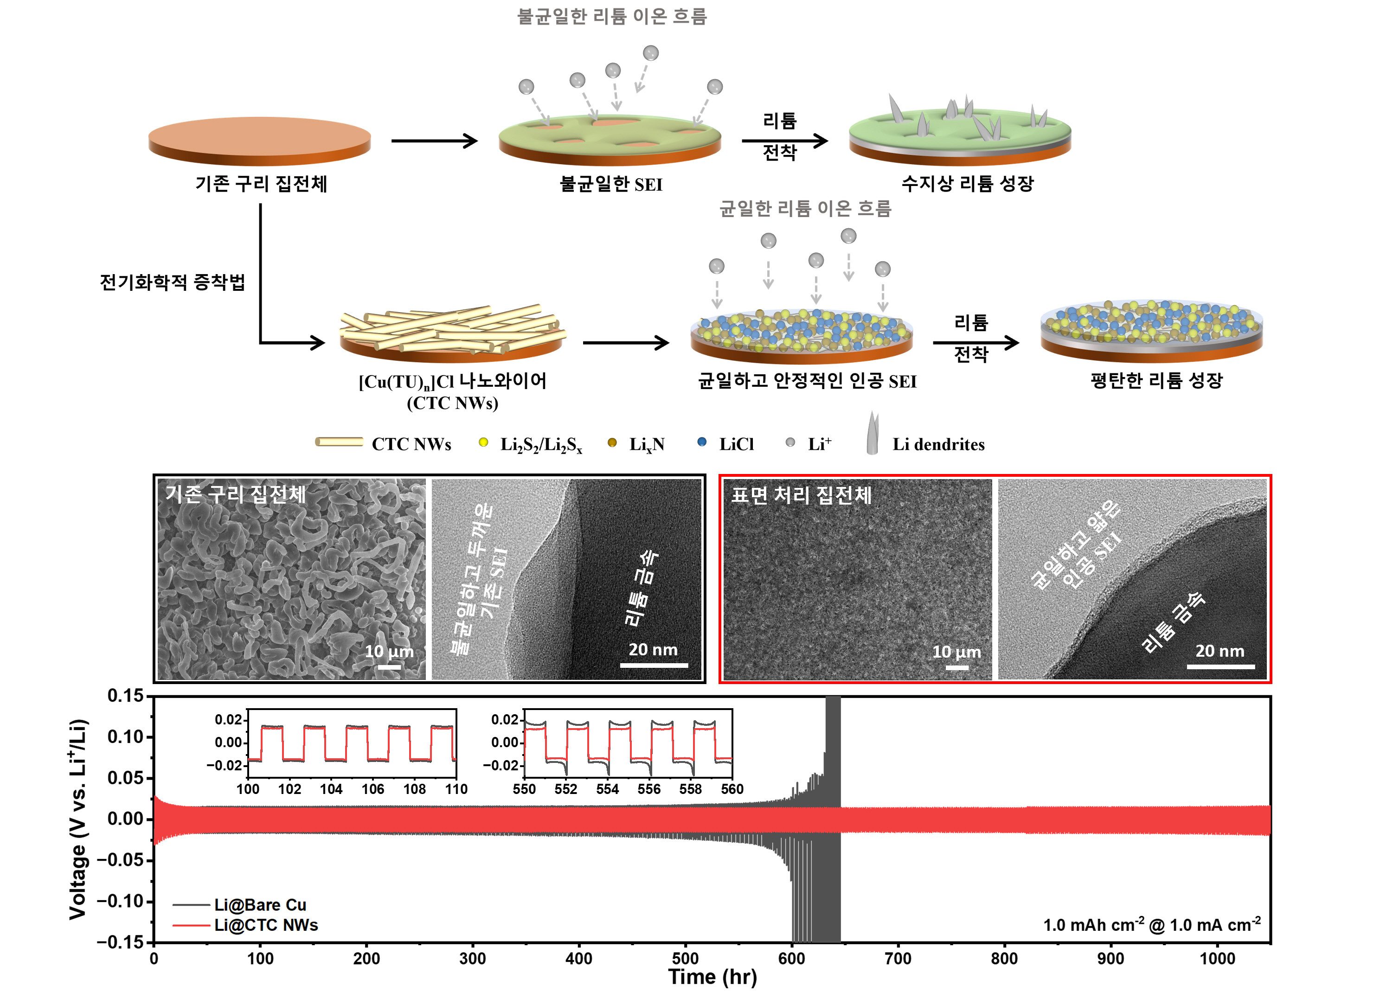

▲ Comparison of interface characteristics and symmetric cell performance according to the presence or absence of a multi-inorganic SEI layer using an electrochemical deposition method. The figure above shows the process of forming a uniform and thin SEI by suppressing lithium growth formation by forming a multi-inorganic SEI precursor with a nanowire shape on the surface of a conventional copper current collector through an electrochemical deposition surface treatment. Thanks to these characteristics, low overvoltage characteristics are maintained even after repeated charge and discharge for more than 1,000 hours in a symmetric cell.

The multi-inorganic solid electrolyte interfacial layer generated in this process induces uniform deposition of lithium and facilitates lithium diffusion, ensuring a long battery life.

* copper-thiourea nanowire complex: Copper cations are located at the center, and thiourea and chloride ions (Cl-) are bound as ligands surrounding it. It is characterized by an elongated nanowire-shaped structure.

In particular, this technology shows a solid electrolyte interfacial resistance that is 2.2 times lower than that of existing lithium metal batteries and a lithium ion diffusion speed that is about 7 times higher, dramatically improving the charge/discharge performance of lithium metal batteries.

The research team said that this technology extended the symmetrical cell life of lithium metal batteries by more than 1,000 hours, and that in a full cell based on a lithium iron phosphate (LFP) cathode, the capacity retention rate improved by 30% in the first 140 cycles.

Professor KwangSup Eom said, "The results of this study suggest a new alternative to solve the problem of unbalanced dendrite formation, which is currently an obstacle to commercialization of lithium metal batteries, through a quick and simple electrochemical treatment method. In particular, this technology is expected to be applicable not only to next-generation lithium metal batteries but also to next-generation batteries that intend to use various metal cathodes such as sodium, aluminum, and zinc."

This study, supervised by Professor KwangSup Eom of the School of Materials Science and Engineering at GIST and led by Ph.D. candidate Changhyeon Lee, was conducted with support from the National Research Foundation of Korea. The results of the study were published online on November 25, 2024, in the prestigious international journal in the field of chemical engineering, the 《Chemical Engineering Journal》 (JCR Top 3.7%).



