GIST suggests the possibility of treating colon cancer by controlling the neurotransmitter 'serotonin'

- Professor Chang-Myung Oh and Jin Hee Ahn (CEO of JD Bioscience) joint research team confirmed the inhibition of colon cancer cell growth by inhibiting HTR2B, one of the serotonin receptors, in a mouse tumor model... Development of a new inhibitor for inhibiting the growth of malignant tumors

- “Confirmed the possibility of treatment through inhibition of colon cancer cell growth, expected to be a new approach for treating colon cancer patients” Published in the international academic journal of pharmacology and pharmaceutical science, 《Biomedicine & Pharmacotherapy》



▲ (From left) Professor Chang-Myung Oh of the Department of Biomedical Science and Engineering, Professor Jin Hee Ahn of the Department of Chemistry, PhD student Jeong-Yun Lee of the Department of Biomedical Science and Engineering, and PhD student Suhyeon Park of the Department of Biomedical Science and Engineering

‘Cancer’ is the number one cause of death in our country, and colon cancer has a high incidence rate and risk of recurrence, ranking second among cancers in Korea. A Korean research team has clarified the relationship between serotonin receptors, a type of neurotransmitter, and colon cancer, and suggested a new alternative for treatment.

The Gwangju Institute of Science and Technology (GIST, President Kichul Lim) announced that a joint research team of Professor Chang-Myung Oh of the Department of Biomedical Science and Engineering and Professor Jin Hee Ahn of the Department of Chemistry (CEO of JD Bioscience) confirmed that colon cancer cell growth was suppressed by inhibiting the activity of HTR2B, one of the serotonin receptors, and further suggested a drug prescription for suppressing the growth of malignant tumors.

Serotonin, which is well known as a substance that regulates nervous system activities such as mood, behavior, and anxiety, is produced by approximately 95% of chromaffin cells in the intestine. Therefore, discussions on the relationship between serotonin and gastrointestinal diseases have been a major interest in the academic world.

In particular, it is well known through several studies that among the various serotonin receptors, HTR2B is closely related to growth factors.

The research team confirmed the mortality rate according to the HTR2B expression ratio in patients without colon cancer and patients with colon cancer, and compared the expression level through fluorescent staining in normal tissue and colon cancer tissue after collecting tissue from colon cancer patients.

As a result, it was confirmed that the group with a high expression rate of HTR2B of 50% or more among colon cancer patients had a survival rate close to 0% after about 8 years, while the group with a relatively low expression rate showed a survival rate of about 60%.

In addition, when HTR2B expression was confirmed in colon cancer tumor tissues and normal tissues attached to them collected from colon cancer patients, it was confirmed that the expression rate of HTR2B in colon cancer tissues was about 60% and in normal tissues, about 30%, a difference of about 2 times.

The research team stated that this means that the expression of HTR2B is high in colon cancer tumors in general, and that colon cancer tumor cells may be more affected by serotonin in their growth than colon tissues.

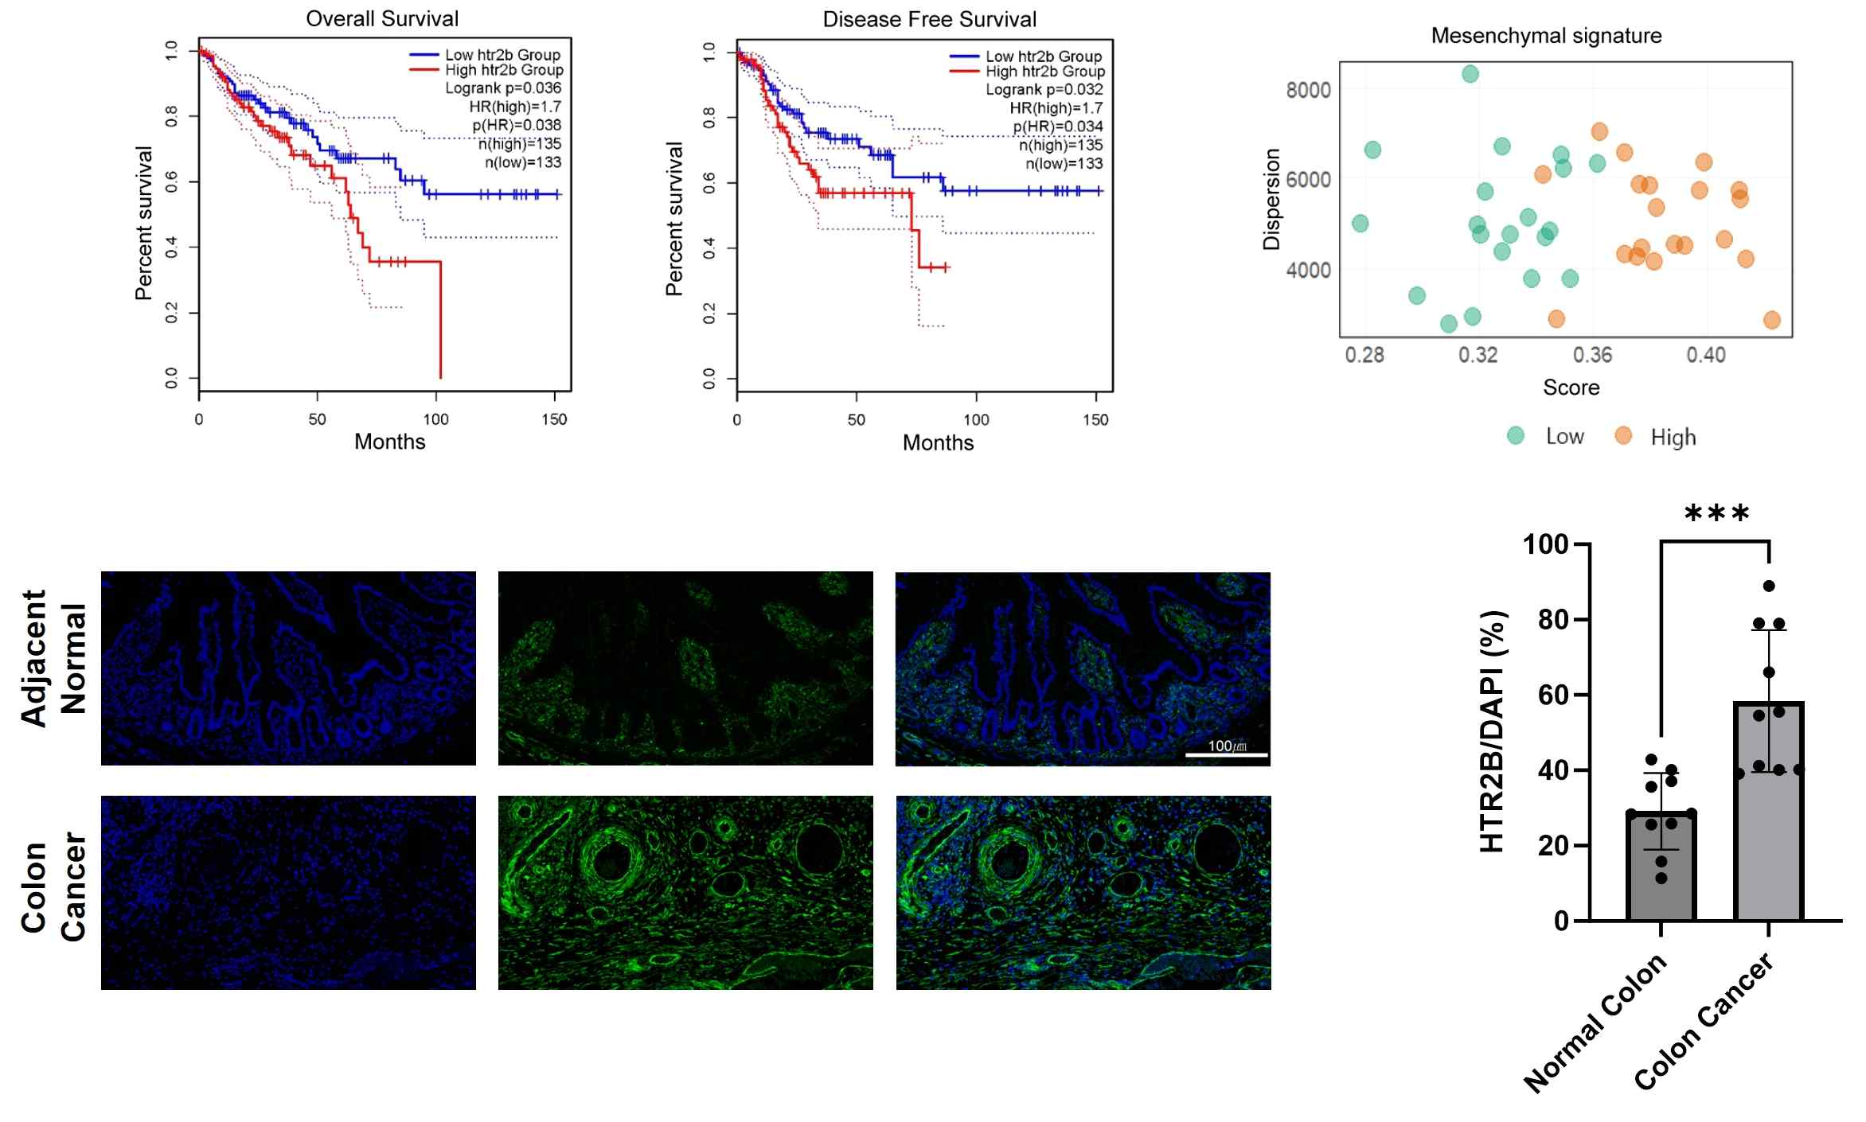

▲ Relationship between HTR2B expression and mortality in patients with colorectal cancer. The level of HTR2B expression was confirmed in patients with colorectal cancer, and it was confirmed that the higher the expression of HTR2B in patients with colorectal cancer, the lower the survival rate.

The research team also created a mouse tumor model injected with colon cancer cells and injected an HTR2B inhibitor (SB204741) intraperitoneally at regular intervals, and confirmed that the overall tumor size and mass were reduced by about 50% or more after about 3 weeks.

The same results were confirmed when a new HTR2B inhibitor (GM-60186) synthesized by Professor Jin Hee Ahn's team was used.

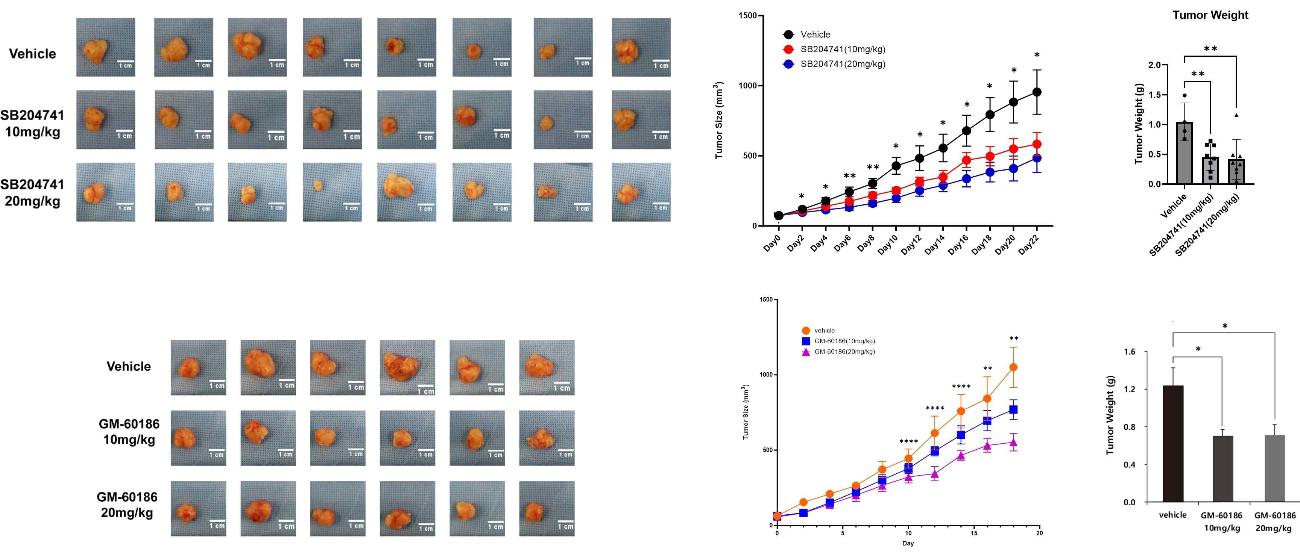

▲ Results of prescribing HTR2B inhibitors in a tumor model. Human colon cancer cell lines were transplanted into mice without immunity to create tumors, and HTR2B inhibitors were administered, confirming that the tumor size was reduced by the drug.

The research team used Ki-67*, which is used as a growth indicator for cancer cells. If the expression of Ki-67 is low, it can be interpreted that growth is relatively suppressed. Therefore, Ki-67 fluorescence staining was performed, and as a result, it was confirmed that the expression of Ki-67 was low in the group prescribed HTR2B inhibitor (SB204741).

The research team further conducted an experiment to confirm the pathway through which this growth suppression occurs, using each individual of MAPK, which is a cellular response pathway among several metabolic pathways connected to serotonin.

When ERK1/2* and p-ERK1/2*, which are important mediators in the MAPK (Mitogen-Activated Protein Kinases), a kinase pathway that mediates cellular responses, were confirmed, the expression of p-ERK1/2 decreased.

In addition, the expression of Cyclin D1, a protein that can affect the growth pathway, also decreased. Cyclin D1 is a regulatory factor that progresses the cell cycle and is affected by various kinases, of which p-ERK1/2 is known to be one.

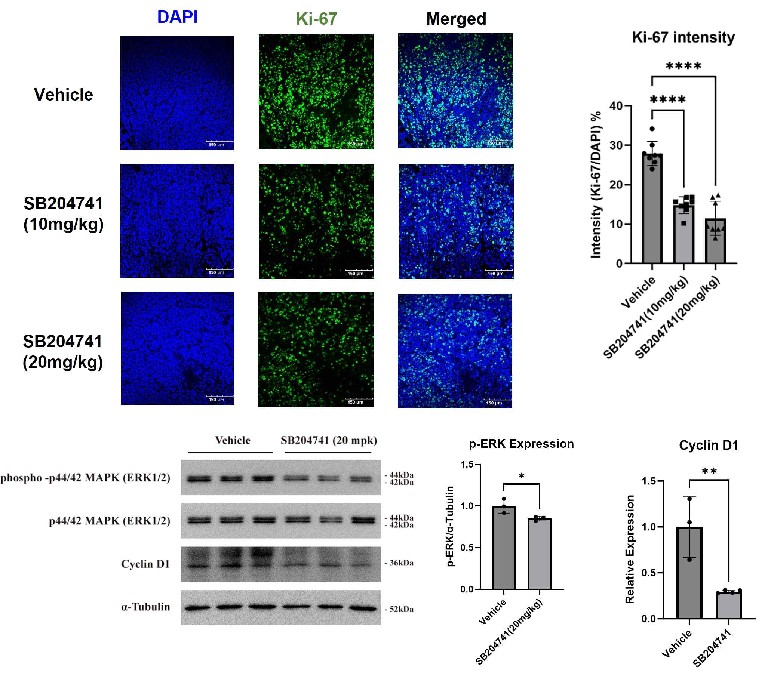

▲ Experimental results using the collected tumor. Tissue was cut and stained with Ki-67 to confirm a decrease in growth index. In addition, a decrease in p-ERK1/2, a mediator within the MAPK pathway, and a decrease in the expression of Cyclin D1 affected by this were confirmed.

Therefore, the decreased expression of Cyclin D1 can be interpreted as meaning that the cancer cell cycle did not progress properly, which in turn affected the inhibition of tumor growth.

* Ki-67: An antigen that can be used to check the overall state of the cell cycle as a marker of cell growth.

* ERK1/2 (Extracellular signal-Regulated Kinases 1/2): A kinase that plays an important signaling role in mediating cellular responses within the MAPK pathway.

* p-ERK1/2: A kinase that plays an important signaling role in mediating cellular responses as a result of phosphorylation of ERK1/2.

* cyclin D1: A protein made by the CCND1 gene that plays a role in regulating the cell cycle.

Professor Chang-Myung Oh said, "Through this research result, we confirmed the possibility of treatment by inhibiting the growth of colon cancer cells by inhibiting the serotonin receptor HTR2B. If we utilize HTR2B inhibitors such as ‘GM-60186’, a new HTR2B inhibitor synthesized in Professor Jin Hee Ahn’s laboratory, we expect that it will be a new approach for treating colon cancer patients."

This study, supervised by Chang-Myung Oh of the Department of Biomedical Science and Engineering and Professor Jin Hee Ahn of the Department of Chemistry, and conducted by PhD students Jeong-Yun Lee and Suhyeon Park of the Biomedical Science and Engineering, was supported by the Excellent New Researcher Project of the National Research Foundation of Korea, and was published in September 2024 in the international academic journal in the field of pharmacology and pharmaceutical science, Biomedicine & Pharmacotherapy.



