GIST elucidates ultra-fast thermal equilibrium process at high temperatures and pressures exceeding 10,000 degrees

- Professor Woosuk Bang's team in the Department of Physics and Photon Science, the world's first calculation of the thermal equilibrium time (electron-ion energy transfer time) inside gold and aluminum at extreme temperatures ranging from thousands to millions of degrees

- Expected to be of significant use in astrophysics and laser nuclear fusion research... Published in the international academic journal 《International Journal of Heat and Mass Transfer》



▲ (From left) Professor Woosuk Bang and student Seongmin Lee of the Department of Physics and Photon Science at GIST

The Gwangju Institute of Science and Technology (GIST, President Kichul Lim) announced that the research team led by Professor Woosuk Bang of the Department of Physics and Photon Science succeeded in elucidating the thermal equilibrium process between electrons and ions that occurs inside extreme high-temperature and high-pressure materials ranging from several thousand degrees to one million degrees for the first time in the world.

This research is expected to be of great use in analyzing phase transitions (state changes in materials) in non-equilibrium states, astronautics, and laser nuclear fusion research.

As technology to implement high-temperature and high-pressure conditions using high-power lasers has developed, it is now possible to reproduce environments similar to the interior of planets in space in laboratories. However, previous research has had difficulty predicting the speed of energy transfer between electrons and ions at high temperatures exceeding 10,000 degrees.

The research team theoretically calculated the time it takes aluminum and gold to reach thermal equilibrium from a non-equilibrium state where the electrons and ions have temperatures ranging from thousands to millions of degrees, respectively.

The research team confirmed that aluminum reaches thermal equilibrium within 5 picoseconds (1 picosecond = 1 trillionth of a second) and gold within 20 picoseconds. The research team explained that these calculation results are almost identical to the results of gold melting time measurements recently published by the US National Accelerator Laboratory (SLAC) in the journal Science.

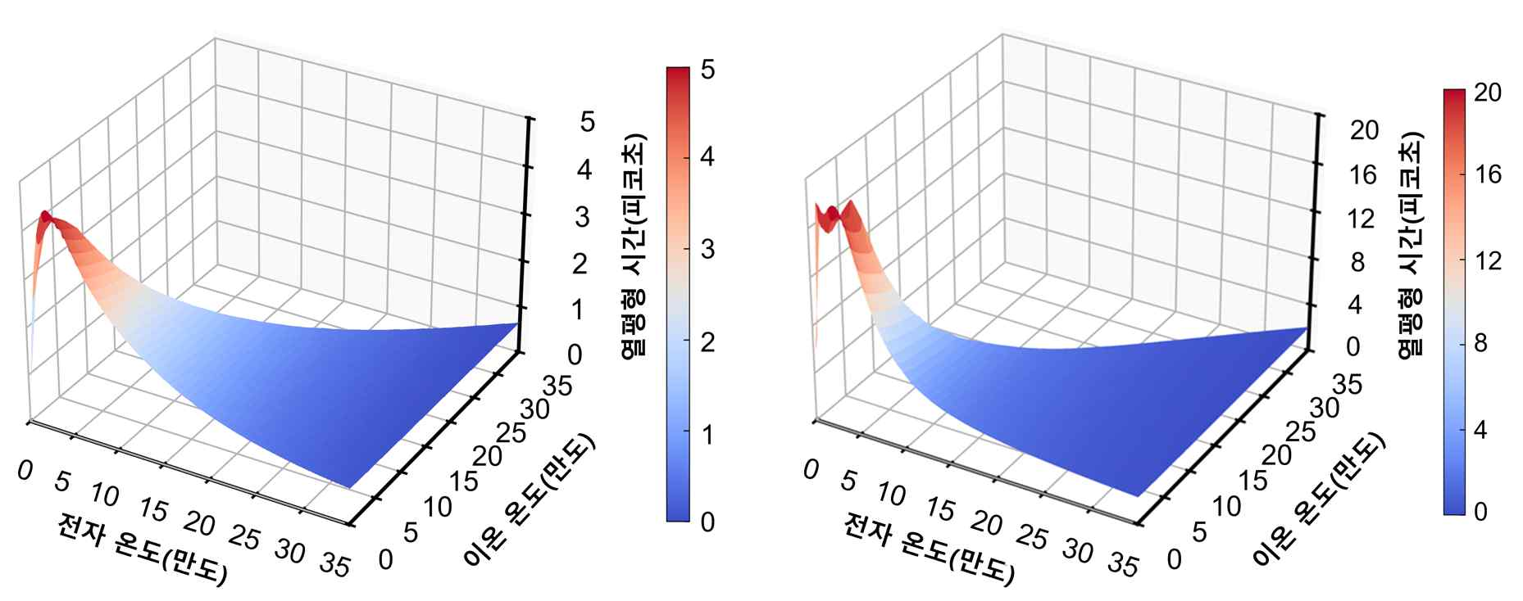

▲ Thermal equilibrium times of electrons and ions calculated in aluminum (left) and gold (right) with various initial conditions. It can be seen that the temperatures of electrons and ions inside the sample become equal within a few picoseconds, quickly reaching thermal equilibrium.

The extreme conditions of high temperature and high pressure discussed in this study have intermediate characteristics between the solid state and the plasma state, and are mainly observed in the interior of planets or in laser nuclear fusion experiments.

When a sample is heated using a high-power laser in a laboratory, electrons with lighter mass are heated before ions, forming a non-equilibrium state. Afterwards, the electrons and ions reach a state of thermal equilibrium through an energy transfer process.

Using two temperature models* and the equation of state of matter developed at the Los Alamos National Laboratory in the United States, the research team theoretically calculated how the electron and ion temperatures inside aluminum and gold with various initial conditions change over time.

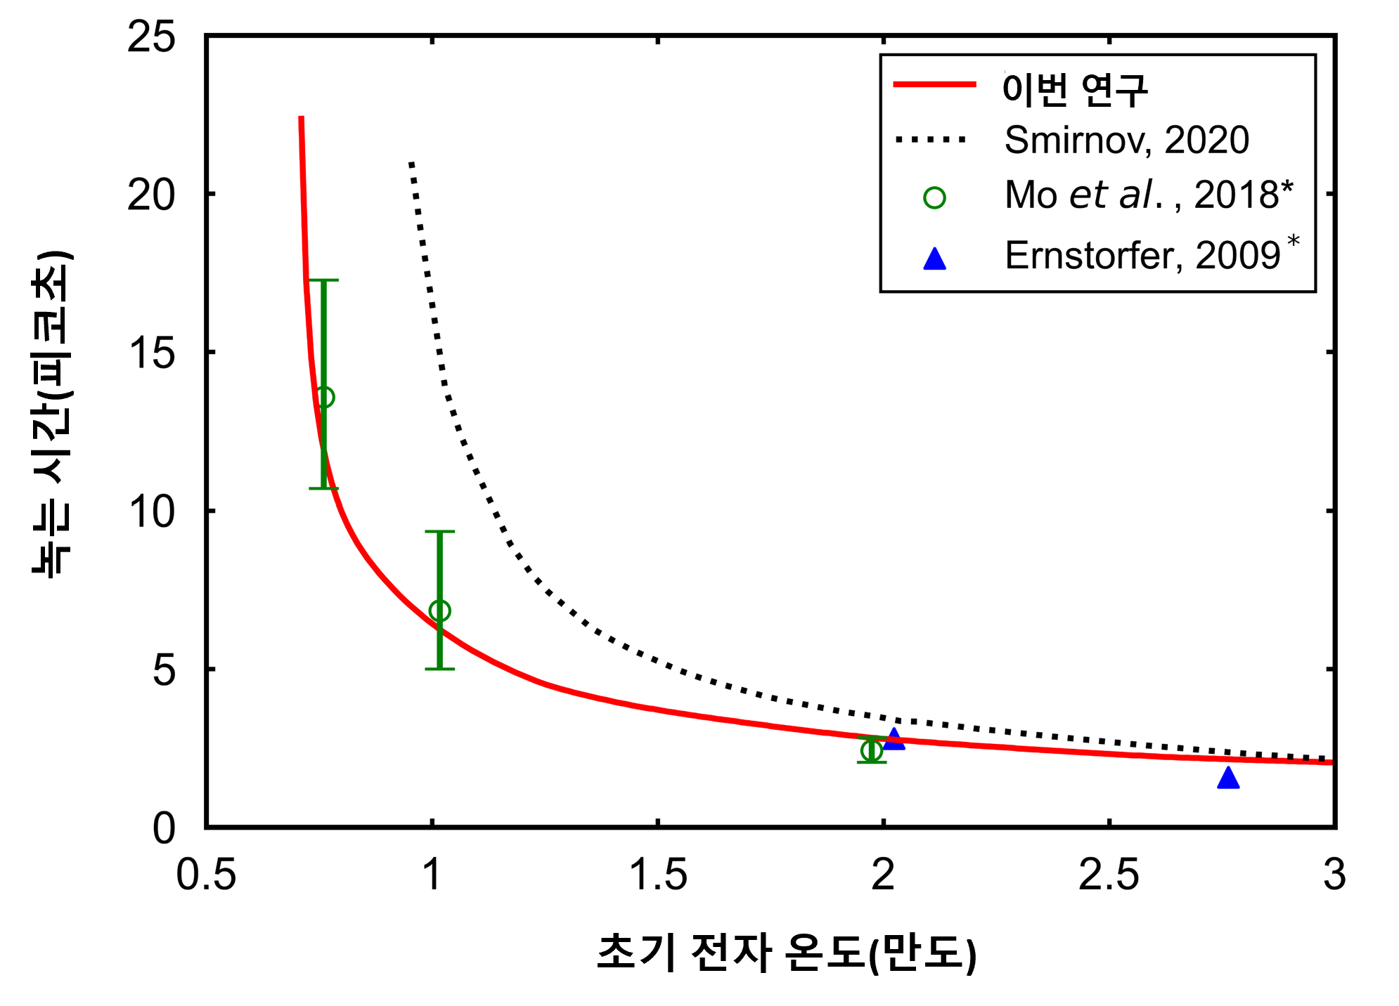

▲ Melting time of gold according to initial electron temperature. This graph compares the time at which gold heated by a high-power laser begins to melt with existing theories (black dotted line) and experimental results. The research team's new calculation results (red curve) explain the existing experimental results well.

The thermal equilibrium time calculated using the heat capacity of electrons and ions, which is well known in the past, at extremes of low and high temperatures was compared with the electron-ion thermal equilibrium time calculated by the research team's new method, and the two values were confirmed to be consistent.

In addition, the time at which gold begins to melt was derived from the results of the X-ray diffraction experiment by the US research team, and the accuracy of the new method developed by the research team was proven by comparing it with the theoretical prediction value of the research team.

* two-temperature model: A model that describes the process by which electrons and ions exchange energy at different temperatures, and is used to predict thermal changes in materials under extreme conditions.

Professor Woosuk Bang said, "The results of this study suggest a method for describing energy transfer between electrons and ions inside matter in extreme conditions of high temperature and high pressure, such as the interior of a planet, and they can be used in future laboratory astrophysics and laser nuclear fusion research."

This study, supervised by Professor Woosuk Bang of the Department of Physics and Photon Science at GIST and in which Seongmin Lee, a combined master's and doctoral student, participated as the first author, was supported by the National Research Foundation of Korea's Mid-career Researcher Support Program and was published on November 15, 2024, in the 《International Journal of Heat and Mass Transfer》, an international academic journal ranked in the top 9.7% in the field of mechanics in JCR.



