GIST develops optimal bidding technology to ensure stable profits for virtual power plants

- Professor Yun-Su Kim's team at the Graduate School of Energy Convergence, reducing uncertainty by finding a bid amount and price that guarantees more than the minimum profit desired by virtual power plant operators... confirming high profit guarantee with over 95% reliability

- "A solution designed from the perspective of virtual power plant operators who are aware of the break-even point for the high volatility and uncertainty of electricity prices that are obstacles to market participation"... published in the international academic journal 《Energy》



▲ (From left) Professor Yun-Su Kim, student Jun-Hyeok Kim, and student Jin Sol Hwang of the Graduate School of Energy Convergence

Unlike in the past when only large-scale power plants such as thermal and nuclear power plants were used to produce electricity, today, virtual power plants (VPPs)* that connect small-scale energy resources and operate them as if they were one power plant have emerged, expanding opportunities to participate in the electricity market.

In this situation, virtual power plant operators must predict the power generation of their own distributed energy resources* and establish strategies to generate profits.

* virtual power plant (VPP): A virtual power plant, literally meaning a virtual power plant, that does not exist physically, but is a platform that integrates distributed energy resources such as renewable energy, energy storage devices, and electric vehicles using information and communication technology (ICT) and operates them as a single power plant.

* distributed energy resource (DER): Resources generated from small-scale renewable energy such as solar energy, wind power, and fuel cells.

The Gwangju Institute of Science and Technology (GIST, President Kichul Lim) announced that Professor Yun-Su Kim's research team from the Graduate School of Energy Convergence has developed a power generation and price bidding technology that guarantees the minimum profit desired by virtual power plant operators.

It is expected that this research result can be utilized to solve the problem of uncertainty and volatility in power generation and price of power grids generated by renewable energy or electric vehicles, and to guarantee stable profits for power generation operators.

As the share of renewable energy and electric vehicles, which are highly uncertain and volatile energy resources, in the power grid gradually increases, the deviation of wholesale electricity prices by time zone is also increasing.

In the case of California, USA, which has a high renewable energy penetration rate, the real-time market price* recorded a high of USD 1,197 per megawatt hour (MWh)* and a low of USD -1,679* as of 2023, and in Korea, it recently showed a fluctuation of about KRW 80,000 to KRW 230,000.

* MWh (Megawatt-hour): A unit of energy, where 1 MWh means the amount of electricity consumed while 1 megawatt of electricity is continuously used for 1 hour. In other words, 1 MWh represents the amount of energy obtained as a result of using 1 megawatt of electricity for 1 hour.

* A negative price means that you pay money to generate electricity, or receive money to consume electricity (such as charging an energy storage device).

Korea currently operates only the all-day market*, but once the real-time market pilot project in Jeju is completed, the real-time market is planned to be expanded nationwide. If the real-time market is introduced, we can expect active market participation by virtual power plants that can change output in short time cycles, as can be seen in the European and North American markets.

However, the high volatility and uncertainty of electricity prices are major obstacles to market participation by operators. The existing power generation and price bidding problem is mainly solved by using a deterministic model* to obtain the bidding amount and price to maximize profits, which is very vulnerable to uncertainty.

* real-time market: A power market where electricity prices are determined every 15 minutes for the next 2 hours.

* a day-ahead market: A power market where electricity prices are determined every hour for the next 24 hours.

* deterministic models: Based on a system where all variables and their interactions are precisely defined. This model can perfectly predict the future state of the system based on given initial conditions and parameters but has the limitation that it may not sufficiently reflect the uncertainty and volatility of the actual market.

The research team applied the Wasserstein distance* as a measurement index of uncertainty to solve the problem of uncertainty in renewable energy production, and used the information gap decision theory* to solve the problem of uncertainty in market prices.

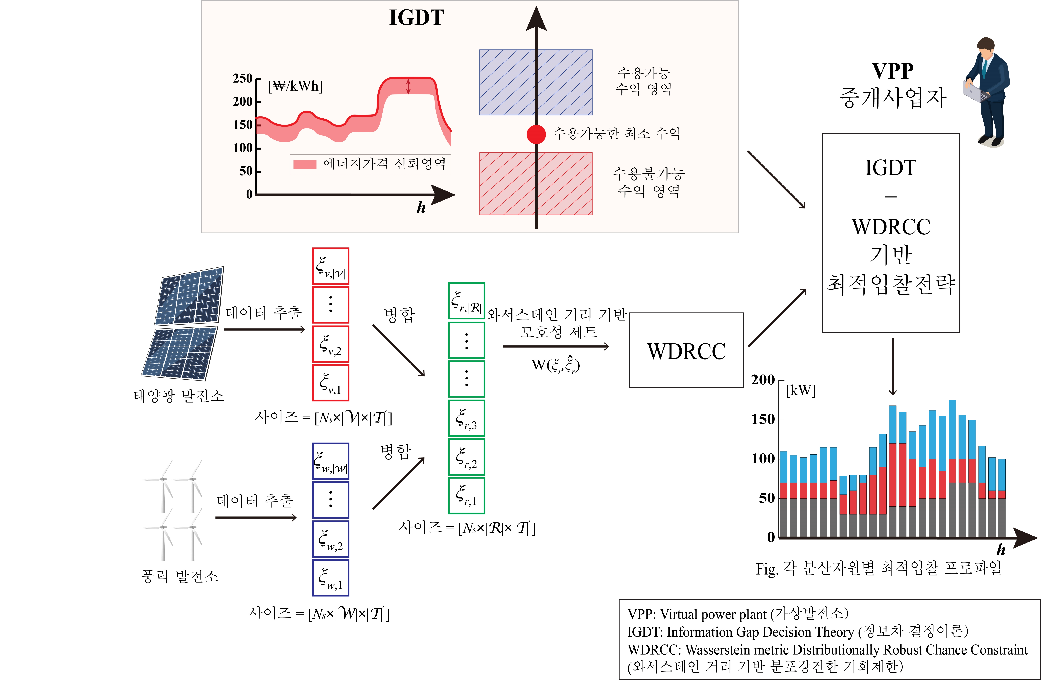

▲ Conceptual diagram of the optimal bidding strategy for a virtual power plant. It shows the relationship between the data flow for optimal bidding and the theory applied to development technology.

Wasserstein distance is a quantitative indicator that can simply express the difference between probability distributions whose exact parameters are unknown. In this study, the past renewable energy output history was used as an example distribution, and the uncertainty problem was solved in a way that the virtual power plant operator can set the degree of difference (Wasserstein distance) between the actual distribution and the example distribution.

* Wasserstein distance: An indicator that quantitatively expresses the difference between probability distributions. In this study, it was applied to solve the problem of not knowing the exact output distribution of renewable energy.

* information-gap decision theory: A decision-making theory that guarantees the level of safety desired by users in an environment with very high uncertainty. In this study, it was applied to resolve the uncertainty of energy prices in the electricity market.

The research team was also able to reduce uncertainty by approaching the method of finding the bid quantity and price to ensure the minimum profit (expected profit) desired by the virtual power plant operator.

The research team compared the newly developed technology (WM, Wasserstein Metric) with four technologies (MD, SAA, RN, RO) that considered uncertainty and expected profit in different ways in a simulation environment.

According to the simulation results ([Figure 2], [Figure 3]), the risk-neutral (RN, Risk-neural) technique showed the highest expected profit, but the lowest reliability (76.9%), confirming that it would be difficult to survive in a market with high uncertainty for a long time.

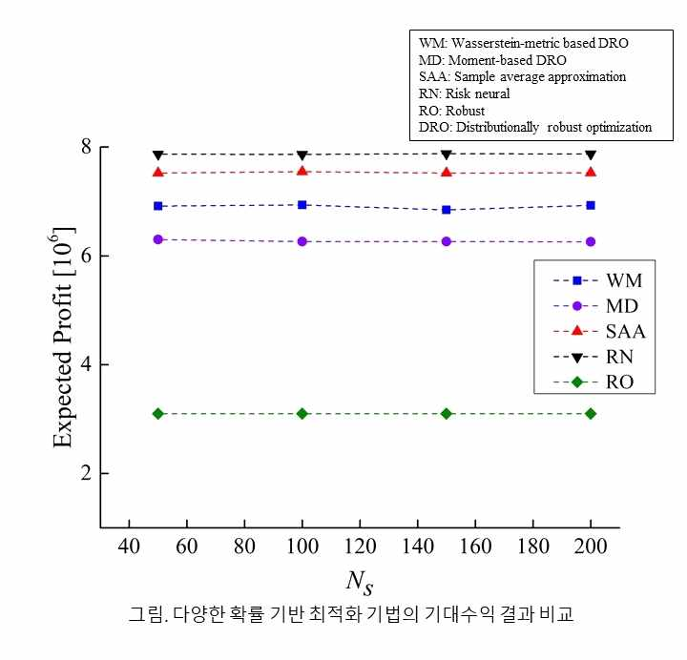

▲ Comparison of expected return results of various probability-based optimization techniques. The horizontal axis is the number of samples, and the vertical axis is the expected return. The technology (WM) developed by the research team showed a performance of up to 88.3% of the highest expected return.

The Robust Optimization (RO) technique showed the highest reliability (100%), but the lowest expected return (39.3% of the highest return), so it was judged that it would be difficult to survive in the market.

On the other hand, the research team's WM showed satisfactory reliability (95%) and expected return (88.3%), so the research team concluded that it would be a realistic alternative that best compromises reliability and profitability among various techniques.

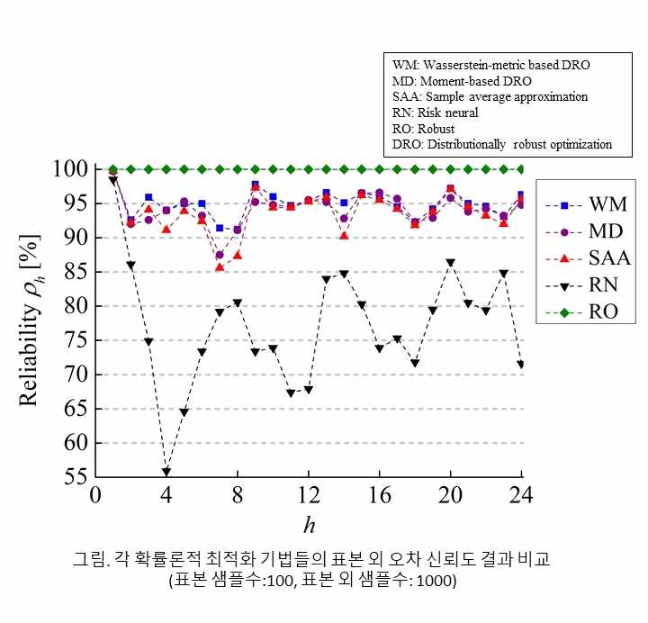

▲ Comparison of out-of-sample error reliability results of each probabilistic optimization technique (horizontal axis is time, vertical axis is reliability). The technology (WM) developed by the research team shows a high reliability of 95%, while the technology (RN) with the highest expected return shows a very low reliability of 76.9% on average.

Professor Yun-Su Kim said, "In power grid operation, the ability to flexibly and safely respond to market uncertainty will be evaluated as more valuable than the quantitative value of energy. The results of this research are expected to be more useful as they are designed from the perspective of business operators who have a good understanding of the break-even point."

This study, supervised by Professor Yun-Su Kim and conducted by doctoral students Jun-Hyeok Kim and Jin Sol Hwang at the GIST Graduate School of Energy Convergence, was supported by the Korea Energy Technology Evaluation Institute project (Development of VPP Integrated Platform for System Flexible Resource Service, ISO-DSO Cooperation System Operation System) funded by the government (Ministry of Trade, Industry and Energy). It was published online in the top 3.8% international academic journal in the field of thermodynamics, 《Energy》, on November 9, 2024, and was applied for a domestic patent in July of this year.



