GIST discovers existence of new surface electromagnetic waves

- Senior Researcher Chul-Sik Kee's research team at the Advanced Photonics Research Institute has broken the mold of existing physics knowledge and confirmed for the first time that surface electromagnetic waves can exist even at the boundary between materials with 'positive permittivity'

- Expected to apply new surface electromagnetic waves in various fields such as biosensors and high-resolution imaging using existing surface electromagnetic waves... Published in the international academic journal 《Physical Review Letters》



▲ (From left) GIST Advanced Photonics Research Institute Senior Researcher Chul-Sik Kee and Postdoctoral Researcher Seong-Han Kim

Surface electromagnetic waves are electromagnetic waves that propagate along the interface formed when two materials meet and are known to exist only at the boundary formed by a material with a ‘negative permittivity*’ and a material with a ‘positive permittivity’.

A representative example is surface plasmon* that exists between a metal with a negative permittivity and an air layer with a positive permittivity. Since the energy of surface plasmon is strongly concentrated only on the metal surface, which is the boundary between the metal and the air layer, if chemicals or biomaterials are placed on the metal surface, a strong interaction can be induced between the surface plasmon and the materials. This interaction is being applied to high-sensitivity sensors and high-resolution imaging.

* permittivity: A physical constant that represents the strength of the electric dipole induced inside a material by an external electric field. In the visible light range, the permittivity of most materials is positive, but metals have negative permittivity.

* surface plasmons (SPs): Refers to the collective vibration of electrons that occurs along the interface where the sign of the dielectric function changes. A representative example is the surface plasmon formed between a metal with a negative dielectric function and air with a positive dielectric function.

The Gwangju Institute of Science and Technology (GIST, President Kichul Lim) announced that Senior Researcher Chul-Sik Kee and Postdoctoral Researcher Seong-Han Kim of the Advanced Photonics Research Institute’s Optical Application Systems Research Department discovered the existence of a new surface electromagnetic wave at the boundary formed by connecting a perfect electric conductor (PEC)* and a perfect magnetic conductor (PMC)* parallel plate waveguide* containing a positive permittivity material (‘PEC-PMC boundary’).

This broke the existing physics knowledge that surface electromagnetic waves exist only at the boundary between negative and positive permittivity materials and confirmed for the first time that surface electromagnetic waves can exist even at the boundary made of positive permittivity materials in unusual environments.

* perfect electric conductor: An ideal material with no parallel electric field component on its surface. Usually, metals with high conductivity function effectively for low-frequency electromagnetic waves.

* perfect magnetic conductor: An ideal material with no parallel magnetic field component on its surface. It does not exist in nature, but artificially created structures function in a specific frequency range.

* parallel plates waveguide: A structure made of two identical PEC or PMC plates separated by a certain distance, and electromagnetic waves propagate between the two plates.

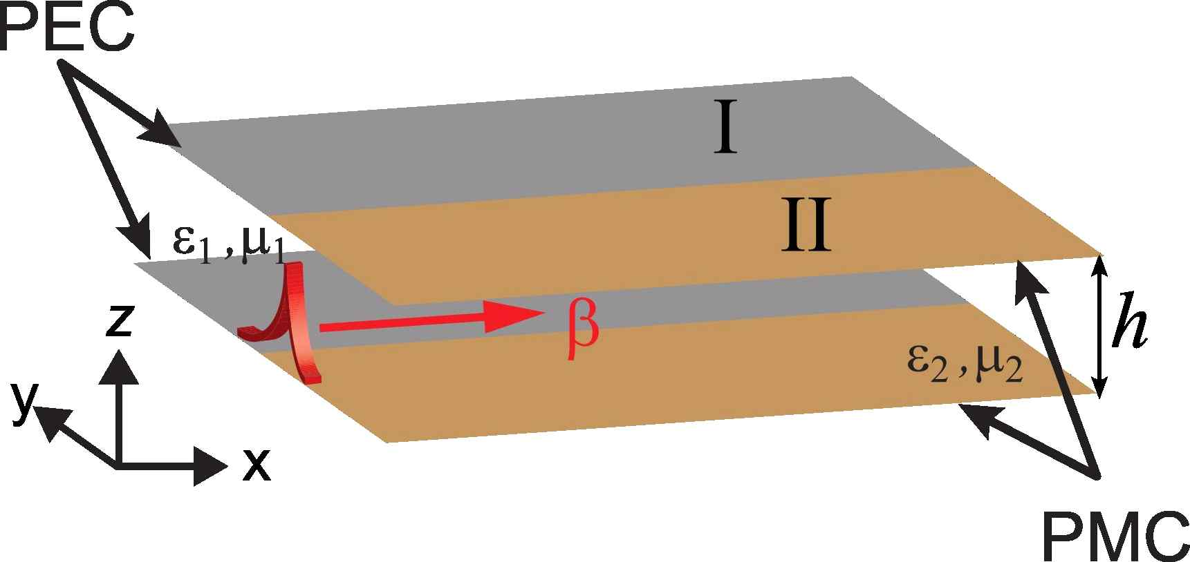▲ Schematic diagram of a PEC-PMC parallel plate waveguide in which a PEC parallel plate waveguide (I) filled with a material having a permittivity ε1 and a magnetic susceptibility μ1 and a PMC parallel plate waveguide (II) filled with a material having a permittivity ε2 and a magnetic susceptibility μ2 are joined.

The research team proved the existence of a new surface electromagnetic wave at the PEC-PMC boundary through theoretical mode analysis and numerical analysis, and verified the generation of a new surface electromagnetic wave at the PEC-PMC boundary by implementing a prism coupling experiment, which is usually used to generate surface electromagnetic waves, through computer simulation.

In addition, it was revealed that the characteristics of the newly discovered surface electromagnetic wave are similar to the surface plasmon induced by free electrons in metals, despite the absence of free electrons at the PEC-PMC boundary.

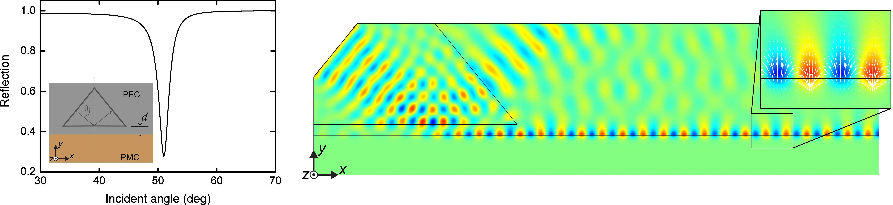

▲ (Left) Computational simulation of reflectivity using prism coupling experiment on PEC-PMC boundary. A large decrease in reflectivity occurs due to surface electromagnetic wave generation near the incident angle of 51 degrees. (Right) Computational simulation of surface electromagnetic wave propagation and electric field characteristics generated at PEC-PMC boundary.

Based on this finding, the research team also confirmed the existence of a new surface electromagnetic wave resonance mode in which energy is strongly concentrated only at the circularly closed PEC-PMC boundary.

* free electrons: Electrons inside the metal that move freely due to external voltage, causing current

* resonance mode: Specific spatial distributions of electromagnetic waves where energy resonance occurs, resulting in high energy absorption

Since PMC is a substance that does not exist in nature, the characteristics of PMC must be artificially implemented in order to experimentally prove the existence of a new surface electromagnetic wave.

Using two-dimensionally arranged square metal rods, the research team proposed a practically fabricable structure that can act as a magnetic conductor within a certain frequency range, and demonstrated the existence and generation of novel surface electromagnetic waves on the surface of the structure.

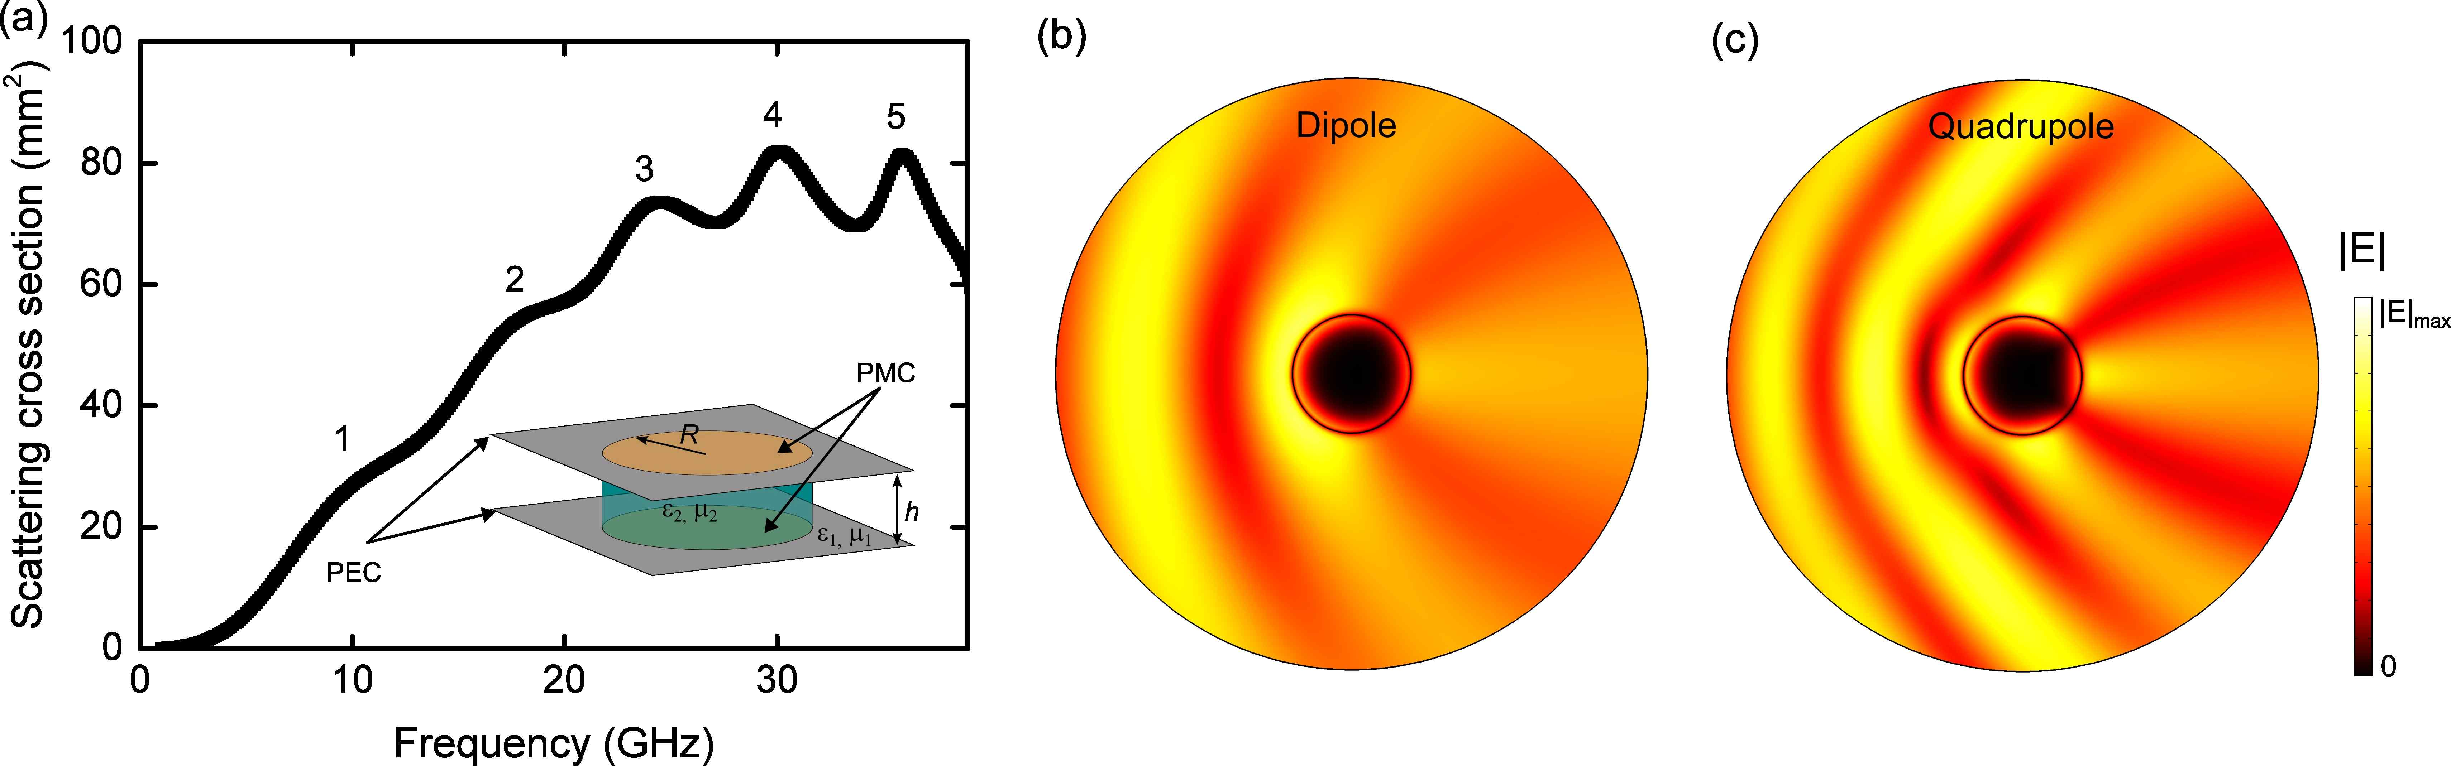

▲ (a) Schematic and scattering characteristics of a PEC-PMC cylinder with a circularly closed PEC-PMC boundary. Computational simulations of the electric field strength of (b) dipole and (c) quadrupole resonant scattering at the circularly closed PEC-PMC boundary.

Senior Researcher Chul-Sik Kee said, "The academic significance of this research achievement is that it expands knowledge on the conditions for generating surface electromagnetic waves and enables a deeper understanding of electromagnetic phenomena. It is expected that new surface electromagnetic waves can be applied to various fields such as biosensors and high-resolution imaging using existing surface electromagnetic waves."

This study was conducted with the support of the Ministry of Science and ICT's Mid-career Researcher Support Project and the Ministry of Education's Creative Challenge Research Project, and was published online on October 30, 2024, in Physical Review Letters, an authoritative journal in physics published by the American Physical Society.



