GIST, Industrial waste → Development of long-term operation solar energy conversion system to produce high value-added products

- Professor Sanghan Lee's team from the School of Materials Science and Engineering developed a solar energy conversion system that maintains performance even after long-term operation (previously 3 hours → over 18 hours, 86.1% efficiency)... Producing cosmetics and anticancer antibiotic raw materials (glyceraldehyde) from industrial waste (glycerol) while simultaneously producing green hydrogen

- "Overcoming the limitations of industrial waste conversion using solar energy" published in the international academic journal 《Small》



▲ (From left) Professor Sanghan Lee and students of the combined master's and doctoral program Yoonsung Jung and Seunghwan Kim

Technology that uses solar energy to turn industrial waste into high value-added products is gaining attention. To do this, the photoelectrode* must maintain its performance for a sufficiently long period of time, but this has not been possible with current solar energy conversion systems.

Korean researchers have introduced a solar energy conversion system that can produce high value-added materials for a long time using inexpensive, highly efficient, and stable materials.

* photoelectrode: A medium that absorbs light and emits or absorbs electrons to generate electrical energy or promote chemical reactions.

The Gwangju Institute of Science and Technology (GIST, President Kichul Lim) announced that a research team led by Professor Sanghan Lee of the School of Materials Science and Engineering has developed a solar energy conversion system that can produce glyceraldehyde*, which is used as a raw material for cosmetics and anticancer antibiotics, from glycerol, an industrial waste product.

* glyceraldehyde: One of the products of glycerol oxidation reaction and is used as a raw material for skin care products in the cosmetics industry and as a raw material for anticancer or antibiotic products in the pharmaceutical industry.

Glycerol is mainly produced as a byproduct in the manufacturing process of environmentally friendly biodiesel* fuel and is currently being discarded as biomass* due to excessive supply.

This task is very challenging because in the process of converting waste into high value-added materials, unusable materials can easily be generated, and system contamination by waste hinders the operation of solar energy conversion systems for a long time.

Therefore, in order to commercialize the high value-added conversion of industrial waste through photoelectrochemical reaction, it is necessary to develop a technology that enables conversion into high value-added products without performance degradation during long-term operation.

* biodiesel: A renewable fuel made from vegetable oil or animal fat. It is an environmentally friendly energy source that can replace fossil fuel-based diesel as a renewable and sustainable energy resource.

* biomass: Biomass refers to organic substances derived from plants, animals, microorganisms, etc. that can be used as energy or resources, and unlike fossil fuels, it is an environmentally friendly and circulable energy source.

The research team succeeded in controlling oxygen vacancies limited to the photoelectrode surface by introducing the oxygen vacancy engineering technique*. Compared to the existing system that could operate for 3 hours, the solar energy conversion system using the photoelectrode grafted with this technology maintained a product conversion efficiency of 86.1% for more than 18 hours.

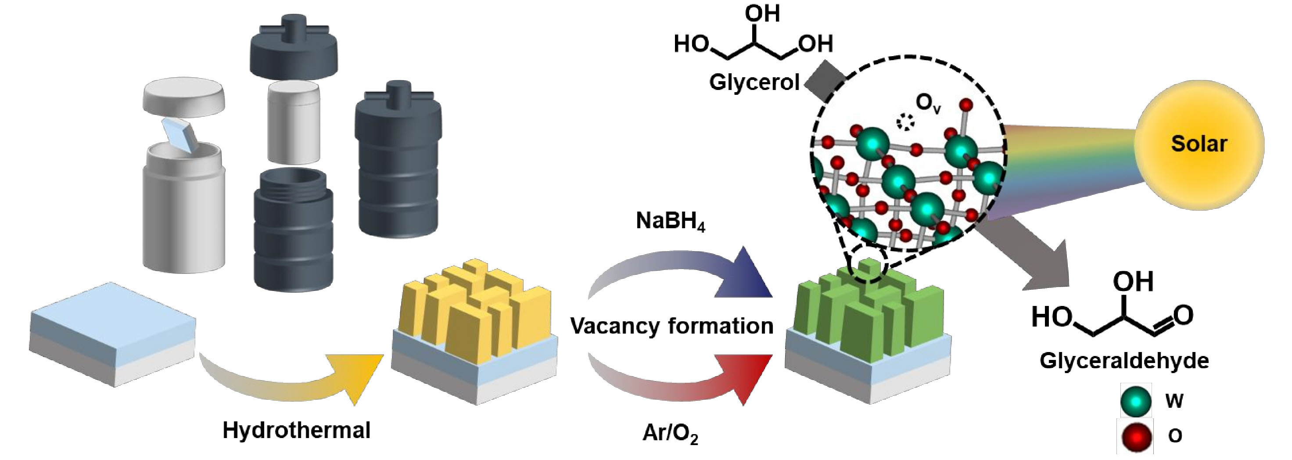

▲ Schematic diagram of an oxygen pore-tuned photoelectrode. The photoelectrode fabricated in this way converts glycerol into glyceraldehyde using solar energy.

The research team explained that this shows the highest efficiency and stability among the research results related to solar energy conversion systems targeting glycerol reported to date. In addition, a high photocurrent of 2.58 mA·cm⁻² and a high value-added material production efficiency of 378.8 mmol·m⁻²·h⁻¹ were achieved.

* oxygen vacancy control technology: Oxygen vacancies are a state in which oxygen atoms are deficient in an oxide crystal structure, and they have a significant impact on the electronic, structural, and chemical properties of a material. Oxygen vacancy control technology is a technology that can control vacancies only in the desired area of ​​the oxide crystal structure.

The research team also succeeded in producing green hydrogen by utilizing the reduction reaction that occurs along with the oxidation reaction in the process of producing glyceraldehyde from glycerol. Through this, the possibility of implementing an economical and eco-friendly system that can produce hydrogen while converting industrial waste was presented.

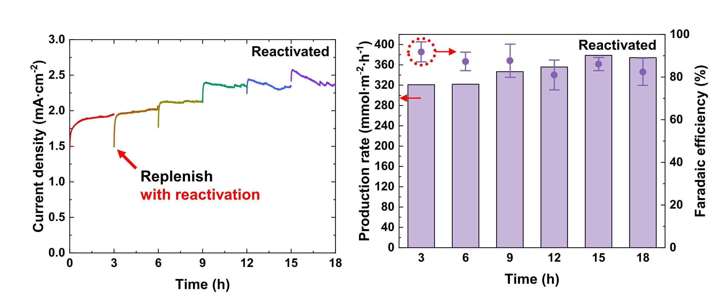

▲ Performance evaluation of the oxygen pore-adjusted photoelectrode developed by the research team. The research team’s photoelectrode was maintained for a long time without significant performance degradation, showing the highest stability performance value among glycerol-related studies reported to date.

Professor Sanghan Lee said, "Through this study, we have overcome the efficiency and stability issues that are major issues in industrial waste conversion, and in particular, the solar energy conversion system based on this will greatly contribute to advancing the commercialization of waste value-added and hydrogen production technology."

This study, led by Professor Sanghan Lee and participated by Yoonsung Jung and Seunghwan Kim, integrated master's and doctoral students, was conducted with the support of the Urban Waste Gasification Material Innovative Conversion Leading Research Center Project, Future Hydrogen Source Technology Development Project, and GIST-MIT Joint Research Project supported by the National Research Foundation of Korea, and was published online on October 24, 2024, in the top 7% international academic journal in the field of applied physics《Small》(IF=13.0).



