“Paradigm Shift in Microbiome Research” GIST-Samsung Seoul Hospital-KBSI develops new metabolome-based immunotherapy treatment that predicts reactivity and increases efficacy

- Professor Hansoo Park, Department of Biomedical Science and Engineering, GIST (CEO of Genome & Company) - Professor Se-Hoon Lee, Division of Hematology-Oncology, Samsung Medical Center - Joint research with Vice President Geum-Sook Hwang, Korea Basic Science Institute (KBSI)

- Development of new treatment methods through metabolome-based research that goes beyond previous microbiome research... Effectively predicts treatment response and can be used as an adjuvant to enhance the effectiveness of existing immunotherapy

- Confirmation of the effects of taurolithocholic acid (TLCA) on reducing tumor growth and enhancing cancer immunity... “A starting point for understanding the impact of metabolites on immune response and metabolic health” Published in the international academic journal 《Drug Resistance Updates》



▲ (From left on the top row) Professor Hansoo Park of GIST, Professor Se-Hoon Lee of Samsung Medical Center, Vice President Geum-Sook Hwang of the Korea Basic Science Institute, (From left on the bottom row) student Sujeong Kim of GIST, Dr. Jueun Lee of the Korea Basic Science Institute, and student Yunjae Kim of GIST

Immunotherapy is gaining attention as an innovative treatment method that activates the immune system of cancer patients to attack cancer cells. However, only about 20-30% of patients respond to the treatment, so research on biomarkers that more accurately predict patients' responses to immunotherapy and new treatment methods are needed.

The Gwangju Institute of Science and Technology (GIST, President Kichul Lim) announced that a joint research team including Professor Hansoo Park of the Department of Biomedical Science and Engineering (CEO of Genome & Company), Professor Se-Hoon Lee of Samsung Medical Center, and Vice President Geum-Sook Hwang of the Korea Basic Science Institute (KBSI) developed a new treatment method that can predict the responsiveness of existing immunotherapy drugs and increase treatment efficacy through targeted and non-targeted metabolite analysis* using plasma* of non-small cell lung cancer* patients.

* non-small cell lung cancer: One of the main types of lung cancer, mainly divided into squamous cell carcinoma, adenocarcinoma, and large cell carcinoma, accounting for about 85% of all lung cancers.

* plasma: The liquid part of blood, consisting of substances excluding blood cells and other solid components.

* targeted and non-targeted metabolite analysis: Targeted analysis is a method of quantitatively analyzing specific metabolites by setting them in advance, and non-targeted analysis is a method of exploring new biomarkers or metabolic pathways by targeting the entire metabolite.

Recent research results have shown that various metabolic processes and metabolites have a significant impact on immune activation and the efficacy of immunotherapy.

In particular, studies based on metabolites such as short-chain fatty acids and bile acids, which are mainly produced and regulated by the microbiome, are an advancement of previous microbiome studies, and are expected to be utilized as adjuvants that can not only efficiently predict treatment response but also enhance the effectiveness of existing immunotherapy.

* immune checkpoint protein: It is a protein expressed on the surface of immune cells that binds to proteins of other immune cells to be activated and participate in the regulation of immune responses. Representative examples include PD-1/PD-L1 and CTLA-4.

The research team collected plasma samples from 76 non-small cell lung cancer patients before and after starting immunotherapy (anti-PD-L1 and anti-PD-1*) treatment (2-3 weeks) and performed non-targeted metabolic profiling and targeted metabolic analysis.

Through this, it was confirmed that amino acid metabolism, glycolysis metabolism, and bile acid metabolism play an important role in predicting the effect of cancer immunotherapy.

The research team verified these results through bioinformatics analysis (bulk RNA sequencing and single-cell RNA sequencing) using additional publicly available data from cancer patients, immune cell experiments, and cancer animal model experiments.

* Anti-PD-L1 and anti-PD-1: Representative immune checkpoint inhibitors, which are antibodies that target the PD-L1 and PD-1 proteins, respectively.

In the case of amino acid metabolism, it was confirmed that the higher the histidine (His) level, the better the responsiveness and treatment prognosis of immunotherapy drugs, and the lower the homocysteine ​​(HCys), phenylalanine (Phe), and sarcosine (Sar) levels.

Therefore, the research team suggested the ratio of these amino acids [His/(HCys+Phe+Sar)] as an important biomarker for predicting the results of immunotherapy drugs (accuracy=80.4%, AUC=0.79), and verified this through bulk RNA and single-cell RNA sequencing analysis in cancer tissues of non-small cell lung cancer patients.

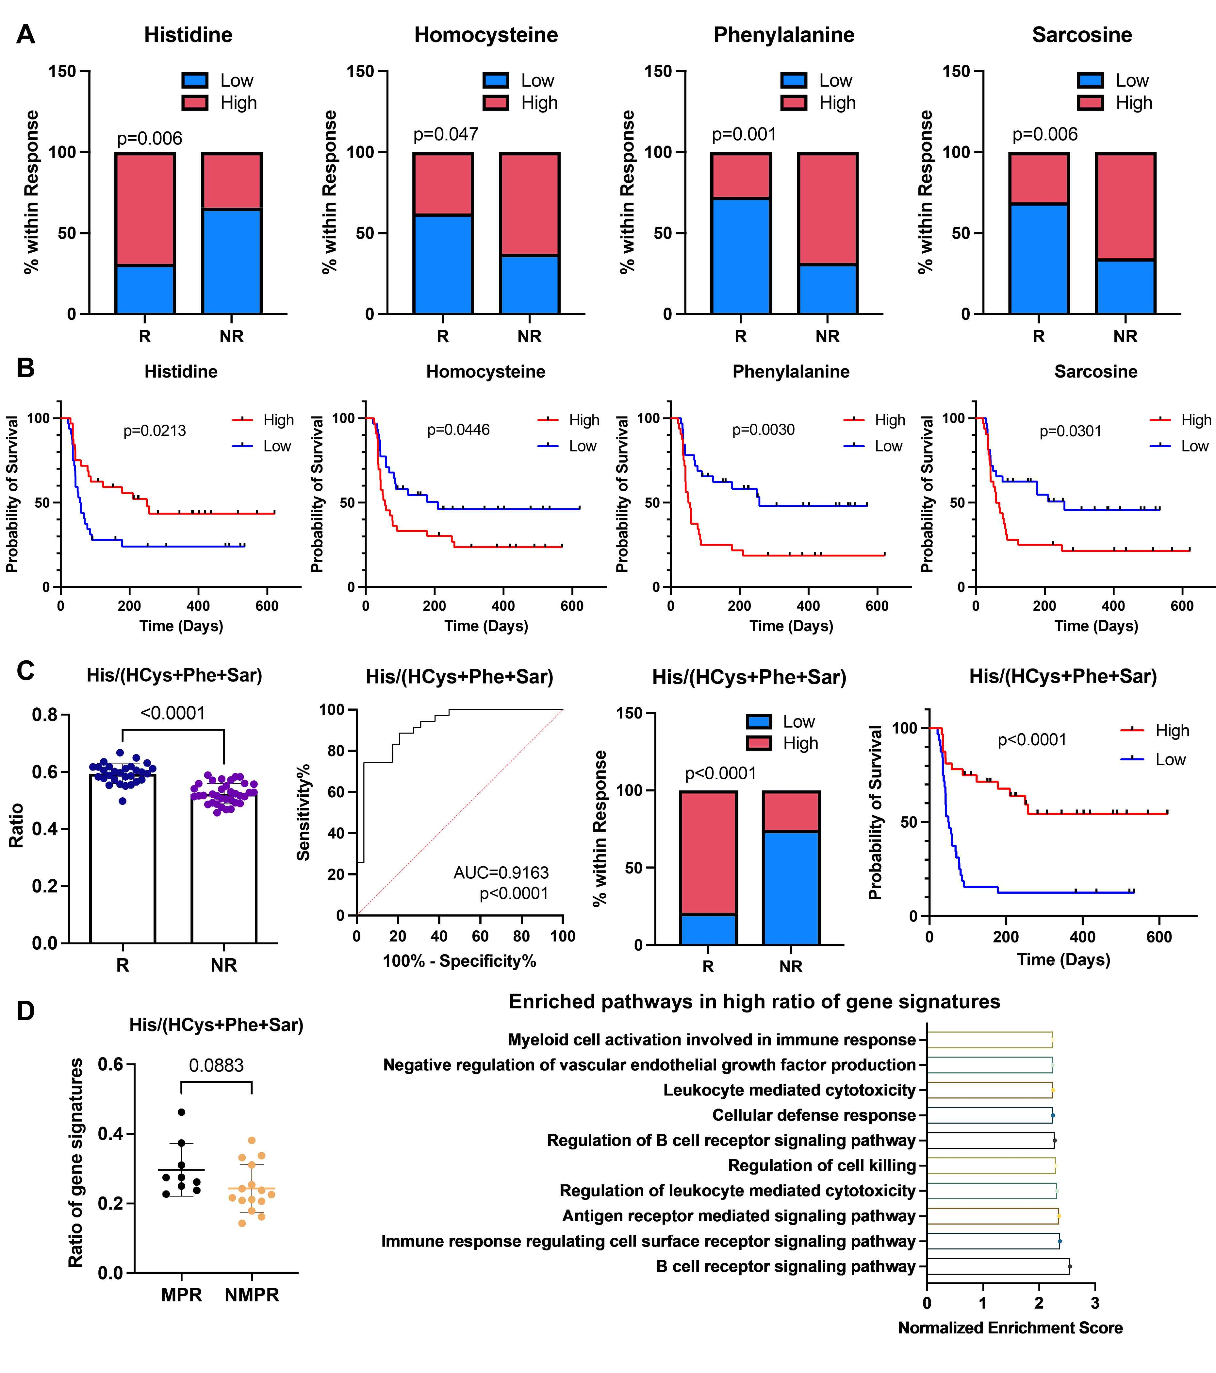

▲ Confirmation of the relationship between amino acid metabolism and immunotherapy responsiveness and prognosis: The higher the histidine (His) level, and the lower the homocysteine ​​(HCys), phenylalanine (Phe), and sarcosine (Sar) levels, the better the immunotherapy responsiveness (A) and the better the treatment prognosis (B). The higher the ratio of the corresponding metabolites (His/HCys+Phe+Sar), the better the immunotherapy responsiveness and treatment prognosis (C), which was verified through bulk RNA sequencing analysis (D).

In addition, it was presented that the metabolites in the process of decomposing sugar (glycolysis) are related to immunotherapy. In particular, in the case of lactate, there was no significant difference in the response group after immunotherapy, whereas the level significantly increased in the non-response group (t-test p-value response group = 0.7290, non-response group = 0.0178). Through this, lactate metabolism was specified as a biomarker that can monitor the effect of immunotherapy.

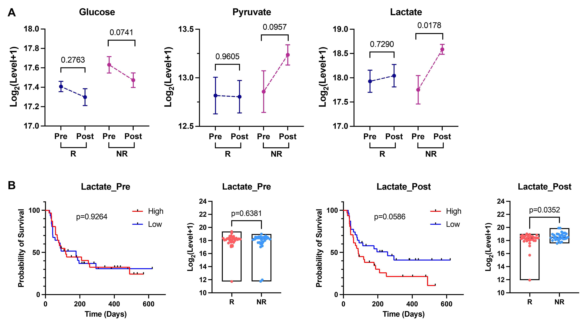

▲ Confirmation of the relationship between the glycolysis process and immunotherapy response and prognosis: The relationship between the representative metabolites of glycolysis, glucose, pyruvate, and lactate, and the responsiveness of immunotherapy was confirmed. Among them, lactate significantly increased in the immunotherapy non-responsive group (A), and when the lactate level increased, the treatment prognosis was poor (B).

Furthermore, the research team also presented the results of an analysis that specific bile acids, glycochenodeoxycholic acid (GCDCA) and taurolithocholic acid (TLCA), are related to the responsiveness and treatment prognosis of immunotherapy.

In particular, taurolithocholic acid (TLCA) directly proliferated T cells and increased cytotoxicity (proliferation: 23.05% → 78.27%, cytotoxicity: 29.6% → 69.1%). In addition, it confirmed the effect of reducing tumor growth by 1.5 to 3 times in a cancer animal model, as well as the effect of enhancing cancer immunity through the increase of CD8+ T cells and NK cells, immune cells that directly attack cancer cells. Accordingly, taurolithocholic acid (TLCA) is proposed not only as a biomarker, but also as an adjuvant that can be applied to actual immunotherapy.

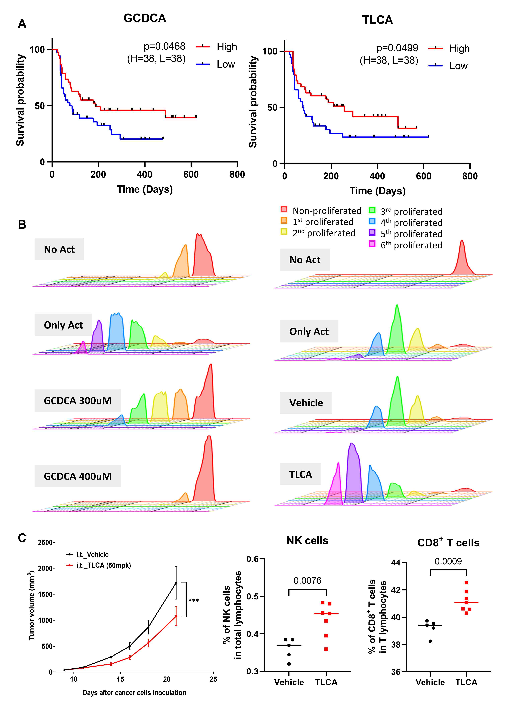

▲ Confirmation of the relationship between bile acids and the prognosis of immunotherapy and the effect of increasing immunity: It was confirmed that specific bile acids, glycochenodeoxycholic acid (GCDCA) and taurolithocholic acid (TLCA), were related to the prognosis of immunotherapy (A). Afterwards, the effect of the two bile acids on T cell proliferation was investigated (B). In particular, taurolithocholic acid (TLCA) enhanced the proliferation of T cells and increased the anticancer immune effect in an actual cancer animal model (C).

Professor Hansoo Park of GIST (CEO of Genome & Company) said, "In microbiome research, metabolomics studies are essential to understanding how metabolites produced and regulated by gut microbes affect patients’ immune responses and metabolic health, and this study provides an important foundation for this."

Professor Se-Hoon Lee of Samsung Medical Center said, "This study was based on samples from patients who actually received immunotherapy for cancer, and the results were applicable for treatment and prediction purposes in clinical settings in the future."

Vice President Geum-Sook Hwang of the Korea Basic Science Institute said, "It is expected that non-targeted and targeted metabolite analysis technologies will be useful technologies for predicting patient treatment efficacy and monitoring treatment effects in clinical settings."

This study, conducted jointly by Professor Hansoo Park of the Department of Biomedical Science and Engineering at GIST (CEO of Genome & Company), Professor Se-Hoon Lee of Samsung Medical Center, and Vice President Geum-Sook Hwang of the Korea Basic Science Institute, was supported by the National Research Foundation of Korea, the Korea Health Industry Development Institute (KHIDI), the GIST Research Project, the Samsung Seoul Hospital Project, and the KBSI Researcher Project, and was published online in the international academic journal in the field of pharmacology and pharmaceutical science, Drug Resistance Updates, on October 10, 2024.



