“Expected to be applied to various energy conversion chemical reactions” GIST, the world’s first to identify hydrogen production reaction path based on electron spin interaction phenomenon

- Professor Junhyeok Seo's team in the Department of Chemistry controls the movement path of protons and electrons and clarifies the hydrogen production reaction mechanism... Design of two types of cobalt compounds with ferromagnetic and antiferromagnetic properties

- Antiferromagnetic cobalt catalyst compounds have higher hydrogen conversion efficiency (100%) than ferromagnetic ones, and hydrogen gas production is also twice as high... Published in the international academic journal 《Nature Communications》



▲ (From left) Professor Junhyeok Seo and doctoral student Jueun Lee of the Department of Chemistry

As environmental pollution and resource depletion become more serious, hydrogen is gaining attention as an eco-friendly energy source to replace fossil fuels, and interest in developing catalysts for hydrogen production is also growing.

The Gwangju Institute of Science and Technology (GIST, President Kichul Lim) announced that Professor Seo Jun-hyeok's research team in the Department of Chemistry controlled the movement of electrons and protons using the exchange bonding* properties of cobalt catalysts and elucidated the hydrogen production reaction mechanism.

This study is a case of applying the understanding of basic scientific phenomena to the development of a hydrogen production catalyst. It is expected that the method of controlling the movement paths of electrons and protons will not only help in studying the reactivity and selectivity of various chemical reactions, but also contribute to increasing the efficiency of catalytic reactions.

* exchange coupling: This refers to the phenomenon in which two unpaired electrons in different atoms or ions interact, and through this interaction, the electron spins can be aligned in the same direction (ferromagnetic spin interaction) or aligned in opposite directions (antiferromagnetic spin interaction).

Although many catalytic reactions that electrochemically produce hydrogen gas have been reported in previous studies, there have been no reported cases of research that uses the interaction phenomenon of electron spin* to control the movement path of protons and electrons and elucidate the hydrogen production reaction mechanism.

* electron spin: Electron spin is one of the fundamental properties of electrons, like mass or charge, and is a physical quantity with a unit of angular momentum.

The research team focused on controlling the movement path of electrons and protons, which are the basic units of hydrogen production reactions. By applying a new control method to elucidate the hydrogen reaction mechanism, a method for producing hydrogen with very high efficiency can be developed.

The research team designed two types of cobalt compounds that each have different ‘electron spin interactions’, that is, ferromagnetic and antiferromagnetic properties.

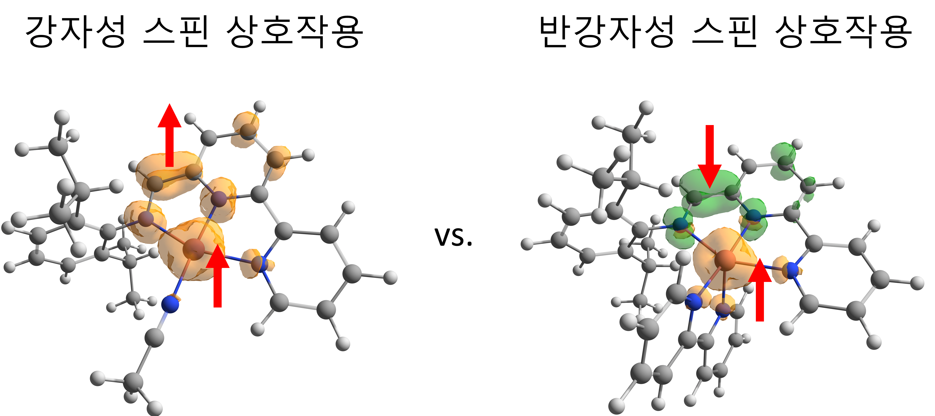

▲ Spin density of cobalt compounds with different spin interactions. (Left) Up spins are distributed to the central metal and ligands, respectively. (Right) Up spins are distributed to the central metal, and down spins are distributed to the ligands.

‘Electron spin interaction’ is the interaction of electron spins introduced into the catalyst system, which affects the energy state of the compound, just as two dancers on a stage dance in one direction or the opposite direction, and affect each other’s movement, and also affects the movement of other electron spins.

The antiferromagnetic cobalt catalyst compound developed in this study produced hydrogen with a conversion efficiency of 100% compared to the amount of charge supplied from the reduction electrode of the electrochemical cell, and showed high catalytic reactivity, producing more than 11×103 hydrogen gas per second.

In contrast, the ferromagnetic cobalt catalyst compound produced about 6×103 hydrogen gas per second, which is half the level of the antiferromagnetic compound. This can be explained by the fact that the antiferromagnetic spin interaction facilitates the transfer of electrons, which in turn increases the efficiency of the hydrogen production catalytic reaction.

Professor Junhyeok Seo said, "This study has led to an understanding of how to control the movement of electrons and protons in hydrogen production reactions. We expect that this method can be applied to various energy conversion chemical reactions in the future."

This study, supervised by Professor Junhyeok Seo of the Department of Chemistry at GIST and conducted by Ph.D. student Jueun Lee, was published in the international journal Nature Communications on October 7, 2024, with support from the Basic Research Program of the National Research Foundation of Korea and the Marine and Fisheries New Business Technology Commercialization Support Program of the Korea Institute of Ocean Science and Technology Promotion.



