Professor Bong-Joong Kim's research team develops high-efficiency hydrogen production iron oxide nano-catalyst technology: Environmentally friendly with no process other than heat treatment required maximizing photoelectrochemical cell activity and lifespan for water decomposition

- Professor Bong-Joong Kim's team from the School of Materials Science and Engineering develops an exosolution technology that strongly binds highly doped metal iron catalysts to substrates... 12-fold increase in photoelectrochemical cell activity for water splitting, maintaining activity for 24 hours

- "Expecting groundbreaking improvements in areas that utilize high-temperature catalytic reactions such as electric vehicles, gas sensors, and gas reforming, or in renewable energy applications"... Published in the international academic journal 《Small Structures》


▲ GIST School of Materials Science and Engineering Professor Bong-Joong Kim

The Gwangju Institute of Science and Technology (GIST, President Kichul Lim) announced that the research team led by Professor Bong-Joong Kim of the School of Materials Science and Engineering has developed a method for spontaneously generating iron oxide nano catalyst particles for high-efficiency hydrogen production.

Maximizing the activity and lifespan of photoelectrochemical cells for water splitting is expected to bring about groundbreaking improvements in areas that utilize high-temperature catalytic reactions such as electric vehicles, gas sensors, and gas reforming, or in areas that apply renewable energy.

The research team developed a new concept of ex-solution technology that extracts all highly doped metal iron catalyst particles from oxide substrates without causing structural defects in the substrate and partially embeds them in the substrate to make them firmly fixed.

In addition, the principle of generation of ex-solution metal catalyst particles and the principle of controlling their size, density, and distribution were elucidated using real-time transmission electron microscopy* techniques.

* transmission electron microscope: A microscope that can observe objects at magnifications of hundreds of thousands of times or more by shooting a high-voltage electron beam that allows them to pass through thin materials.

Exsolution is a technique that heats a metal or metal oxide solid solution to separate the components and thereby firmly and evenly attaches metal nanoparticle catalysts to the metal oxide surface in real time.

The exsolution phenomenon of metal catalyst particles using an oxide support is considered very important in high-temperature catalytic reactions (e.g. gas sensors, etc.) and renewable energy (e.g. gas reforming, fuel cells, etc.) applications because the catalyst particles are embedded on the support surface and do not coarsen even at high temperatures. It is also drawing attention as an eco-friendly future technology that utilizes only heat treatment without any special process.

* coarsening: A phenomenon in which crystal grains become larger when polycrystalline materials are heated at high temperatures.

The exsolution phenomenon occurs through high-temperature heat treatment in a reducing environment after doping a metal element on a crystalline oxide substrate. However, in the conventional method, only a very small amount of the metal element escapes due to the slow diffusion rate of the metal element within the crystalline substrate, making it difficult to generate a large amount of catalyst particles on the substrate, and the escaped metal element causes structural defects in the oxide substrate.

Due to these problems, the activity and durability of the utilized device are drastically reduced, and this has been pointed out as a limitation of catalyst technology.

In particular, iron (Fe) in the existing crystalline substrate strongly bonds with oxygen (O) in the oxide substrate, making it virtually impossible to exsolate. For example, iron can only be exsolated under high hydrogen partial pressure and high temperature, but at this time, the problem of the oxide substrate decomposing occurred.

Instead of the existing method, the research team coated a sol-gel solution of strontium titanate (SrTiO3) heavily doped with iron elements onto the substrate and performed heat treatment in a vacuum. When observing while increasing the temperature using a real-time transmission electron microscope technique, the coated thin film experienced a phase change from an amorphous solid to a crystalline solid at 800 degrees Celsius.

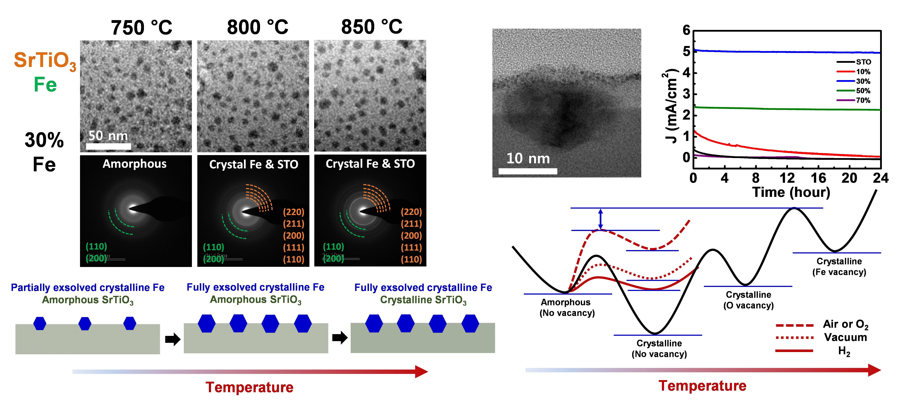
[Figure] Real-time observation of iron particle exsolution from amorphous and photoelectrochemical cell reaction (1) Real-time transmission electron microscope imaging and diffraction analysis of Fe exsolution phenomenon on sol-gel coated SrTi0.7Co0.3O3 amorphous substrate (2) Transmission electron microscope image showing Fe particles embedded in the substrate (3) J-t plot of photoelectrochemical cell (4) Thermal free energy landscape for interpretation of amorphous exsolution

In particular, the entire amount of iron element doped at 50% was exsolved onto the substrate at low temperature in the amorphous state. The exsolved iron particles were very small and uniform in size and distribution, and were partially embedded in the substrate.

In addition, the particles were oxidized to magnetite (Fe3O4)* at room temperature and pressure, undergoing a phase change into a material with a small band gap and excellent light absorption and conductivity, and by aligning the ‘type II band*’ with the substrate, it was easy to separate unpaired electrons, thereby maximizing the activity and lifespan of the photoelectrochemical cell for water splitting.

Compared with strontium titanate, the activity increased approximately 12-fold (5.10 mA/cm2 at 1.23 V vs. reversible hydrogen electrode) and maintained almost the same activity (97% retention) for 24 h.

* magnetite (Fe3O4): Iron oxide mixed with iron(II) and iron(III) ions, strongly magnetic, iron oxide commonly found in nature

* type II band alignment: When two semiconductors are joined, the conduction band of one semiconductor is lower than that of the other, and the valence band is relatively higher on the opposite side, so that electrons and holes are located in different semiconductors and spatially separated.

The research team additionally revealed through first-principles calculations* that this phenomenon is due to the low vacancy creation energy of iron elements in amorphous solids.

* first-principles calculation: A method of calculating the movement of atoms or electrons using only basic physical laws and constants. It has been proven to be accurate and efficient, and has recently been gaining attention.

Professor Bong-Joong Kim said, "The results of this study have provided a new avenue for research on exosolution by confirming the applicability of the exosolution technology to iron (Fe), an element with a strong bond to oxygen, while the technology could only be applied to metal elements with a weak bond to oxygen."

This study, led by Professor Bong-Joong Kim (corresponding author) of the School of Materials Science and Engineering at GIST, was conducted with the support of the National Research Foundation of Korea's mid-level research project and the GIST-MIT collaborative research project, and was published online in the international nano-related academic journal Small Structures on October 28, 2024.



