GIST-KIER develops next-generation heat storage molded body with 2.5 times higher heat storage density and structural stability

- GIST School of Environment and Energy Engineering Professor Jong Hoon Joo – KIER Dr. Sungkook Hong joint research team develops heat storage molded body with 2.5 times higher heat storage density than existing ones and stable even after 80 axial heat release tests

- Expected to be used in the molding technology of oxide heat storage materials that require high reaction speed and mechanical stability... Published in the international academic journal in the energy field, 《Renewable and Sustainable Energy Reviews》

▲ (From left) Professor Jong Hoon Joo of GIST (corresponding author), Dr. Sungkook Hong of Korea Institute of Energy Research (joint corresponding author), and PhD student Soomin Choi of GIST (first author)

As the use of intermittent renewable energy sources such as solar and wind power increases, interest in heat storage technology that can meet energy supply and demand is increasing. A Korean research team has succeeded in creating a heat storage molded body that has a heat storage density 2.5 times higher than existing molded bodies and maintains its structure even after 80 axial heat release tests.

The Gwangju Institute of Science and Technology (GIST, President Kichul Lim) announced that the research team of Professor Jong Hoon Joo of the School of Environment and Energy Engineering and Dr. Sungkook Hong of the Korea Institute of Energy Research (KIER) have developed a heat storage molded body that has high heat storage performance and structural stability even in repeated heat storage cycles.

Among various heat storage materials, magnesium oxide (MgO) has attracted much attention due to its high heat storage density, non-toxicity, and economic efficiency. However, it has limitations in that the heat storage performance is reduced due to the agglomeration of powder particles during repeated heat storage and release processes, and the system stage is clogged, which reduces system efficiency.

To solve these problems, the development of a molded body is essential, but research on this is still insufficient, and more advanced molding techniques are required due to the structural instability of the molded body caused by the change in material volume during the axial heat release* process.

* axial heat release: heat storage and release (heat storage, heat release)

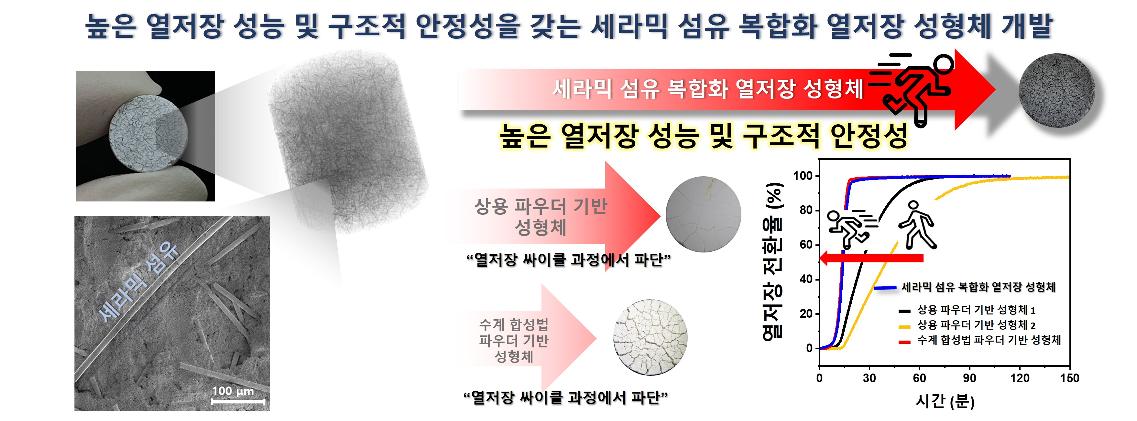

The research team succeeded in overcoming these limitations and developing a molded body with high heat storage density and structural stability in repeated heat storage cycles.

Using powder obtained through an aqueous synthesis method, a molded body with a wide pore distribution and specific surface area was manufactured, and the structural stability of the molded body was improved by introducing a sintering* process and ceramic fibers.

* sintering: A process of applying sufficient temperature and pressure to particles with a large specific surface area, such as powder, to form a more dense mass.

The ceramic fiber composite magnesium oxide (MgO) molded body developed by the research team showed excellent heat storage reactivity despite the sintering process.

The developed ceramic fiber composite molded body has a hydration rate of approximately 85% and a high heat storage density of 984 J g⁻¹. This is approximately 2.5 times higher than that of the existing commercial powder-based molded body. In addition, while the commercial powder-based molded body was fractured after 2-3 heat storage cycles, the molded body developed by the research team was confirmed to maintain its structure even after 80 axial heat release cycle tests.

Professor Jong Hoon Joo said, "The new heat storage molding technology developed by the research team is expected to be utilized in the molding technology of various oxide heat storage materials that aim for high reaction speed and mechanical stability by securing stability in the heat storage cycle."

This study was conducted with the support of the SCI Convergence Research Group Project supported by the National Research Council of Science and Technology (NST), the KIER Basic Project, and the Leading Research Center Project of the Ministry of Science and ICT. The research was led by Ph.D. student Soomin Choi under the supervision of Professor Jong Hoon Joo of GIST and Dr. Sungkook Hong of KIER, and was published online in the renowned international academic journal in the energy field, 《Renewable and Sustainable Energy Reviews》 (top 2.7%), on September 4, 2024.



