GIST develops electrolytic additives for water electrolysis that lower production costs and improve performance and durability: Expected to mass-produce eco-friendly ‘ultra-high purity green hydrogen’

- Professor Jaeyoung Lee's team from the School of Earth Sciences and Environmental Engineering develops an electrode that can operate stably at the world's highest current density (9000 mA cm-2), which is 9 times higher than the existing commercial water electrolysis reactor

- "Solving the performance and durability issues of water electrolysis technology simultaneously, 9 times higher purity per unit area, and advancing the hydrogen economy through green hydrogen production"... Published in 《Chemical Engineering Journal》

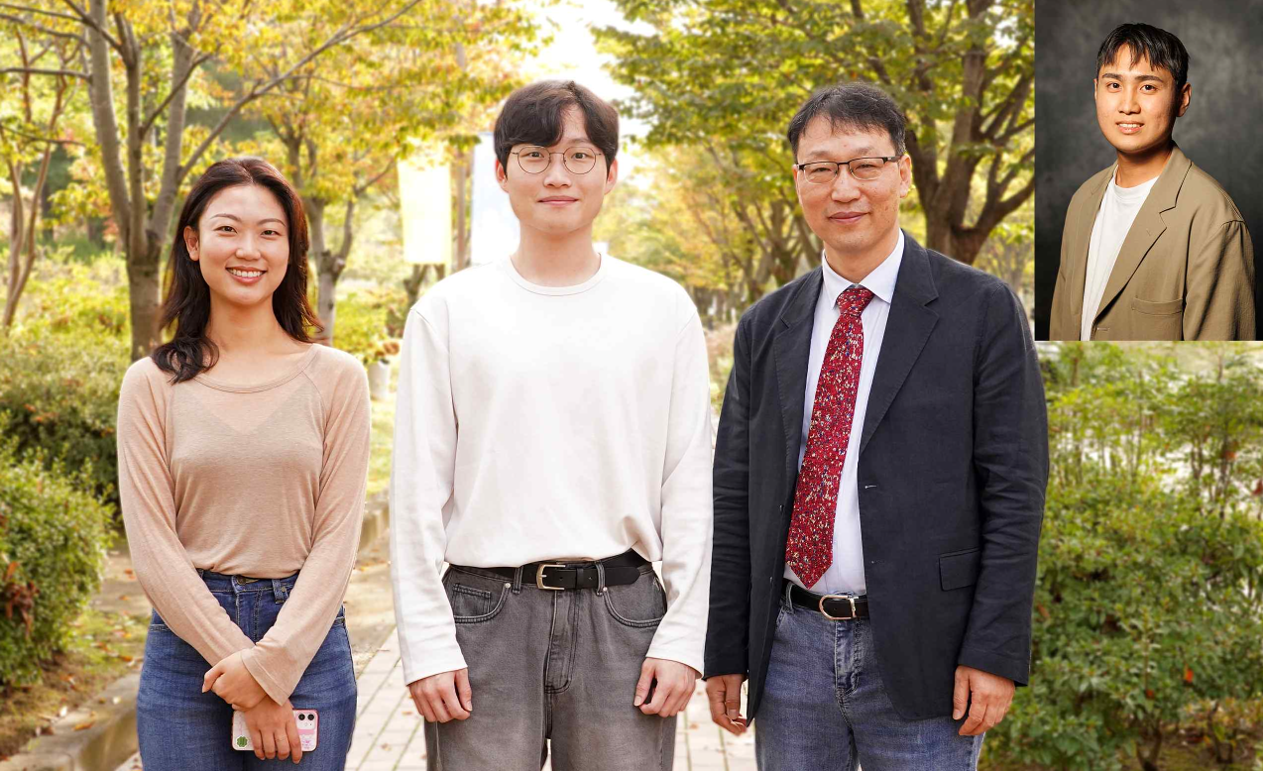▲ (From left) Student Sooan Bae (co-author, GIST), student Dong-yeol Lee (co-author, GIST), Professor Jaeyoung Lee (corresponding author, GIST), Dr. Sinwoo Kang (first author, GIST)

In order to achieve the goal of ‘2050 Carbon Neutrality’ established through the enactment of the Basic Carbon Neutrality Act in 2021, electrolysis technology that obtains hydrogen by electrolyzing water is gaining attention. In the process of electrolysis using a catalyst, the oxygen generation reaction occurs, and the active metal of the catalyst is lost from the electrode, which reduces the efficiency of the entire electrolysis system. However, Korean researchers have developed an electrolyte additive optimized for electrode catalysts to solve this problem.

When the newly developed electrolyte additive is used, ‘ultra-high purity green hydrogen’ is produced at a level of 99.999%, which is far superior to existing methods, through negative ion exchange membrane electrolysis, and it is expected to contribute to advancing the commercialization of mass production processes.

The Gwangju Institute of Science and Technology (GIST, President Kichul Lim) announced that a research team led by Professor Jaeyoung Lee (Director of the Ertl Carbon Emission Research) in the School of Earth Sciences and Environmental Engineering developed a highly durable nickel-iron electrode and electrolyte additive that can operate at 9000 mA cm⁻², which is nine times higher than the existing electrolysis cell, in anion exchange membrane electrolysis using an iron ion electrolyte additive.

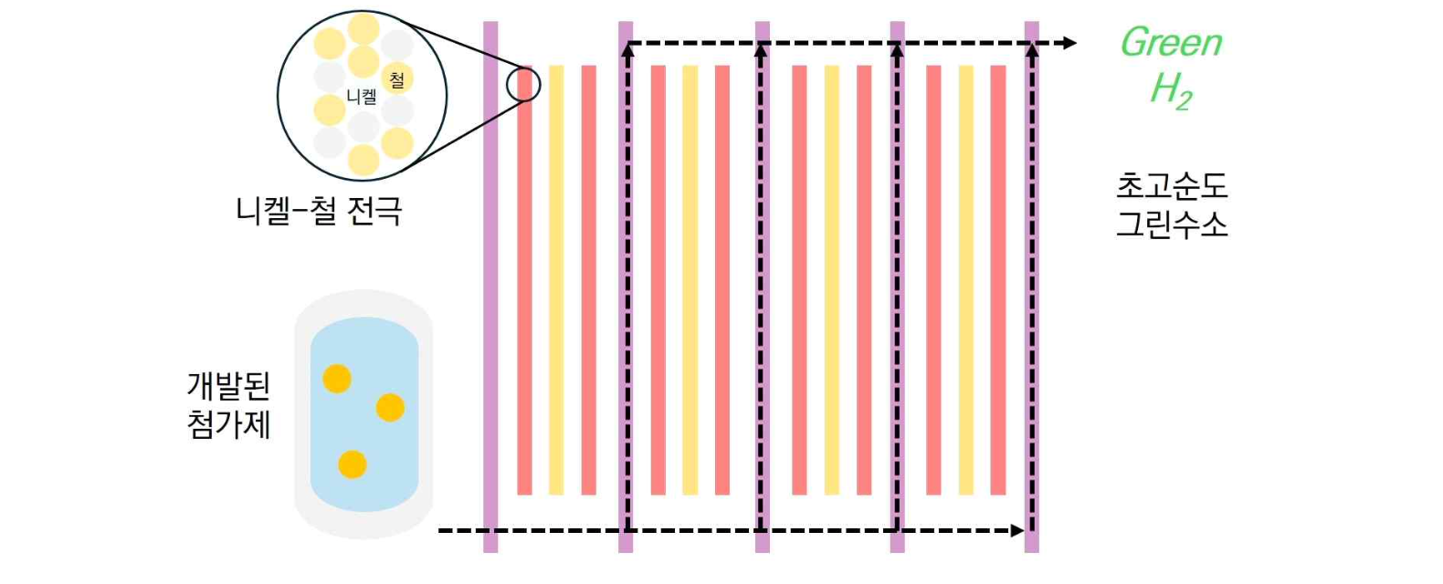▲ 3rd generation anion exchange membrane high-performance electrolysis stack. A high-durability nickel-iron electrode and electrolyte additive have been developed that can operate at a current density of 9000 mA cm⁻², which is nine times higher than that of existing electrolysis cells, in anion exchange membrane electrolysis capable of producing ultra-high purity green hydrogen.

Currently, iridium and ruthenium are mainly used as catalysts for water electrolysis, but their high price is an obstacle to commercialization. Therefore, the development of a non-precious metal electrocatalyst that is inexpensive, high-performance, and durable for use in oxygen generation reactions is urgent.

The research team confirmed through real-time Raman analysis* that iron (Fe), an electrolyte, changed the oxygen evolution reaction path to a lattice oxygen evolution reaction* and thus improved the reaction rate. In addition, through induced coupled plasma analysis*, they confirmed that iron was continuously re-adsorbed onto the electrode to maintain the number of active sites (sites where the catalytic reaction occurs).

Iron dissolved in the aqueous solution causes oxygen at the electrode to participate in the oxygen evolution reaction, which was confirmed to induce the lattice oxygen evolution reaction and increase the rate of production of oxygen molecules per hour at the active site.

* real-time Raman analysis: Provides information on intermolecular and intramolecular vibrations and provides information on chemical bonds that change during electrochemical reactions.

* lattice oxygen evolution reaction: A reaction in which oxygen atoms (O) in the lattice of a non-precious metal electrocatalyst directly participate in an electrochemical reaction to generate oxygen molecules (O₂).

* inductively coupled plasma analysis: Inductively coupled plasma (ICP) is an argon plasma with high-temperature thermal energy obtained by a high-frequency inductive coupling method. When a test solution is sprayed into this plasma, the atoms contained in the test solution become excited, and this is a method of identifying elements or performing quantitative analysis by measuring the wavelength and intensity of the atomic emission spectrum generated at this time.

The research team developed a standard-sized (9.0 cm²) electrode that can operate at a current density of 9,000 mAcm⁻², which is nine times higher than that of existing commercial water electrolysis cells, by utilizing the principle that partial electrolytic dissolution by high current accelerates the dissolution of iron near lattice oxygen, but at the same time, iron in the aqueous solution is re-absorbed onto the electrode.

* lattice oxygen: Oxygen atoms (O) directly bonded to metal in metal oxide electrode catalysts.

The research team demonstrated that this electrode is applicable to a 512 cm² prototype stack and confirmed that it functions stably for 500 hours as a core element of a water electrolysis electrode.

Professor Jaeyoung Lee said, "The significance of this research result is that it simultaneously solves the performance and durability issues of water electrolysis technology by designing an electrolyte that can produce high-purity green hydrogen more than 9 times per unit area. In particular, as an eco-friendly research result suitable for the carbon-neutral era, we plan to seek commercialization with Esus Co., Ltd. (www.esus.co.kr), a membrane electrode assembly (MEA) specialized proof-of-concept (PoC) company."

This study, led by Professor Jaeyoung Lee (corresponding author) and Dr. Sinwoo Kang (first author) of the School of Earth Sciences and Environmental Engineering at GIST, was conducted with the support of the Overseas Excellent Research Institute Joint Research Project and the National Hydrogen Key Laboratory Project supported by the National Research Foundation of Korea (NRF) under the Ministry of Science and ICT, and was published online in the world-renowned academic journal in the field of chemical engineering, Chemical Engineering Journal, on October 5, 2024.

