GIST-IBS, world's first proof of strong-field quantum electrodynamics phenomenon: World's first implementation of 'nonlinear Compton scattering' with self-developed world's strongest intensity 4PW (petawatt) ultra-strong laser

- Professor Chang Hee Nam of the Department of Physics and Photon Science and Senior Researcher Jae Hee Sung of the Advanced Photonics Research Institute, a groundbreaking breakthrough in overcoming the existing experimental limitations of strong-intensity light-matter interaction... Attempted in Europe, the US, and China, but failed to prove

- First successful experimental identification of the phenomenon of 'nonlinear Compton scattering', in which one electron and more than 300 laser photons collide to convert into a single gamma-ray photon with an energy of 470 MeV (megavolts)

- "Entry into a new area of light-matter interaction research (strong-field quantum electrodynamics)... Opens the possibility of realizing cosmic celestial phenomena on the ground" Published in the international academic journal 《Nature Photonics》

▲ (From left) Chang Hee Nam, a professor at the Department of Physics and Photon Science at GIST, and Jae Hee Sung, senior researcher at the Advanced Photonics Research Institute

Since the invention of the ‘artificial light’ laser in 1960, the intensity of lasers has increased rapidly, and the scope of physical phenomena that humans can explore has also expanded significantly. A Korean research team has proven for the first time the phenomenon of strong field quantum electrodynamics, which had been studied only theoretically until recently and for which experimental research has only recently begun.

The Gwangju Institute of Science and Technology (GIST, President Kichul Lim) announced that a research team led by Professor Chang Hee Nam of the Department of Physics and Photon Science and Senior Researcher Jae Hee Sung of the Advanced Photonics Research Institute experimentally demonstrated nonlinear Compton scattering*, a strong field quantum electrodynamics phenomenon, using an ultra-strong laser.

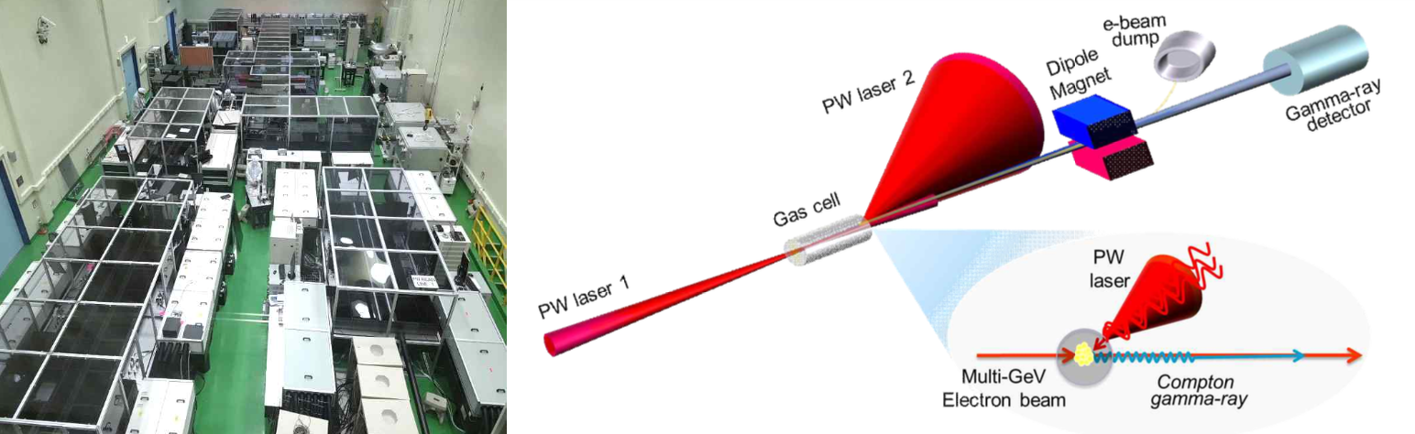▲ (From left) Conceptual diagram of the world’s most powerful ultra-high-intensity laser (GIST & IBS) and nonlinear Compton scattering experiment.

The most fundamental theory of the interaction between light and matter (i.e., electromagnetic phenomena) is quantum electrodynamics, which is a combination of special relativity and quantum mechanics. The quantum electrodynamics of weak light was theoretically completed and verified by the 1950s, but there is a lack of research on strong field quantum electrodynamics, in which the quantum mechanical vacuum* caused by strong light affects the light-matter interaction.

This research achievement not only dramatically overcomes the existing experimental limitations on strong-intensity light-matter interactions, but also opens up the possibility of reproducing celestial phenomena occurring in space on Earth.

* quantum mechanical vacuum: In general or classical physics, a vacuum is an empty space where there is nothing, but in quantum mechanics, it is a space where particles and antiparticles are constantly created and annihilated for a very short time. This is called a quantum mechanical vacuum.

When strong light and matter interact, quantum mechanical vacuum fluctuations emerge as an important factor in the interaction, which was theoretically predicted in the 1930s, but it has not been possible to prove it experimentally because the laser power required to prove it is too strong.

Usually, one electron and one photon collide, but if the light is strong enough, one electron and a large number of photons collide at the same time, generating one high-energy photon. This is called ‘nonlinear Compton scattering’ and refers to the most fundamental physical phenomenon that occurs in the new interaction field.

Research to experimentally prove nonlinear Compton scattering has been conducted for more than 10 years by groups with ultra-strong laser facilities in Europe, the United States, and China.

Despite the continuous efforts of research groups around the world, such as the Extreme Light Infrastructure consortium of the European Union, the LUXE project of the European X-ray Free-electron Laser, the FACET project of the Stanford Linear Accelerator in the United States, and the SEL project of the Shanghai Institute of Optics and Precision Mechanics in China, until recently, only indirect evidence for nonlinear Compton scattering or results in areas where the light is not strong enough have been presented.

Through this study, the GIST-IBS research team directly demonstrated nonlinear Compton scattering in a region where light intensity is extremely high using an ultra-strong laser, thereby opening up a new area of ​​research in light-matter interaction.

The GIST-IBS research team has already achieved a world record of a focused intensity of over 10² W/cm² using a self-developed ultra-strong laser in 2021, and has implemented nonlinear Compton scattering for the first time in the world using a self-developed 4 PW (petawatt) ultra-strong laser with the world's highest intensity.

*PW: 1000 trillion W = 1015 W

The research team split a super-intense laser into two beams, focusing one beam on a gas to generate high-energy electrons, and then colliding the other beam with the high-energy electrons to cause nonlinear Compton scattering.

When an ultra-intense laser beam with an intensity of 3X10²⁰ W/cm² collides with an electron with an energy of 2.4 GeV (10⁹ eV), a nonlinear Compton scattering phenomenon is experimentally observed, in which a single electron is converted into a single gamma-ray photon with an energy of 470 MeV (10⁸ eV) by the collision of more than 300 laser photons.

* eV: electronvolt, a unit of energy that is the energy required for one electron to move against a potential of 1 volt.

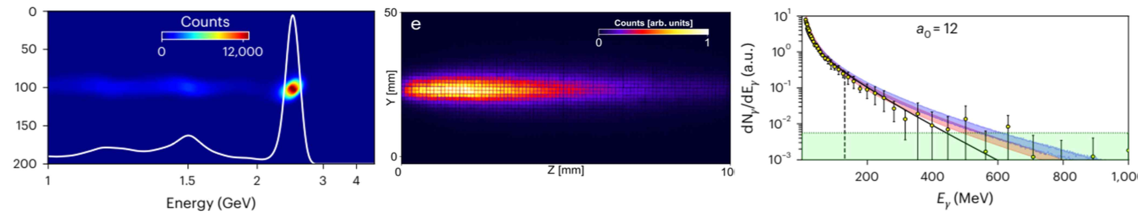▲ Results of the nonlinear Compton scattering experiment. (Left) The spectrum of the high-energy electron beam generated by the ultra-strong laser shows that the electron energy is 2.4 GeV. (Center) The measurement signal of the high-energy photon (gamma-ray) generated by the collision of the ultra-strong laser and the high-energy electron beam shows. (Right) The spectrum of the gamma-ray obtained by analyzing the measurement signal of the gamma-ray shows that a gamma-ray with an energy of 470 MeV was generated, which is a gamma-ray that can be obtained when 330 laser photons collide with electrons with an energy of 2.4 GeV.

Professor Chang Hee Nam said, "Through this research achievement, the study of light-matter interaction has entered a new field, namely strong-field quantum electrodynamics, where quantum vacuum emerges as the main character of the interaction, and has also led to a better understanding of the nature of vacuum. It is expected that through the study of light-matter interaction using an ultra-strong laser, various celestial phenomena can be realized on the ground, confirming theoretical predictions presented so far and discovering new physical phenomena."

This study, conducted by Professor Chang Hee Nam of the Department of Physics and Photon Science at GIST and Dr. Jae Hee Sung of the Advanced Photonics Research Institute, was supported by the IBS Center for High-Intensity Laser Science and the GIST Ultrashort Photon Beam Research Facility Operation Project, and was published online in the international academic journal in the field of optics, Nature Photonics, on October 14, 2024.



