“I walk in the content as if I were walking on the ground” GIST develops 360-degree treadmill that feels like walking on the ground, implementing the world’s best ultra-thin and ultra-high-speed design

- Professor Jungwon Yoon's team develops a next-generation metaverse walking interaction interface device that solves the problems of existing 360-degree treadmills... Exhibit at Yeonggwang e-Mobility Expo from Thursday, October 17 to Sunday, October 20
- "Expected to present innovative entertainment and game industry models ranging from rehabilitation treatment to disaster training" Scheduled to be presented at the International Robotics Society 'IROS 2024' on Thursday, October 17

▲ (From left) Professor Jungwon Yoon, Dr. Sanghun Pyo, and PhD student Jinsun Choi

The Gwangju Institute of Science and Technology (GIST, President Kichul Lim) announced that the world’s fastest and thinnest ‘helical speed change drive* 360-degree treadmill’ developed by Professor Jungwon Yoon and Dr. Sanghun Pyo (Center for Brain and Nanorobotics Research) of the School of Integrated Technology, and PhD candidate Jinsun Choi (School of Integrated Technology) has been invited to the Yeonggwang e-Mobility Expo and will be exhibited for four days from October 17 to 20.

* helical gear drive: This refers to transmitting power through a gear structure with a helical tooth shape, and it is a drive method with reduced noise and higher power transmission performance compared to conventional gear drive.

The research team succeeded in developing a new ‘360-degree treadmill’ that implements a high-speed/high acceleration/deceleration two-dimensional infinite ground by stacking two levels of special helical pulleys and helical gears in series to overcome the limitations of the low motion performance (2 m/s, 1.5 m/s2) of the previously developed 360-degree treadmill* and to resolve the risk of falling due to excessive thickness (over 50 cm).

* 360-degree omni-directional treadmill: A typical treadmill, commonly called a treadmill, only supports walking exercise in one dimension (one way), but a metaverse interaction platform using a 360-degree omni-directional treadmill can physically interface with the space implemented in the metaverse by identifying walking intention (speed, direction) in real time and enabling walking exercise in all two-dimensional directions while maintaining the user's location at the reference location.

The research team's 360-degree directional treadmill, which has secured motion performance (4 m/s, 5 m/s2) that is more than twice that of previous models, was designed with a thickness of approximately 24 cm, the same as a typical treadmill, so that it can be easily installed at home, and has the advantage of providing a service that allows users to freely explore virtual spaces, as it applies a walking interface control algorithm based on ankle joint torque prediction that enables a stable walking interface.

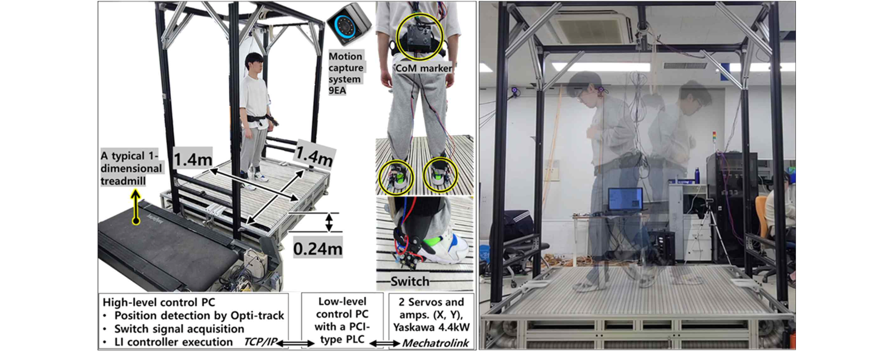▲ Implementation of an all-directional walking interface through a 360-degree treadmill that matches the user's speed

Currently, big tech companies such as Meta and Disney are also developing various forms of 360-degree directional mechanisms for the next-generation metaverse interaction platform where users can actually experience human walking.

The most recently announced 'Holo-tile' by Disney Company is a large number of disks placed on the floor that rotate to follow the user's walking speed for interaction, similar to the '360-degree treadmill' developed by this research team, but the '360-degree treadmill' simulates the ground through a belt, so it can provide the user with the same sensation of the real ground as a regular treadmill, Holo-tile, which use small disks, are a far cry from the real thing, and suffer from excessive size and thickness due to the use of a large number of actuators and relatively very slow motion performance, making it impossible to interface with fast-moving users.

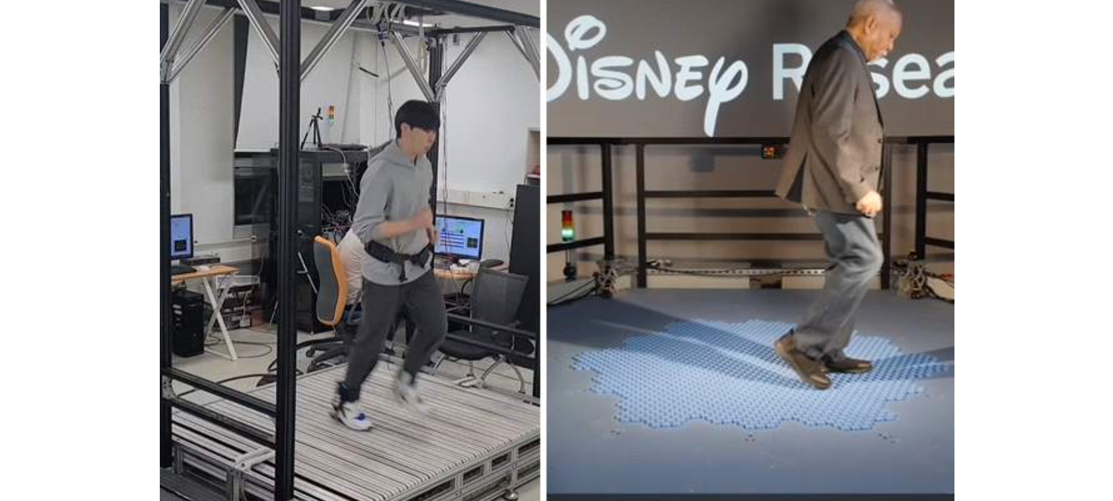▲ Comparison of our research team’s 360-degree directional treadmill (left) and Disney’s Holo-tile (right) for building a walking interaction platform for the next-generation metaverse. While the research team performs the interface while moving at a speed of over 3 m/s, Disney’s Holo-tile performs a walking interface at around 1 m/s with its slow motion performance.

Professor Jungwon Yoon said, "As the demand for devices that can actually walk in the current metaverse world is increasing, our research team's ultra-thin, ultra-high-speed 360-degree directional treadmill is a source technology that provides a realistic and intuitive user experience for natural walking in a virtual environment. It is expected to present an innovative entertainment and game industry model with competitiveness that provides safe and effective rehabilitation and treatment for patients and the elderly, virtual reality education and training that assumes disaster situation reproduction, and more vivid experiences."

This research result was developed with the support of the Ministry of Science and ICT's University Technology Management Promotion Project-IP Star Scientist Project and AI-based Convergence Talent Support Project, the National Research Foundation of Korea's Public Technology-Based Market Linkage Support Project, and the GIST Science and Technology Innovation Center's Prototype Production Support Project, and is scheduled to be presented on Thursday, October 17 at the 'IROS 2024 (International Conference on Intelligent Robots and Systems)'*, an international robotics conference held in Abu Dhabi from the 14th to the 18th (local time) of this month.

* IROS 2024: IROS, co-hosted by the Institute of Electrical and Electronics Engineers (IEEE) and the Robotics Society of Japan (RSJ), is a world-renowned robotics conference with approximately 4,000 robotics engineers from around the world.



