GIST develops ultra-high-speed cable cooling technology that reduces electric vehicle charging time to 3 minutes and 20 seconds

- Professor Seunghyun Lee's team from the School of Mechanical and Robotics Engineering developed an innovative cooling method to solve the problem of high heat generation during electric vehicle charging, shortening the electric vehicle charging time to less than 3 minutes and 20 seconds, which is the same time it takes to refuel an internal combustion engine.

- Also used in high-current transmission fields and annular tube structure devices... "Expected to drastically improve the convenience of electric vehicle use" Published in the international academic journal 《International Communications in Heat and Mass Transfer》

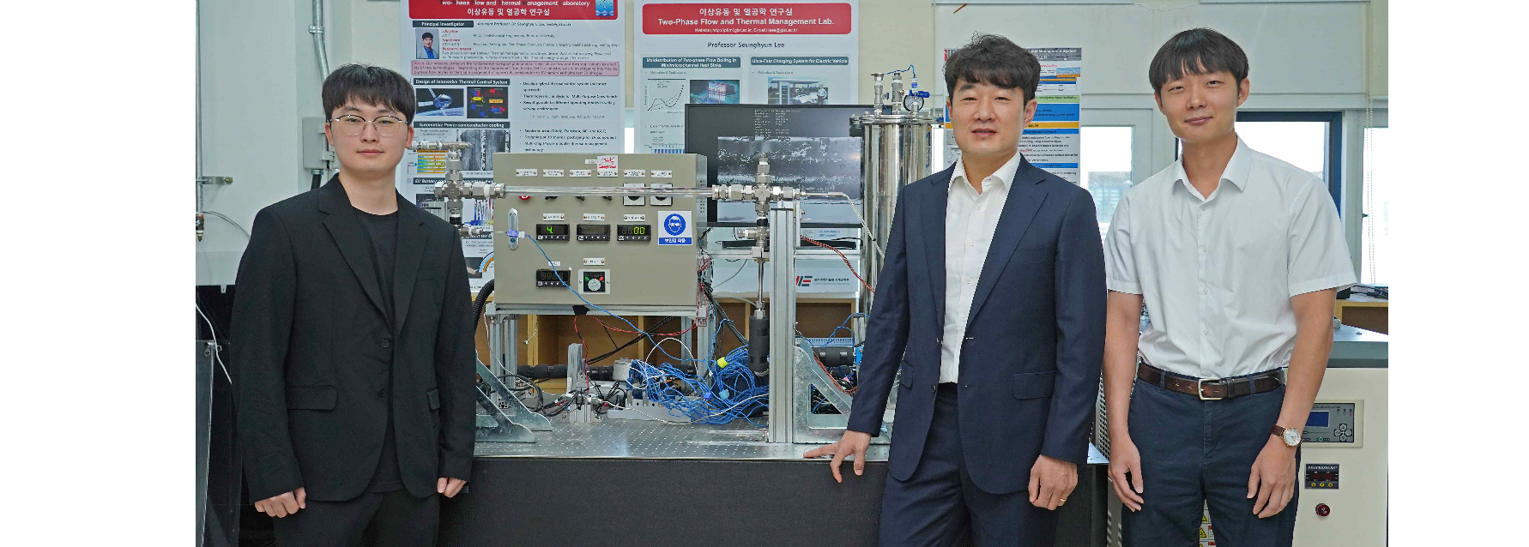▲ (From left) Master’s student Hyeonseok Noh of the School of Mechanical and Robotics Engineering, Professor Seunghyun Lee, and PhD student Haein Jung

A Korean research team has developed a technology that drastically shortens the charging time of electric vehicles. This technology can be used not only in electric vehicle charging systems but also in various fields that transmit high currents, such as ultra-low temperature cooling cables, high-speed trains, monorails, and power transmission lines. It is also expected to be applied to devices with annular tube structures that pass through a high-temperature central axis, such as nuclear reactors, oil and natural gas drilling facilities.

The Gwangju Institute of Science and Technology (GIST, President Kichul Lim) announced that a research team led by Professor Seunghyun Lee of the School of Mechanical and Robotics Engineering has successfully developed an innovative charging cable cooling technology that can shorten the charging time for high-performance electric vehicle batteries to 3 minutes and 20 seconds*, the same as the refueling time for internal combustion engine vehicles.

* The time required to charge a 100kWh electric vehicle battery (high-performance electric vehicle battery equivalent to the Tesla Model S or Kia EV9) to 80%. The estimated charging time is based on the condition that the cable surface temperature is kept at a safe temperature (80°C) using 800Vdc voltage and a 7m long charging cable. The charging time may be shorter for smaller batteries.

Even with rapid charging, the fact that it takes more than 30 minutes* remains an inconvenience when using electric vehicles, and there are two main reasons why such a long charging time is necessary.

* Society of Automotive Engineers (SAE) Level 3 standard

First, the insulating coating of the charging cable has low thermal conductivity and does not conduct heat well, limiting the release of internal heat to the outside. Second, the charging time is longer because the excessive heat generated during rapid charging is not effectively cooled.

To address this, the research team experimentally verified a method to efficiently cool a heating cable by utilizing a cooling loop under rapid charging conditions [Figure (a)] [Figure (b)] and using insulating fluid in a horizontal annular tube structure [Figure (c)].

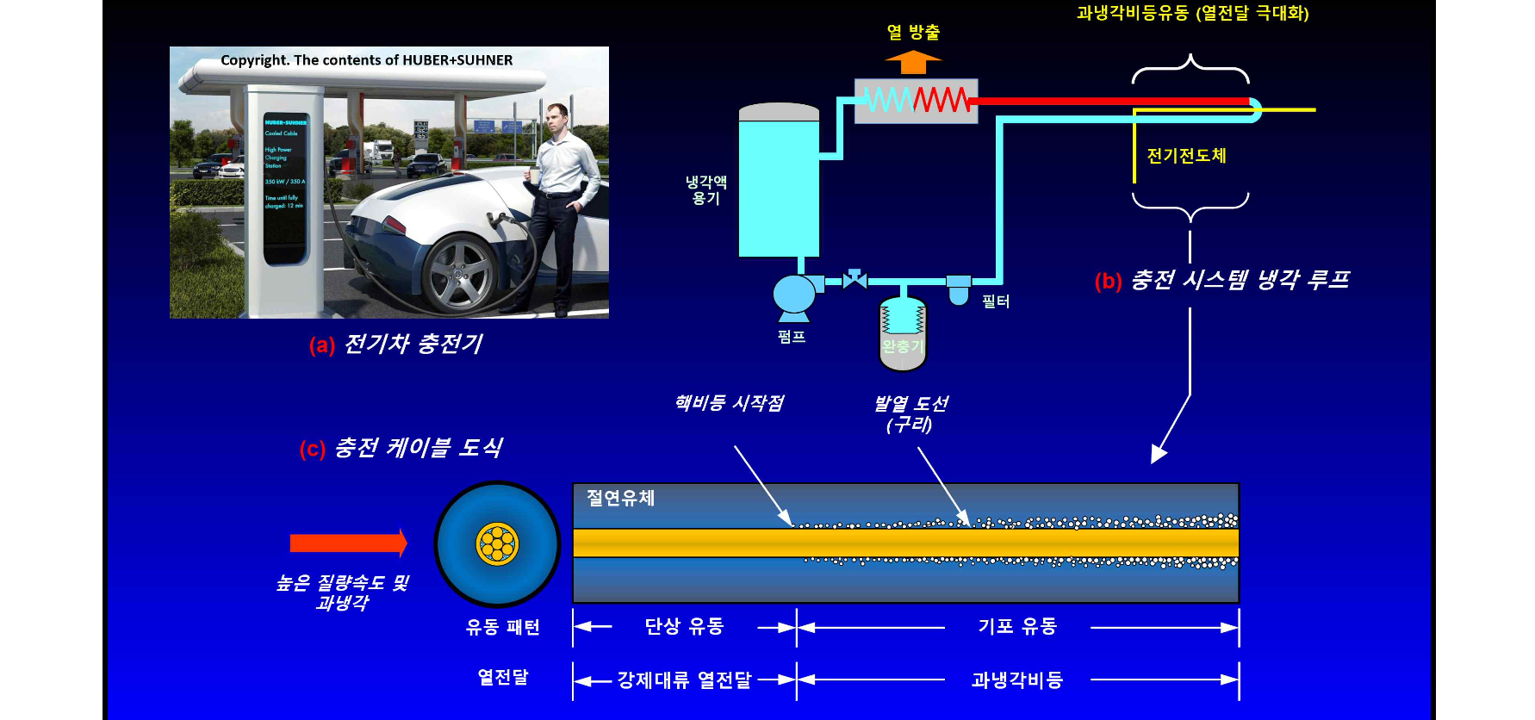▲ Concept image of supercooling boiling flow cooling using insulating fluid during rapid charging of electric vehicles: (a) High-power rapid charging scene of electric vehicles, (b) Schematic diagram of coolant loop for cooling conductor cables inside charger - coolant cools electric conductors, (c) Insulating fluid flows around the annular tube inside electric conductors, with the upstream showing cooling by single-phase convection and the downstream showing cooling by bubble boiling.

In this process, bubble formation on the surface of the heating cable was promoted, enabling more efficient heat transfer through phase change (boiling), thereby preventing overheating and failure.

Based on the cooling experiment data, the research team predicted that a 7m commercial charger cable would be capable of charging at 1,440kW (1,800A) for an 800Vdc electric vehicle battery [Figure 2], demonstrating that this would be more than twice as fast as the world's fastest 640kW (800A) rapid charger.

At this time, it was also confirmed that the cable surface temperature was safely maintained below 80°C. In particular, this result was derived based on the standard of charging a 100kWh-class high-performance electric vehicle battery to 80%, and if the battery capacity is smaller than this, the charging time can be shortened even further.

* annular tube: A structure in which the inner cylinder and outer cylinder are concentric.

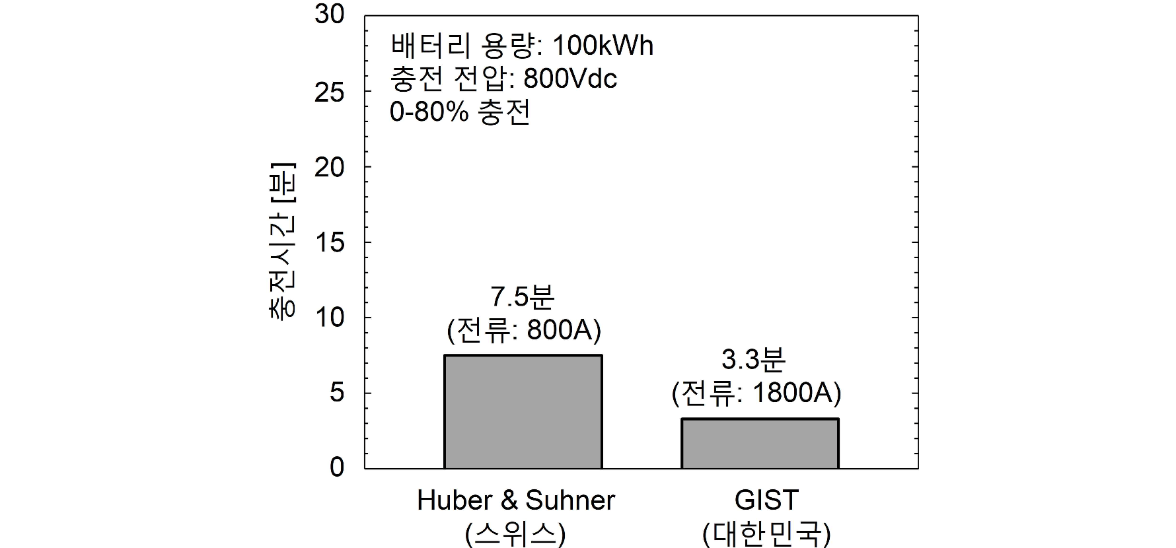▲ Comparison of the theoretical 0-80% charge time of a 100kWh electric vehicle battery. The results of comparing the charging time of an ultra-fast charger from Huber & Suhner of Switzerland, known as one of the fastest commercial electric vehicle chargers in the world, with the chargeable time of the supercooled boiling fluid cooling experiment used in this study. The experiment means the achievable time when the maximum charging power is sustained under the condition that the surface temperature of the 7m cable is maintained below the safe temperature of 80°C. Through direct contact supercooled boiling fluid cooling of the insulated refrigerant conductor, the charging time of high-performance electric vehicle batteries can be shortened to 3 minutes and 20 seconds, which is the internal combustion engine refueling time.

In the experiment, the research team used supercooled boiling flow* to supply the cooling fluid below its boiling point, but as boiling was activated in the longitudinal direction on the cable surface, the cooling liquid changed phase into vapor, resulting in efficient heat transfer, and through this process, the surface temperature could be maintained constant.

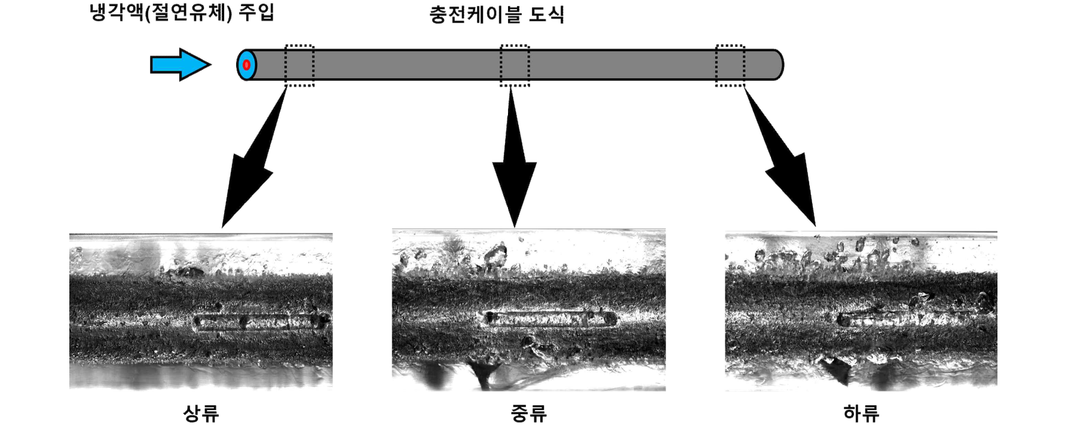▲ Cooling characteristic image along the length of the cable: The schematic diagram of the charging cable above and the high-speed camera image on the side show the process in which boiling is activated along the length of the heating cable surface when the cooling insulating fluid is injected, thereby enhancing heat transfer. This indicates that the surface temperature of the charging cable can be maintained constant.

In particular, supercooled boiling flow exhibits a higher heat transfer coefficient in the process of liquid-to-vapor phase change compared to single-phase flow*, providing more effective cooling performance under the same conditions. These heat transfer characteristics play an important role in maximizing heat transfer performance at high temperatures.

* supercooled boiling flow: A phenomenon in which bubbles are generated on the wall surface when the coolant is lower than its saturation temperature (boiling point), and the bubbles are quickly condensed by the surrounding cold coolant. It exhibits high heat transfer performance and has the characteristics of excellent cooling performance.

* single-phase flow: A flow in which the fluid flows in only one phase (liquid in the current study). It flows without bubble formation and the heat transfer efficiency is relatively low.

Experiments were conducted under various flow rate and temperature conditions, simulating the heating of a charging cable by covering a copper block with a cartridge heater.

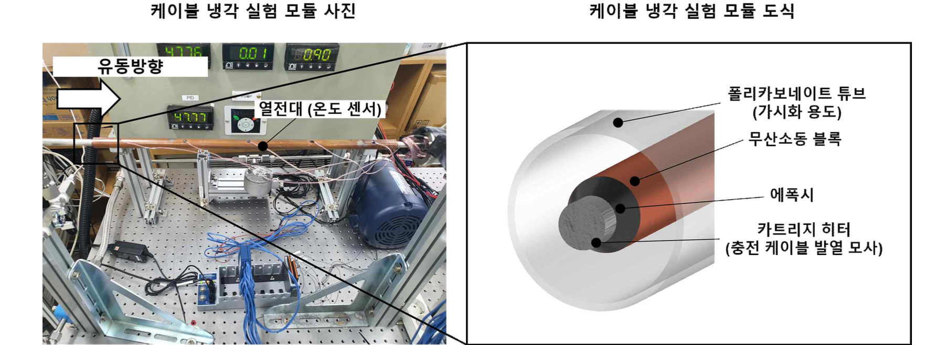▲ Experimental setup for measuring temperature along the length of a charging cable: Photograph and schematic diagram showing a copper block installed on the surface of a cartridge heater and a thermocouple attached to measure the surface temperature. The cartridge heater simulates the Joule heat generated in the copper conductor of a charging cable, and thermocouples were installed at various locations on the copper block to measure temperature changes along the length and top and bottom.

The experimental apparatus was designed with a thermocouple temperature sensor attached to the heater surface to precisely measure the heat transfer coefficient, and all data were stored in a computer through pressure and flow sensors and a data acquisition system.

The research team installed a high-speed camera on the side of the experimental module to observe the heating characteristics and record the bubble behavior and cooling process. This enabled them to analyze the performance of the supercooled boiling flow under various operating conditions.

The results of the supercooled boiling flow experiment, in which bubbles are generated by local superheating on the cable surface while the coolant is maintained below the boiling point, are divided into partially developed boiling (PDB) and fully developed boiling (FDB).

▲ Schematic diagram of the cooling heat transfer regime of supercooled boiling flow in a horizontal annular tube: The supercooled boiling flow regime is divided into partially developed boiling (PDB), in which the supercooling of the coolant is large and the surface superheat is small, which suppresses bubble formation, and fully developed boiling (FDB), in which the working fluid approaches the saturation temperature (boiling point) and the surface superheat increases, activating bubble formation.

In the PDB section, the supercooling of the coolant is large and the surface superheat is small, so bubble formation is suppressed, whereas in the FDB section, the bubble formation is activated as the working fluid approaches the saturation temperature and the surface superheat increases. In particular, in the FDB system, the bubbles are concentrated upward due to buoyancy, and as a result, the phenomenon that the temperature at the top of the cable is higher than that at the bottom has been newly confirmed.

The research team compared the supercooled non-isotropic flow and single-phase convective cooling performances under conditions of maintaining the safe temperature (below 80°C) of a 7m charging cable, and measured the charging time required to charge an electric vehicle battery to 80% and 100% while maintaining the safe temperature of the cable under the same cooling flow rate conditions (Qv = 3.0 GPM).

Through this, it was confirmed that supercooled boiling flow has superior cooling performance compared to single-phase convection cooling, enabling high current charging and shortening the charging time [left graph].

In addition, when comparing the cooling flow rate and the pump motor power required to maintain the safe temperature of the cable under the same charging current conditions (I = 1800 A), the subcooled boiling flow was efficient in terms of energy consumption as it could maintain the safe temperature even with a smaller cooling flow rate.

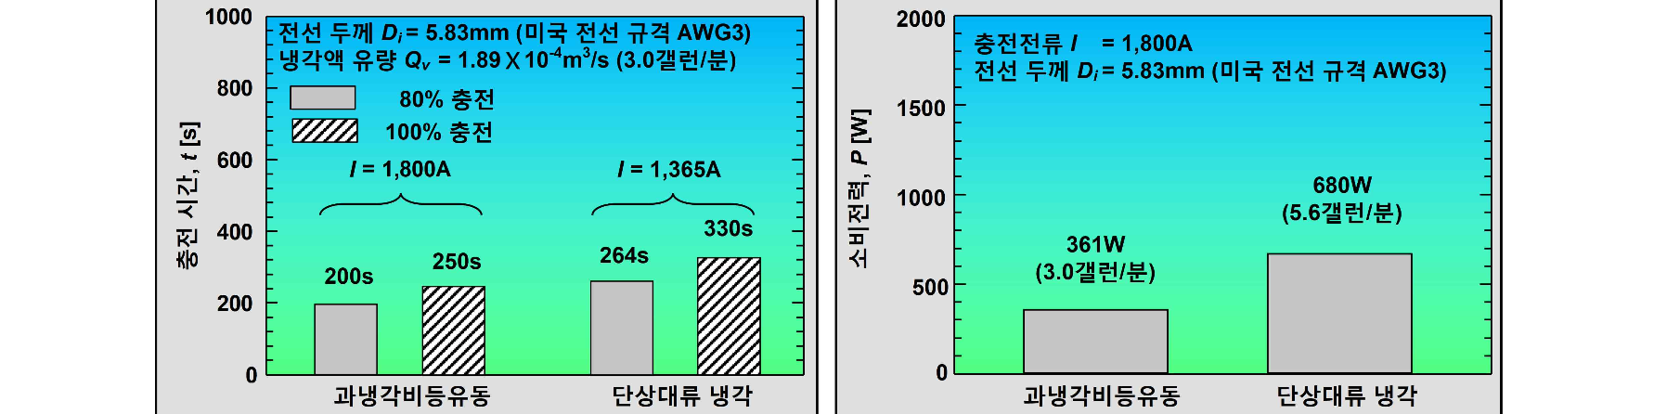▲ Comparison of supercooling boiling flow and single-phase convection cooling performance under the condition of maintaining the safety temperature of the 7m charging cable within 80°C. The left side shows the charging time when charging 80% and 100% of the electric vehicle battery with the maximum current that maintains the cable safety temperature under the same cooling flow rate condition (Qv = 3.0 GPM), and the right side shows the required pump motor power considering the cooling flow rate required to maintain the safety temperature under the same charging current condition (I = 1800 A).

Professor Seunghyun Lee said, "This research result is expected to dramatically improve the convenience of using electric vehicles as it provides a technological foundation that can significantly shorten the charging time of electric vehicles."

This research was conducted by Haein Jung, a doctoral student, and Hyeonseok Noh, a master's student, under the supervision of Professor Seunghyun Lee of the School of Mechanical and Robotics Engineering at GIST, and was supported by the Korea Electric Power Corporation's Electric Power Research Institute and the Ministry of Science and ICT's Mid-career Researcher Program. The results of the research were published online on September 19, 2024, in the renowned international journal in the field of heat transfer, International Communications in Heat and Mass Transfer.



