GIST, First-in-class immune anticancer drug GENA-104 function elucidated; New target CNTN4 overexpressed in cancer cells confirmed; Expected to develop new drug to treat patients who do not respond to existing immune anticancer drugs

- Professor Hansoo Park (CEO of Genome & Company) of the Department of Biomedical Science and Engineering, identification of anticancer immunity mechanism through interaction between CNTN4 overexpressed in cancer cells and app expressed in immune cells
- Development of GENA-104, a novel immuno-oncology target that suppresses CNTN4, and proof of anticancer efficacy... Published in International Journal 《Science Immunology (IF=17.6, JCR Top 2.2%)》

▲ (From left in the top row) Professor Hansoo Park of GIST Department of Biomedical Science and Engineering, Director Miyoung Cha of Genome & Company, Senior Researcher Bu-Nam Jeon of Genome & Company, (From left in the bottom row) Sujeong Kim, a student of GIST Department of Biomedical Science and Engineering, and Yunjae Kim, a student of GIST Department of Biomedical Science and Engineering

The microbiome (body microbial community) new drug development company ‘Genome & Company’ and the research team of Professor Hansoo Park of GIST have presented the therapeutic potential of a new immune anticancer agent. In particular, the newly developed new target immune anticancer agent is expected to show positive effects even in patients who did not respond to existing immune anticancer agents.

The Gwangju Institute of Science and Technology (GIST, President Kichul Lim) announced that a joint research team of Professor Hansoo Park of the Department of Biomedical Science and Engineering and Professor Park's start-up company Genome & Company (CEOs Yoo-Seok Hong, Ji-Soo Bae, and Hansoo Park) announced the results of a study that elucidated the interaction between CNTN4, a novel immune-oncology target, and its interaction partner APP (amyloid precursor protein) at the immune synapse*, and developed GENA-104, an antibody that inhibits CNTN4, which can increase the therapeutic efficacy of existing immune-oncology drugs.

* immune synapse: A structure formed for signal transmission between T cells and antigen-presenting cells (APCs), which plays an important role in regulating immune responses.

‘Immuno-oncology drugs’ that activate the patient’s immune system by controlling the interaction between immune checkpoint proteins* are used as one of the standard cancer treatments, but even in cancers known to be effective, only about 20-30% of patients show a response, and most patients develop resistance and the cancer relapses, which is a limitation.

To overcome the resistance of these immunotherapy drugs, active research is being conducted to discover new immunotherapy targets and treat these targets alone or in combination with existing immunotherapy drugs.

* immune checkpoint protein: It is a protein expressed on the surface of immune cells that binds to proteins of other immune cells to be activated and participate in the regulation of immune responses. Representative examples include PD-1/PD-L1 and CTLA-4.

The research team confirmed that the new target CNTN4 is overexpressed in various cancers, including gastric cancer, liver cancer, and pancreatic cancer, and that when it binds to T cells, which are immune cells, it inhibits the proliferation of T cells and the secretion of cytokines (IFN-γ, TNF-α), which are protein immunomodulators.

On the other hand, when CNTN4 was combined with T cells and co-cultured with GENA-104, an antibody that inhibits CNTN4, the proliferation and cytokine secretion of T cells that had been inhibited by CNTN4 were restored. In addition, CNTN4 inhibits the signal transduction of T cell receptor (TCR) and the nuclear translocation of transcription factors, and GENA-104 neutralized this. [Figure 1]

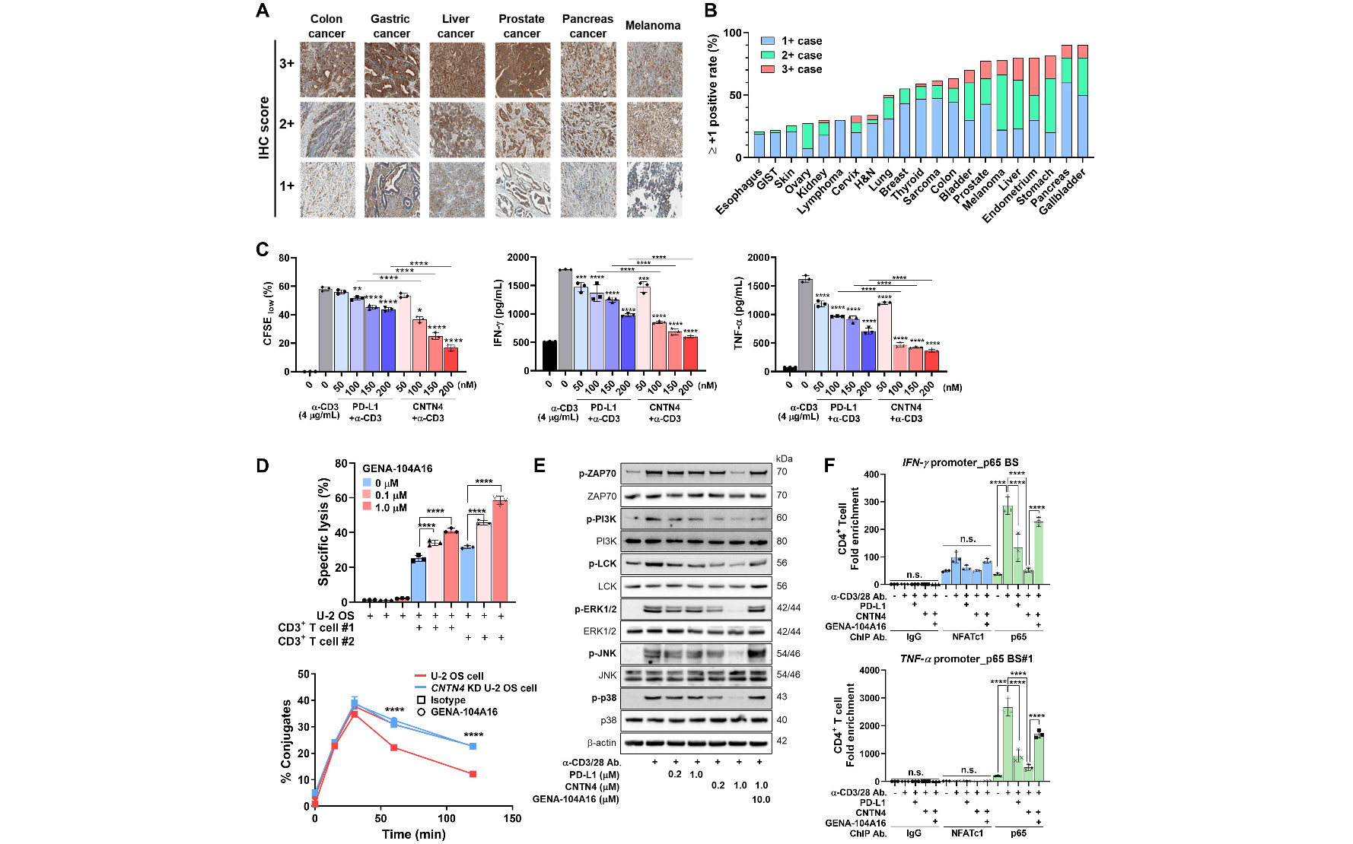▲ Confirmation of T cell inhibitory effect of CNTN4 and neutralizing effect by GENA-104: CNTN4 is overexpressed in various cancers, and when CNTN4 binds to T cells, it inhibits T cell proliferation and cytokine secretion. The T cell inhibitory effect was restored by GENA-104 treatment.

When GENA-104 was administered to a cancer animal model, it was confirmed that tumors were significantly reduced, and according to the preclinical results, the tumor growth inhibition rate was approximately 50% compared to the control group in the CT26* tumor model. In particular, the tumor growth inhibition rate was approximately 75% in the CT26/Cntn4* tumor model in which CNTN4 was overexpressed, suggesting that the expression level of CNTN4 and the tumor reduction rate are proportional. These results imply that GENA-104 effectively offsets the T cell suppression effect induced by CNTN4 and has strong therapeutic potential in tumor models. [Figure 2]

* CT26: A mouse-derived colon cancer cell line, mainly used as a tumor model in immuno-oncology research.

* CT26/Cntn4: A cell line in which CNTN4 is overexpressed in the CT26 cancer cell line.

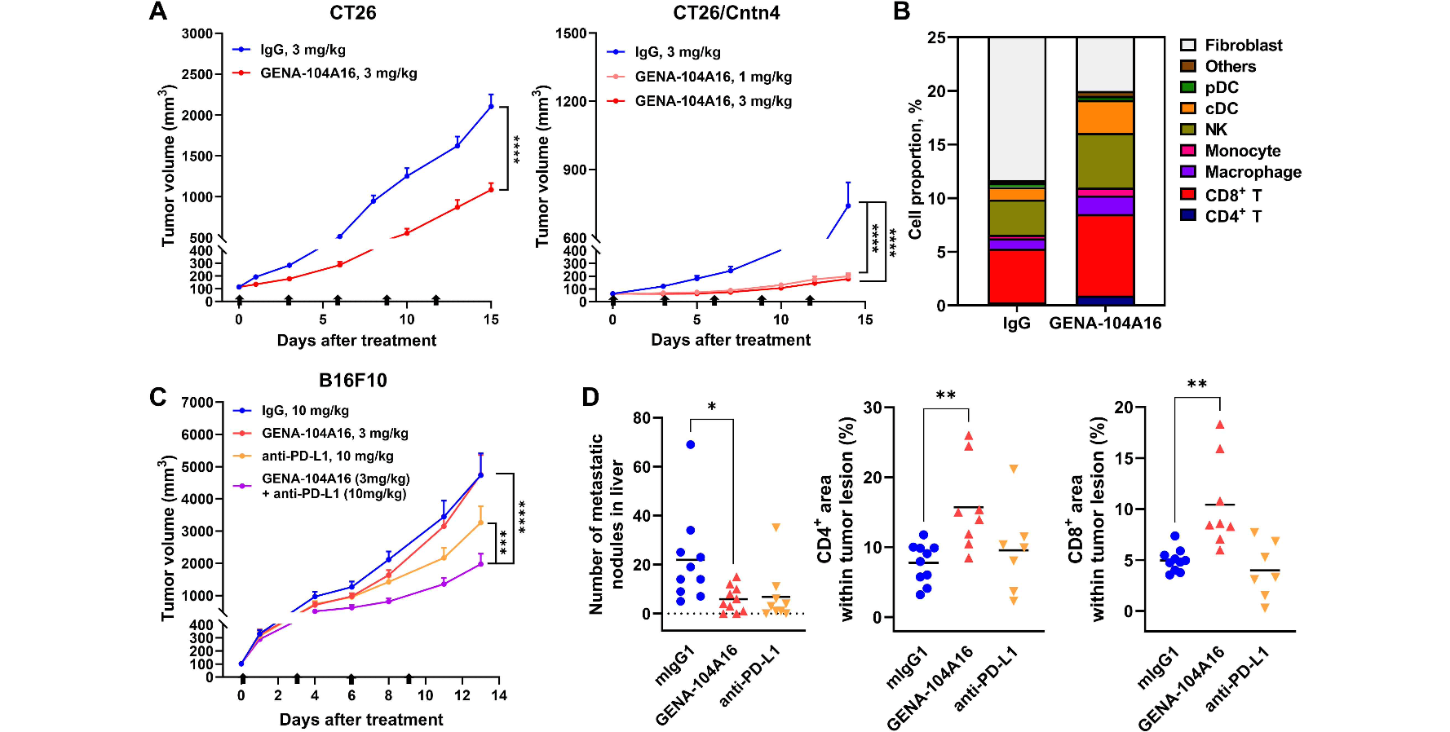▲ Confirmation of anticancer effect by GENA-104: Through preclinical testing using cancer animal models, it was confirmed that GENA-104 administration inhibited tumor growth and increased T cell infiltration into cancer tissue. In addition, it showed a synergistic effect with existing immune anticancer drugs (anti-PD-L1).

In addition, the research team confirmed that CNTN4 is involved in T cell suppression by interacting with APP expressed on the surface of T cells. GENA-104 treatment increased cytotoxicity in App WT* T cells, but the effect did not occur in App KO* T cells.

That is, it was confirmed that CNTN4 inhibits T cell activation by interfering with T cell receptor (TCR) signaling through interaction with APP and weakening TCR-MHC binding. [Figure 3]

* WT: Wild type, refers to a natural organism or cell without genetic modification or mutation.

* KO: Knockout, refers to a technology that disables a specific gene and blocks the function of that gene.

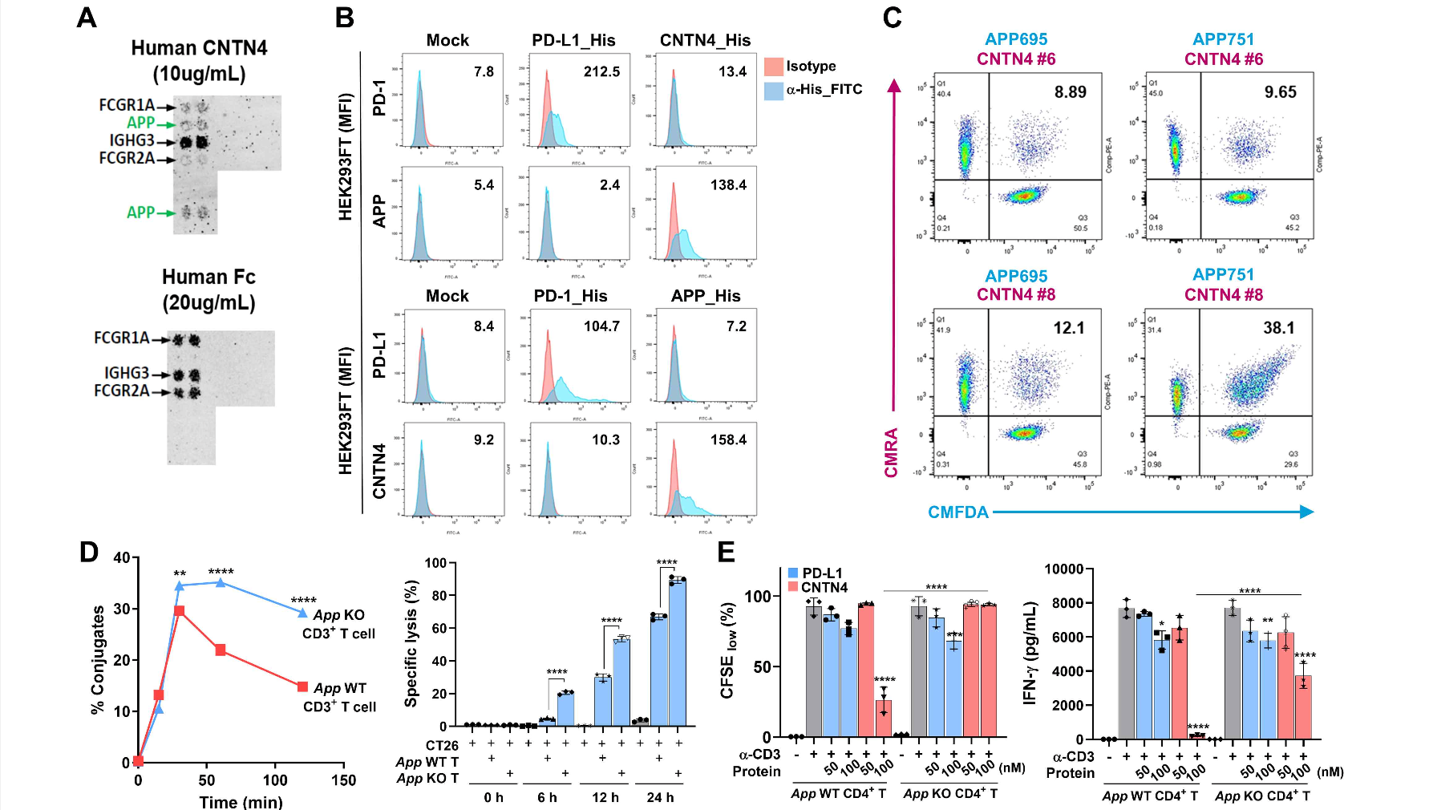▲ Clarification of T cell suppression mechanism through CNTN4-APP interaction: CNTN4 expressed in cancer cells interacted with APP expressed in T cells. It was confirmed that the T cell suppression effect by CNTN4 disappeared in APP KO T cells.

Through analysis of published clinical data and RNA sequencing data, we confirmed that CNTN4 was expressed at a higher level than PD-L1* in patients who did not respond to existing immunotherapy, and that the higher the CNTN4 expression, the lower the survival rate and the worse the prognosis.

These results imply that GENA-104, a CNTN4 inhibitory antibody, has high potential as a treatment that can be expected to be effective for patients who did not respond to existing immunotherapy. In addition, APP was also high in the non-responsive patient group, suggesting that the CNTN4-APP axis can induce immune suppression. [Figure 4]

* PD-L1: A ligand that binds to immune cells and suppresses immune responses. It is mainly expressed in tumor cells and plays a role in avoiding attacks by T cells.

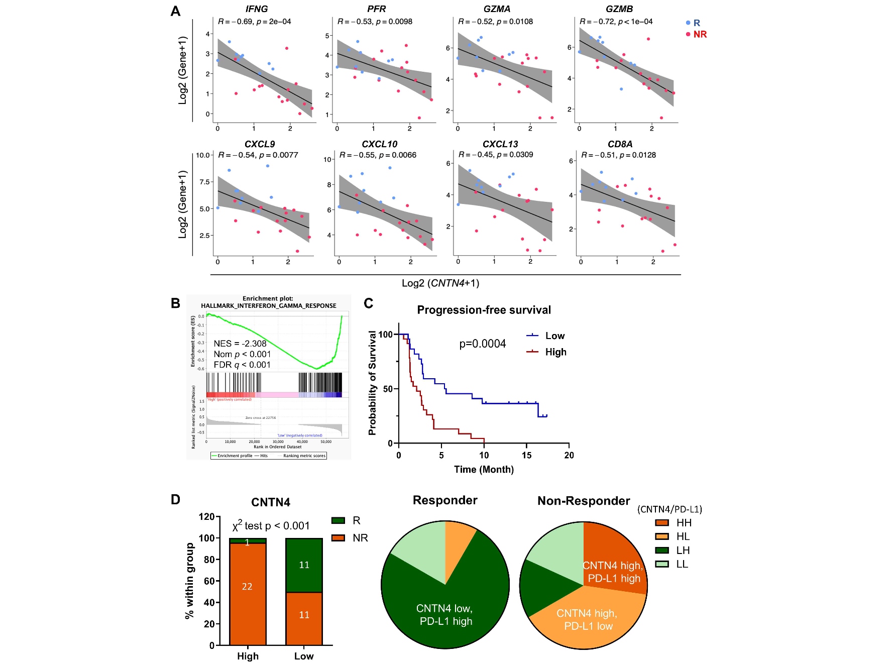▲ Confirmation of clinical significance according to CNTN4 expression: CNTN4 was expressed more highly in the non-responsive patient group compared to the existing immune anticancer drug response group, and a negative correlation was observed between various immune-related indicators and CNTN4 expression. In addition, the higher the CNTN4 expression, the worse the prognosis.

Professor Hansoo Park said, "The results of this study were published in a credible international academic journal, and the excellence of the research results was recognized by experts in the field of immunology. Furthermore, the significance lies in the fact that the possibility of success for the CNTN4 inhibitory antibody, ‘GNEA-104’, has been academically proven."

This study, supervised by Professor Hansoo Park of the Department of Biomedical Science and Engineering at GIST and conducted in collaboration with Dr. Bu-Nam Jeon of Genome & Company, and PhD students Sujeong Kim and Yunjae Kim of the Department of Biomedical Science and Engineering at GIST, was supported by the Inter-Ministry New Drug Development Program, the National Research Foundation of Korea, and the GIST Research Institute, and was published online in the international journal Science Immunology* on October 11, 2024.

* Science Immunology: A sister journal of Science, one of the world's top three academic journals, it is a globally authoritative academic journal in the fields of immunology and tumor immunology. It has a high impact index of IF 17.6 and top 2.2% of JCR.



