“Replacing Lead → Tin Increases Eco-friendliness and Improves Electrical Properties” GIST develops new doping method for perovskite semiconductor materials

- Professor Kwanghee Lee of the School of Materials Science and Engineering and Dr. Ju-Hyeon Kim of the Heeger Center for Advanced Materials's research team develops high-performance p-type thin film transistor devices with improved electrical properties through atomic-level interactions at the semiconductor material interface
- "Resolving the biggest obstacle to the development of organic-inorganic mixed perovskite materials, expecting to utilize them as key materials for next-generation eco-friendly and high-performance semiconductor devices"... Published in the international academic journal 《Advanced Functional Materials》

▲ (From left) Professor Kwanghee Lee of the School of Materials Science and Engineering and Dr. Ju-Hyeon Kim of the Heeger Center for Advanced Materials

As competition in artificial intelligence (AI) and semiconductor technology accelerates, a Korean research team has developed a new method to improve the electrical properties of eco-friendly perovskite materials and succeeded in implementing semiconductor devices, which is expected to be utilized as a next-generation semiconductor material.

The Gwangju Institute of Science and Technology (GIST, President Kichul Lim) announced that the research team led by Professor Kwanghee Lee of the School of Materials Science and Engineering and Dr. Ju-Hyeon Kim of the Heeger Center for Advanced Materials have discovered a new p-type doping* method for lead-free tin-based perovskite* materials and developed a high-performance p-type thin-film transistor* using it.

* perovskite: A mineral crystal structure discovered in the Ural Mountains of Russia in 1839, it is drawing attention as a leader in next-generation optoelectronic materials due to its high charge transfer and light absorption.

* doping: A method of controlling electrical properties by intentionally adding impurities to an intrinsic semiconductor. The electrical properties of a semiconductor material change depending on the degree of doping, and when extra holes are created, it is classified as p-type, and when electrons are created, it is classified as n-type.

* thin film transistor: A transistor is a semiconductor device that amplifies signals or performs a switching function by controlling the flow of current or voltage. A thin film transistor is a type of field effect transistor that controls the current flowing through a thin film semiconductor by applying an electric field (field effect) perpendicular to it.

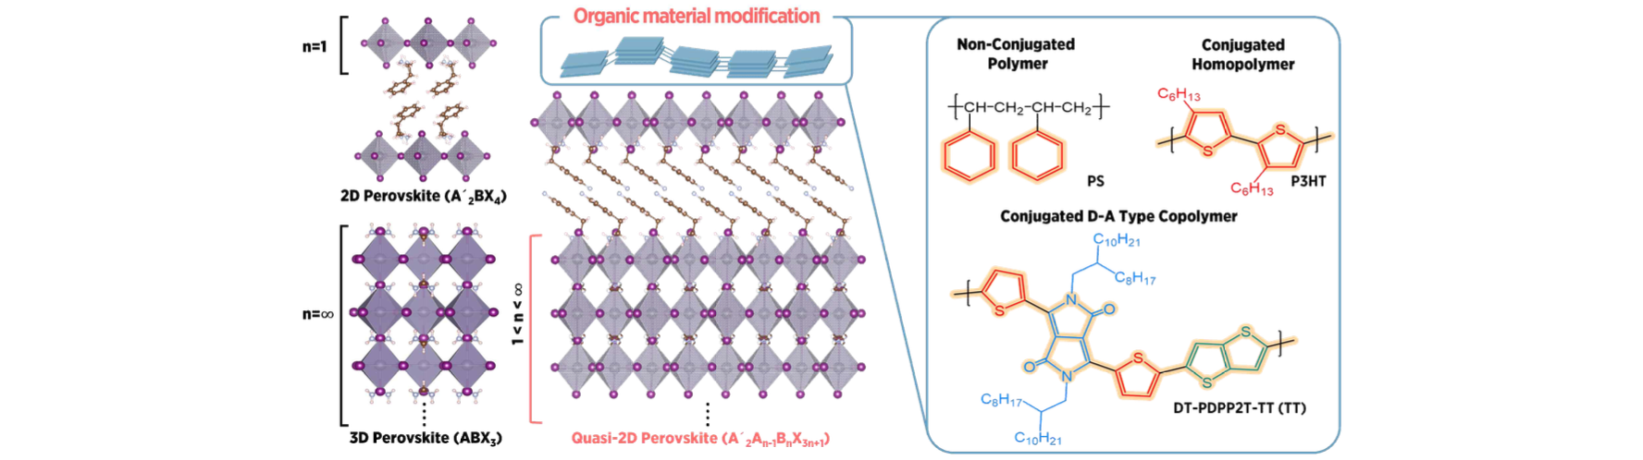▲ Quasi-two-dimensional perovskite structure used in this study (left): Perovskite structure that is a combination of existing two-dimensional and three-dimensional perovskite structures. Two-dimensional perovskites have high environmental stability, and three-dimensional perovskites have excellent electrical conductivity, and this quasi-two-dimensional perovskite material has both of these advantages. Schematic diagram of the polymer application method for p-type doping and the chemical structure of the conductive polymer (right): Compared to existing lead-based perovskites, tin-based ones have poor electrical properties. In order to improve the electrical properties, this study used a method of applying an organic polymer to the upper surface.

In the solar cell field, perovskite semiconductor materials are attracting attention as next-generation optoelectronic semiconductor materials due to their high efficiency device performance of over 26.7%, which is not much different from that of existing silicon-based solar cells in terms of efficiency, and their high price competitiveness.

However, since the perovskite materials currently used in optoelectronic devices use lead* as one of the main metals, environmental issues are a major obstacle to commercialization.

* lead (Pb): It is a heavy metal with a high density and atomic number 82. It has a significant impact on environmental pollution and the human nervous system, but due to its unique properties, it is used in batteries, bullets, radiation shielding, semiconductors, and photoconductors.

To solve this problem, tin-based perovskite materials using tin have been studied extensively worldwide, but it has been pointed out that the electrical properties are not as good as those of lead-based perovskites due to low crystallinity and many defects in the material itself.

* tin (Sn): It is an element in the same group as lead and carbon with atomic number 50. It has excellent ductility and electrical conductivity, and tin-based perovskites have very similar properties to lead-based perovskites.

However, the research team that focused on the characteristics of tin element, which is prone to oxidation*, discovered that the electrical properties of perovskite materials improved when a polymer material containing sulfur element was introduced to the surface of the perovskite material.

* oxidation: A phenomenon in which atoms, molecules, or ions lose electrons.

It was observed that tin ions on the perovskite surface interact with sulfur elements in the polymer material, changing the oxidation number of the tin ions from (2) to (4). It was confirmed through Hall effect measurement* and Fermi energy level measurement* that the holes generated as a result remain on the perovskite surface and induce p-type doping of the material.

* Hall effect measurement: The Hall effect refers to the direction of movement of electrons in a material due to the magnetic field that is generated when they move through an applied magnetic field, and the resulting potential difference. Through the Hall effect measurement, the type of charge (negative charge, positive electron), the concentration of charge, and the speed of charge carriers flowing in conductors or semiconductors can be determined.

* Fermi energy level: The highest energy level among the energy levels of electrons at a point where the absolute temperature is 0 K, and the level that electrons have a 1/2 probability of occupying above 0 K.

This new p-type doping not only suppresses recombination loss caused by defects within the tin-based perovskite material, but also causes smooth movement of charge carriers, as confirmed by femtosecond laser transient absorption spectroscopy* by Dr. In-Wook Hwang's team at the Advanced Photonics Research Institute of GIST.

* femtosecond transient absorption spectroscopy analysis: A spectroscopy method that can observe physical phenomena occurring in a material that absorbs light in the femtosecond (one quadrillionth of a second) time unit.

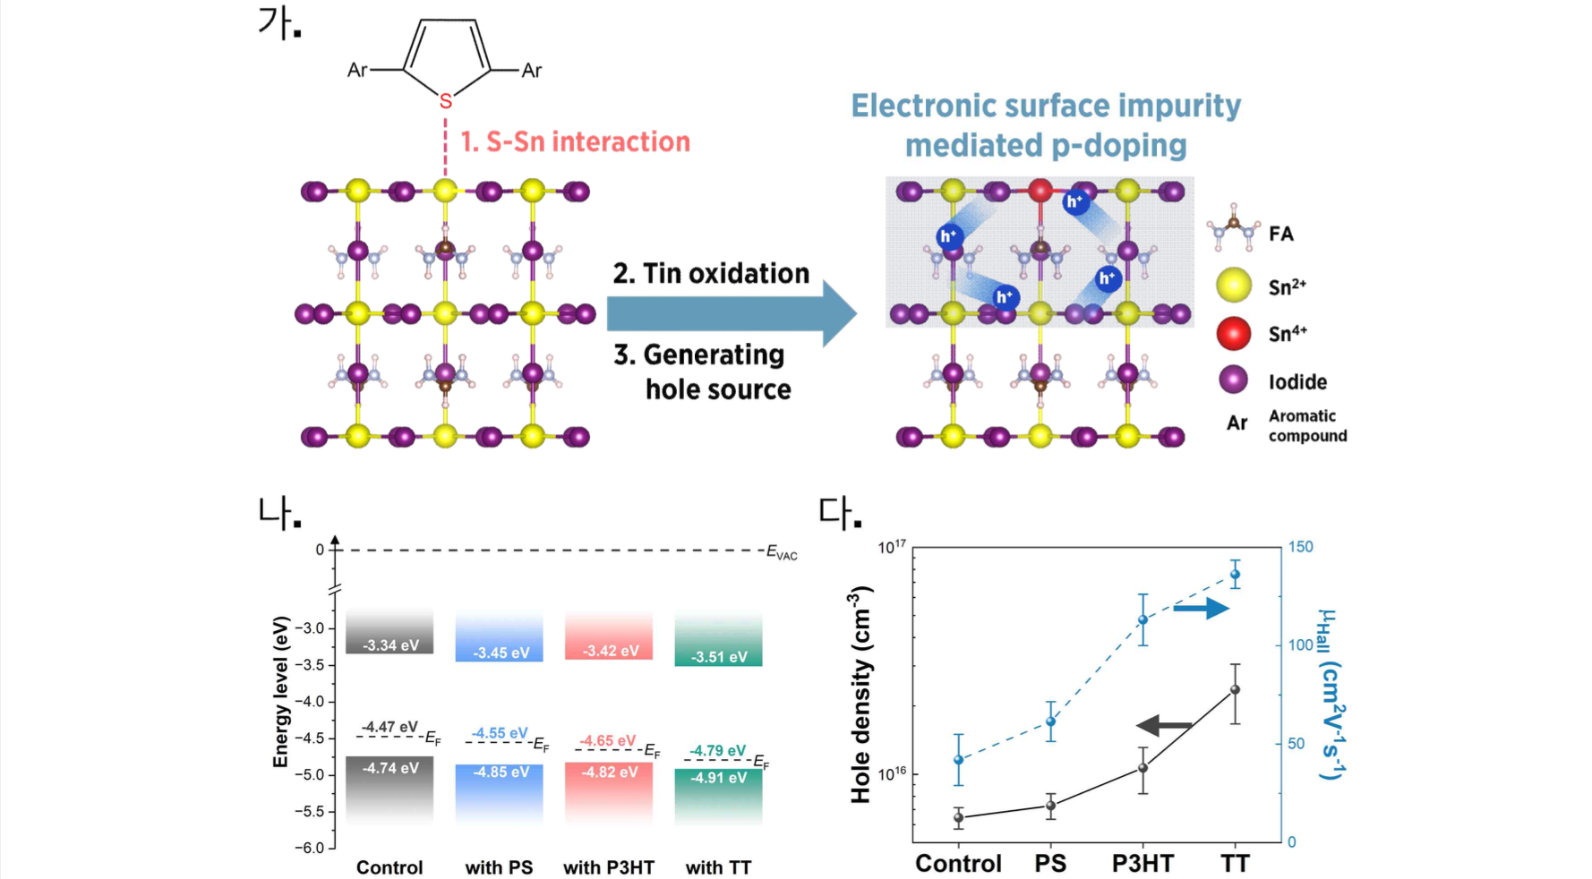▲ (a) Mechanism of the p-type doping method revealed in this study, (b) Graph related to Fermi energy level change due to p-type doping, and (c) Hall effect measurement graph. - Sulfur atoms in polymer materials oxidize tin ions on the surface of perovskite materials through interaction with them. As a result, excess holes are created in the perovskite materials, inducing p-type doping. As evidence of p-type doping, a decrease in Fermi energy level, an increase in hole concentration, and an increase in Hall effect mobility are observed.

The thin film transistor based on lead-free perovskite material using the novel p-doping method developed by the research team showed a charge mobility of 53 cm²V⁻¹s⁻¹, which is about 8 times higher than that of existing devices. In addition, it showed stable operation even after 1,000 on/off operations of the device, and it was confirmed to have high stability in a voltage stress test.

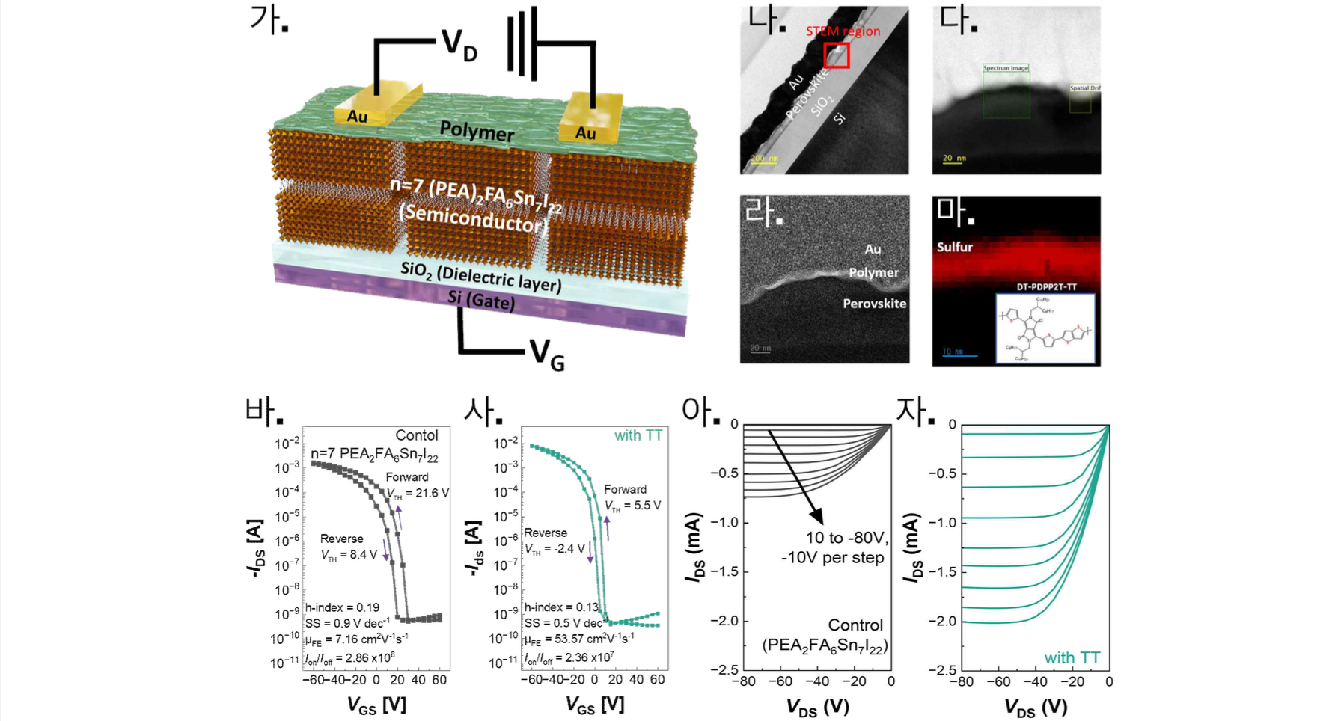▲ (a) Structure of the p-type thin film transistor used in this study, (b) Transmission electron microscope cross-section of the device, (c) STEM image, (d) Sobel processing image, and (e) sulfur element EELS spectrum image (chemical structure of the polymer used). Data related to the transfer curve and output curve of the thin film transistor. Control group (bar, a) vs. experimental group (g, y): As a result of applying the optimized p-type doping, a lead-free peroskite-based p-type thin film transistor with a charge mobility approximately 8 times higher than that of the control group was realized.

Professor Kwanghee Lee said, "This research result suggests a new principle that can solve both environmental problems and electrical property degradation problems by replacing heavy metal lead, which is a major obstacle in the development of organic-inorganic mixed perovskite materials, with tin. This is expected to greatly accelerate the commercialization of next-generation semiconductor materials as the concept of doping, which has had a great influence on the development of existing modern semiconductor materials, can be applied to perovskite materials."

Dr. Ju-Hyeon Kim said, "Almost all of the experiments and analyses required for this study were easily conducted using the facilities and equipment of the Heeger Center for Advanced Materials, the Central Research Institute, and the Advanced Photonics Research Institute within GIST. For follow-up and derivative research, we are conducting international joint research with Linkoping University, a world-class research institute in Sweden, with the support of the Sejong Science Fellowship from the National Research Foundation of Korea."

This study, led by Professor Kwanghee Lee and Dr. Ju-Hyeon Kim of GIST, was conducted with the support of the Climate Change Response Technology Development Project, the Mid-career Researcher Project, and the Sejong Science Fellowship from the National Research Foundation of Korea under the Ministry of Science and ICT. The results of the study were published online in the ‘Early View’ version of the world-renowned materials journal ‘Advanced Functional Materials’ on August 29, 2024.



