“Wireless charging while on the move” GIST develops new wireless power technology that is not restricted by direction

- Professor Chun T. Rim's team at the Graduate School of Energy Convergence, the first to identify the cause of the orthogonal-axis rotating magnetic interference phenomenon... Development of resonant circuit stabilization technology for commercialization of omnidirectional wireless power
- Finding quantitative conditions to resolve the vicious cycle of 'magnetic saturation → rapid power loss'... Published in the October issue of 《IEEE Transactions on Power Electronics》 published by the Institute of Electrical and Electronics Engineers

▲ (From left) Professor Chun T. Rim, Professor Yun-Su Kim, Dr. S. Ahson A. Shah, and Dr. Tai Xuan Van

The Gwangju Institute of Science and Technology (GIST, President Kichul Lim) announced that the research team led by Professor Chun T. Rim of the Graduate School of Energy Convergence has succeeded in developing a new omnidirectional wireless power technology by discovering a method to prevent interference between rotating magnetic axes, which is attracting attention as a next-generation wireless power technology.

Wireless power can prevent electrical accidents and increase charging convenience by eliminating the cables of wired power. In particular, omnidirectional wireless power technology is a next-generation technology that can supply power wirelessly even while moving, applied to robots that move with six degrees of freedom (three-axis position, three-axis rotation), industrial autonomous vehicles (AGVs), wearable devices, and the Internet of Things (IoT).

In order to obtain omnidirectional characteristics, a rotating magnetic field must be created by two pairs of coils that are orthogonally intersected*, but there was a limitation in that the wireless power supply could not be increased because the resonant circuit became unstable due to the inter-axis interference phenomenon.

* intersect: when two magnetic lines of force intersect each other

The research team discovered that this problem is because magnetic saturation* occurs at the intersection of the two coils, which reduces the inductance* of the coils, raising the resonant frequency* of the circuit, which increases the coil current and worsens the magnetic saturation.

In order to increase the efficiency of power transmission, wireless power coils use a core (ferrite or nano crystal line) as a magnetic material, but as the current increases, magnetic saturation occurs that exceeds the performance of the core, and a vicious cycle begins.

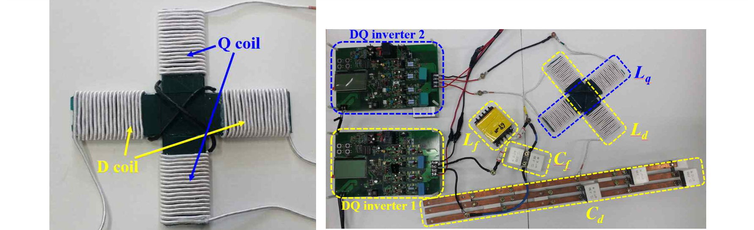▲ The wireless power coil (left) and experimental device (right) developed by the research team. The cross-shaped coil is a coil with two axes that are spatially and topologically orthogonal, and is driven by two inverters.

Once a wireless power circuit falls into a vicious cycle, the imbalance between the two axes intersecting at right angles becomes so severe that a rotating magnetic field is no longer generated, power loss increases rapidly, and wireless power transmission becomes impossible.

* magnetic saturation: A phenomenon in which the magnetic flux (sum of magnetic lines of force) increases when the current in a coil containing a magnetic material increases and then stops increasing.

* inductance: A proportional coefficient indicating the strength of the magnetic field generated by the current in the coil, in units of Henry (H)

* resonant frequency: The frequency at which an electrically vibrating circuit resonates, in units of Hertz (Hz)

To solve this problem, some of the vicious cycles need to be broken, which can be done by changing the coil design or controlling the current in a more stable manner.

The research team quantitatively found the conditions for preventing a vicious cycle from occurring by linearly analyzing a nonlinear magnetic circuit*, and through this, the wireless power supply can be increased by more than 30% compared to the current level.

* magnetic circuit: A path through which magnetic flux flows, which can operate nonlinearly in the core portion.

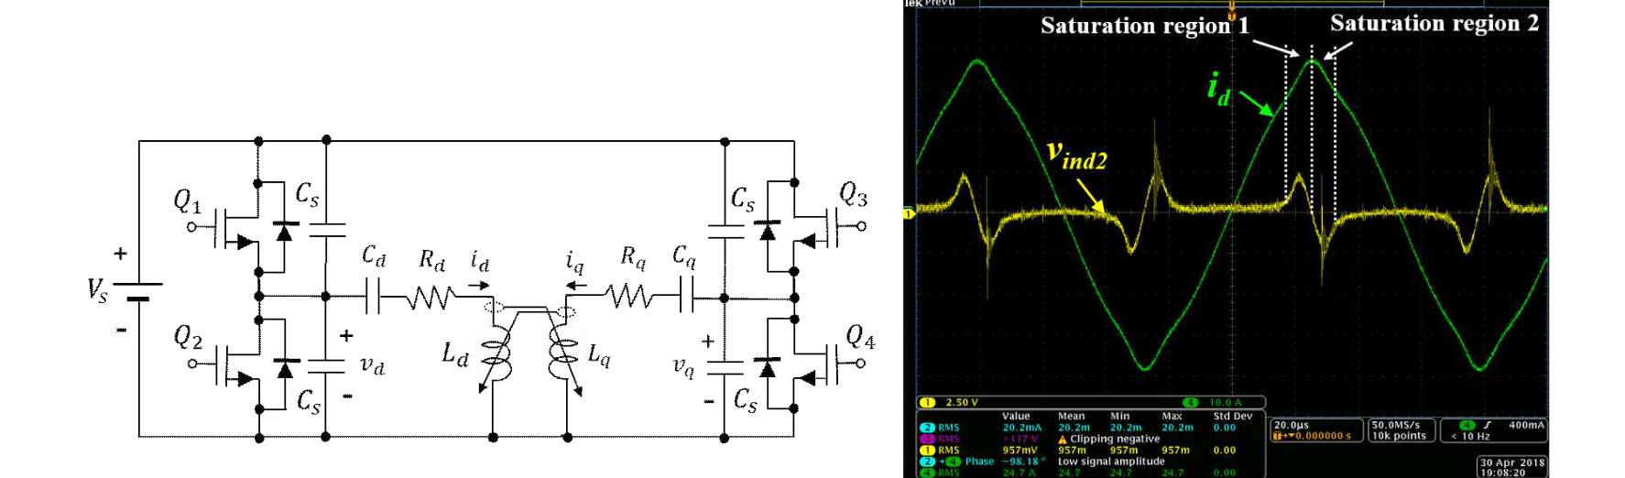▲ Resonant circuit (left) and experimental waveform (right) for generating an omnidirectional rotating magnetic field. The circuit on the left shows that the LC (inductor-capacitor) resonant circuits connected to each of the two half-bridge inverters cause mutual interference, and the waveform on the right shows that the current waveform is seriously distorted due to magnetic saturation.

Professor Chun T. Rim said, "As mobile device usage increases, wireless power technology can be used to charge freely without spatial constraints. This is a technology that is absolutely necessary for commercialization and a hurdle that must be overcome."

This study, supervised by Professor Chun T. Rim and participated by Dr. S. Ahson A. Shah (first author), Dr. Xuan Van Thai (second author), and Professor Yun-Su Kim, was supported by the Basic Research Program (NN39130) of the National Research Foundation of Korea, and the technology was published in the October 2024 issue of the IEEE Transactions on Power Electronics (IF=6.6), an authoritative journal in the field of power electronics published by the Institute of Electrical and Electronics Engineers (IEEE).



