GIST-Georgia Institute of Technology, development of lithium metal battery with high stability and 3 times longer lifespan reduces manufacturing costs and time with easy anode manufacturing process

- Professor KwangSup Eom's team developed a lithium metal battery with significantly improved stability and lifespan through simple electrochemical treatment inside the battery cell with a lithium metal cathode that replaces graphite... Used in next-generation electric vehicles, etc.
- Maintained more than 85% of the initial capacity after more than 425 charge/discharge cycles, and lifespan increased by more than 3 times... Joint research with Professor Tom Fuller of Georgia Tech, published in the international academic journal 《Small Structures》

▲ (From left) Professor KwangSup Eom and doctoral student Subin Kim

As electric vehicle sales continue to grow steadily in the global automobile market, interest in next-generation secondary batteries with larger capacity and faster charging and discharging than commercialized lithium-ion batteries is growing.

Graphite, the cathode material* of existing lithium-ion batteries, has almost reached its theoretical limit capacity, and development of cathode materials with higher capacity is necessary to increase energy density.

* anode material: It plays an important role in the charging speed and lifespan of the battery by storing and releasing lithium ions from the anode and allowing current to flow.

The Gwangju Institute of Science and Technology (GIST, President Kichul Lim) announced that the School of Materials Science and Engineering's Professor KwangSup Eom's team, in joint research with Professor Tom Fuller of Georgia Tech in the U.S., has developed a technology to solve the chronic dendrite growth problem* of lithium metal anodes and improve rate* and cycle characteristics through the development of functional additives and an electrochemical surface treatment process.

* dendritic growth problem: When lithium metal batteries are repeatedly charged and discharged, lithium grows on the surface of the lithium in the shape of tree branches. This is called dendrite growth. When the metal battery is in operation, dendrites grow like needles on the surface of the cathode, piercing the separator and destroying the battery, which is considered a problem that harms performance and safety.

* rate: The characteristic in which the capacity retention rate improves or worsens as the charge/discharge speed increases.

Lithium metal batteries, which replace graphite with lithium metal as the cathode material, are attracting attention because they can theoretically achieve cathode capacity 10 times higher than that of lithium ion batteries.

However, as lithium dendrites* grow during charging and discharging of lithium metal batteries, they can penetrate the separator* and cause a short circuit in the battery, and as lithium is plated, its volume expands, causing the battery to swell and the internal pressure to increase, which are safety and durability issues that are hindering commercialization.

* lithium dendrite: During the charging process of a lithium metal battery, lithium is unevenly deposited on the electrode and grows in the form of dendrites. See the attached glossary.

* separator: A thin film of insulating material that prevents the positive and negative electrodes inside the battery from contacting each other and is related to the safety of the battery.

The research team developed a lithium metal anode with lithiation* by inducing electrochemical oxidation of thiourea, used as an electrolyte additive, to form copper sulfide (Cu2S) on the surface of the anode current collector.

* lithiophilicity: A property of a current collector that lowers the lithium nucleation energy barrier, enabling uniform and abundant lithium nucleation.

The lithium metal anode developed in this way homogenizes lithium nucleation and growth by the lithium-philic interface, while lithium sulfide (Li2S) with high ion conductivity is created during the solid electrolyte interphase (SEI) formation process, effectively suppressing dendritic crystal growth.

In addition, the lithium metal cathode developed by the research team has the advantage of being able to drastically reduce cost and time compared to other processes because it uses only a small amount of inexpensive functional additives and electrochemical signals during the manufacturing process.

Using this lithium metal anode, the research team succeeded in creating a lithium metal battery with a lifespan more than three times longer than that of a conventional copper collector-based lithium metal anode.

When using a conventional copper current collector, the developed capacity rapidly decreased after 147 charge/discharge cycles at high current density (charge or discharge once every 30 minutes), but the lithium metal anode made with the new processing technique showed stable performance with a capacity of more than 85% of the initial capacity even after 425 charge/discharge cycles.

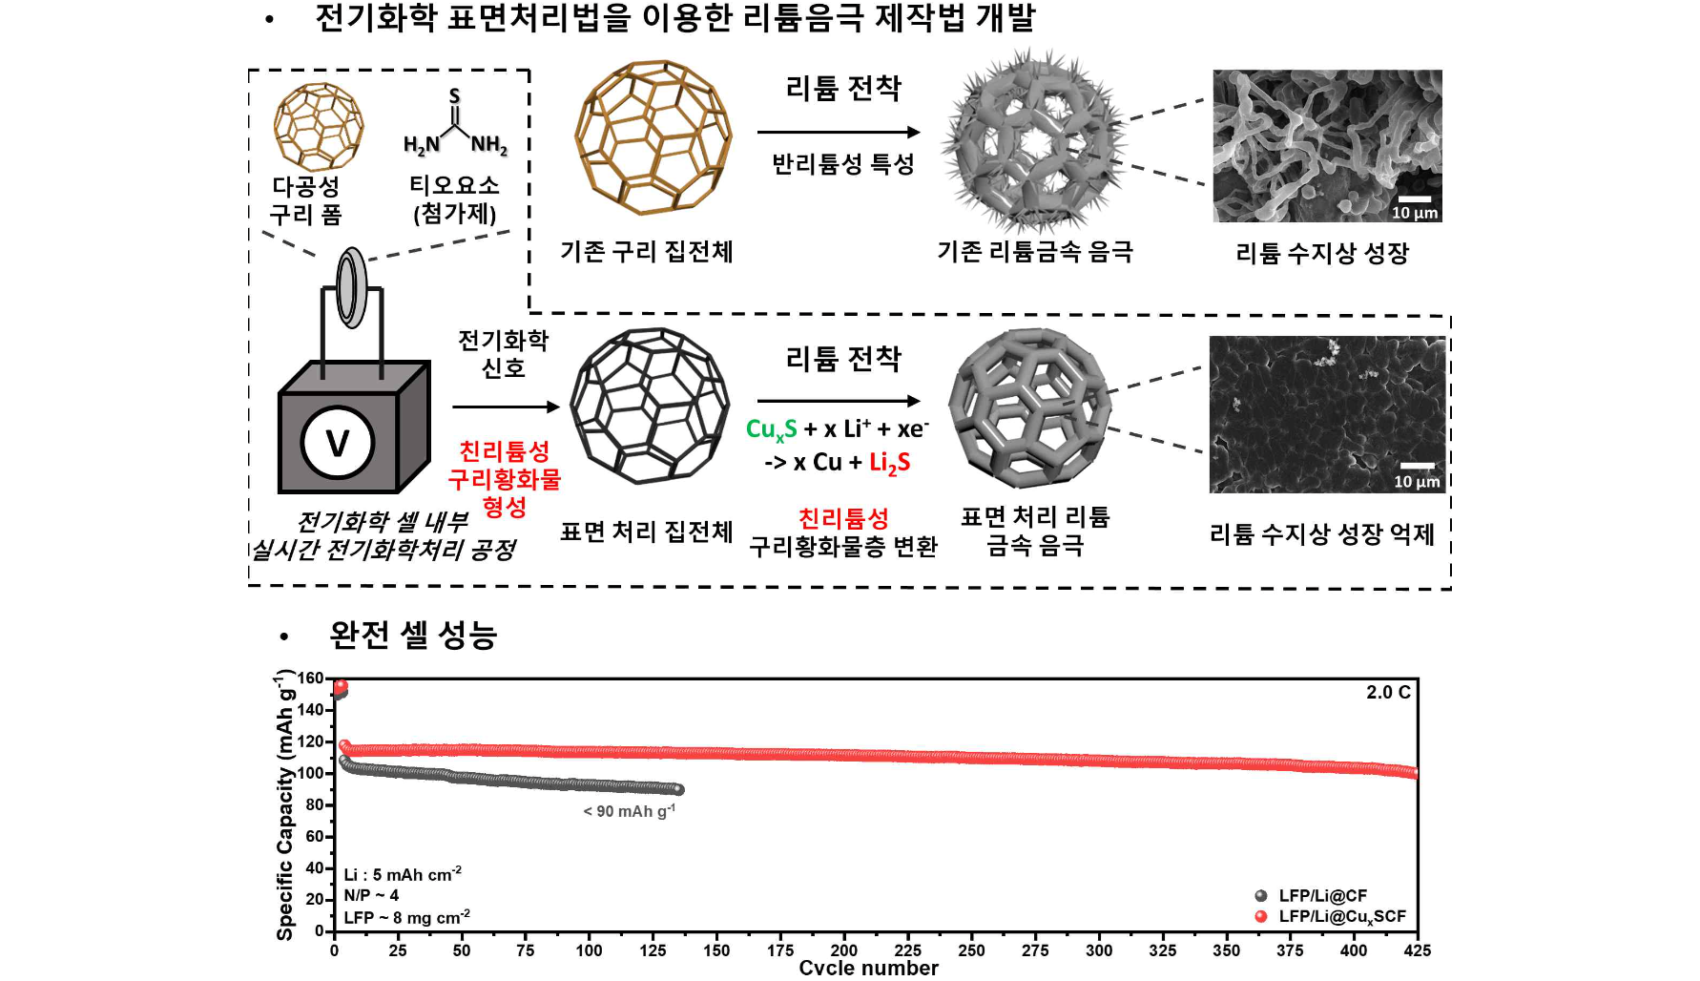▲ Schematic diagram of the development of a lithium anode manufacturing method using an electrochemical surface treatment method, comparison of lithium metal plating shapes and full cell performance. In a full cell using lithium metal as the anode and lithium iron phosphate (LiFePO4) as the cathode, the lithium metal anode that underwent electrochemical treatment showed a battery life more than three times longer at high current density.

Professor KwangSup Eom said, "A new methodology has been proposed that can significantly improve the stability of lithium metal batteries by simply electrochemically treating the battery cell without adding an external process. A method that can most easily reduce cost and time among methods to improve the stability and lifespan of lithium metal batteries with an energy density more than twice that of existing lithium secondary batteries for use in automobiles or aeromobility."

This study, supervised by Professor KwangSup Eom of the School of Materials Science and Engineering at GIST and Professor Tom Fuller of Georgia Tech, and conducted by PhD student Subin Kim, was supported by Hyundai Motor Company (battery R&D project for AAM), the National Research Foundation of Korea, and Georgia Tech (publication fee support). The results of the research were published online on August 19, 2024, in the world-renowned international academic journal in the field of materials engineering (nanomaterials), Small Structures (journal impact factor (2023): 13.9, JCR top 7.0%).



