GIST develops ‘WatchCap’, a wearable device to help people with low vision

- Professor SeungJun Kim's research team from the Institute of Integrated Technology proposes a hat-shaped device that compensates for visual field loss in people with low vision in everyday environments... Selected for presentation at the international academic conference 'ACM UbiComp 2024'
- Utilizing the 'Hanger Reflex' phenomenon made famous by TikTok's 'Hanger Challenge', it provides virtual deformation force to induce more head movement, thereby assisting people with low vision in their daily activities

▲ (From left) Professor SeungJun Kim, master's student Taewoo Jo, PhD student Dohyeon Yeo, PhD student Gwangbin Kim, master's student Seokhyun Hwang

As the number of people with low vision who suffer from visual field loss due to glaucoma, retinal degeneration, etc. increases due to aging, Korean researchers have developed a wearable device in the form of a hat that facilitates the visual exploration process of people with low vision, and its potential use as an everyday assistance tool is expected.

The Gwangju Institute of Science and Technology (GIST, President Kichul Lim) announced that a research team led by Professor SeungJun Kim of the Institute of Integrated Technology developed an algorithm that classifies the gaze recognition stage of a person with low vision and a wearable system in the form of a hat, ‘WatchCap,’ that encourages the user to nod during the exploration stage.

The results of this research are scheduled to be presented at the ACM international joint conference on Pervasive & Ubiquitous Computing (UbiComp)* in October.

* UbiComp 2024: October 5-9, 2024, Melbourne, Australia

‘Watchcap’ was developed to assist visual perception and navigation procedures such as pathfinding and spatial recognition for people with low vision who have difficulty with visual perception due to visual field loss.

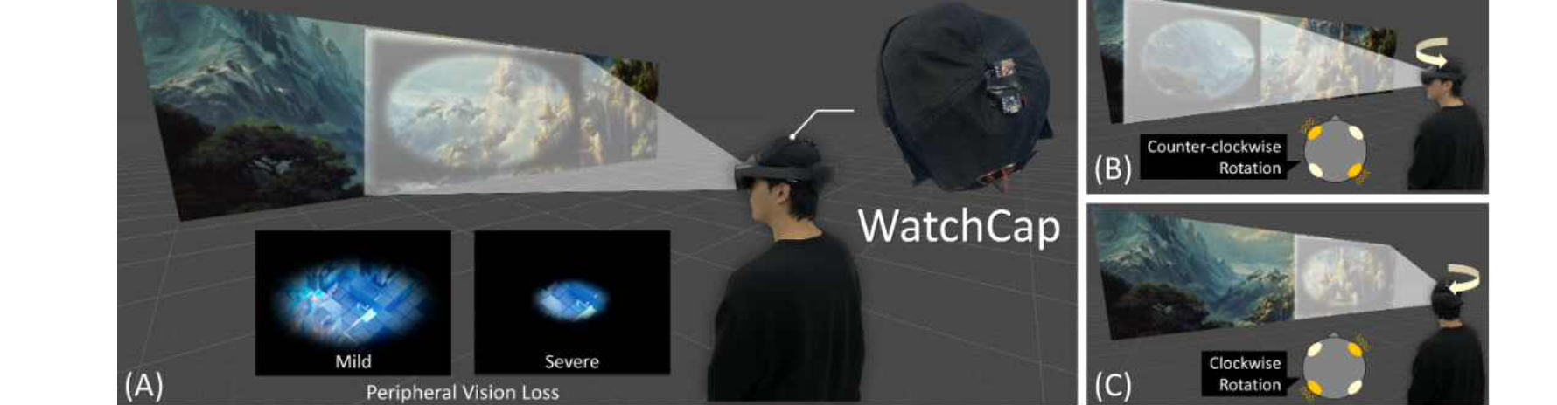▲ WatchCap system overview. Promotes larger head movements during the user's visual exploration process.

Existing low vision assistance tools have limitations in that they either limit the field of vision by using augmented reality information or expand the field of vision with optical devices, which results in poor compatibility with glasses worn by low vision patients or changes in the magnification of objects, interfering with spatial perception.

The ‘Watchcap’ system classifies the visual recognition process of low vision users through the 1st visual search and 2nd visual scanning stages in order to secure active vision for low vision users, and provides a virtual deformation force by inducing more head movement by inducing the ‘Hanger Reflex*’ phenomenon through vibration stimulation.

The research team integrated this system into a wearable device in the form of a hat and tested its effectiveness on people with low vision who suffer from peripheral vision loss due to glaucoma, retinal degeneration, uveitis, and other causes.

As a result, it was proven that the visual recognition process of low vision patients can be facilitated to unconsciously explore a wider space without explicit intervention or explanation, thereby assisting with the difficulties in daily life caused by visual field loss of low vision patients.

* Hanger Reflex: A phenomenon in which the neck reflexively turns when a hanger is placed on the head.

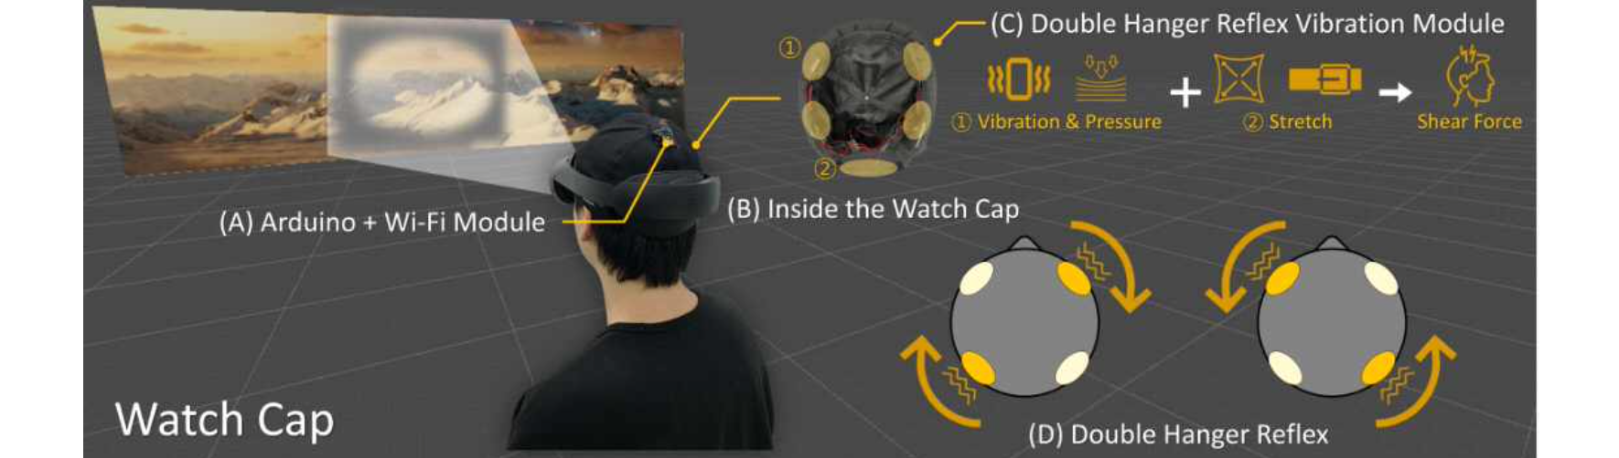▲ WatchCap system operation principle. It responds to the gaze recognition stage of a person with low vision and provides virtual rotational restoring force to the user during the exploration stage through a vibration module, thereby inducing greater head movement during the two-way visual exploration process.

Professor SeungJun Kim said, "People with low vision tend to show more active head and eye movements during visual exploration to compensate for their visual loss. This technology is a system that unconsciously induces and promotes this through visual stage classification using artificial intelligence and physical stimulation. 'WatchCap' is expected to be able to help people with low vision suffering from glaucoma, retinitis pigmentosa, etc. in their daily activities as it is freely compatible with visual aid tools and glasses using augmented reality."

This research, supervised by Professor SeungJun Kim of the Institute of Integrated Technology at GIST and conducted by researchers Taewoo Jo (graduated with a master's degree from GIST in February 2024), Dohyeon Yeo, Gwangbin Kim, and Seokhyun Hwang, was supported by the GIST-MIT Joint Research Project.

Professor SeungJun Kim, who is currently an adjunct professor at GIST's AI Graduate School and AI Policy & Strategy Graduate School, is conducting research on artificial intelligence and human-computer interaction for human-centered intelligence of physical systems.



