GIST develops next-generation antibiotics using active oxygen, a new breakthrough in treating resistant bacteria infections and sepsis

- GIST Department of Chemistry Professor Jiwon Seo – Konkuk University Department of Bioscience and Biotechnology Professor Yangmee Kim joint research team, maximizes antibacterial effect and minimizes toxicity by combining active oxygen generating catalyst and cell membrane destroying peptoid
- Sepsis animal model anti-inflammatory and anti-sepsis efficacy proven... “Blocking the source of bacteria acquiring antibiotic resistance opens the possibility of developing next-generation antibiotics” Published in international academic journal 《Journal of Medicinal Chemistry》

▲ (From left) GIST Department of Chemistry Professor Jiwon Seo, Konkuk University Professor Yangmee Kim

The Gwangju Institute of Science and Technology (GIST, President Kichul Lim) announced that a joint research team led by Professor Jiwon Seo of the Department of Chemistry and Professor Yangmee Kim of the Department of Bioscience and Biotechnology at Konkuk University developed an antibiotic with low toxicity by combining a catalyst that generates active oxygen* with an antimicrobial peptoid* that damages cell membranes.

The results of this study, which presented an antibacterial catalyst strategy that generates reactive oxygen, have proven that they can be used to develop new antibiotics without the risk of resistance.

* reactive oxygen species (ROS): Reactive oxygen species are chemically reactive molecules that contain oxygen atoms.

* peptoid: A new material developed to artificially mimic the function of biological proteins, a peptide derivative, a biological polymer.

As the development of antibiotics with new mechanisms of action has gradually decreased since the 1980s, the World Health Organization (WHO) estimates that the number of deaths caused by multidrug-resistant bacteria* will reach 10 million per year by 2050.

In particular, lipopolysaccharides (LPS) in the outer membrane of Gram-negative bacteria* act as a permeability barrier and, when released into the bloodstream, can induce a strong immune response and cause life-threatening sepsis. However, existing antibiotics for sepsis treatment have a high resistance rate to Gram-negative bacteria, so the development of antibiotics with new mechanisms of action is necessary.

Accordingly, research on antimicrobial peptides derived from nature is actively being conducted, and various mimetics are being developed based on these to improve stability in vivo. Among them, antimicrobial peptoids are attracting attention as new antibiotics that will solve the problem of resistant bacteria based on their high stability and broad antimicrobial activity.

* multidrug-resistant bacteria: Bacteria that are resistant to multiple antibiotics, which limits the antibiotics that can be used to treat infectious diseases.

* Gram-negative bacteria: Bacteria that are stained red in the Gram reaction, including Escherichia coli, Shigella, gonococci, lactobacillus, cholerae, and pestis. They are weak to digestive enzymes and do not respond well to penicillin, etc.

The research team introduced the ‘amino terminal Cu(II) and Ni(II) binding (ATCUN) motif’, which generates hydroxyl radicals, a powerful oxidizing agent, through a catalytic reaction, into existing antibacterial peptoids that destroy bacterial cell membranes and induce aggregation of various intracellular organelles and genes, thereby developing an antibiotic with improved selectivity* and multi-targeting mechanisms*.

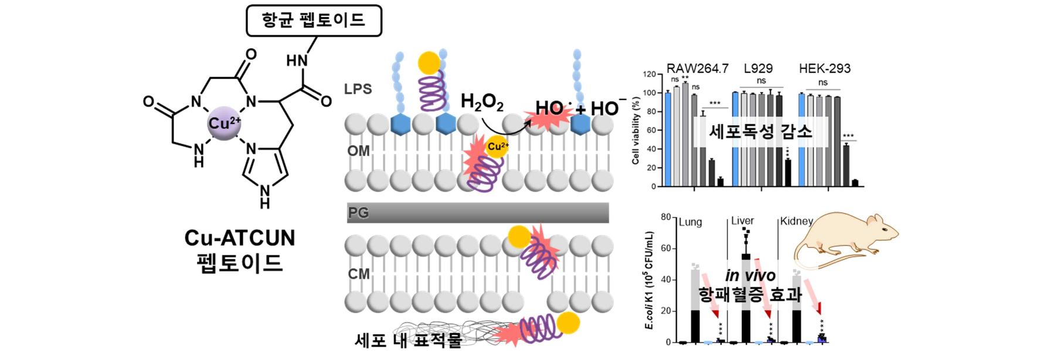▲ Schematic diagram of Cu-ATCUN antibacterial catalyst peptoid and verification of antibacterial action mechanism and antibacterial effect in animal model. Cu-ATCUN antibacterial peptoid destroys bacterial membranes, aggregates intracellular targets, and oxidizes them by generating strong oxidizing substances. This substance has excellent antibacterial activity while having low toxicity to animal cells, and showed anti-sepsis and anti-inflammatory effects in a sepsis mouse model.

The research team, which discovered the effective substance ‘Peptoid 22’ through antibacterial activity and toxicity screening, revealed that this substance maintains the antibacterial mechanism of existing peptoids and that the oxidizing substance generated through the ‘Cu-ATCUN motif’ induces DNA oxidation and cell membrane lipid peroxidation of bacteria, causing fatal oxidative damage to bacteria.

‘Peptoid 22’ showed the same antibacterial activity as existing peptoids, but significantly reduced toxicity to human cells. In addition, it showed effective anti-septic and anti-inflammatory effects in a mouse model of sepsis* induced by Gram-negative bacteria, and was confirmed to have no toxicity to major organs including the liver, lungs, and kidneys.

The sepsis mouse model administered peptoid 22 (5 mg/kg, 4 times every 4 hours, intraperitoneally) showed a 60% survival rate for 96 hours, whereas the control mouse model not treated with peptoid showed 100% death after 34 hours, verifying the validity of the animal model.

* selectivity: This is expressed as a comparison value for antibacterial activity and mammalian cell toxicity, and a higher selectivity value means lower toxicity.

* multi-target mechanism: This refers to the principle of simultaneously attacking and killing multiple targets essential for the survival and reproduction of bacteria, and is known to be effective in suppressing the development of resistance.

* sepsis: A systemic inflammatory response syndrome that occurs when the blood is infected with bacteria that have invaded the body. It can lead to death within a short period of time.

Professor Jiwon Seo said, "This study suggests a way to use oxidative attack as a new weapon to maximize the effectiveness of antimicrobial peptoids. It opens up new possibilities for the development of next-generation antibiotics that can fundamentally block the acquisition of antibiotic resistance in bacteria."

This study, conducted by Professor Jiwon Seo's team at GIST, was supported by the National Institute of Health's Infectious Disease Management Technology Development Research Project, the Mid-career Researcher Support Project of the Ministry of Science and ICT and the National Research Foundation of Korea, the Regional Innovation Leading Research Center (RLRC), and the Nanomaterial Technology Development Project. The results of the research were published online on August 29, 2024, in the Journal of Medicinal Chemistry, an international academic journal ranked in the top 4.9% in the field of medicinal chemistry published by the American Chemical Society.



