“Hydrogen production efficiency improved by 3 times” GIST develops method for manufacturing supported nano catalyst particles using thermodynamic phase separation phenomenon

- Professor Bong-Joong Kim's team, uniformly distributed high-density tin disulfide (SnS2) nanoparticles on the surface of bismuth vanadate (BiVO₄)... Presenting a new way forward for catalyst exosolution technology that has reached its limit
- Broadening the horizon of heterogeneous catalyst technology, expected to drastically improve hydrogen production efficiency in various fields such as gas sensors and gas reforming to be applied to electric vehicles... Published in the international academic journal 《Small Methods》

▲ Professor Bong-Joong Kim of the School of Materials Science and Engineering

An eco-friendly, high-efficiency catalyst production technology that dramatically increases hydrogen production efficiency has been developed by Korean researchers.

The Gwangju Institute of Science and Technology (GIST, President Kichul Lim) announced that a research team led by Bong-Joong Kim of the School of Materials Science and Engineering has developed a new concept of supported catalyst* production technology that binds high-density tin disulfide (SnS2) nanoparticles uniformly distributed on the surface of bismuth vanadate (BiVO₄)* using the thermodynamic phase separation* phenomenon.

* phase separation: A phenomenon in which a mixture is separated into two or more phases with different physical or chemical properties.

* bismuth vanadate (BiVO₄): A photocatalyst that absorbs light to promote chemical reactions, promising for environmental applications such as water splitting and pollutant removal. In particular, it generates hydrogen through water splitting with its efficient light absorption ability in the visible light range.

* supported catalyst: A catalyst made by dispersing or binding a catalytically active material (metal, metal oxide, etc.) to the surface of a solid support (mainly an inactive material such as oxide or carbon).

The phenomenon of exsolution* of metal catalyst particles on oxide supports has been considered very important for high-temperature catalytic reactions (e.g., gas sensors) and renewable energy applications (e.g., gas reforming, fuel cells) because the catalyst particles are embedded in the support surface and do not undergo coarsening (crystal grain enlargement by heating polycrystalline materials at high temperatures).

* ex-solution: When a high-temperature reducing atmosphere (700-800 degrees Celsius or higher, hydrogen atmosphere) is applied, a phenomenon in which a specific metal component is separated from a specific oxide substrate or support (mainly a perovskite-structured oxide, e.g. ABO3) and comes out to the substrate surface. Precious metals or highly active metals substituted mainly at the B atom site come out to the substrate surface and form particles.

The exsolution phenomenon occurs by doping a metal element into a solid oxide substrate and then performing a high-temperature heat treatment in a reducing environment. This conventional method has a problem in that only a very small amount of the metal element escapes due to the slow diffusion rate of the metal element within the solid substrate, making it difficult to generate a large amount of catalyst particles on the substrate, and the escaped metal element causes structural defects (e.g., oxygen vacancies) in the oxide substrate.

In addition, metals that strongly bind to oxygen are only exsolved in excessively strong reducing environments, causing the oxide substrate to decompose. Therefore, the activity and durability of the utilized device are drastically reduced, which has been pointed out as a limitation of catalyst technology.

* vacancy: A state in which atoms are absent from their original positions in the lattice. An increase in vacancy concentration may result in changes in the lattice structure.

The research team utilized thermodynamic phase change phenomena called eutectic melting* and eutectic phase separation*. First, the BiVO₄ substrate was crystallized using the sol-gel method, and then SnS₂ was deposited at 200 degrees Celsius using the atomic layer deposition method.

This temperature is higher than the eutectic melting temperature of the BiVO₄ and SnS₂ compounds, so the two substances turn into liquid phases, and when the sample is then lowered to room temperature, the two substances separate again due to the eutectic phase separation phenomenon. At this time, SnS2 exists in the form of particles embedded in the surface of the BiVO₄ substrate.

* eutectic melting: When two or more substances are mixed in a specific ratio, the mixture melts at a temperature lower than the individual melting points of each substance.

* eutectic phase separation: A phenomenon in which two or more phases are separated when two or more substances of a specific composition are melted at the eutectic point and then cooled.

The research team observed the temperature increase using real-time X-ray diffraction* and real-time transmission electron microscopy* techniques. They confirmed that the diffraction contrast and diffraction points disappeared, indicating that the two substances, BiVO₄ and SnS₂, changed into liquid compounds, and then decomposed into two solid substances when the temperature was lowered to room temperature.

* X-ray diffraction: A technology that analyzes the atomic arrangement and crystal structure of a material by utilizing the diffraction phenomenon that occurs when X-rays are irradiated on a material with a crystal structure.

* transmission electron microscope: A microscope that can observe objects at magnifications of hundreds of thousands of times or more by shooting a high-voltage electron beam through them to allow them to pass through thin materials.

BiVO₄ has a ▴ small bandgap*, ▴ appropriate conduction band edge*, and ▴ valence band edge* positions that are useful for water splitting anodes, and SnS₂ also has a small bandgap and Type II band alignment* with BiVO₄, making it very advantageous for water splitting.

In addition, the research team suppressed the recombination of electrons and holes generated by light by thinly coating amorphous zinc sulfide (ZnS) on the defects on the surfaces of BiVO₄ and SnS₂, and rapidly moved the two substances by utilizing the shallow energy level* of the amorphous layer.

* bandgap: The energy region where electrons cannot exist in a semiconductor or insulator

* conduction band edge: The lowest energy level of the conduction band in a semiconductor or insulator

* valence band edge: The highest energy level of the valence band in a semiconductor or insulator

* type II band alignment: A state in which the conduction band and valence band are misaligned, which promotes separation of electrons and holes and charge transfer, making it a structure advantageous for photovoltaic devices

* shallow energy levels: A state in which the energy levels generated by doped impurity atoms or defects in a semiconductor are very close to the valence or conduction band

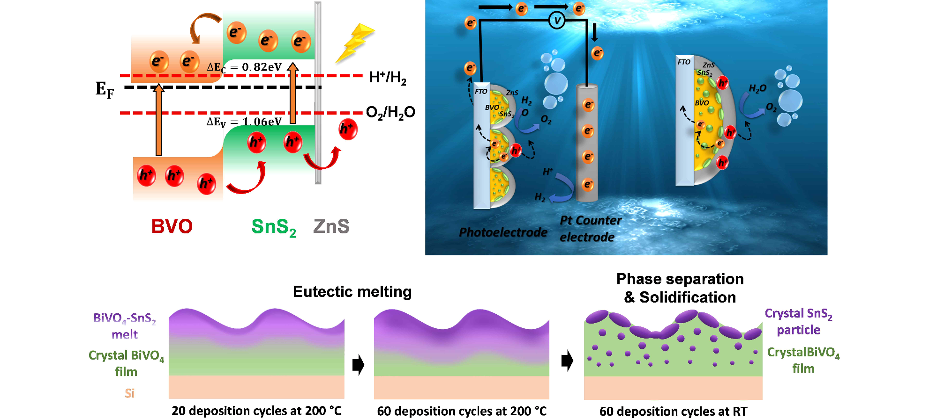▲Type II band alignment between BiVO₄ and SnS₂ (top left), schematic diagram of the final photoelectrochemical water decomposition anodic reaction mechanism (top right), and schematic diagram of SnS₂ nanoparticles embedded in BiVO₄ through eutectic dissolution and eutectic phase separation processes occurring during PLD deposition (bottom).

As a result, it showed an efficiency improvement of nearly three times (0.84% → 2.27%) compared to the BiVO₄ single photoelectrode, and the decrease in efficiency could be suppressed to less than 10% for 24 hours.

Professor Bong-Joong Kim said, "The significance of this research achievement lies in the fact that it presents a new path in the field of supported catalyst technology, which has reached its limit. By dramatically increasing hydrogen production efficiency, it is expected to bring about improvements in various fields such as hydrogen production for electric vehicles, gas sensors, gas reforming, and fuel cells."

This study, led by Bong-Joong Kim (corresponding author) of the School of Materials Science and Engineering at GIST, was conducted with the support of the National Research Foundation of Korea's Mid-career Researcher Support Program and the GIST-MIT International Joint Research Program, and the results of this study were published online in the prestigious nanotechnology journal Small Methods on September 9, 2024.



