“Scientists who opened a new path for studying ideal time from a physical perspective” GIST undergraduate students Tae-Gyun Lee and Hyeok-Jun Im, third year students, apply physics theory to reveal the meaning of “Ogamdo Poem No. 4”

- 3Dizing the ‘number board’ of “Ogamdo Poem No. 4” and finding the electromagnetic principle implemented here... Revealing that it is a work that sees through and diagnoses the inside of a patient (the world) like an MRI
- “A poet is truly a ‘doctor’ who sees through and diagnoses the inside of society, a sense of mission beyond the ideal”
- Published in the KCI academic journal 《The Korean Poetics Studies》... The paper was supervised by Professor Soo Jeong Lee, based on the Ogamdo series of poems, and was selected for the grand prize in the 45th Seoul Dance Festival and is scheduled to be performed at the Arko Arts Theater Grand Theater on November 15

▲ (From left) Student Tae-Gyun Lee (first author), student Hyeok-Jun Im (second author), Professor Soo Jeong Lee (corresponding author)

※ Paper Review 《The Korean Poetics Studies》

“Usually, new attempts are difficult to support with theoretical grounds, and often end up as the creative ideas of individual researchers. However, this study shows excellent results in both logic and creativity, from finding a connection between non-relativistic electromagnetism and ideal life to having a solid theoretical foundation in theories other than literature. In addition, the meticulous attitude of the researchers, who secured the validity of this study in works other than the subject work, is something that future researchers can emulate.”

“The researchers’ excellence and sincerity are clearly demonstrated in the meticulousness of the logic, the connection between the theory and the work, etc. We send our support and applause to the researchers who has worked hard to produce a solid paper in both quality and quantity.”

“A paper that stands out for its creativity in elucidating the existence and uniqueness implied by the arrangement of numbers through mathematical principles”, “A paper that opens up a new path for the study of Yi Sang’s poetry by approaching Yi Sang’s text with a unique perspective and methodology”

The Gwangju Institute of Science and Technology (GIST, President Kichul Lim) announced that two undergraduate students have published a groundbreaking research paper interpreting Yi Sang’s difficult poem "Ogamdo Poem No. 4" from an electromagnetic perspective.

The title of the paper is "Electromagnetic Principle of Internal Diagnosis Implemented in 'Crow’s Eye View (Ogamdo) Poem No. 4'", and the research was conducted by Tae-Gyun Lee (first author, Department of Physics and Photon Science) and Hyeok-Jun Im (second author, School of Electrical Engineering and Computer Science), who are currently in their third year of the undergraduate program, under the guidance of Professor Soo Jeong Lee (corresponding author) in the Division of Liberal Arts and Sciences.

This paper received high praise from the academic community, such as “It is excellent in both logic and creativity” and “It is a new path for the study of Yi Sang’s poetry”, and was published in the 79th issue of The Korean Poetics Studies, a KCI journal in the field of Korean literature* (published on August 31, 2024).

* KCI Journal: A journal listed in the Korea Citation Index (KCI) managed by the National Research Foundation of Korea.

"Ogamdo Poem No. 4" is one of the five senses series by the genius poet Yi Sang’s and is a difficult work composed of upside-down number plates rather than text. It uniquely expresses the main theme of the series, "observation," and there is no disagreement that Yi Sang, who called himself a doctor, is diagnosing a patient, but there are different opinions about the interpretation of the number plates, the meaning of the diagnosis, and the identity of the patient. All previous discussions have read the number plates horizontally or vertically.

However, when read horizontally or vertically, the number sequence on the number pad is interrupted by ‘•’. This study proposes a new way of reading the number pad in diagonal and spiral directions, breaking away from this existing approach, and made the number pad three-dimensional by utilizing clues in the poem.

The research team discovered the principles of electromagnetics implemented in the number pad using the clues given in “Ogamdo Prototype 4,” thereby revealing that “Ogamdo Prototype 4” is a work that sees through and diagnoses the inside of a patient (the world) based on electromagnetic principles.

The research team revealed that Yi Sang had placed various clues (reversed numbers, a sequence that is interrupted by a '•' when read horizontally or vertically, 'diagnosis 0•1', etc.) in the "Ogamdo Poem No. 4" and induced the keyboard to be rolled into the shape of a cylinder and a torus*. They confirmed that when the sequence was read in a spiral in this three-dimensional structure, the sequence that had appeared abnormal because the left and right were reversed and interrupted was read in a normal form.

* torus: A circular ring. A shape with a hole in the middle, commonly called a donut shape.

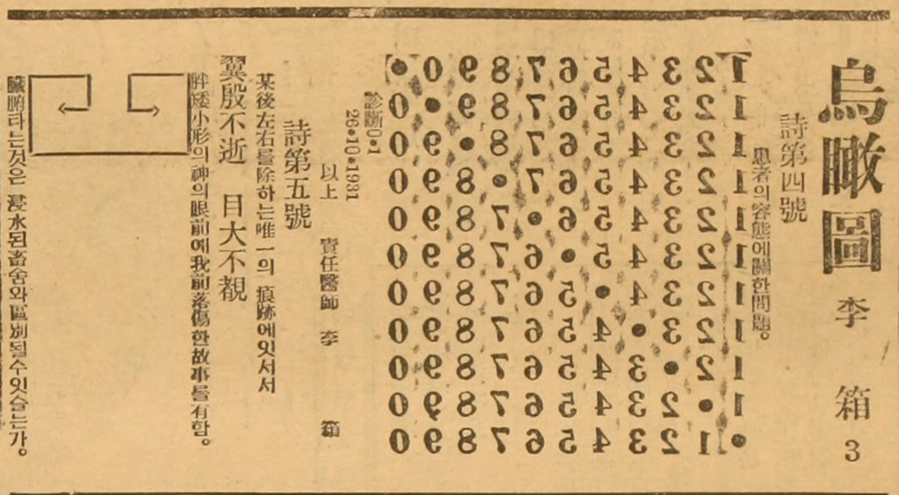
▲ Original text of “Ogamdo Poem No. 4” (right). This is the original text of “Ogamdo Poem No. 4” published in the Chosun JoongAng Ilbo. The most noticeable part is the number pad, and it is noteworthy that it is inverted. If you look closely at “Diagnosis 0∙1,” the numbers “0” and “∙” do not provide information about left and right, but the slant at the beginning of the number “1” shows that it is not inverted left and right. This means that the content of the diagnosis is not inverted left and right, and suggests that the diagnosis certificate (number pad) should be returned to its original state.

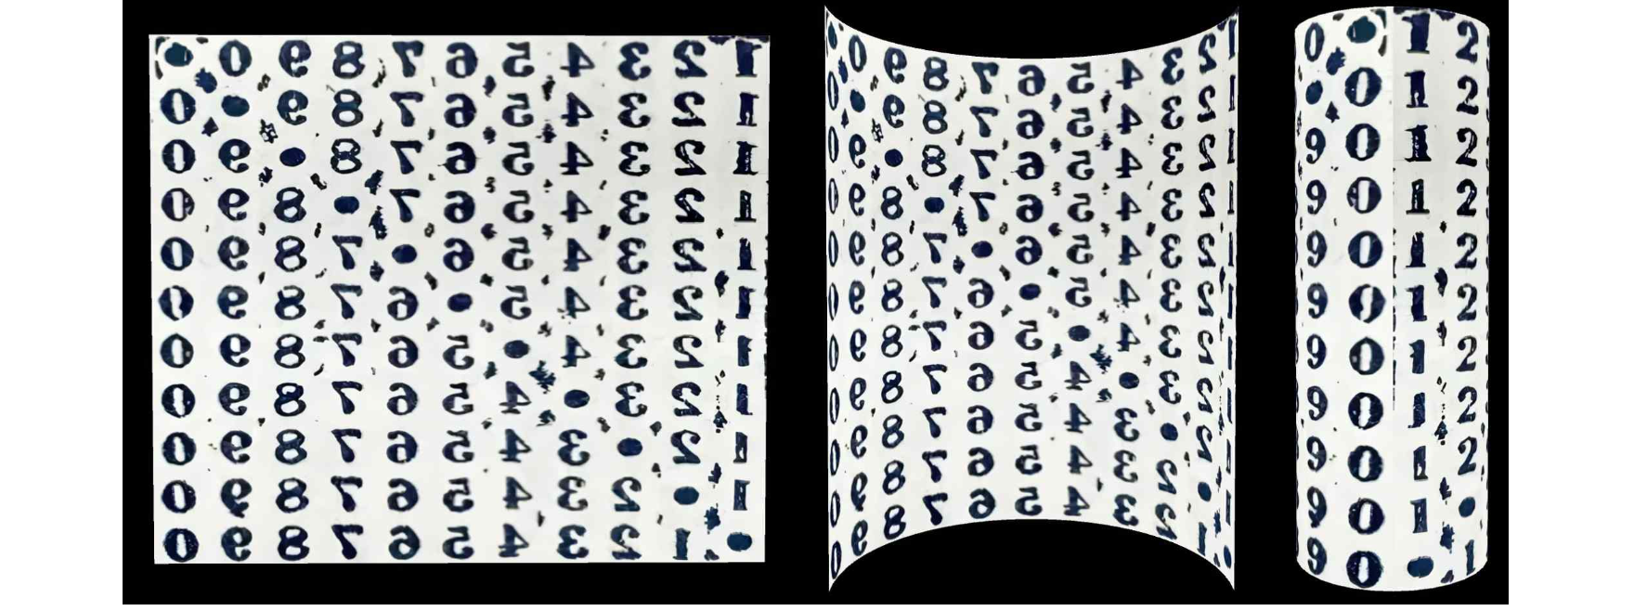▲ The process of rolling the number pad of “Ogamdo Poem No. 4” forward. The diagnosis contents, “0∙1,” are created at the very bottom and top of the right cylinder, and you can see that the numbers are straight. When the number pad is rolled forward like this to create a cylinder, the reader enters the cylinder, and the reader and the world the reader lives in become the subject of the diagnosis by the doctor, Yi Sang.

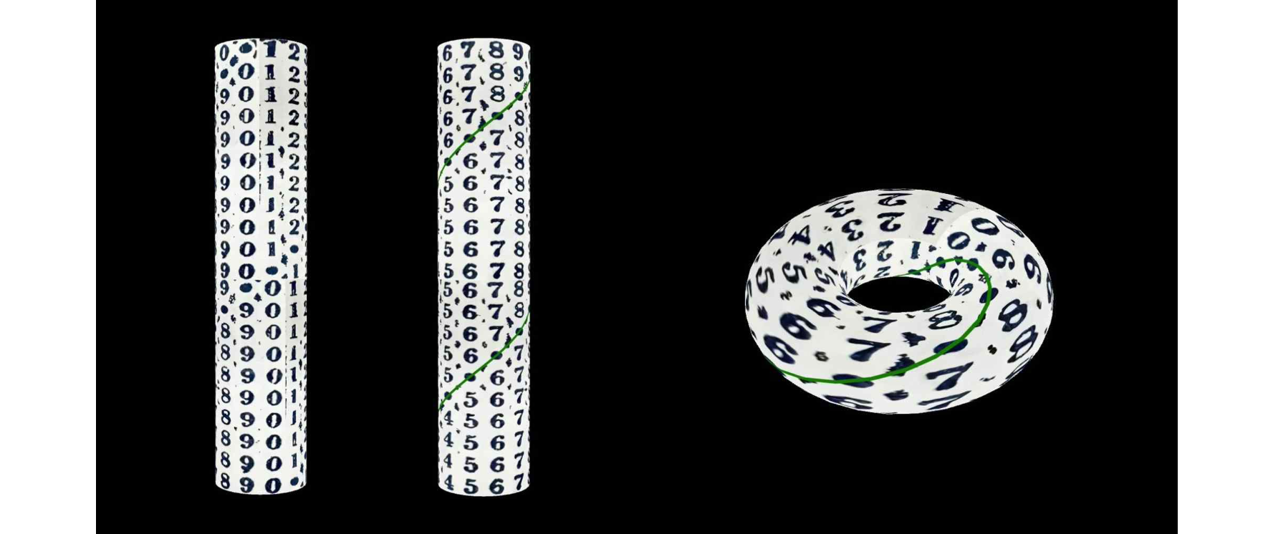▲ The appearance of a cylinder made by rolling up the number pad forward and connecting a new cylinder so that “0•1” overlaps, and the appearance of indicating the direction of the spiral path of the “1 2 3 4 5 6 7 8 9 0” sequence that repeats without a break (left), and the appearance of connecting the top and bottom of the cylinder made with the number pad to make a torus shape (right). The fact that “0” follows “9” implies that the sequence will repeat as “1 2 3 4 5 6 7 8 9 0 1 2 3....” How can we continue to read the sequence of “1 2 3 4 5 6 7 8 9 0” without a break? There are two ways. As in [Figure 3], connect an infinite number of cylinders so that the “0∙1”s on the top and bottom of the cylinder overlap, or connect the top and bottom of the cylinder to make a torus shape.

The research team revealed that they used Stokes’ theorem*, which is naturally derived from the fact that the sequence and ‘•’ form a closed space by drawing a spiral trajectory, to see inside the cylinder for the purpose of diagnosing abnormalities that are not apparent on the outside.

This theorem is a core principle of electromagnetism that allows the diagnosis of internal conditions using only information from the boundary, and it has been clarified that the number pad of the poem reflects this scientific concept. The research team also discovered that the number pad allows the application of the divergence theorem and Helmholtz theorem of electromagnetism, which calculate the internal vector field using external information.

* Stokes’ theorem: In vector calculus, it is a theorem that states that information about the interior can be known only through information about the boundary (a closed curve) without directly looking at the interior.

Furthermore, the research team confirmed that all three conditions (rotation, divergence, and boundary conditions) for using the Helmholtz theorem* were satisfied in the torus structure created using the number pad.

Through this, the research team discovered that they could guarantee the ‘existence’ of the patient inside and the ‘uniqueness’ of its shape by utilizing the surface information of the three-dimensional number plate and the Helmholtz theorem. At this time, the research team analyzed the patient inside the cylinder as a vector field, and the five senses as a vector field* map that imaged the invisible patient (vector field) inside.

* Stokes’ theorem: A core principle of electromagnetism. Once divergence, rotation, and boundary conditions are set, it guarantees the existence and uniqueness of a vector function in the space (inside) created by the boundary. It is also called the fundamental theorem of vector calculus.

* vector field: A vector is a quantity that has both magnitude and direction, and a vector field is a function that assigns one vector to each point in space. Examples of vector fields that can be seen in real life include wind speed, which indicates the direction and how fast the wind blows at each point. A vector field is also called a vector function.

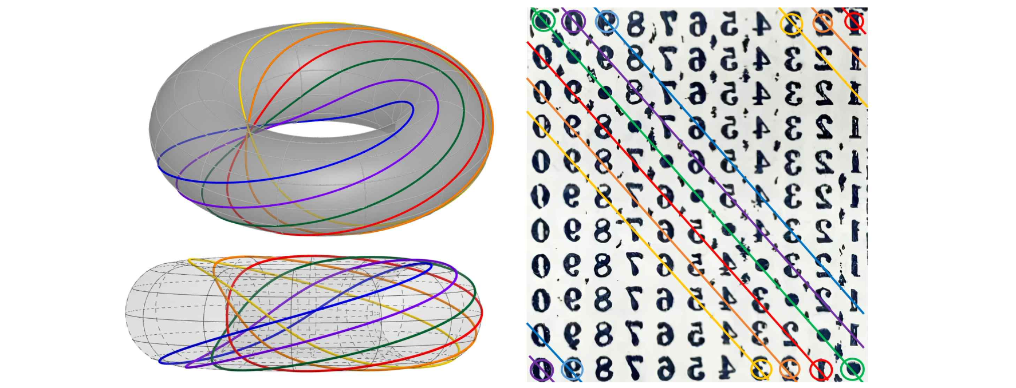▲ The paths (red, orange, yellow, blue, purple) formed by numbers (‘1 2 3 4 5 6 7 8 9 0’) and the paths formed by ‘•’ (green) are displayed on the number plate of ‘Ogamdo Poem No. 4’ (right), and the paths form a closed curve on the torus structure created by rolling up the number plate (left).

The research team interpreted that in “Ogamdo Poem No. 4,” “Doctor Yi Sang” looks inside of society in a non-invasive way like an MRI. Through this, it was revealed that “Ogamdo Poem No. 4” does not directly treat the illness of the patient (the world), but it reveals tat the mechanism for diagnosing the illness of the patient (the world) is literature and poetry, and that it is the poet’s responsibility to see through and diagnose the invisible interior.

This study is an extension of the content presented by Tae-Gyun Lee (first author) in the <Ideal Literature and Science> class offered in the spring semester of 2024. <Ideal Literature and Science> is a course that explores Yi Sang's works from a convergence of literature and science, and has already submitted several meaningful research results on Yi Sang's poetry.

In addition, the ‘Risang Torus’ program, which visualizes the core content of the research, was developed by advancing the assignment for the <Art and Technology> class that Hyeok-Jun Im (second author) took concurrently in the same semester.

Professor Soo Jeong Lee said, "This is the fourth time that a paper has been published through the 〈Ideal Literature and Science〉 class. They were all excellent studies, but this time, I am very proud that third-year undergraduate students, not graduates or fourth-year students, completed such original and in-depth research. In addition, this year marks the 90th anniversary of the publication of 'Ogamdo,' making this research even more meaningful."

The first author, Tae-Gyun Lee, said, "Through excellent electromagnetism and multivariable analysis classes, I was able to deeply understand physics concepts and have a perspective on the world based on this in my daily life. This background was a great help in achieving this achievement, and I am grateful for GIST's educational environment where I could deeply learn both science and humanities."

The second author, Hyeok-Jun Im, said, "I had a meaningful experience participating in the work of concretizing the 4th volume of the Ogamdo Poem, and I hope that our paper will become the first step in interpreting a poem written on a flat surface in a three-dimensional way."

The research results of this paper, which are significant as an academic result of the exploration of the ideal, are expected to expand into the field of art as it has been confirmed that Professor Soo Jeong Lee's paper dealing with the series of poems on the five senses of idealism will be performed on stage in the form of a dance performance.

The title of the performance is <Ogamdo: The World Seen by a Crow> (Blue Dance Theater, Choreography by Yoojin Jung)*, and it was selected for the grand prize category at the 45th Seoul Dance Festival* and is scheduled to be performed at the Arko Arts Theater Grand Theater on November 15.

Professor Lee said, "The knowledge and inspiration reflected in the dance script also came from the research process with students, and I hope that this research and performance will serve as an opportunity to reexamine Yi Sang's work in a modern way."

* <Ogamdo: The World Seen from a Crow> (Blue Dance Theater, Choreographer Jeong Yu-jin): Four works of Ogamdo 1, 2, 4, and 10 were reinterpreted and reconstructed as contemporary art. Artistic director Hye-jeong Kim, choreographer Yoojin Jung, director Kyu-jong Kim, and writer Soo Jeong Lee participated. Blue Dance Theater is a group that aims to popularize dance through dance dramas that combine dance, acting, and video.

* Seoul Dance Festival: Hosted by the Korea Dance Association, the Seoul Dance Festival began as the Republic of Korea Dance Festival in 1979 and is Seoul's representative arts festival that will celebrate its 45th anniversary in 2024. It focuses on discovering globally competitive dance art pieces, and in the competition category, premieres of creative works from various genres such as ballet, Korean dance, and modern dance are performed as large-scale works lasting around an hour.

This study, supervised by Professor Soo Jeong Lee of the Division of Liberal Arts and Sciences at GIST and conducted by undergraduate students Lee Tae-gyun and Lim Hyeok-jun, was published in 《The Korean Poetics Studies》, a Korean literature journal published by the Korean Poetics Society, on August 31, 2024.



