GIST-Kangdong Kyunghee University Hospital, first construction of ‘long non-translated RNA’ cell map... Revealing correlation between aging and ‘long non-translated RNA’

- GIST School of Life Sciences Professor Jihwan Park and Kangdong Kyung Hee University Hospital Professor Sang-Ho Lee's joint research team establishes gene regulation network through aged kidney cells and reveals biological function of 'long untranslated RNA'
- 'Long untranslated RNA' providing clues to cause of aging, expected to be utilized as treatment strategy for aging and diseases... Published in the international academic journal in the field of nephrology, 《Journal of the American Society of Nephrology》

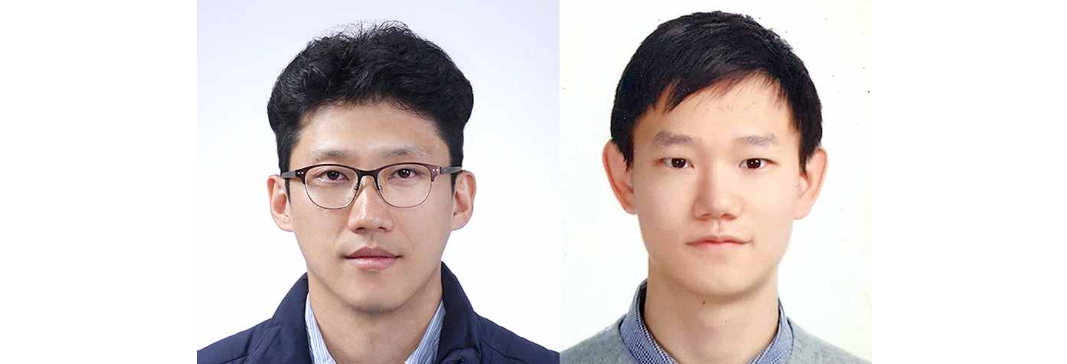▲ (From left) Professor Jihwan Park of the School of Life Sciences and PhD student Gyeong Dae Kim

Long non-coding RNA (lncRNA), which was previously considered a by-product with no special function and thus did not receive much attention as a research subject, is now receiving attention as numerous recent studies have revealed that it directly or indirectly affects cellular functions within cells and causes various diseases and aging.

However, despite its importance, follow-up research is hampered by the lack of a cell map that can serve as a reference for the study of ‘long noncoding RNAs.’

* long non-coding RNA (lncRNA): A transcript that is longer than 200 nucleotides and does not encode proteins.

The Gwangju Institute of Science and Technology (GIST, President Kichul Lim) announced that the research team of Professor Jihwan Park of the School of Life Sciences and the joint research team of Professor Sangho Lee of Kangdong Kyung Hee University Hospital combined the existing single-cell technology* with a technology that only identifies ‘long UCRNA’ to build a cell map of ‘cell-specific long UCRNA’ and ‘aging-specific long UCRNA’ in six tissues (kidney, lung, liver, heart, small intestine, thymus) and aged kidney.

The research team extracted six tissues from an 8-week-old adult mouse model and a kidney from a 21-month-old aged mouse model.

* single-cell analysis technology: This is a technology that can analyze the expression of all genes expressed in tens of thousands of individual cells in a single experiment and is currently evaluated as one of the most important next-generation technologies in the fields of biology and medicine.

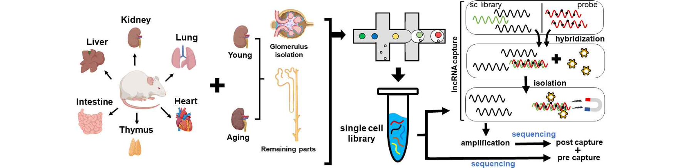▲ Schematic diagram of analysis combining single-cell analysis technology and target technology in six tissues and aging kidneys. Transcriptome data at the individual cell level were obtained using single-cell technology in six tissues and aging kidneys, and only long-frequently translated RNAs were isolated and used for analysis using technology that can identify only specific transcripts.

The research team built a gene regulation network by integrating the transcriptional regulatory factors and downstream regulatory gene information centered on the ‘long non-coding RNA’ discovered in each cell, and revealed the biological functions of ‘long non-coding RNA’ in cellular roles such as lipid metabolism and immune cell activation in each tissue.

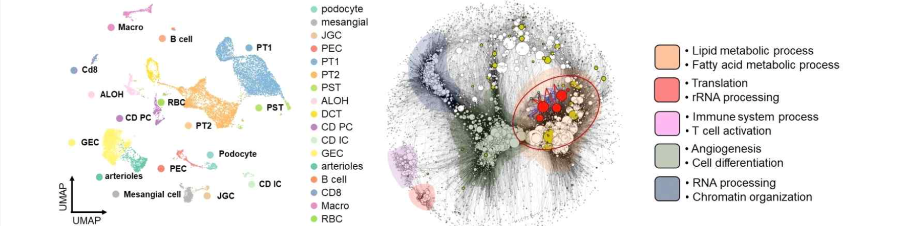▲ Classification of each cell type in the kidney through single-cell analysis (A) and gene regulatory networks centered on long untranslated RNAs in each cell and the biological functions of each network (B). (A) is a diagram showing each cell type in the kidney through single-cell clustering analysis, and (B) is a diagram showing the gene regulatory network based on the co-expression and regulatory mechanisms between long untranslated RNAs and other transcripts in the kidney, and each color in the gene regulatory network represents a different biological meaning.

They applied the developed single-cell analysis technology to aged kidneys to observe changes in genes and long non-coding RNAs due to aging.

The characteristics of aging were first observed in the glomeruli, the core organs of the kidneys responsible for filtration, based on high inflammatory responses and aging scores. By discovering the co-expression patterns of genes that induce these inflammatory responses and long non-coding RNAs in various cells that make up the glomeruli, we succeeded in revealing the correlation between aging and ‘long non-coding RNAs.

In addition to glomeruli, they observed an overall increase in immune cells in aged kidneys, and identified ‘long untranslated RNA’, which commonly increases in these immune cells with aging.

Professor Jihwan Park said, "This research achievement enabled us to create an analysis map that is highly useful for studying ‘long non-coding RNA’. ‘Long non-coding RNA’, which provides a clue to the cause of aging, can be used as a treatment strategy for aging and disease."

First author and doctoral student Gyeong Dae Kim said, "Through this analysis technique, we hope to uncover the causal relationship between ‘long untranslated RNA’ and not only aging kidney but also various other diseases."

This study, supervised by Professor Jihwan Park Park of GIST and conducted by student Gyeong Dae Kim and Dr. So-I Shin, was supported by the National Research Foundation of Korea's Excellent New Researcher Project, National Life Research Resources Advancement Project, and Regional Innovation Leading Research Center Project, and was published as a cover paper in the July 2024 issue of the 《Journal of the American Society of Nephrology》, an international academic journal in the field of nephrology.



