“Converting hydrogen contained in industrial waste gas into a high value-added compound” GIST develops multi-enzyme reactor that does not require purification process

- Professor Inchan Kwon's research team from the School of Materials Science and Engineering expects to utilize a material conversion (fructose → drug) system using hydrogen resources... Confirmation of usability in waste gas through simulated gas with similar components to actual waste gas, reuse possible at least 6 times
- "It will contribute to the formation of an eco-friendly and sustainable industrial structure by producing value-added materials at low cost"... Published in the international academic journal 《Chemical Engineering Journal》

▲ (From left) Professor Inchan Kwon of the School of Materials Science and Engineering and Hyeonseon Bak, an integrated course student

A technology has been developed to make high value-added compounds by using the hydrogen contained in waste gas as is without separating it separately.

The Gwangju Institute of Science and Technology (GIST, President Kichul Lim) announced that a research team led by Professor Inchan Kwon of the School of Materials Science and Engineering has developed a multi-enzyme reactor that can industrially produce high value-added compounds such as drugs using inexpensive hydrogen resources.

Hydrogen, which emits only water as a byproduct when generating energy, is gaining attention as a very eco-friendly resource. In particular, as we enter the era of carbon neutrality, hydrogen found in waste gases and gasified solid waste generated at industrial sites is attracting attention as a high-energy resource for sustainable development due to its low production cost.

However, hydrogen sources with low production costs, such as industrial waste gas, contain gases that reduce the efficiency of the catalyst, requiring a separate hydrogen purification process, which has the disadvantage of being very expensive.

To solve this problem, the research team developed an eco-friendly multi-enzyme biocatalyst that can utilize hydrogen resources without a separate purification process.

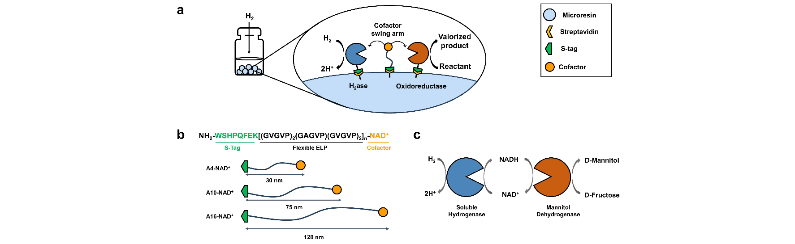▲ A reusable biocatalytic reactor that can utilize inexpensive hydrogen resources. Two enzymes and a cofactor swing arm immobilized on the same resin.

The research team developed a biocatalyst that maintains its function, unlike inorganic catalysts whose function is greatly reduced when exposed to various components contained in waste gas. They designed a biocatalyst that produces mannitol, a pharmaceutical, from waste gas and fructose by linking hydrogenase* and mannitol reductase* with a cofactor*.

* hydrogenase: an enzyme that catalyzes the oxidation-reduction of hydrogen

* mannitol reductase: an enzyme that catalyzes the oxidation-reduction reaction between fructose and mannitol

* cofactor: an organic or metal compound necessary for enzyme activity

The enzyme reactor designed in this way showed a mediation efficiency of more than 200%. To increase the mediation efficiency, the two enzymes and the cofactor linked to the elastin-like polypeptide were fixed in the same resin, and the length of the polypeptide linked to the cofactor and the concentration of the components in the resin were controlled.

The feasibility of using waste gas was verified through a simulated gas with a similar composition to actual waste gas, and when compared to the production volume when high-purity hydrogen was used as a resource, a similar production efficiency of over 80% was shown under simulated waste gas conditions.

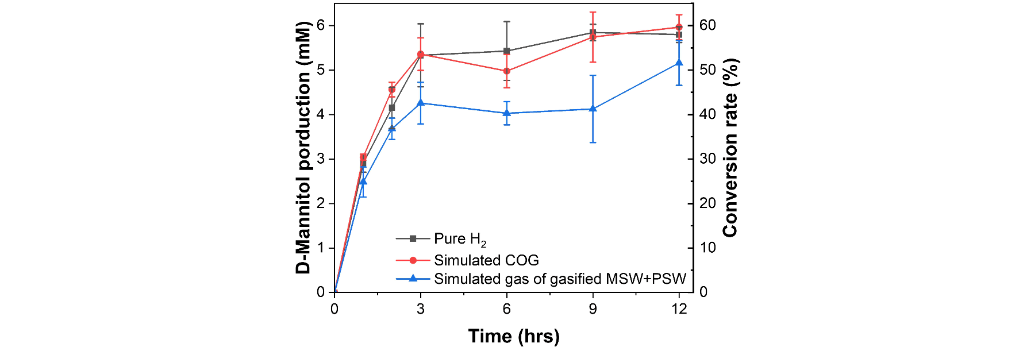▲ Mannitol production efficiency under waste gas simulation conditions. Comparison of mannitol production by the developed biocatalytic system under purified hydrogen conditions (black), waste gas simulation conditions (red), and gasified solid waste conditions (blue). Similar production was confirmed under the three conditions.

It is expected that the results of this study can be utilized in a more environmentally friendly and sustainable material conversion system by overcoming the decrease in catalyst efficiency in the process of producing hydrogen.

Since the enzyme reaction system is fixed on the solid phase and the product exists in the aqueous phase, the two phases can be easily separated using a simple filter. An experiment was conducted to repeat the separation of the enzyme reaction system and the product, and it was confirmed that the production efficiency was maintained at least 6 times. This proved that the system is reusable.

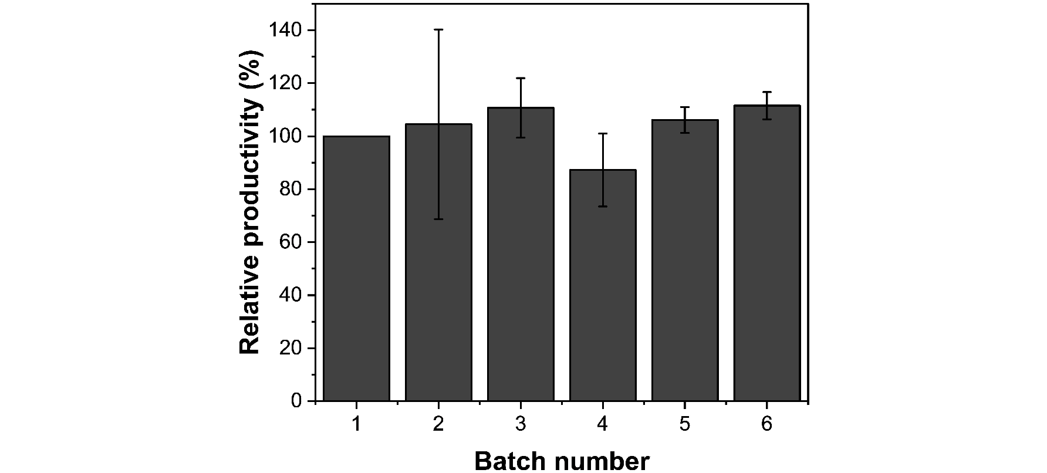▲ Maintaining reusable production of the developed system. Confirming that production was maintained during 6 repeated uses of the reactor.

Professor Inchan Kwon said, "The results of this study demonstrate the potential of utilizing enzyme reactors for sustainable industrial processes by utilizing hydrogen resources contained in waste gas. It is expected that this will contribute to the development of industrial structures in a more environmentally friendly and sustainable manner by producing value-added materials at low cost using hydrogen from waste gas without a separate purification process."

This research, supervised by Professor Inchan Kwon of the School of Materials Science and Engineering at GIST and conducted by integrated course student Hyeonseon Bak, was supported by the Leading Research Center Project of the National Research Foundation of Korea, and was published online on August 3, 2024 in the 《Chemical Engineering Journal》, an international academic journal ranked in the top 5% in the field of chemical engineering.



