GIST develops new neuropathic pain treatment... Increases pain relief effect and reduces side effects

- Professor Yong-Chul Kim's research team in the School of Life Sciences develops an antagonist that inhibits the pain-inducing receptor 'P2X3R'... Shows up to 65% pain relief effect while reducing side effects such as loss of taste
- "By first confirming a binding mode between P2X3R and drugs that is different from what has been discovered so far, we expect to make a great contribution to future related research", published in the international academic journal 《Journal of Medicinal Chemistry》

▲ (From left) Professor Yong-Chul Kim and Professor Mi Sun Jin of the School of Life Sciences at GIST, Professor Myung-Ha Yoon of the Department of Medicine at Chonnam National University, doctoral student Ga-Ram Kim of the School of Life Sciences at GIST, and Dr. Subin Kim

‘Neuropathic pain’ is caused by nervous system abnormalities and leads to a decrease in quality of life such as depression, sleep disorders, and anxiety accompanied by chronic pain.

To alleviate symptoms, drugs such as anticonvulsants such as gabapentin* that reduce the secretion of pain-related neurotransmitters are being used, but the pain-reducing effect is low and can cause dizziness and gastrointestinal disorders, so the development of next-generation new drugs is necessary.

* gabapentin: A drug that binds to voltage-dependent calcium channels (VSCCs) in the synaptic membrane, inhibits calcium influx into nerve terminals, and reduces the secretion of pain-related neurotransmitters such as norepinephrine.

The Gwangju Institute of Science and Technology (GIST, President Kichul Lim) announced that the research team of Professor Yong-Chul Kim of the School of Life Sciences has developed a ‘P2X3R* antagonist’ that could be the clue to a new treatment for neuropathic pain.

* P2X3R (P2X3 receptor): It is an ATP-activated ion channel receptor responsible for pain signal transmission in the nervous system.

Sensory nerves that transmit signals from peripheral tissues to the brain express the signal transmission receptor ‘P2X3R’, and if signal transmission through ‘P2X3R’ is excessively activated, it causes neuropathic pain.

With this in mind, the research team set a goal of developing a drug that can treat neuropathic pain by inhibiting the activity of P2X3R, and successfully developed an antagonist that lowers the activity of P2X3R through the design and synthesis of optimized compounds based on the triazolopyrimidine core skeleton*.

* triazolopyrimidine core skeleton: This is the structure that serves as the basis for synthesis, and derivatives with various residues introduced are synthesized using this.

This antagonist potently inhibited the activity of P2X3R even at very low concentrations of 55 nM (nanomolar) and showed high selectivity for P2X3R over other P2XR subtypes*, which could reduce side effects such as loss of taste.

* P2XR subtype: Refers to ATP-activated P2X ion channel receptors, and activity has been evaluated for P2X1, P2X2, P2X2/3, P2X3, P2X4, and P2X7 receptors.

The research team confirmed that when the drug was administered into the spinal cord of a neuropathic pain animal model (SNL-induced neuropathic pain rats), pain was relieved along with an increased pain threshold, and a pain relief effect of up to 65% was observed.

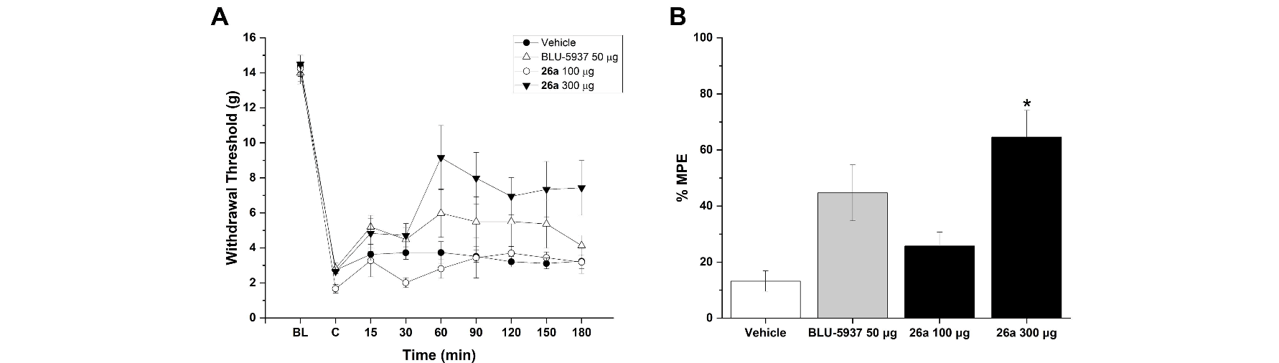▲ Pain relief effect of a new antagonist confirmed in a neuropathic pain model. Figure (A) measures the pain threshold value of each experimental group, and compared to the control group, it was confirmed that pain was relieved in the group administered BLU-5937, an antagonist drug currently under development, and 26a, a new antagonist. Figure (B) shows the results showing the maximum pain relief effect.

In particular, the research team confirmed the binding mode of the drug, which selectively binds to the allosteric site* of P2X3R and induces stabilization of the desensitized state* of the receptor, thereby inhibiting P2X3R activity, through cryo-EM.

* allosteric site: refers to a site other than the active site where ATP binds in P2X3R.

* desensitized state: A state in which an agonist (ATP in the case of P2X3R) binds to the channel, but the channel does not open.

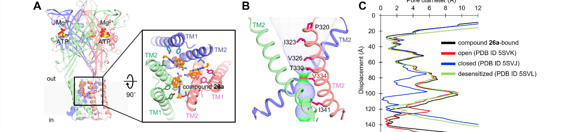▲ Results of cryo-EM analysis. Figure (A) shows the binding mode of the novel antagonist 26a, confirming that the three molecules of the novel antagonist symmetrically bind to the allosteric site of the homotrimeric P2X3R. Figure (B) shows the ion conduction pathway (red <1.3 Å, green 1.3-2.0 Å, and blue >2.0 Å) and figure (C) compares the pore radius with different P2X3 receptor states, confirming that the novel antagonists adopt a conformation similar to the previously reported desensitized state, limiting or completely blocking ion conductance.

School of Life Sciences Professor Yong-Chul Kim said, "Through this study, we succeeded in developing an antagonist that effectively reduces the activity of P2X3R as a leading compound for the development of new drugs to complement the currently used neuropathic pain treatment agents. The research team is expected to greatly contribute to future P2X3R-related research by confirming for the first time through cryo-electron microscopy that it exhibits efficacy at a different binding site from existing P2X3R inhibitors."

This study was conducted jointly by GIST doctoral student Ga-Ram Kim and Dr. Subin Kim under the guidance of Professors Yong-Chul Kim and Mi Sun Jin of the School of Life Sciences at GIST and Professor Myung-Ha Yoon of the Department of Medicine at Chonnam National University. It was supported by the National Research Foundation of Korea project funded by the Ministry of Science and ICT and the Korea Research Institute of Chemical Technology project. The research results were published online in the Journal of Medicinal Chemistry, an authoritative international academic journal in the field of medicinal chemistry, on August 5, 2024.



