“Overheating and Malfunction-Free Thermal Management System Developed”
Korea-US joint research team develops technology to accurately predict cooling system performance deterioration

- GIST-Sungkyunkwan University-Purdue University joint research team, developed an innovative machine learning application technology that solved a chronic problem in the field of heat transfer technology... Accurate prediction of the time of the first dry-out occurrence possible
- Expected to be applied to designing cooling systems that can operate efficiently in extreme environments such as space exploration... Published in the international academic journal 《International Journal of Heat and Mass Transfer》

▲ (From left) Professor Seunghyun Lee of the School of Mechanical Engineering, master's student Hyeonseok Noh, Professor Sung-Min Kim of Sungkyunkwan University, and Professor Issam Mudawar of Purdue Univ.

As explosions and thermal runaway caused by battery overheating are pointed out as the main causes of electric vehicle fires, which have recently become a social problem, the importance of thermal management for accident prevention is increasing. Amid this, an artificial intelligence technique applicable to battery thermal management systems has been developed by a joint research team between Korea and the United States.

The Gwangju Institute of Science and Technology (GIST, President Kichul Lim) announced that a joint research team led by Professor Seunghyun Lee of the School of Mechanical Engineering, Professor Sung-Min Kim of Sungkyunkwan University, and Professor Issam Mudawar of Purdue University in the U.S. successfully developed an innovative machine learning application technology that solved a chronic problem in the field of heat transfer technology.

This research achievement enables the accurate prediction of the timing of the first dry-out* occurrence, enabling the design of more reliable thermal management systems that can operate without overheating or failure even at high heat flux*.

It is also expected to be of great help in the design of cooling systems that can operate efficiently in extreme environments such as space exploration.

* heat flux: The amount of heat that flows per unit time and per unit area, and refers to the amount of heat transfer between the wall of an object and the fluid flowing in contact with it.

* dry-out: When the heat flux increases, the liquid supply for heat transfer is not continuous, the liquid film is broken, and the heat transfer surface is dried by steam. This is called dry-out. If the heat flux is increased to a critical value in this state, the heat transfer efficiency of the system will drop sharply and rapid heat destruction will occur on the heat transfer surface.

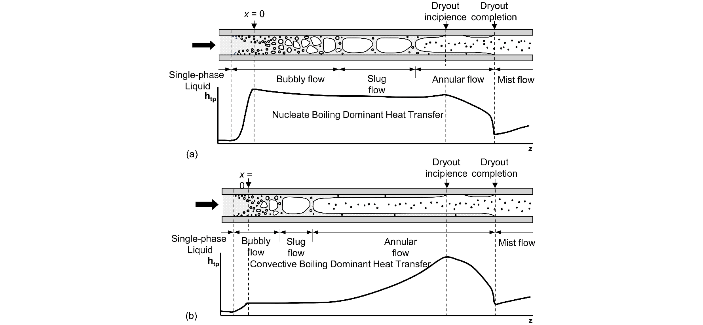▲ Dry-out formation process within the channel. It shows the change in heat transfer coefficient according to the dry-out formation process and the change in fluid behavior depending on the heat transfer characteristics ((a) nucleate boiling* dominated heat transfer, (b) convective boiling dominated heat transfer).

* nucleate boiling: A type of boiling that generates bubbles with the foaming point as the nucleus.

The development of high heat flux* heating devices such as electronic devices and aerospace components has made effective thermal management an essential element. Dryout in cooling systems can drastically reduce heat transfer efficiency, and this phenomenon is particularly noticeable in mini/micro channels*, where the boiling and evaporation processes are further complicated by the small cross-sectional area and limited geometry of the channels.

Conventional first dry-out occurrence prediction methods mainly rely on empirical correlation and analytical models, and have limitations in interpreting complex phenomena according to various fluid and channel geometries. [Figure 1]

For a long time, many researchers have tried to develop empirical correlation models based on actual experiments to predict the dry-out phenomenon caused by heat generation in electronic equipment, but they have encountered various analytical limitations.

* high heat flux: Heat flux is the amount of heat flowing per unit time and per unit area, and refers to the amount of heat transfer between the wall of an object and the fluid flowing in contact with it. The high heat flux range generally refers to a heat flux of 10² W/cm² or more.

* mini/micro channel: A cooling module with one or more channels with a diameter of millimeters or micrometers arranged on a wide plate through which a fluid can pass for surface cooling.

The research team used XGBoost, one of the high-performance machine learning* algorithms, to predict the quality* of early dry-out occurrence in saturated flow boiling* in mini/micro channels, achieving a prediction accuracy of 2.45%, which is higher than the existing empirical correlation and analytical models.

* saturated flow boiling: This refers to the behavior of the fluid that occurs based on the given heat flux on the channel wall and the channel inlet flow velocity conditions, when the working fluid is completely saturated.

* quality: In thermodynamics, quality refers to the mass fraction of vapor in a saturated mixture; saturated vapor has a quality of 100%, and saturated liquid has a quality of 0%.

* machine learning (ML): A subcategory of artificial intelligence, it refers to a computer process that uses neural networks to recognize patterns and improve the ability to identify such patterns.

The research team utilized machine learning to more accurately predict the timing of the first dry-out occurrence within the channel. In particular, by applying the XGBoost algorithm*, they successfully predicted the degree of first dry-out occurrence based on various experimental data.

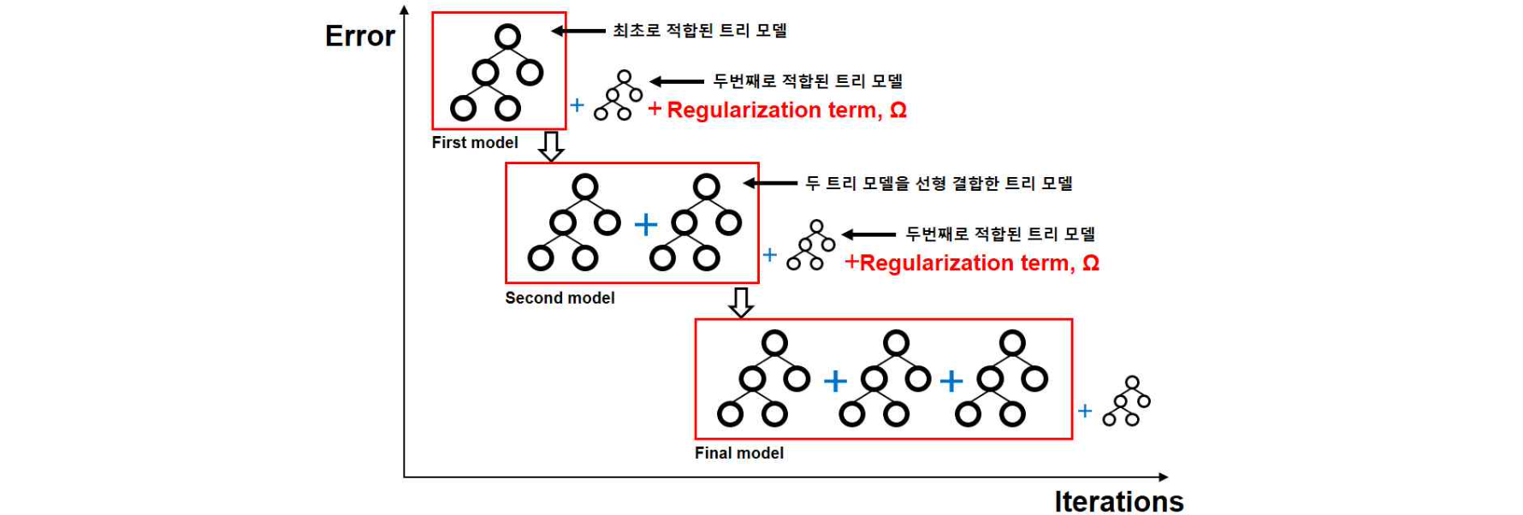▲ Schematic diagram of the XGBoost prediction model formation process. The lower axis represents the number of machine learning repetitions, and the left axis represents the error between the predicted value and the actual value by the XGBoost prediction model. As the number of learning repetitions increases, the vulnerabilities of the previous learning model are improved, which appears in the form of improving prediction accuracy.

The database utilized by the research team consists of 997 data points collected from 26 studies covering 13 working fluids and various channel sizes and flow conditions, providing a sufficient basis for training the machine learning model.

* XGBoost algorithm: A type of machine learning, supervised learning* algorithm with a technique added to prevent overfitting* to the existing Gradient Boosting algorithm.

The research team additionally used Optuna*, a hyperparameter* optimization software, to maximize the prediction accuracy of the XGBoost model. As a result, they achieved a very high accuracy of only 2.45% mean absolute error (MAE) in predicting the first dry-out occurrence.

This is a significant improvement over the existing correlation prediction model (mean absolute error = 12.5%).

* hyperparameter: External configuration variables set to the model to implement the optimal training model, including learning rate, number of training repetitions, etc.

* optuna: An open source library that automatically tunes and optimizes hyperparameters of Python-based machine learning models.

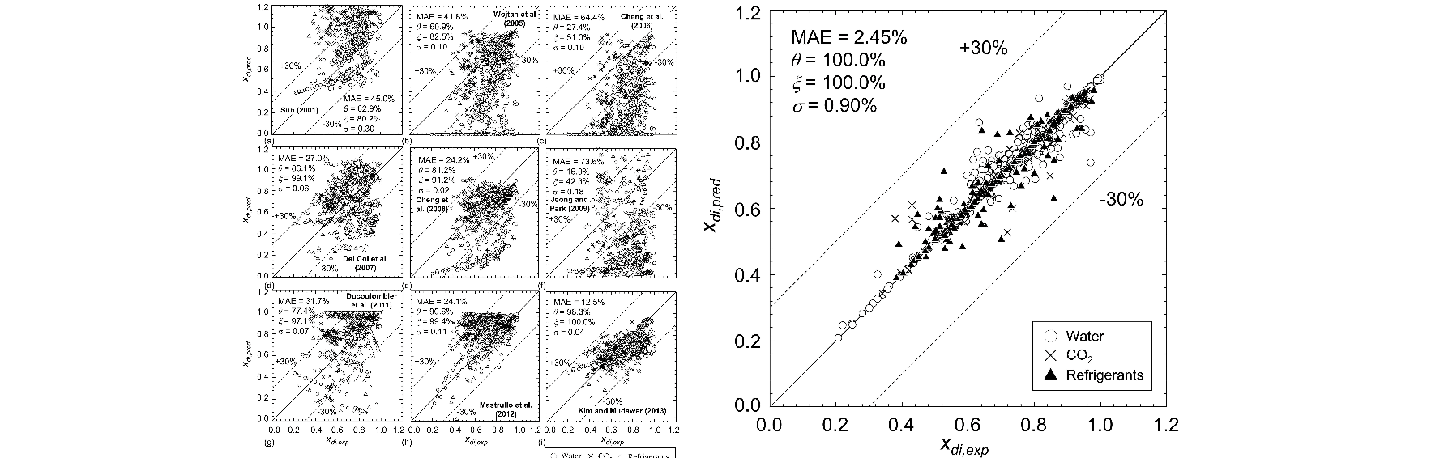▲ Performance evaluation of the XGBoost prediction model developed in this study (left) Results of previous studies (right) Results of this study. The lower axis represents experimental data, and the left axis represents the values ​​predicted by the XGBoost prediction model. Regardless of the working fluid, it shows excellent prediction performance with an absolute error of 2.45%, which is lower than the average absolute error of 12.5% of the previous best empirical correlation model, and all data are within the predicted 30% range.

Professor Seunghyun Lee said, "Through this study, we confirmed the successful application of machine learning to the field of abnormal flow* heat transfer and thermal management. In the future, we plan to expand the model to include various fluid and system operating conditions, and to expand the application range of machine learning by combining it with a real-time monitoring system in industrial fields of abnormal flow heat transfer and thermal management. We plan to use it to prevent and predict thermal runaway in electric vehicle batteries in the future."

* two-phase flow: refers to a flow in which two or more phases exist among solid, liquid, and gas.

This study was a joint research result of GIST, Sungkyunkwan University, and Purdue University in the United States, supervised by Professor Seunghyun Lee of the Department of Mechanical Engineering at GIST and conducted by master's student Hyeonseok Noh, and was supported by the National Research Foundation of Korea (NRF) project supported by the Ministry of Science and ICT.

The research results were published online on June 15, 2024 in the International Journal of Heat and Mass Transfer, a renowned international academic journal in the field of heat transfer and thermal management.

