Large-area organic solar cells open up commercialization possibilities with eco-friendliness and high efficiency

- GIST·UNIST, Developing new photoactive layer material, 200cm² large-area organic solar cell efficiency surpasses 11.44%
- Commercialization promoted by process utilizing low-toxicity non-halogen solvent and slot-die coating published in international journal 『Adv. Funct. Mater.』

▲ (From left) GIST Senior Researcher Hongkyu Kang, Professor Kwanghee Lee, and Research Fellow Yang-Soo Lee (first author)

A Korean research team achieved a photoelectric conversion efficiency (PCE)* of 11.44% in a 200 cm² large-area organic solar cell manufactured using a low-toxicity, non-halogen solvent*.

* non-halogenated solvent: A solvent that does not contain halogen elements (chlorine, bromine, fluorine, etc.). Compared to halogenated solvents, it is environmentally friendly with less toxicity and environmental impact, and has high stability. Representative non-halogenated solvents include toluene and xylene.

* power conversion efficiency (PCE): This indicates the rate at which solar energy is converted into electrical energy and is an important indicator for evaluating the performance of solar cells.

The Gwangju Institute of Science and Technology (GIST, President Kichul Lim) announced that a joint research team including Senior Researcher Hongkyu Kang of the Research Institute for Solar and Sustainable Energies, Professor Kwanghee Lee of the School of Materials Science and Engineering, and Professor BongSoo Kim of Ulsan National Institute of Science and Technology (UNIST) succeeded in dramatically improving the uniformity of photoactive layer films and implementing high-efficiency, large-area organic solar cells by asymmetrically expanding the alkyl chain* of a bifullerene acceptor*.

It is expected that this research result will be an important turning point that will bring us one step closer to commercializing organic solar cells.

* non-fullerene acceptor: An important component that accepts electrons in the photoactive layer of an organic solar cell. Compared to fullerene-based acceptors, it has greater structural diversity and is easy to control the light absorption range and electrical properties.

* alkyl chain: An alkyl group is a hydrocarbon molecule with one hydrogen atom removed, and is composed of carbon and hydrogen. The structure formed when these alkyl groups are bonded together is an alkyl chain.

Organic solar cells have the potential to be easily integrated into a wide range of applications, from smart windows in buildings to wearable technology, and interest in large-area organic solar cells for commercialization is growing.

Existing large-area organic solar cells have had difficulties in commercialization because they use highly toxic halogen solvents, which are harmful to the environment and the human body. In addition, non-halogen solvents with low toxicity have a problem in that the uniformity of the film decreases due to the ‘agglomeration phenomenon’ of the non-fullerene acceptor, which reduces the efficiency as the area of ​​the active layer of the organic solar cell increases.

Therefore, there is an urgent need to develop a new material that can form a uniform large-area photoactive layer film that reduces the aggregation of non-fullerene acceptors when using non-halogen solvents.

The research team used a method to asymmetrically extend the alkyl chain of a non-fullerene acceptor. As the solubility of the non-fullerene acceptor improved in a non-halogen solvent, the agglomeration phenomenon was effectively reduced, enabling the formation of a uniform photoactive layer film even over a large area of ​​200 cm².

* halogenated solvent: A solvent containing halogen elements such as chlorine, bromine, and fluorine. It has high solubility in organic compounds and is widely used (ex: chloroform, methylene dichloride, chlorobenzene, etc.). It is toxic and poses a high risk to the human body and the environment, so care must be taken when using and handling it.

* aggregation: A phenomenon in which molecules gather to form lumps. Excessive aggregation of the photoactive layer in organic solar cells reduces the uniformity of the film and reduces the efficiency of the solar cell by interfering with the charge transfer path due to phase separation.

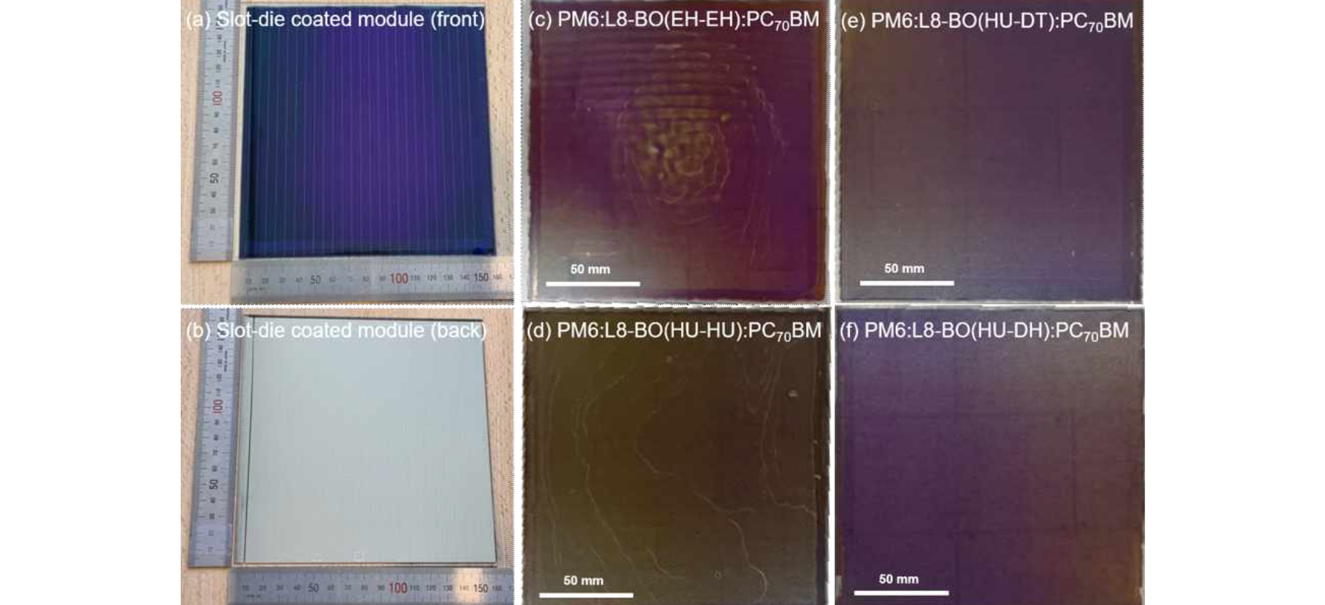▲ Photographs of a large-area organic solar cell with a photoactive layer area of ​​200 cm² (a) front, (b) back, (165 mm × 160 mm), (c-f) photographs of a photoactive layer film fabricated by the slot-die coating technique. It can be confirmed that a uniform large-area photoactive layer film was fabricated without agglomeration in the photoactive layer film using the novel non-fullerene acceptors L8-BO (HU-DT) and L8-BO (HU-DH).

This study demonstrates that asymmetrically extending the alkyl chain of a non-fullerene acceptor is an effective strategy for improving the efficiency of large-area organic solar cells fabricated with non-halogen solvents, and this approach reduces the agglomeration of the non-fullerene acceptor within the photoactive layer and significantly improves the uniformity of the film, thereby enhancing the efficiency of large-area organic solar cells.

The research team investigated the effect of asymmetric extension of the alkyl chain on the aggregation of non-fullerene acceptors in o-xylene, a halogen-free solvent. In this study, the alkyl chain of L8-BO(EH-EH) was extended and replaced with 2-heptylundecyl (HU), 2-decyltetradecyl (DT), and 2-dodecylhexadecyl (DH) groups, developing three new non-fullerene acceptors, L8-BO(HU-HU), L8-BO(HU-DT), and L8-BO(HU-DH), respectively.

The novel non-fullerene acceptors with extended alkyl chains showed significantly improved solubility in o-xylene compared to the conventional L8-BO(EH-EH) and suppressed agglomeration, contributing to the formation of more uniform photoactive layer films. In particular, the least agglomeration was observed in the blended film containing L8-BO(HU-DT) among the non-fullerene acceptors with asymmetrically extended alkyl chains.

As a result, the PM6:L8-BO(HU-DT):PC70BM-based organic solar cell using L8-BO(HU-DT) achieved a high efficiency of 11.44% in a large-area organic solar cell with a photoactive layer area of ​​200 cm². This is a very high efficiency among large-area organic solar cells fabricated with a non-halogen solvent, and exhibits a much better performance than the PM6:L8-BO(EH-EH):PC70BM-based organic solar cell with the same area (6.50%).

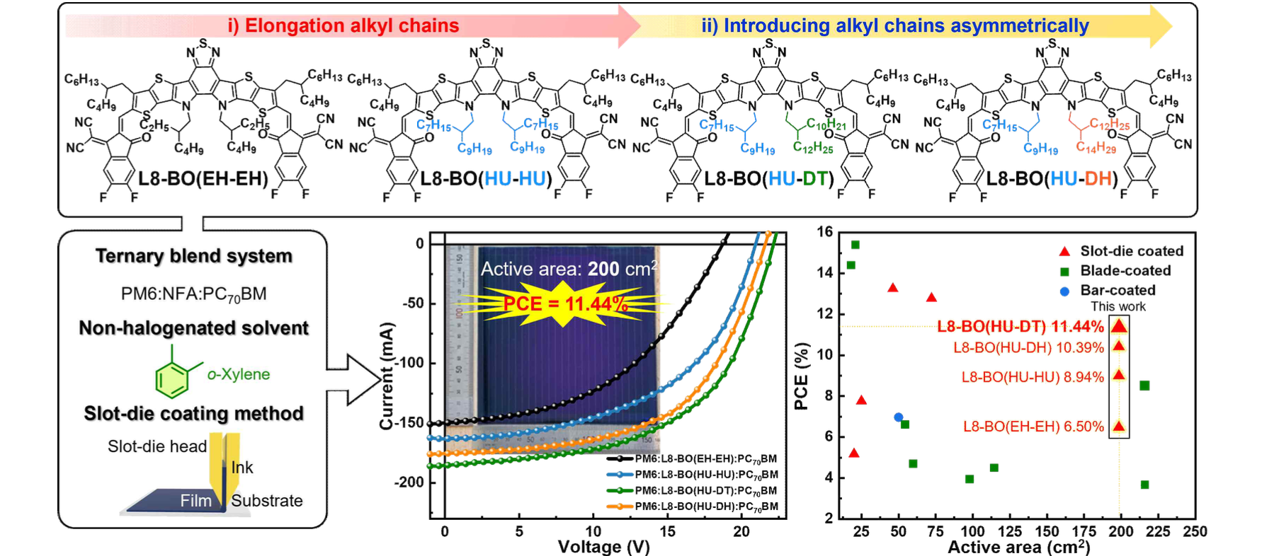▲ Comparison of chemical structures and large-area organic solar cell efficiency of materials used in this study: Novel non-fullerene acceptors L8-BO(HU-HU), L8-BO(HU-DT), and L8-BO(HU-DH) were synthesized by asymmetrically extending the alkyl chain of the existing L8-BO(EH-EH). PM6: Non-fullerene acceptor: PC70BM The photoactive layer was fabricated by the slot-die coating method using o-xylene, a non-halogen solvent. As a result, a high photoelectric conversion efficiency of up to 11.44% was recorded in a large-area organic solar cell with a photoactive layer area of ​​200 cm².

Dr. Hongkyu Kang said, "This research result is expected to contribute greatly to the commercialization of next-generation organic solar cells by using non-halogen solvents with low toxicity. The slot-die coating method is suitable for the roll-to-roll process, greatly increasing the possibility of mass production and commercialization of large-area organic solar cells."

This study, supervised by GIST Research Institute for Solar and Sustainable Energies Senior Researcher Hongkyu Kang and conducted by Research Institute for Solar and Sustainable Energies Researcher Yang-Soo Lee, was supported by the Climate Change Response Technology Development Project supported by the Ministry of Science and ICT and the National Research Foundation of Korea, and the GIST Research Institute for Solar and Sustainable Energies Institutional Project, and was published online in the world-renowned materials journal ‘Advanced Functional Materials’ on July 18, 2024.



