“Commercialization of the dream battery with low fire and explosion risk and high energy density is brought forward” GIST-LG Energy Solution-KETI develops new technology for all-solid-state batteries with high ion conductivity and stable response to lithium metal

- A joint research team led by Professor Sangryun Kim of the GIST Graduate School of Energy Convergence developed a high-performance NCM/Li all-solid-state battery with a reversible capacity approaching 100% Coulomb efficiency even after 200 charge/discharge cycles through an independent design of a hydride-sulfide solid electrolyte
- Expected to be applied to the development of next-generation battery technologies such as not only hydride-based all-solid-state batteries but also lithium-ion, sodium-ion, and potassium-ion batteries... Published in the international academic journal 《ACS Energy Letters》

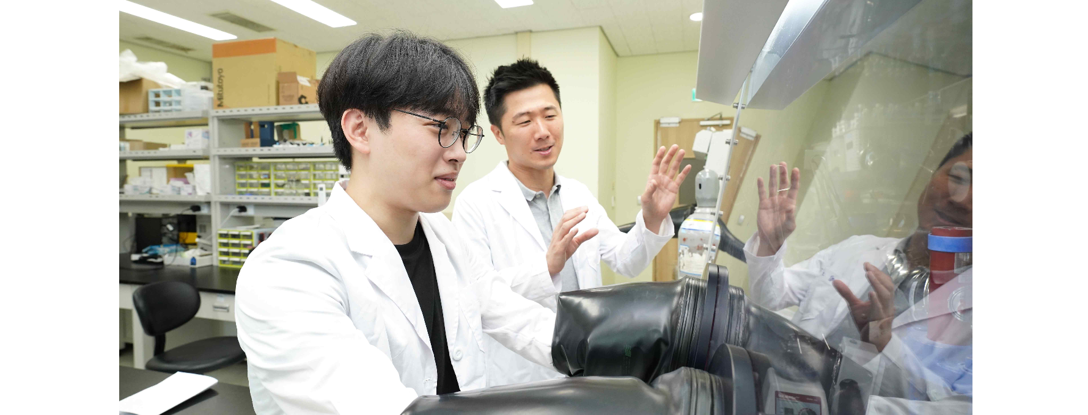▲ (From left) Master’s student Taegyoung Lee and Professor Sangryun Kim

Recently, research on secondary batteries with high stability and energy density is being actively conducted to develop batteries optimized for electric vehicles, and among them, interest in the ‘all-solid-state battery,’ a type of next-generation battery called the ‘dream battery,’ is growing.

All-solid-state batteries are expected to significantly reduce the risk of fire and explosion and increase energy density by replacing the liquid electrolyte between the positive and negative electrodes with a solid, and battery-related companies are actively developing technology to advance commercialization.

The Gwangju Institute of Science and Technology (GIST, President Kichul Lim) announced that the research team of Professor Sangryun Kim of the GIST Graduate School of Energy Convergence, together with the LG Energy Solution research team and the Korea Electronics Technology Institute (KETI) Next-Generation Battery Research Center, developed a hydrogenation-sulfide solid electrolyte that has high conductivity* and shows a stable reaction to lithium metal.

With this research achievement, it is expected that it will be possible to overcome the limitations (unstable reaction to NCM* and lithium metal) of the existing sulfide-based solid electrolyte with the structure of argyrodite (a rare mineral composed of silver, germanium, and sulfur)* and provide a solid electrolyte for NCM/Li all-solid-state batteries that operates with excellent stability even at high voltage and high current.

* ionic conductivity: The degree to which ions can move within a material

* argyrodite structure: A solid electrolyte that has the same structure as the mineral Ag₈GeS₆ and exhibits lithium ion conductivity

* NCM: Nickel (Ni), cobalt (Co), and manganese (Mn) are used as cathode materials

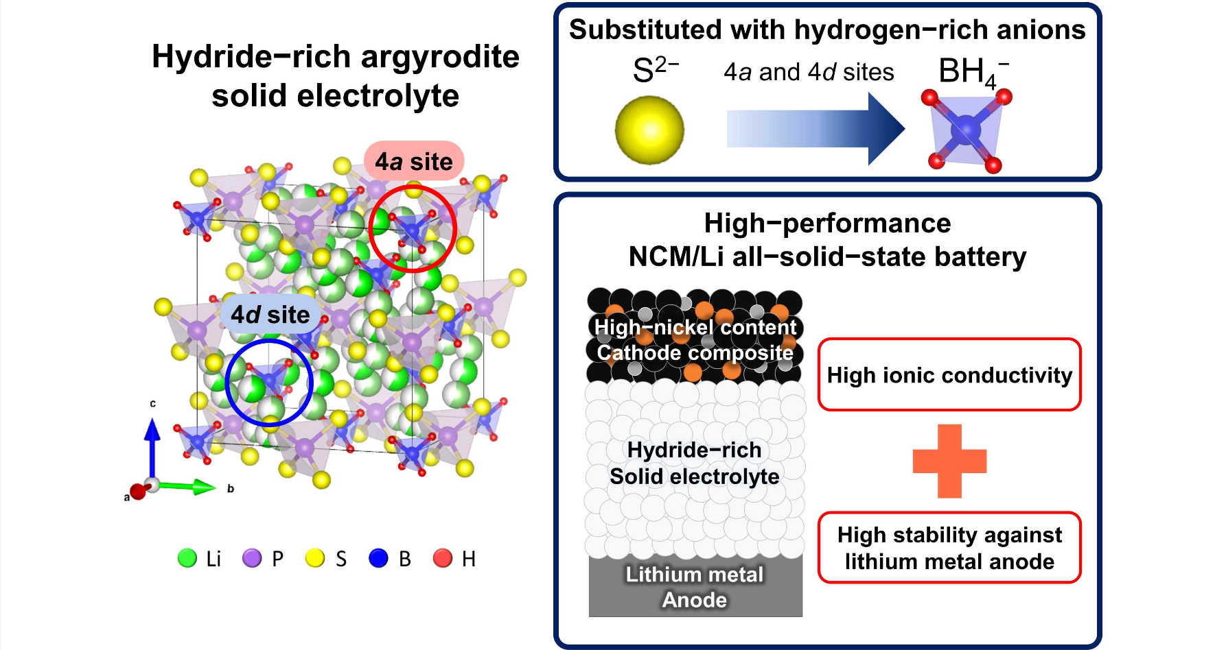
▲ Figure summarizing the research results: Explains the advantages achieved by coexisting hydrides and sulfur in the argyrodite structure.

All-solid-state batteries using NCM cathode materials and lithium metal anode materials have high energy and power density, so they can be used in next-generation electric vehicles, ships, etc.

However, there are disadvantages such as difficulty in driving at high current densities and frequent occurrence of irreversible capacity* due to the unstable reaction of the solid electrolyte to NCM and lithium metal.

* irreversible capacity: This refers to the capacity that cannot return to its previous state due to a change in the properties of the material. Battery design is possible only when the difference between the irreversible capacities of the positive and negative electrodes is understood.

The research team was able to design a high-performance all-solid-state battery as well as a solid electrolyte with improved ionic conductivity and reducibility through a unique material design that allows hydride anions and sulfur anions to coexist in the crystal structure of an argyrodite sulfide-based solid electrolyte.

Through the designed hydrogen-sulfide solid electrolyte Li₅PS₄(BH₄)₂, a stable reaction was induced toward lithium metal even at high currents, and low interfacial resistance between the solid electrolyte and lithium metal was confirmed.

* crystal structure: A structure in which atoms, ions, or molecules are arranged in a regular and repeating manner within a solid substance.

* reduction: In chemistry, the ability of a substance to gain electrons and reduce another substance.

The research team succeeded in creating a high-performance NCM/Li solid-state battery with a reversible discharge capacity with a Coulombic efficiency* approaching 100% even after 200 charge-discharge cycles at high current density by applying a hydrogenated-sulfide solid electrolyte to the NCM/Li solid-state battery.

* Coulomb efficiency: This is a value that represents the efficiency of converting electrical energy into chemical energy in an electrochemical device. It refers to the energy conversion efficiency when charging and discharging electricity in an electrochemical device (e.g., a battery). A battery is said to have a better Coulomb efficiency when it returns the same amount of energy it stored when storing and discharging it.

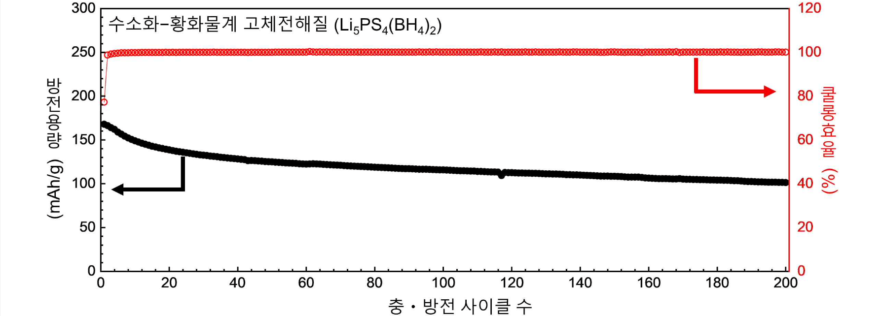▲ Electrochemical performance of hydrogenation-sulfide solid-state battery: Using Li₅PS₄(BH₄)₂, a hydrogenation-sulfide solid electrolyte, an NCM/Li solid-state battery demonstrates 200 discharge capacity and coulombic efficiency at high current density. It achieves a coulombic efficiency close to 100% and demonstrates reversible discharge capacity with excellent lithium metal stability.

Professor Sangryun Kim said, "The results of this study suggest the importance of highly reductive hydrides and help to advance the understanding of solid electrolyte design for NCM/Li all-solid-state batteries. It is expected that this will be applied to the development of next-generation battery technologies such as lithium-ion batteries, sodium-ion batteries, and potassium-ion batteries as well as all-solid-state batteries utilizing hydrides in the future."

This study, supervised by Professor Sangryun Kim and conducted by master's student Taegyoung Lee of the GIST Graduate School of Energy Convergence, was supported by the Industry-Academia Joint Research Project sponsored by LG Energy Solution, the Individual Basic Research of the National Research Foundation of Korea, and the Civil-Military Cooperation Promotion Agency's Civilian-Military Dual-Use Technology Development Project, and was published online in the renowned international academic journal in the field of materials science, 'ACS Energy Letters', on August 21, 2024 (based on US local time).



