Korea-UK-Sweden-France International Joint Research Team Releases World's First Human Disease Microbiome Map

- GIST - King's College London - Royal Institute of Technology, Sweden - INRAE, France joint research team, analyzes big data from 19 countries to identify gut microbiome characteristics related to 23 diseases including diabetes, inflammatory bowel disease, and depression
- "It will serve as a foundation for accelerating the development of biomarkers and data-based personalized treatment for non-invasive disease treatment based on the microbiome"... Published in international academic journal 《Genome Research》

▲ (From left) Professor Sunjae Lee of GIST, Professor Saeed Shoaie of King's College London, Professor Mathias Uhlen of KTH Royal Institute of Technology, and Professor S Dusko Ehrlich of the INRAE Research Institute in France

The microbiome*, or intestinal microorganisms, are known to play an important role in regulating our body’s immune system. Interest in the microbiome is increasing significantly as research results are published showing that it can help treat not only colon diseases but also obesity, metabolic diseases, cardiovascular diseases, and cancer.

* microbiome: A combination of the words microbe and biome, it refers to the entire genome of the microbial population living in a specific environment. Microbiome analysis is performed to find out the relationship between diseases/traits and microorganisms through the composition of the intestinal microbial flora.

The Gwangju Institute of Science and Technology (GIST, President Kichul Lim) announced that the research team led by Professor Sunjae Lee of the School of Life Sciences, together with a joint research team from King's College London in the U.K., KTH Royal Institute of Technology in Sweden, and the French National Institute of Agriculture, Food and the Environment (INRAE), have released the world's first human disease microbiome map (Human Gut Microbiome Atlas).

The results of this study are expected to help understand how gut microbes affect disease.

The human gut microbiome is the diverse collection of bacteria, viruses, fungi, and other microorganisms that live in the human gut and help the body perform key functions, such as digestion. Recent studies have shown a strong link between changes in the composition of the gut microbiome and the development of diseases such as depression, Alzheimer's, and type 2 diabetes.

The link between the gut microbiome and disease has become a growing topic of interest to researchers, but establishing a healthy gut microbiome has been challenging, and few studies have been conducted across different regions and diseases.

The joint research team analyzed previously published big data on the gut microbiome from 19 countries around the world and identified the characteristics of the gut microbiome associated with 23 diseases, including diabetes, inflammatory bowel disease, and depression.

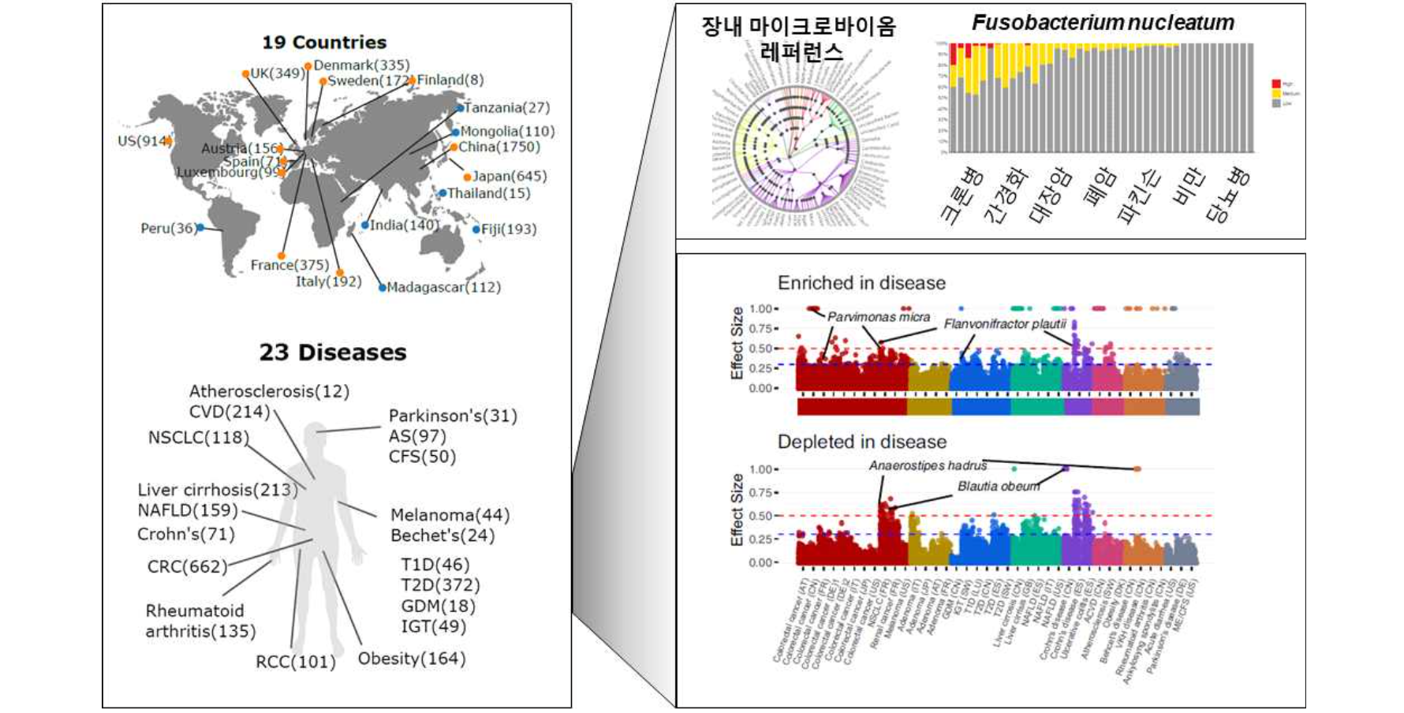▲ Human Gut Microbiome Atlas. It provides information on gut microbiome strains associated with diseases by compiling big data on human gut microbiomes for 23 diseases in 19 countries around the world (Source: https://www.microbiomeatlas.org/).

The research team conducted an in-depth analysis of 6,014 human gut shotgun metagenomic data sets (microbiome data sets) from across North America, Europe, and South and East Asia. Using meta-analysis and machine learning models, they classified which bacteria were most prevalent in healthy individuals and those with specific diseases, and linked specific functions to specific bacteria.

Of particular note is the discovery that the harmful strains of Fusobacterium, Clostridium, and Streptococcus increased in the intestinal microbiome of patients with the disease, while the short-chain fatty acid*-producing strains of Lachnospiraceae, which are beneficial intestinal bacteria, decreased.

* shotgun metagenome: A method to sequence all microbial genome information (the process of determining the base sequence of DNA or RNA) within a specific sample, enabling more accurate microbial community analysis and analysis using actual genetic data to determine the functional role of microorganisms.

* short-chain fatty acids: Fatty acids produced by metabolizing plant fiber consumed by beneficial bacteria.

The research team also confirmed that the microbiome characteristics of the disease, such as the increase in Clostridium strains, are also associated with normal people in Westernized countries. In particular, in the case of the Westernized microbiome, as bacteria that promote intestinal inflammation and antibiotic-resistant strains continue to increase, it is expected that eating habits that can restore intestinal health along with a Westernized diet will become important in the future.

The result of this study, the ‘Human Gut Microbiome Atlas’, was made public through an open access platform (https://www.microbiomeatlas.org/).

Professor Sunjae Lee said, "The results of this study have allowed us to more clearly reveal the true nature of the human disease microbiome, which has not been properly elucidated due to the limitations of small-scale studies conducted so far. In the future, the development of biomarkers* for noninvasive disease treatment based on the microbiome, which can diagnose colon cancer or pancreatic cancer early and predict prognosis through stool tests alone, will accelerate."

Professor Lee also said, "In addition, it is expected that the development of data-based personalized treatment methods will be accelerated through the development of precision nutrition models or personalized probiotics."

* biomarker: An indicator that can detect changes in the body using cells, blood vessels, proteins, DNA, etc.

This study, led by Professor Sunjae Lee of the School of Life Sciences at GIST and conducted in collaboration with a joint research team from King's College London in the UK, KTH Royal Institute of Technology in Sweden, and the French National Institute of Agriculture, Food and the Environment (INRAE), was supported by the Basic Research Program (Excellent New Researcher) and the Biomedical Technology Development Program of the National Research Foundation of Korea, the GIST-MIT AI-X Project, and the Research-Oriented Hospital Project of the Ministry of Health and Welfare, and was published in the international academic journal in the field of genome engineering, Genome Research, on July 23, 2024.



