“Discovering new anticancer targets using gene scissors” GIST-Seoul National University discovers new anticancer target TPST2 by using CRISPR gene scissors-based genome screening

- GIST Biotechnology Professor Hansoo Park (CEO of Genome & Company) and Seoul National University College of Medicine Professor Sung-Yup Cho joint research team, CRISPR gene scissors-based genome screening platform and tumor mouse model-based new biomarker candidate 'TPST2' that can predict the efficacy of new anticancer drugs is identified as a new therapeutic target as a cancer immunosuppressor
- Confirmation of improved response to existing immunotherapy drugs through TPST2 inhibition in tumor mouse model... "TPST2 inhibition activates IFNγ signaling regulation and induces activation of immune cells in tumors"
- Published in the most authoritative journal in the field of cancer biology, 《Molecular Cancer (IF=27.7, JCR top 3.11%)》

▲ (From left on the top row) Professor Hansoo Park of the Department of Biomedical Science and Engineering, Professor Sung-Yup Cho of Seoul National University College of Medicine, and researcher Yumi Oh of Seoul National University (From left on the bottom row) GIST student Sujeong Kim, GIST student Yunjae Kim, and GIST student Hyun Kim

CRISPR-Cas9, a third-generation gene scissors technology that can precisely cut and modify specific genes, has been rapidly developing since it was first introduced in 2012 and is being used as an innovative tool in the field of gene editing, such as cancer research and treatment.

The Gwangju Institute of Science and Technology (GIST, President Kichul Lim) announced that a joint research team including Professor Hansoo Park of the Department of Biomedical Science and Engineering (CEO of Genome & Company) and Professor Sung-Yup Cho of Seoul National University College of Medicine have discovered a new anticancer target, TPST2, using a genome screening platform based on the CRISPR gene scissors and a tumor mouse model, elucidated the anticancer immune regulation mechanism, and confirmed that the therapeutic efficacy of immunotherapy can be increased through TPST2 inhibition.

Immune checkpoint therapy (ICT) has brought about a major change in the cancer treatment market, but most patients develop resistance due to intrinsic and extrinsic factors of tumor cells.

To overcome ICT resistance, the GIST-Seoul National University joint research team discovered a new target, TPST2, that can increase the responsiveness to immunotherapy using a genome screening platform based on CRISPR gene scissors.

The research team injected the CRIPSR library targeting 19,050 genes into a human breast cancer cell line (MDA-MB-231) so that the genes were randomly deleted. Afterwards, they examined the changes in tumor growth in vivo by concurrently treating anti-PD-1 in humanized mice carrying the human gene, and confirmed that the frequency of sgRNA targeting TPST2 decreased in anti-PD-1 treated tumors compared to control tumors. This suggests that inactivation of TPST2 makes cells more sensitive to anti-PD-1 treatment.

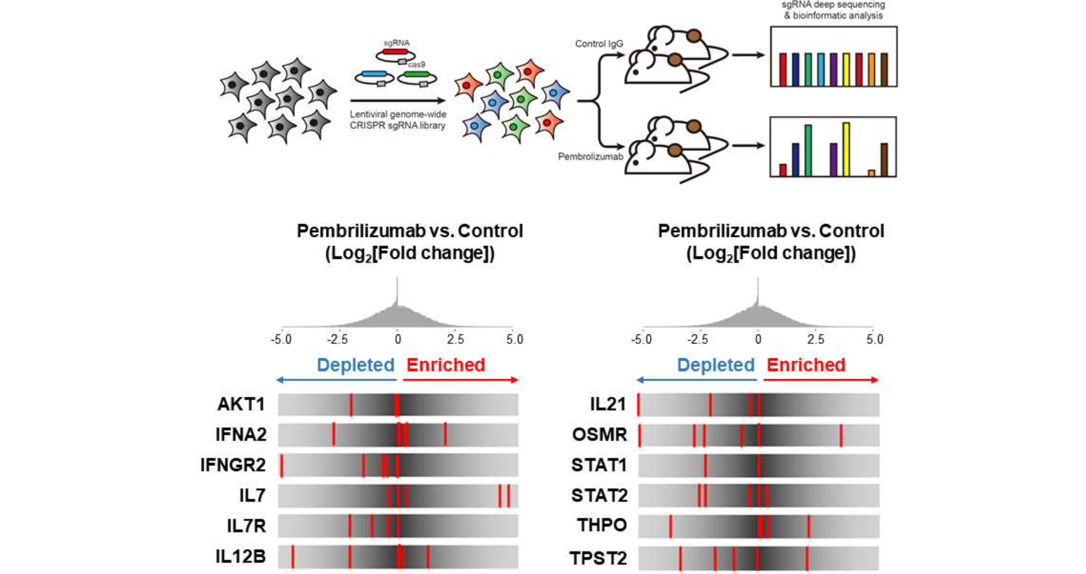▲ Discovery of TPST2, a novel anticancer target, through genome screening using CRISPR gene scissors: Anti-PD-1 treatment was performed by transplanting cancer cell lines injected with the CRISPR library into humanized mice, and the frequency of sgRNA targeting TPST2 decreased in anti-PD-1 treated tumors compared to control tumors.

The research team used transcriptome analysis, immunoprecipitation, and mass spectrometry to elucidate the mechanism by which TPST2 regulates immunity by sulfation* of IFNGR1. They deduced that inhibition of TPST2 can activate IFNγ signaling and enhance the efficacy of anti-PD-1 therapy. [Figure 2]

* sulfation: The process by which a sulfate group is added to a specific amino acid residue by an enzyme.

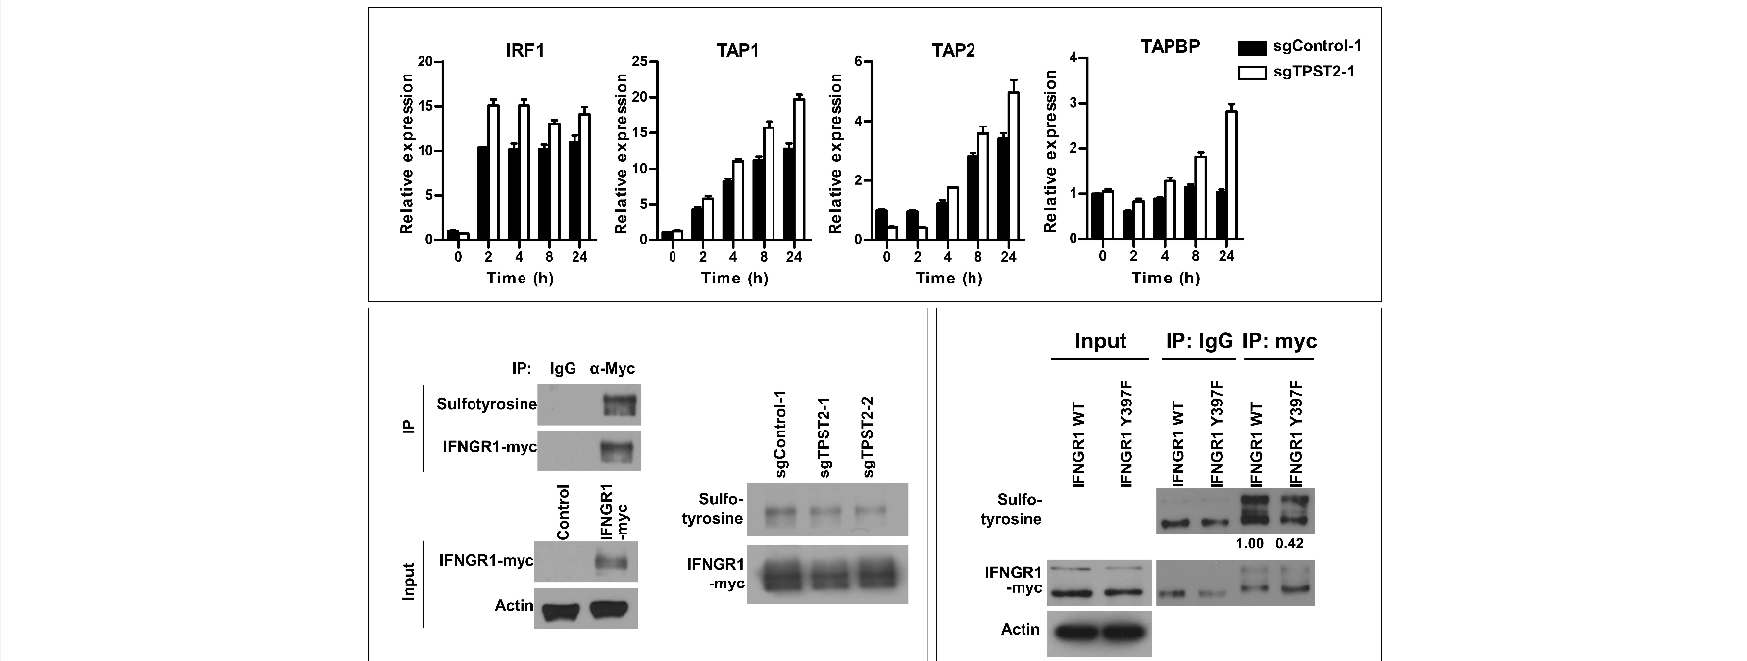▲ Study on the immune regulatory mechanism of TPST2: Using various analysis techniques such as transcriptome analysis, immunoprecipitation, and mass spectrometry, it was revealed that TPST2 inhibits IFN-γ signaling by sulfonating the Y397 residue of IFNGR1.

In addition, in a preclinical trial using a tumor mouse model, tumor growth was significantly suppressed and the anti-PD-1 treatment effect was greatly improved by simply deleting TPST2. Using flow cytometry, the research team was able to confirm that deleting TPST2 induced the activation of immune cells within the tumor. Through this, the research team concluded that inhibition of TPST2 could maximize the anticancer effect by enhancing the immune response of anti-PD-1 treatment.

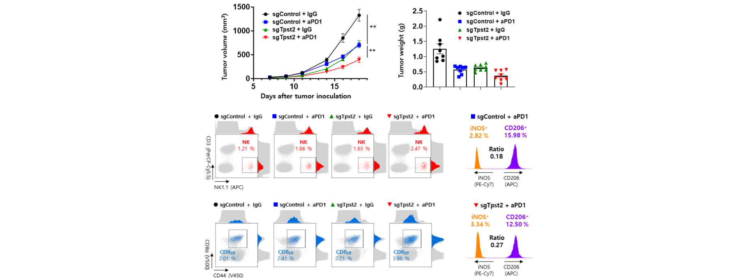▲ Verification of anticancer effect of TPST2 inhibition through preclinical experiments: Using a tumor mouse model, the results of concurrent treatment with TPST2-deleted cell lines and anti-PD-1 treatment confirmed that TPST2 deletion significantly inhibited tumor growth and induced immune system activation compared to the control group.

The research team analyzed various clinical cohorts and confirmed that the amplification and expression of the TPST2 gene were increased in various cancer types compared to normal tissues. In particular, it was confirmed that patients with breast cancer, head and neck cancer, ovarian cancer, sarcoma, gastric cancer, and endometrial cancer had worse prognosis when TPST2 expression was high. These results suggest that TPST2 inhibition may play an important role in cancer immunotherapy.

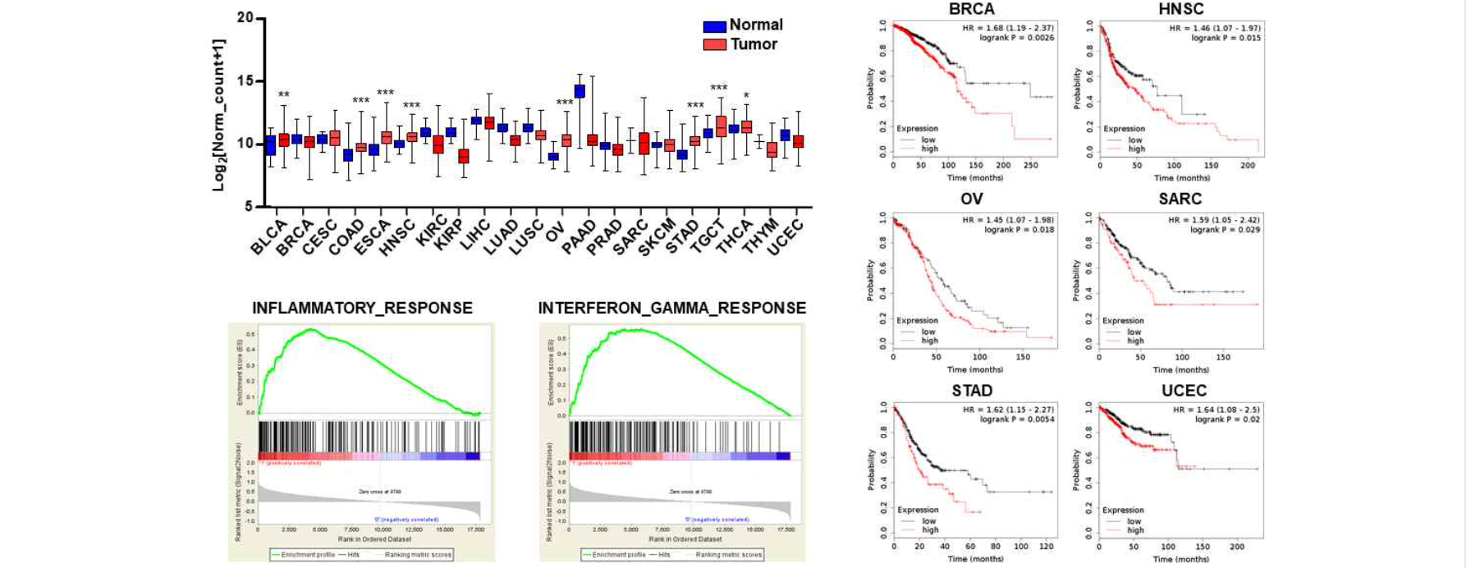▲ Results of clinical cohort analysis on TPST2: It was confirmed that TPST2 was overexpressed in many tumors compared to normal tissues, and that higher TPST2 expression was associated with a worse prognosis.

GIST Department of Biomedical Science and Engineering Professor Hansoo Park said, "Through the development of TPST2 inhibitors, it is possible to identify TPST2 biomarkers in various cancer patients who do not respond to existing immunotherapy and develop customized combination anticancer therapy strategies accordingly."

Seoul National University Professor Sung-Yup Cho said, "This study, using a CRISPR-based genome screening platform, revealed that TPST2 plays an important role in the response to immunotherapy. The results of this study suggest that TPST2 can be considered as a new anticancer treatment target as a cancer immunosuppressor."

This study, supervised by GIST Department of Biomedical Science and Engineering Professor Hansoo and Seoul National University College of Medicine Professor Sung-Yup Cho, and conducted in collaboration with researcher Yumi Oh of Seoul National University College of Medicine and GIST Department of Biomedical Science and Engineering students Sujeong Kim, Yunjae Kim, and Hyun Kim, was supported by the Korea Drug Development Fund, the National Research Foundation of Korea, the Seoul National University Creative Leading Young Investigator Project, and the GIST Researcher Project. The results of the study were published online on August 2, 2024, in Molecular Cancer, which is considered the most authoritative international academic journal in the field of cancer biology.



