GIST-Yonsei University-Ceramic Technology Institute joint research team develops solid oxide fuel cell technology that works without problems even at high temperatures that can soar to over 900 degrees in 3 seconds

- Overcoming the low thermal shock resistance of ceramics with thermal stress-based design of solid oxide fuel cells
- No cracks or fractures even at rapid heating rates reaching temperatures above 900°C in 3 seconds, and high stability confirmed even after more than 100 thermal shock cycles... Published in the international academic journal 《ACS Energy Letters》
- Expected to be utilized in power generation devices that require high-speed operation as auxiliary power sources for mobile devices such as drones

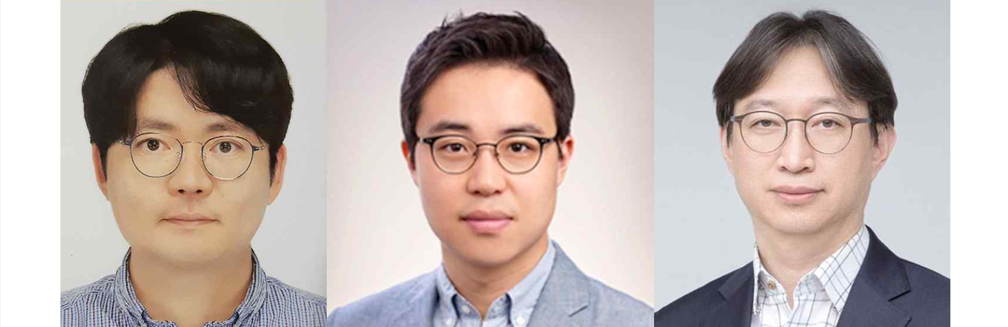▲ (From left) GIST Professor Jong Hoon Joo, Yonsei University Professor Jongsup Hong, and Korea Institute of Ceramic Engineering and Technology Dr. Tae Ho Shin

The Gwangju Institute of Science and Technology (GIST, President Kichul Lim) announced that the research team led by School of Environment and Energy Engineering Professor Jong Hoon Joo, together with the research teams of Yonsei University Professor Jongsup Hong, and Korea Institute of Ceramic Engineering and Technology Dr. Tae Ho Shin, developed solid oxide fuel cell technology that operates even if temperatures rise above 900 °C in less than 3 seconds.

It is expected that the technology developed this time can be utilized in power generation devices that require rapid operation, such as auxiliary power sources for mobile devices such as drones.

Solid oxide fuel cells made of ceramic materials have the disadvantage of being vulnerable to thermal shock due to low thermal conductivity and high elastic modulus. Accordingly, the temperature rise* speed cannot be increased, and the operating time is usually long, reaching 4-6 hours. In addition, there is a disadvantage of unstable performance in rapid thermal cycles*.

* temperature rising: Raising the temperature of hot water to the commercial temperature after ignition (after combustion begins).

* thermal cycle: refers to a thermodynamic cycle, which involves heating and cooling a material according to a certain relationship between time and temperature in heat treatment.

Based on their understanding of thermal stress*, the research team designed the electrolyte material and thickness characteristics of a solid oxide fuel cell and produced a fuel cell with high thermal shock resistance.

To this end, unlike conventional ceramic-based fuel cells that are brittle and hardly bend, they developed an electrolyte that can bend to a small radius by using mechanically stable zirconia (ZrO₂) doped with 3 mol% yttria (Y₂O₃) with high flexibility as an electrolyte material and controlling the electrolyte thickness to approximately 20 μm.

* thermal stress: Deformation inside an object that occurs when temperature changes or heat is not transferred evenly while thermal expansion or contraction of the object is suppressed.

* brittleness: A phenomenon in which an object is destroyed with little plastic deformation when subjected to an external force.

Through this electrolyte design, the ceramic-based solid oxide fuel cell manufactured by the research team showed stability in thermal stress simulations, allowing the cell to operate without being destroyed even under rapid temperature changes.

The solid oxide fuel cell developed by the research team operated without cracking or fracture even at a heating rate of over 900 °C within 3 seconds, and showed high stability even after more than 100 thermal shock cycles. Furthermore, it was confirmed that operation was possible even in extreme operating environments where temperatures reached 1000 °C within 1 second.

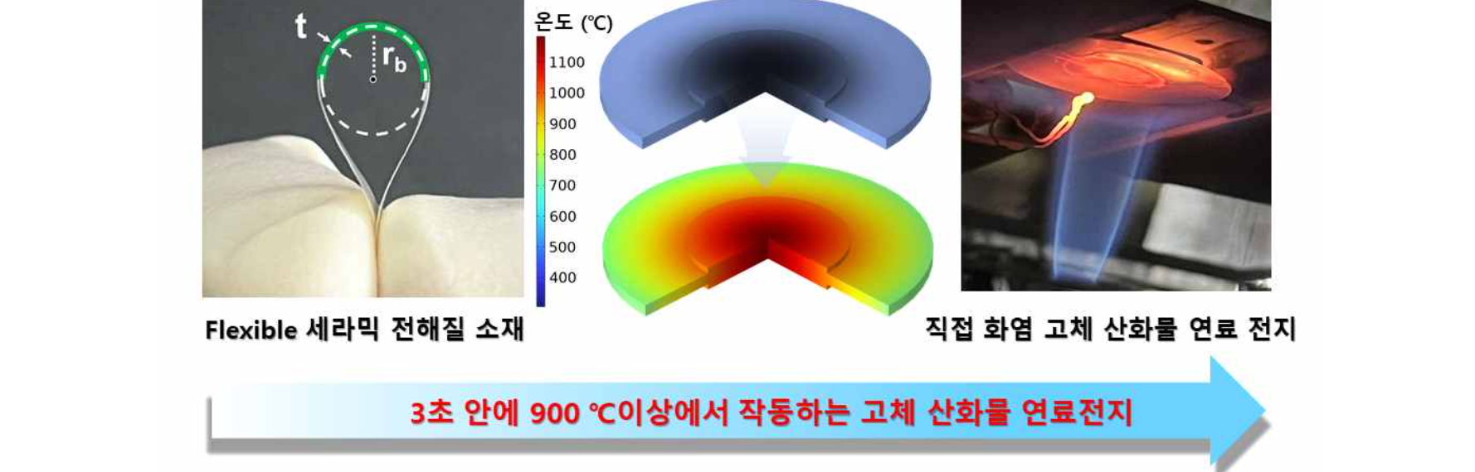▲ Solid oxide fuel cell operating at over 900 °C within 3 seconds: A ceramic fuel cell with high thermal shock resistance was manufactured by designing the electrolyte material and thickness characteristics, and thermal stress distribution simulation was used to theoretically prove that high-temperature operation within 3 seconds is possible.

Professor Jong Hoon Joo said, "It is expected that this research achievement will contribute to the development of technology to improve the thermal shock resistance of not only solid oxide fuel cells but also a wider range of high-temperature ceramic-based electrochemical devices by solving the thermal shock problem caused by rapid temperature changes in the ceramics."

This study was conducted with the support of the National Research Foundation of Korea's Basic Research and Development Project, Future Hydrogen Innovation Technology Development Project, and Leading Research Center Project, and was published online in the renowned international academic journal in the energy field, ACS Energy Letters, on July 24, 2024.



