“Fecundity transplants enhance the effectiveness of cancer treatment for cancer patients” GIST-Seoul Asan Medical Center, the world’s first to elucidate the effectiveness of immunotherapy through stool transplants and the discovery of anticancer immune-potent strains

- GIST Professor Hansoo Park and Seoul Asan Medical Center Professor Sook Ryun Park joint research team, confirmed the case of improved treatment response in patients with low resistance to existing immunotherapy through fecal transplant... “Suggesting the possibility of overcoming immunotherapy resistance in solid cancer patients”
- Proved that gut microbiota composition affects immune response and anticancer treatment effect... “We will continue to research and develop the optimal microbial community that increases beneficial bacteria and reduces harmful bacteria” Published in international academic journal 《Cell Host & Microbe》

▲ (From left) Professor Han-soo Park of the Department of Biomedical Science and Engineering at GIST, Professor Sook Ryun Park of the Department of Oncology at Seoul Asan Medical Center, GIST student Yunjae Kim, GIST doctoral course graduate Gihyeon Kim, and GIST student Sujeong Kim

Recently, it has been revealed through various studies that the intestinal microbiota environment has various effects on our entire body, and in particular, that the composition of intestinal microbiota can affect the human immune system and the occurrence and treatment of cancer. Accordingly, research on treatment methods using intestinal microbiota and their applicability as supplements is being actively conducted worldwide.

The Gwangju Institute of Science and Technology (GIST, President Kichul Lim) announced that a joint research team led by Professor Han-soo Park of the Department of Biomedical Science and Engineering and Professor Sook Ryun Park of the Department of Oncology at Seoul Asan Medical Center announced the world's first research results showing that the effectiveness of immunotherapy for solid cancer patients can be increased through fecal transplantation (FMT)*.

* fecal microbiota transplantation (FMT): A method of transplanting microorganisms present in healthy or effective feces to a patient.

‘Immunotherapy’, which activates the patient’s immune system by regulating the interaction between immune checkpoint proteins*, is used as one of the standard cancer treatments, but the immunotherapy treatment effect is shown in only about 20-30% of patients with cancer types known to be curable, and most of them develop resistance to immunotherapy, which limits the recurrence of cancer.

Recently, there has been a lot of research on cancer treatment using fecal transplants since the results of a study were published showing that changes in the gut microbiota composition of patients with malignant melanoma who have developed resistance to immunotherapy can restore the response to immunotherapy. However, to date, there have been no clinical research results showing that fecal transplants can improve the effect of immunotherapy for metastatic solid cancers such as liver cancer, stomach cancer, and esophageal cancer.

* immune checkpoint proteins: Also called immune checkpoint proteins, these are substances that regulate the activity of immune cells. Representative examples include PD-1/PD-L1 and CTLA-4.

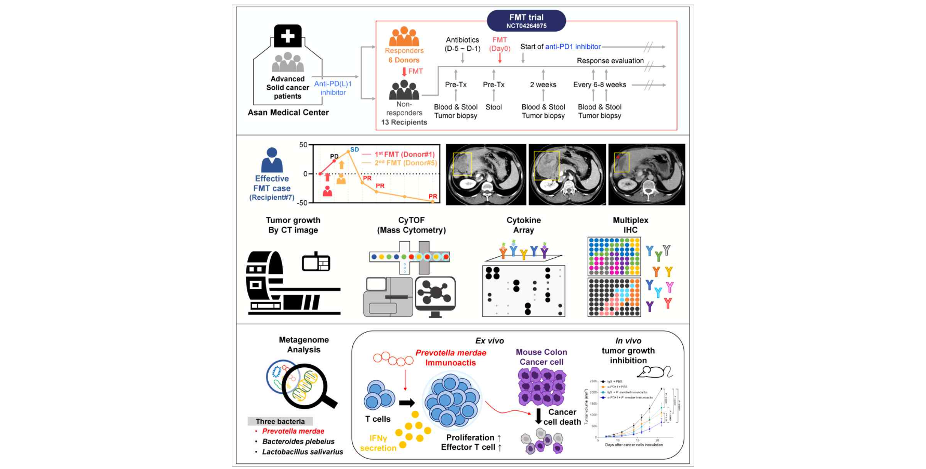▲ Schematic diagram of this study: After conducting FMT clinical trials, efficacy results were confirmed through various analysis techniques, and beneficial bacteria were discovered and their efficacy was proven through metagenomic analysis and preclinical studies.

The joint research team of GIST and Seoul Asan Medical Center transplanted the stool of patients who responded to immunotherapy* to 13 patients with stage 4 solid cancers, including liver cancer, stomach cancer, and esophageal cancer, who had developed resistance to immunotherapy, and then administered immunotherapy again.

As a result, one patient with metastatic liver cancer showed partial remission with a 48% decrease in tumor size, nearly half, after fecal transplantation, and five patients with metastatic cancer showed stable status with no further progression of cancer after fecal transplantation. Through this, it was confirmed that immunotherapy was effective in nearly half of the 13 patients with immunotherapy resistance through fecal transplantation.

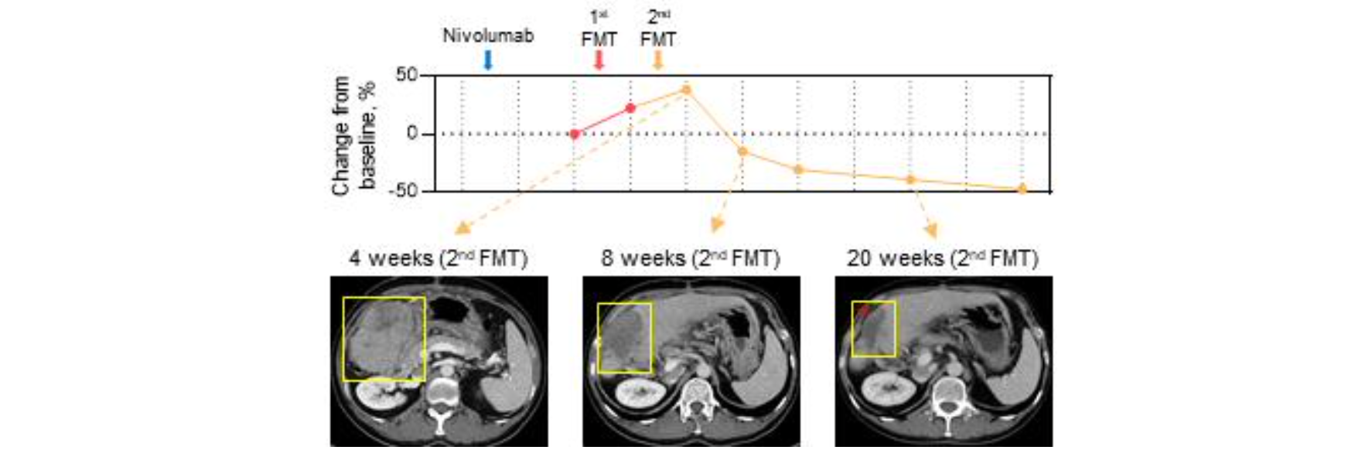▲ CT image and tumor size change of a patient who showed partial remission after fecal transplant: The tumor size was reduced to approximately 50% of the initial size after the second fecal transplant and immunotherapy treatment.

The research team conducted a fecal metagenome analysis to find out which strains among the various strains in the feces affect the treatment effect of immunotherapy. They discovered and confirmed that a species called ‘Prevotella merdae’ is a beneficial bacterium with a therapeutic effect, and isolated the strain from the donor’s feces and named it ‘Prevotella merdae Immunoacits’ for the first time. Afterwards, they confirmed that the beneficial bacterium enhances T cell division and cytotoxicity, and proved through preclinical studies using a mouse model that it inhibits cancer growth and increases the efficacy of immunotherapy.

* patients responding to immunotherapy: Refers to patients whose cancer has been completely remitted (eliminated) or partially remitted for at least 6 months after immunotherapy treatment.

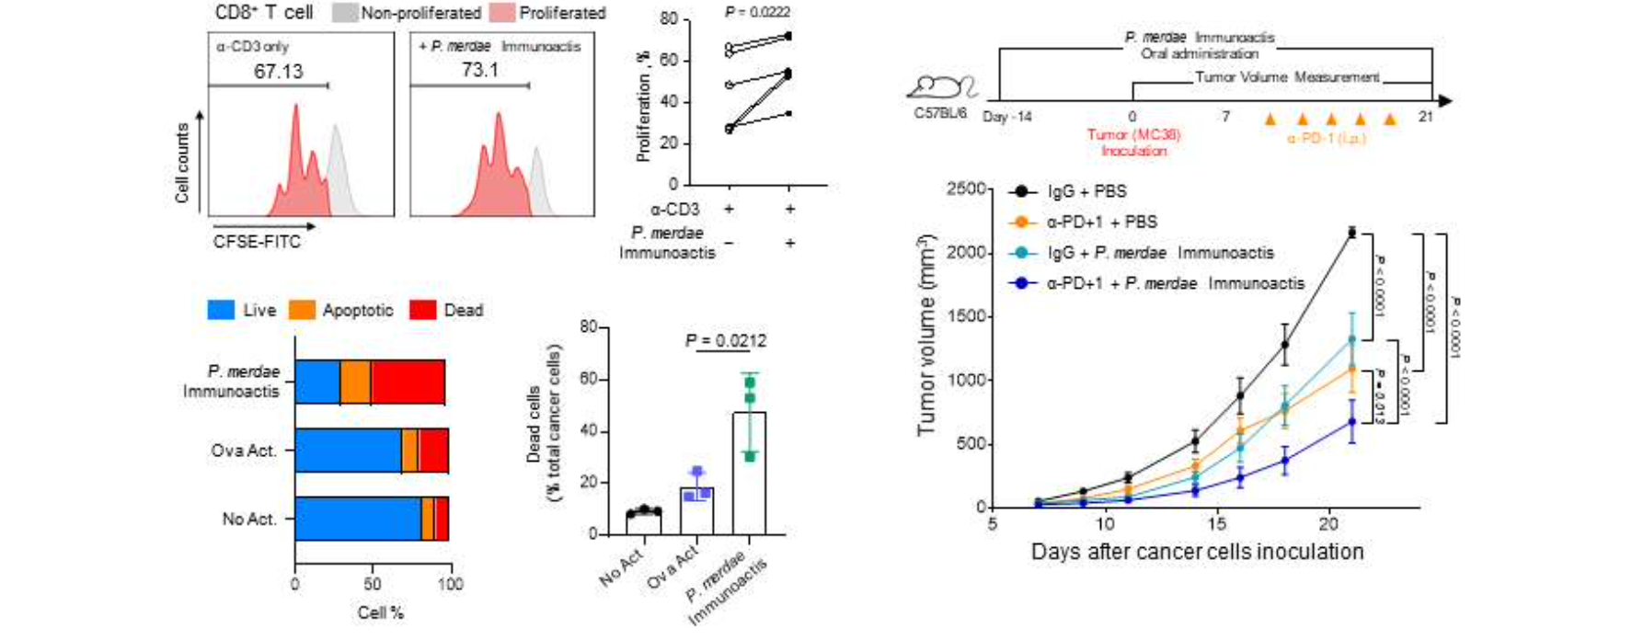▲ Results of efficacy verification experiments of Prevotella merdae Immunoactis: Enhancement of T cell division and cytotoxicity, and inhibition of tumor growth confirmed in preclinical tests.

In addition, two types of harmful bacteria, ‘Bacteroides plebeius’ and ‘Lactobacillus salivarius’, were discovered from patients who did not respond well to treatment despite fecal transplantation, and through the same experiment, it was revealed that they suppressed T cell division and cytotoxicity while also promoting cancer growth.

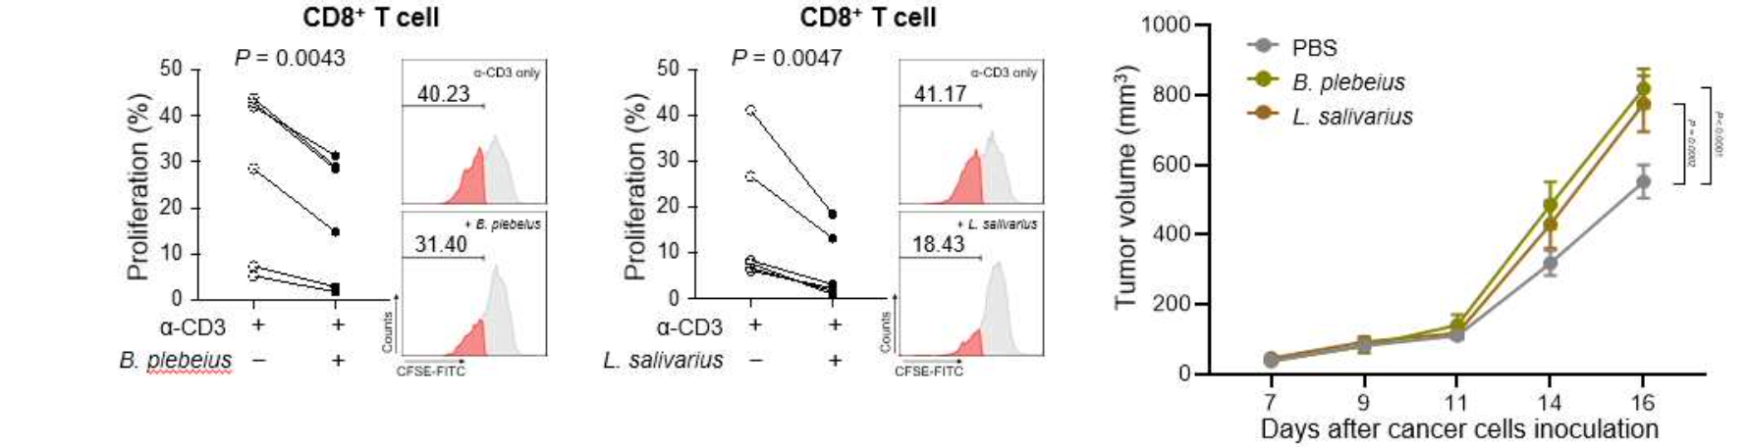▲ Results of efficacy verification experiment on two types of harmful bacteria, Bacteroides plebeius and Lactobacillus salivarius: Inhibition of T cell division and promotion of tumor growth confirmed in preclinical tests.

In particular, it was confirmed that the combination of three strains was correlated with the degree of immune cell activation, and that the efficacy of immunotherapy did not improve when harmful bacteria were present together even when beneficial bacteria were present. Through this, it was proven that the combination of intestinal microorganisms, beyond a single strain, affects the immune response and anticancer treatment effect.

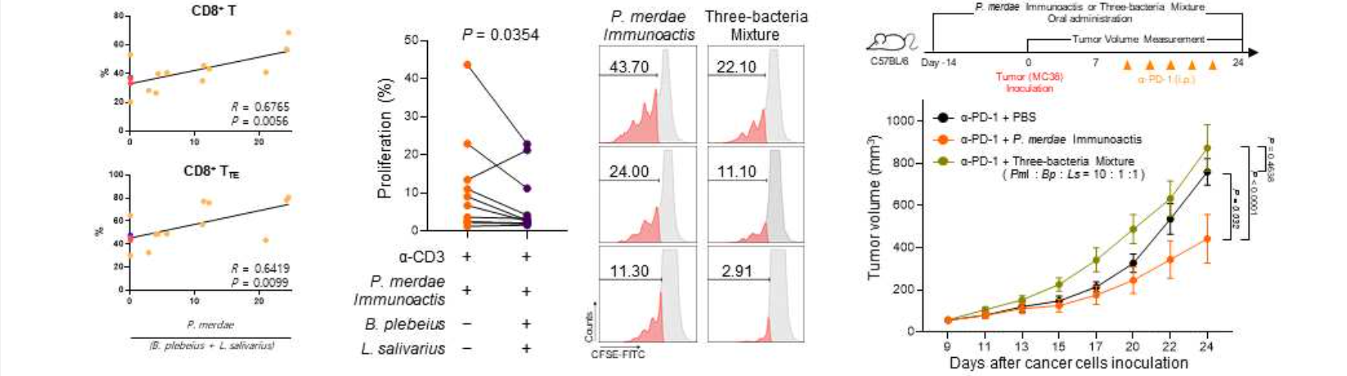▲ Experimental results showing the importance of the three strain complex: It shows that there is a correlation between the ratio of the three strains and the immune activity of the human body. In addition, even when there are beneficial bacteria, when harmful bacteria are present together, T cell division is suppressed and tumor growth is also promoted.

GIST Department of Biomedical Science and Engineering Professor Han-soo Park said, "Previously, many studies were conducted on the efficacy of single strains, but this study confirmed that the microbial community has a more significant effect on the immune anticancer treatment response than a single microorganism. In the future, we plan to continue research and development on the optimal microbial community that increases beneficial bacteria and reduces harmful bacteria to improve cancer treatment results through research on the combination of intestinal microorganisms and optimization of cancer immune responses."

Seoul Asan Medical Center Department of Oncology Professor Sook Ryun Park said, "When cancer cells become resistant to immunotherapy, the most effective treatment that can be applied disappears, and this study is very significant in that it suggests the possibility of overcoming immunotherapy resistance in solid cancer patients. We will continue to study intestinal microorganisms to develop new treatments to overcome immunotherapy resistance."

This study, supervised by Professor Han-soo Park of the Department of Biomedical Science and Engineering at GIST and Professor Sook Ryun Park of Seoul Asan Medical Center, and conducted in collaboration with doctoral students Yunjae Kim and Sujeong Kim of the Department of Biotechnology at GIST, was supported by the National Cancer Center Project, the GIST Researcher Project, and the Bio and Medical Technology Development Program of the National Research Foundation of Korea, and was published online in the international journal 《Cell Host & Microbe》 on July 25, 2024.



