GIST-Soongsil University develop new OLED polymer material with improved performance and suitable for large-scale production

- GIST Senior Researcher Hongkyu Kang and Soongsil University Professor Beom-Goo Kang's joint research team developed a new polymer material 'poly(A)' based on poly(triphenylamine) to improve the thermal stability and luminous efficiency of OLED devices
- Compared to existing PEDOT-using devices, it showed a maximum luminance of 15,900 cd/m2 and a maximum luminous efficiency of 4.8 cd/A, which are 4 and 9 times higher, respectively... High thermal stability and reduced production costs
- Suitable for large-scale production... Research results published in the international academic journal 《European Polymer Journal》

▲ (From left) GIST Research Institute for Solar and Sustainable Energies Senior Researcher Hongkyu Kang, GIST Heeger Center for Advanced Materials Dr. Jun-Ho Jang, Soongsil University Professor Beom-Goo Kang, Soongsil University student Woo Jae Jang

A Korea research team has developed a new polymer material that can significantly improve the thermal stability and luminous efficiency of OLED devices for displays, increase the efficiency of the OLED manufacturing process, and reduce production costs.

The Gwangju Institute of Science and Technology (GIST, President Kichul Lim) announced that a joint research team led by Senior Researcher Hongkyu Kang of the Research Institute for Solar and Sustainable Energies and Professor Beom-Goo Kang of Soongsil University developed a new material for the hole transport layer* that can improve the performance of organic light-emitting diodes*.

* organic light emitting diode (OLED): A diode that emits light using organic compounds. It operates on the principle that electrons and holes recombine in the organic layer when current flows, emitting light.

* hole transport layer: A layer located between the anode and the light-emitting layer in electronic devices such as organic light-emitting diodes and solar cells, which plays a role in efficiently transporting holes.

Among commercialized display devices, organic light-emitting diodes (OLEDs) have the advantage of providing excellent picture quality and clear images because each pixel emits light independently, and saving power consumption by emitting only the necessary portions of light during display.

On the other hand, there is a disadvantage in that screen burn-in may occur if a specific image is displayed for a long time due to the self-luminous structure, and the brightness of the screen may decrease over time due to aging of the OLED material. Therefore, research is actively being conducted recently to improve the performance of OLED and reduce production costs.

Existing PEDOT*-based hole transport layers have problems with not only thermal stability but also solvent stability. The research team developed a new poly(triphenylamine)*-based hole transport layer material that can overcome these problems.

* PEDOT (Poly (3,4-ethylenedioxythiphene)): An organic conductive polymer that is transparent, has excellent electrical conductivity, is light, and is flexible. PEDOT is generally used in a mixture with PSS (polystyrene sulfonic acid) and is used as a hole transport layer or electrode material in various electronic devices.

* triphenylamine (TPA): A compound with a structure in which three phenyl groups are bonded to one nitrogen atom, and is mainly used as an organic semiconductor and hole transport layer material.

The newly developed new polymer utilized the solvent resistance* of the hole transport layer. The research team heat-treated the new polymer at a temperature of over 200°C to impart solvent resistance, which enabled the solution process as the hole transport layer did not collapse during the solution process.

* solvent resistance: The ability of a polymer to withstand exposure to a solvent without its chemical structure or physical properties changing, and is an important indicator for evaluating the stability of polymer materials.

This study focused on the synthesis and characterization of a new hole transport layer material based on poly(triphenylamine). The research team used living anionic polymerization.

The monomer N-([1,1′-biphenyl]-4-yl)-N-(4′-ethenyl[1,1′-biphenyl]-4-yl)-9,9-dimethyl-9H-fluoren-2-amine was successfully polymerized and named ‘poly(A)’.

* living anionic polymerization: A method in which the polymer chain is maintained as a single species while growing under specific conditions during the polymerization reaction process, and the polymer chain is continuously grown by adding monomers without a termination reaction. The molecular weight and molecular weight distribution of the polymer can be precisely controlled.

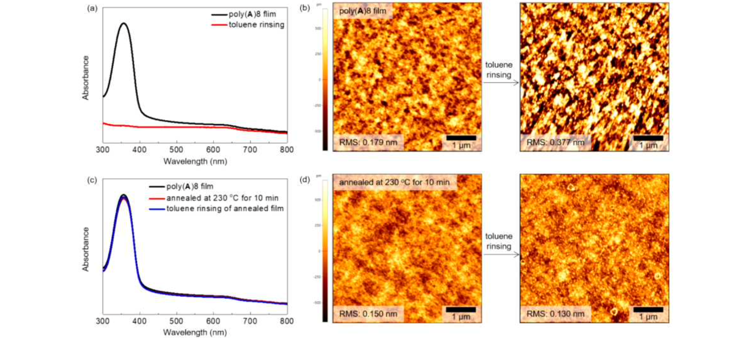▲ Solvent resistance characteristics of poly(A) material: a) UV-VIS spectra of non-heat-treated poly(A) film before and after toluene solvent resistance test, b) Atomic force microscope images of non-heat-treated poly(A) film before and after toluene solvent resistance test, c): UV-VIS spectra of heat-treated poly(A) film before and after toluene solvent resistance test, d): Atomic force microscope images of heat-treated poly(A) film before and after toluene solvent resistance test.

The synthesized poly(A) polymer has a precisely controlled molecular weight and narrow molecular weight distribution, and the OLEDs fabricated through it showed a maximum luminance* of 15,900 cd/m² and a maximum luminous efficacy of 4.8 cd/A, which are four times and nine times higher performances, respectively, compared to devices using conventional PEDOT.

* luminance: It refers to the luminous intensity per unit area of a light source, that is, the amount of light flux (amount of light) emitted per unit solid angle from the unit area of the light source.

In addition, it has high thermal stability with a decomposition temperature of 417°C and a glass transition temperature of 205°C, and since it is possible to use a solution process, it can replace the existing expensive deposition process, making it efficient in terms of reducing production costs.

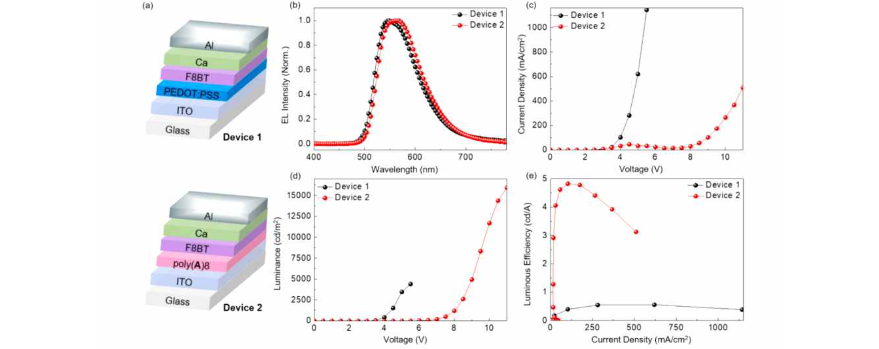▲ Comparison of OLED devices fabricated with a PEDOT hole transport layer and OLED devices fabricated with a poly(A) hole transport layer: a) OLED device structures fabricated with PEDOT and poly(A) hole transport layers, b) Comparison graph of electroluminescence spectra (EL) of PEDOT and poly(A) OLED devices, c) Comparison graph of current density and voltage of PEDOT and poly(A) OLED devices, d) Comparison graph of luminance and voltage of PEDOT and poly(A) OLED devices, e) Comparison graph of luminous efficiency and current density of PEDOT and poly(A) OLED devices

Senior Researcher Hongkyu Kang said, "This study, which has opened up new possibilities for increasing the efficiency of the OLED manufacturing process, is significant in that it has developed materials suitable for large-scale production. It is expected to contribute greatly to the development of the OLED industry in the future, and we will continue to develop more efficient and economical OLED manufacturing processes through continuous research."

This study, supervised by Senior Researcher Hongkyu Kang and Soongsil University Professor Beom-Goo Kang, and led by GIST Dr. Jun-Ho Jang and Soongsil University master’s course student Woo Jae Jang as first authors, was supported by the National Research Foundation of Korea (NRF)’s Individual Basic Research Program (Basic Research), University Key Research Institute Support Program, Nanofab Utilization Support Program, and GIST Research Institute for Solar and Sustainable Energies (Institutional Project). The results of the study were published online in the July 3, 2024, issue of the European Polymer Journal, an authoritative journal in polymer science.



