“In an era where accuracy in weather forecasting is more important than ever” Korea-US international joint research team develops indicators for evaluating forecast model performance

- A joint research team led by Professor Jin-Ho Yoon of GIST confirmed a close relationship between the ‘intra-seasonal (15-32 days) predictability’ of a forecast model and the ‘capability to simulate climate average conditions (mean field)’... Designed and analyzed an index that even considers the characteristics of seasonal changes
- The clearly revealed ‘intra-seasonal predictability’-‘mean field’ relationship and a new evaluation index based on the mean field provide a critical clue for improving the performance of future forecast models... Published in the international academic journal <Climate Dynamics>

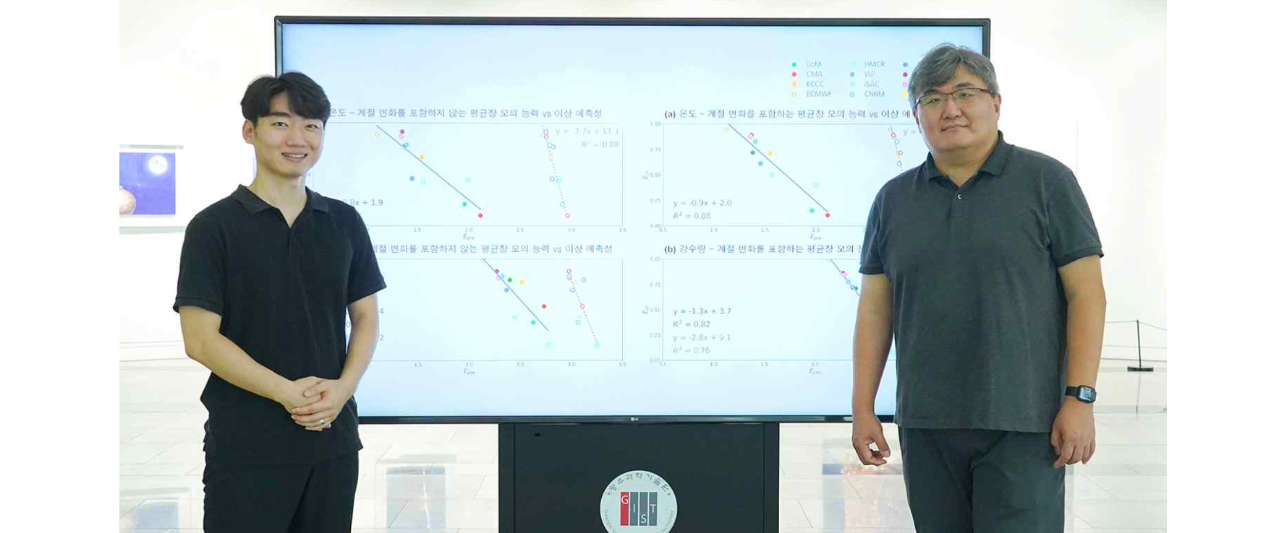▲ (From left) PhD student Jihun Ryu and Professor Jin-Ho Yoon

The ‘numerical weather forecast model’ calculates future weather by solving the atmospheric equation (which explains the state and movement of the atmosphere), and the accuracy of weather forecasts using this has gradually improved as a result of numerous trials and errors. However, weather forecasts within 10 days and ‘seasonal forecasts’ (forecasts from the 15th to the 32nd in this study)* still require significant improvement.

* sub-seasonal forecast: From the perspective of forecasting, a period of less than 10 days is generally called a weather forecast, and a forecast for one month later is called a seasonal climate forecast. The period between the two, from 10 days to one month later, is classified as a sub-seasonal forecast. However, in this study, it refers to a forecast for 15 to 32 days.

A joint research team between Korea and the United States has revealed that the time scale within a season and the model's ability to simulate the mean field* and the forecast values ​​ten days to a month in advance are closely related, and proposed a new index to evaluate model performance.

* model mean field: refers to the long-term average state simulated by the model.

* simulation ability: In this study, the model’s prediction results were divided into ‘the ability to simulate the mean field, which is the average state of the Earth created by the model’ and ‘the anomaly predictability, which is expressed as how high or low it is from the average state.’

The Gwangju Institute of Science and Technology (GIST, President Kichul Lim) announced that an international joint research team led by Professor Jin-ho Yoon of the School of Earth Sciences and Environmental Engineering analyzed various forecast models of the ‘Sub-seasonal to Seasonal Prediction Project’ and discovered a correlation between superior predictability* and superior mean field simulation ability* in all regions of the globe, the equator, and mid-latitudes, and in all four seasons.

* mean field simulation ability: Forecast models are computer programs based on dynamical equations that describe the general circulation of the atmosphere and ocean, and mathematically calculate these equations to produce results. Each model simulates different climate averages, which are evaluated by various evaluation indicators such as annual averages or mean fields. The ability of a model to simulate climate averages is called mean field simulation ability.

* model predictability: Evaluated after excluding the mean field. For example, predicting hotter or more precipitation than usual.

Among the various international cooperation projects being carried out to improve the predictability of weather forecasts, the ‘Intra-Seasonal and Inter-Seasonal Forecasting Project’* is a representative example.

* Sub-seasonal to Seasonal Prediction Project: This is a joint project supported by the World Weather Research Programme (WWRP), the World Climate Research Programme (WCRP), and the World Observation Programme (THORPEX), which are international cooperative research programs operated by the World Meteorological Organization (WMO), to improve prediction technology and understanding of nature over the weather prediction period from within a season to a season (usually 1 to 3 months), to support the application of prediction technology in industry, and to support the use of prediction information in applied fields.

As these international joint projects have been carried out over the past 10 years, intraseasonal predictability has improved significantly. This is the result of improving the results of simple annual and monthly average field evaluation indicators and has been upwardly leveled to the point where there is no advantage between models.

The research team developed a new model evaluation index to demonstrate a clearer relationship between the mean field and predictability of the forecast model. They designed and analyzed an index that considers not only the mean field but also the characteristics of seasonal changes by utilizing the widely used empirical orthogonal function (EOF)*.

* empirical orthogonal function (EOF): When analyzing time series data or time series data of spatial image data, the changes in the data are separated into independent functions. The basis function is called the empirical orthogonal function, and the analysis method used at this time is called the empirical orthogonal function analysis method.

Even the European Centre for Medium-Range Weather Forecasts (ECMWF) forecast model, which is usually considered the best, was found to still show potential for improvement when considering seasonal changes. In other words, it was confirmed* that in evaluating the performance of a forecast model, the ability to simulate seasonal changes, which have a semi-annual periodicity and show seasonal changes, is important in addition to the mean field, which is expressed as a large cycle from winter to summer over a year.

* The mean field that is generally discussed has the form of ‘(a) annual cycle 1’, and has a cycle that repeats once a year, increasing in the summer and decreasing in the winter. However, when the empirical orthogonal function (EOF) is applied to the mean field, ‘annual cycle 2’ and ‘seasonal cycles 1 and 2’ that were not visible because they were hidden by ‘annual cycle 1’, which has the strongest influence in the mean field. ‘Annual cycle 1’ is often called the winter-summer pattern, and ‘annual cycle 2’ is called the spring-fall pattern, but ‘seasonal cycles 1 and 2’ do not have a precise name, so they are expressed as the characteristics of seasonal changes that have two cycles per year.

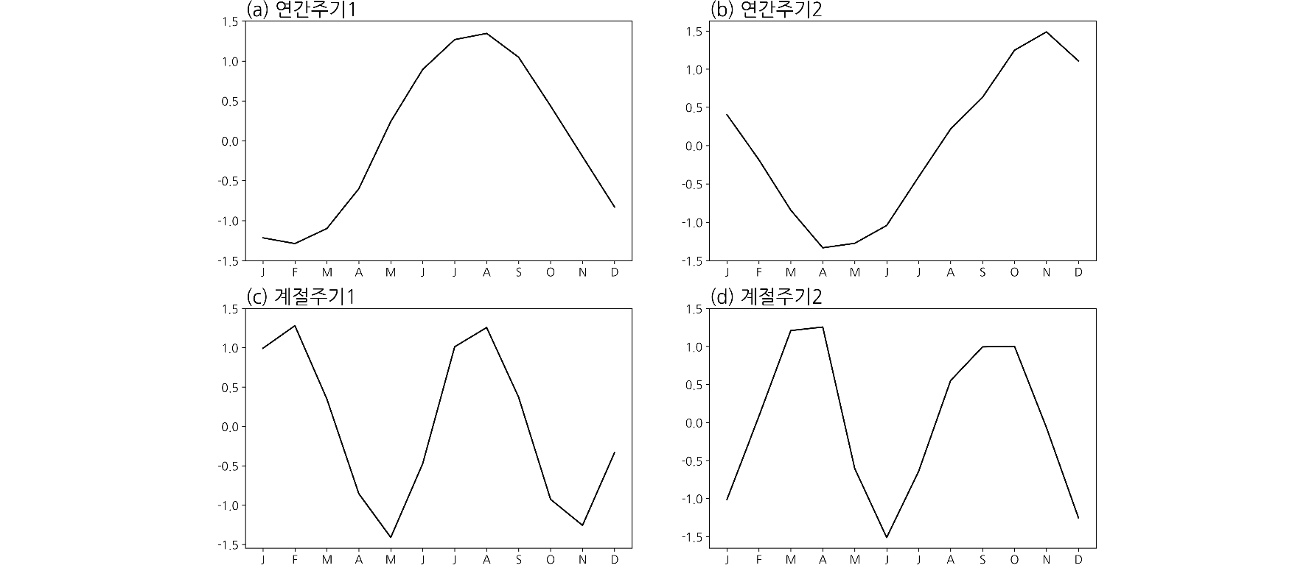

According to the research team, considering the global mean field of a forecast model and its ability to simulate seasonal changes together increases the coefficient of determination* by approximately 7% compared to not considering seasonal changes, and in particular, an increase of more than 30% in the coefficient of determination was confirmed for precipitation in tropical regions.

This means that predictability can now be estimated using only the mean field and seasonal variation simulation capabilities of a relatively easy-to-calculate forecast model, and it is also significant in that it provides a critical clue for improving the performance of forecast models in the future, the research team explained.

* coefficient of determination: In regression analysis, a regression model is set up to identify the trend of sample data, and then the data is used to estimate coefficients to derive an estimated linear equation. The coefficient of determination is a coefficient that measures how well the derived regression line explains the actual sample. If this value is 1, it means that the regression line perfectly matches the data. On the other hand, if the coefficient of determination value is 0, it means that the regression line does not explain the distribution of the data at all.

As a result of analyzing the performance evaluation index of the forecast model created by the research team, it was confirmed that the model of the European Centre for Medium-Range Weather Forecasts (ECMWF) had the best performance.

Professor Jin-Ho Yoon said, "Through this study, we clearly revealed the relationship between seasonal predictability and mean field and proposed a new evaluation index based on the mean field. These relationships and evaluation indexes will serve as milestones for improving forecast models."

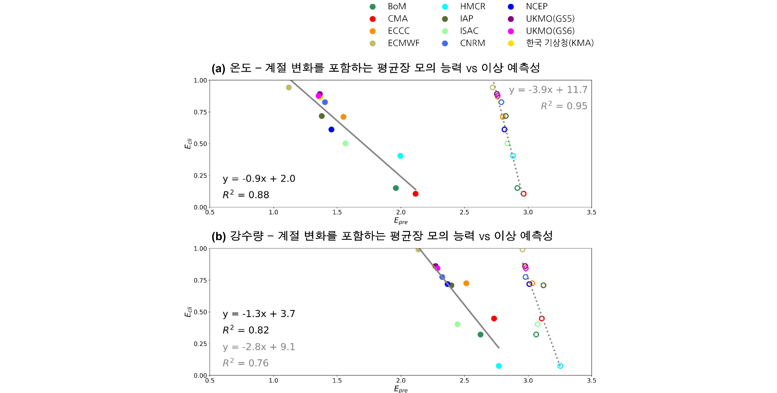▲ Relationship between the mean field simulation ability and predictability of the S2S model. It can be confirmed that the model of the European Centre for Medium-Range Weather Forecasts (ECMWF) is the best. (a) and (b) represent temperature and precipitation, respectively. The mean field simulation ability used in this study is on the left axis, and the anomaly predictability is on the lower axis. The closer to the upper left, the better the performance. Solid lines, filled marks, and black text represent relationships on a weather scale, and dotted lines, empty marks, and gray text represent relationships on a time scale within a season.

This study, led by Professor Jin-Ho Yoon and PhD candidate Jihun Ryu of the School of Earth Sciences and Environmental Engineering at GIST and participated by Professor Shih-Yu (Simon) Wang of Utah State University (USU) and Professor Jee-Hoon Jeong of Chonnam National University, was conducted with the support of the Mid-career Researcher Support Program of the National Research Foundation of Korea and the Overseas Excellent Scientist Support Program (Brain Pool) of the Korea Meteorological Administration and the Drought Special Weather Center.

The results of the study were published online on Friday, June 28, 2024, in the prestigious international journal in the field of meteorology, Climate Dynamics.



