“There is no need to wear something cumbersome” GIST develops virtual reality (VR) technology that enhances immersion in a more natural and comfortable way without wearable devices

- Professor Kyung-Joong Kim's team in the School of Integrated Technology has developed a technology that recognizes user behavior by analyzing foot pressure data with a high-resolution carpet-type tactile sensor... Movement and intention can be identified more precisely, and movement can be realized more naturally
- New AI model ‘Self-Teaching Vision Transformer (STViT)’ accurately distinguishes similar movements... Taking VR technology (user interface/interaction method) to the next level
- Expected to be used in various fields such as education, medicine, and entertainment... Announcement of the global academic conference ‘IEEE VR 2024’ and invitation to the TOP conference hosted by the Korea Information Science Society

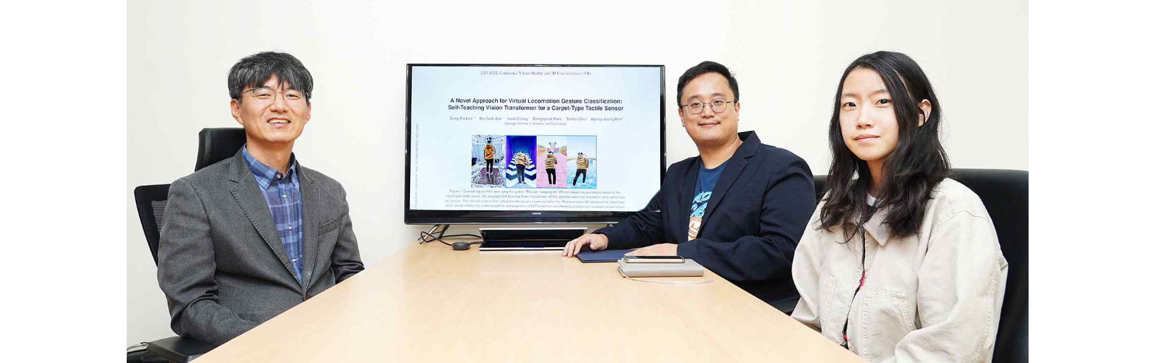▲ (From left) Professor Kyung-Joong Kim and doctoral students Ho-Taek Joo and Sung-Ha Lee

Virtual reality (VR), which allows spatial and temporal experiences in an artificial environment rather than reality, can be more immersed and enjoyed by the experiencer as it feels similar to reality. Recently, a new technology that accurately recognizes user movements in real time in a VR environment has been developed and is attracting attention.

The Gwangju Institute of Science and Technology (GIST, President Kichul Lim) announced that Professor Kyung-Joong Kim's research team in the School of Integrated Technology developed a technology that recognizes behavior by analyzing the user's foot pressure data in detail using a high-resolution carpet-type tactile sensor, breaking away from the existing method of relying on wearable sensors.

As a result, it is possible to more precisely understand the user's movements and intentions in VR, and it is expected that the results of this research can be used to implement natural movement in a virtual environment.

Natural movement in virtual reality is a basic element that greatly improves the immersion and interactivity of the VR environment, and although various studies have been conducted in this field, problems that need to be solved still remain.

The biggest problem is that, unlike virtual space, there are physical limitations in real space. To overcome these limitations in real space, research has been conducted to recognize movements in place and translate them into movements in a virtual environment.

However, existing research methods require the user to wear a sensor, and the sensor worn at this time can make the user's movements uncomfortable. Therefore, for user convenience, technology is needed to accurately recognize the user's behavior without wearing a sensor.

To process the high-resolution foot pressure data from the sensors, the researchers developed a new artificial intelligence model, the Self-Teaching Vision Transformer (STViT), based on Vision Transformer (ViT)*, that can accurately distinguish between similar motions.

The model incorporates elements of the existing Data-efficient Image Transformer (DeiT) and Shifted window Vision Transformer (SwinViT) and utilizes a “self-learning” approach that continuously updates itself by leveraging knowledge from previous training steps.

* Vision Transformer (ViT): The latest technology in the field of artificial intelligence vision that divides images into small pieces and analyzes each piece to understand the entire image. By imitating the human visual system, it can classify and identify images very accurately, and can accurately detect abnormal behavior by analyzing complex images in real time.

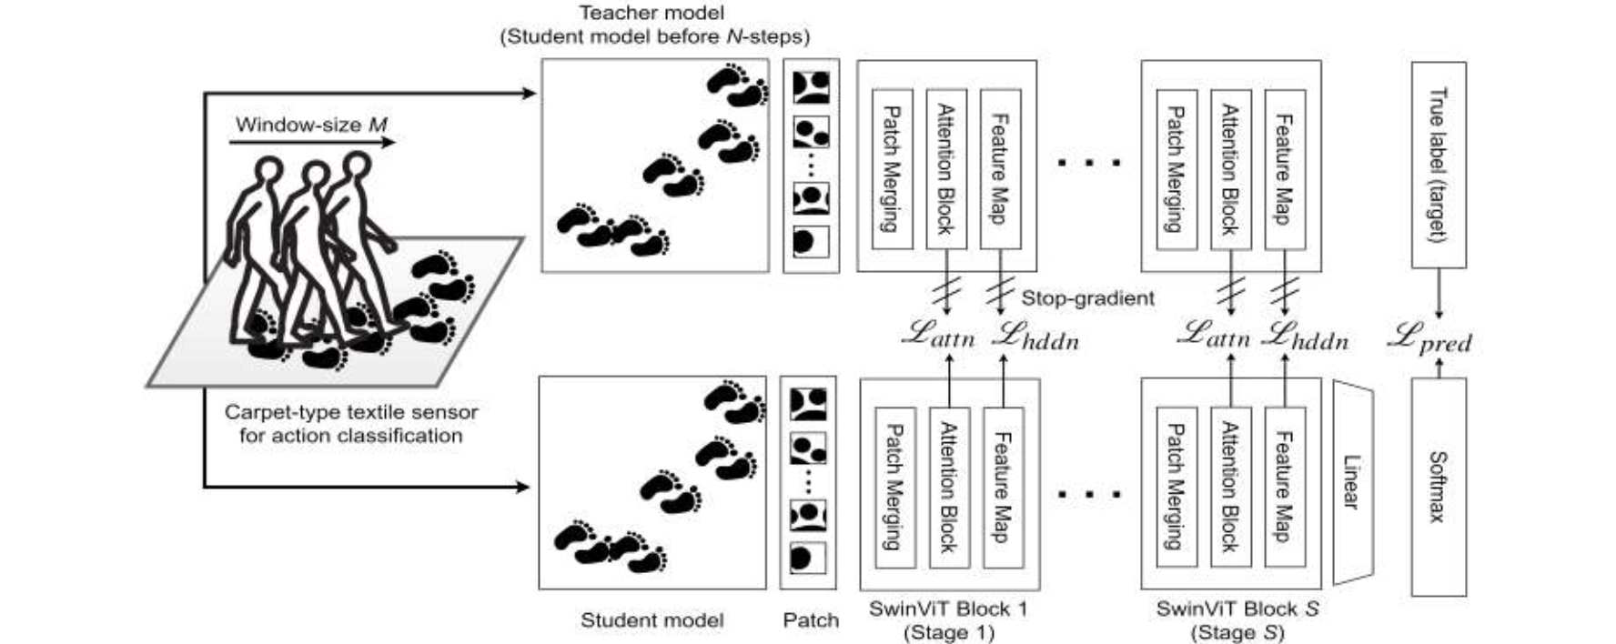▲ Overall structure of the STVIT algorithm: The proposed Self-Teaching Vision Transformer (STViT) algorithm infers the movement actions performed by the user. This inferred motion is reflected in the avatar's movements within the VR environment.

This research outcome represents an important step forward in raising the level of VR technology in terms of user interface and interaction method, and it is expected to be used in various fields such as education, medicine, and entertainment using VR.

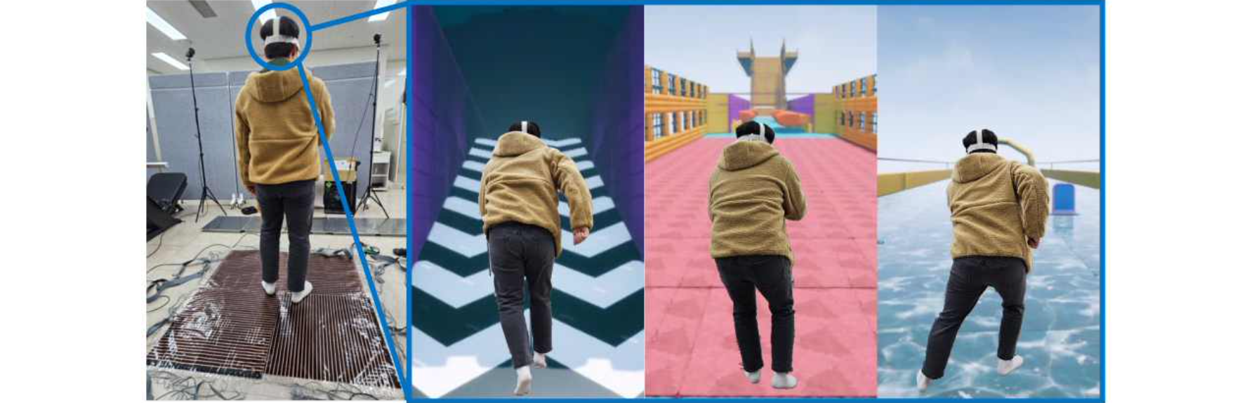▲ A user enjoying a VR game using the proposed algorithm: The user is immersed in the VR game by performing various actions using the proposed algorithm on the sensor. The first photo is the user playing the game, and the second, third, and fourth photos are the VR screen the user is looking at.

For example, in the medical field, the patient's rehabilitation process can be monitored more closely, and in the educational field, learning effects can be maximized through realistic interactions.

Above all, this technology helps users naturally immerse themselves in the VR environment. The sophisticated motion recognition function is expected to play a role in further enhancing the quality of the VR experience by accurately capturing the movements of the user's hands and feet, making interactions in the virtual world as natural as reality.

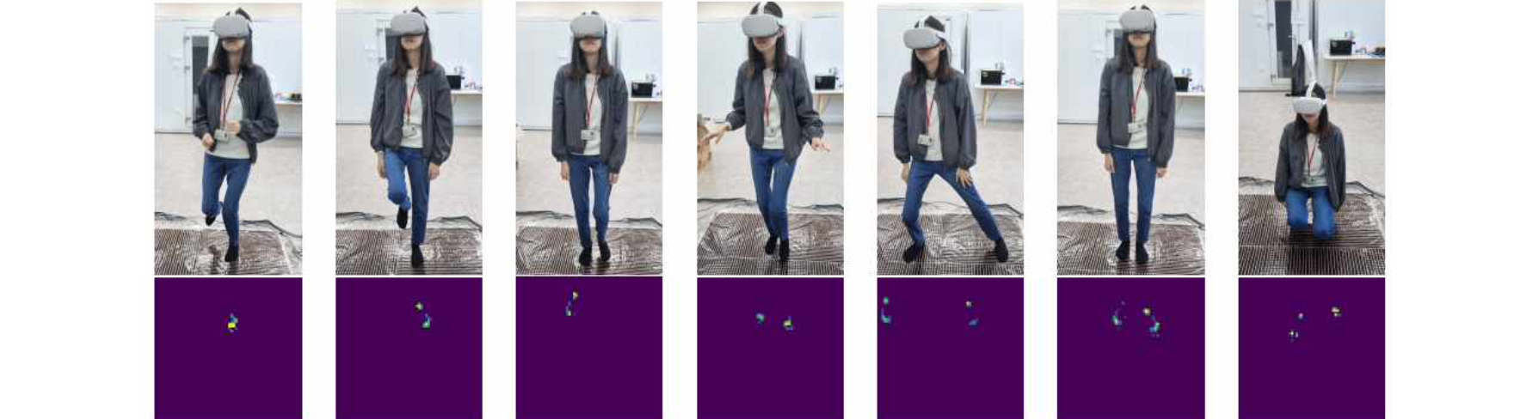▲ Distinguishing various movements through the STVIT algorithm: These are movements that can be inferred through the STViT algorithm. You can distinguish between running/marching/walking/creeping/standing/sitting, etc. Because the proposed algorithm can distinguish between various actions, you can become more immersed in VR games.

Professor Kyung-Joong Kim said, "The results of this research are expected to be utilized as an interface that can recognize user movements more naturally and comfortably without the need for a wearable device. It is expected to solve natural mobility problems in virtual reality and open new possibilities to provide a more immersive user experience."

This research, led by Professor Kyung-Joong Kim of the GIST School of Integrated Technology and conducted by doctoral students Sung-Ha Lee, Ho-Taek Joo, and Yunho Choi, and master's students Insik Chung and Donghyeok Park, was conducted under the 'GIST-MIT AI International Cooperation Project' and 'Science and Technology Project to Open the Future of the Region' and received support from the 'IEEE VR Conference 2024', a global academic conference, and presented at the Top Conference session (June 27, 2024) hosted by the Korea Information Science Society.



