GIST dramatically improves situation prediction and decision-making AI technology, predicting situations 10,000 times faster in the real-time strategy game <StarCraft II>

- Professor Chang Wook Ahn’s team developed the ‘Monte Carlo Tree Search Technique (MCTS)’ based on an alternative model... Dramatically increased search efficiency and performance stability compared to the existing MCTS
- Reduced simulation inference time from ‘minutes to hours’ to ‘milliseconds to seconds’ range
- Expected to be used in decision-making to solve real-world application problems such as autonomous driving, stock trading, and risk prediction... Published in the international academic journal 《Engineering Applications of Artificial Intelligence》

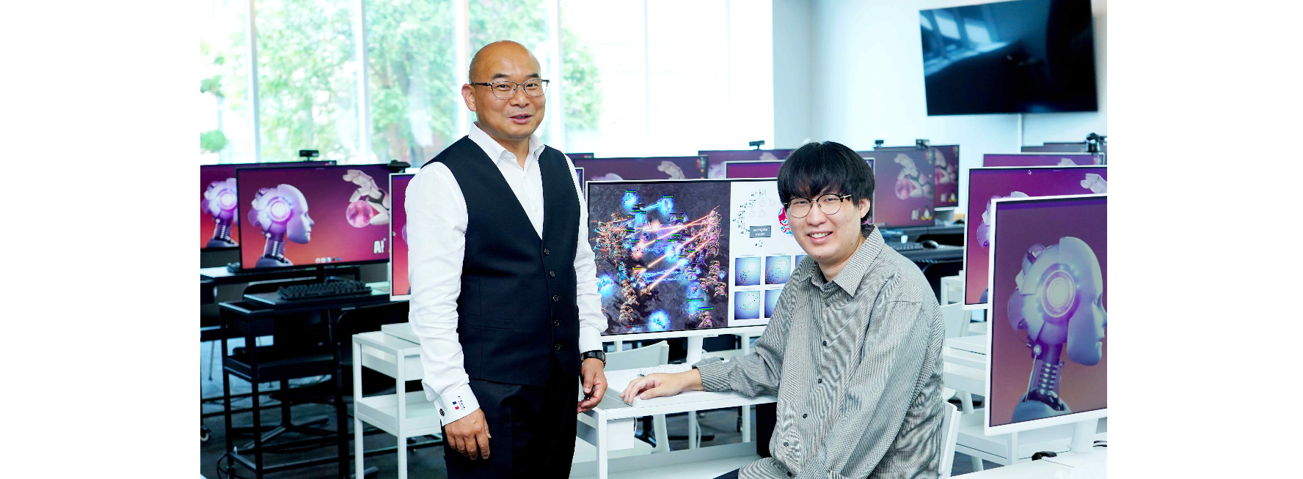▲ (From left) Professor Chang Wook Ahn and doctoral student Donghyeon Lee of the Arificial Intelligence Graduate School used alternative models to predict game situations in real time and make decisions to conduct battles.

Monte-Carlo is one of the 10 administrative districts of the Principality of Monaco and is famous for its casinos and gambling venues. The algorithm that probabilistically calculates the value of a function is called the Monte Carlo Method, which originated in the city of gambling.

The Gwangju Institute of Science and Technology (GIST, President Kichul Lim) announced that a research team led by Professor Chang Wook Ahn of the Arificial Intelligence Graduate School has applied the Monte Carlo Tree Search (MCTS)* method developed based on the Surrogate Model to StarCraft II, a real-time commercial video game, to predict game situations 10,000 times faster than the existing MCTS, dramatically improving search efficiency and performance stability.

Although MCTS is a very effective situation prediction technique, it was previously impossible to apply to real-time strategy (RTS) games such as StarCraft due to its high complexity. It is expected that the results of this research can be applied not only to games but also to real-world problems.

* substitute model: A method of solving problems by creating a simple and fast model that can be used in place of a complex and computationally expensive actual model or system. It is mainly used in fields such as optimization problems and simulation.

Monte Carlo Tree Search (MCTS) is a heuristic search algorithm for decision-making in complex and uncertain environments, and it is mainly applied when playing games. Researchers focused on expanding search trees based on random sampling in the search space, analyzing how to determine the most optimal way to move.

The existing MCTS technique, which estimates the expected value for situation prediction based on random simulation, takes a long execution time and is complex, so there are limitations in applying it to real-time commercial RTS games that require a high computational amount.

In particular, StarCraft II, a representative real-time strategy game, requires each game participant to secure resources and control the opponent's species in conditions where only limited environmental observation is possible. The complexity is very high because the game must be operated by comprehensively considering dynamics, etc.

The research team built a replacement model by learning virtually reproduced game data through a new reinforcement learning method and proposed a replacement model-based MCTS technique that can estimate the expected value of situation prediction using only partial results of the simulation. Its performance was verified by applying it to Trat II.

Unlike the existing MCTS, the technique developed by the research team uses a replacement model to immediately estimate the expected value of the in-game state without simulation, reducing the simulation inference time that used to take several minutes to several hours to the range of milliseconds (one thousandth of a second) and seconds.

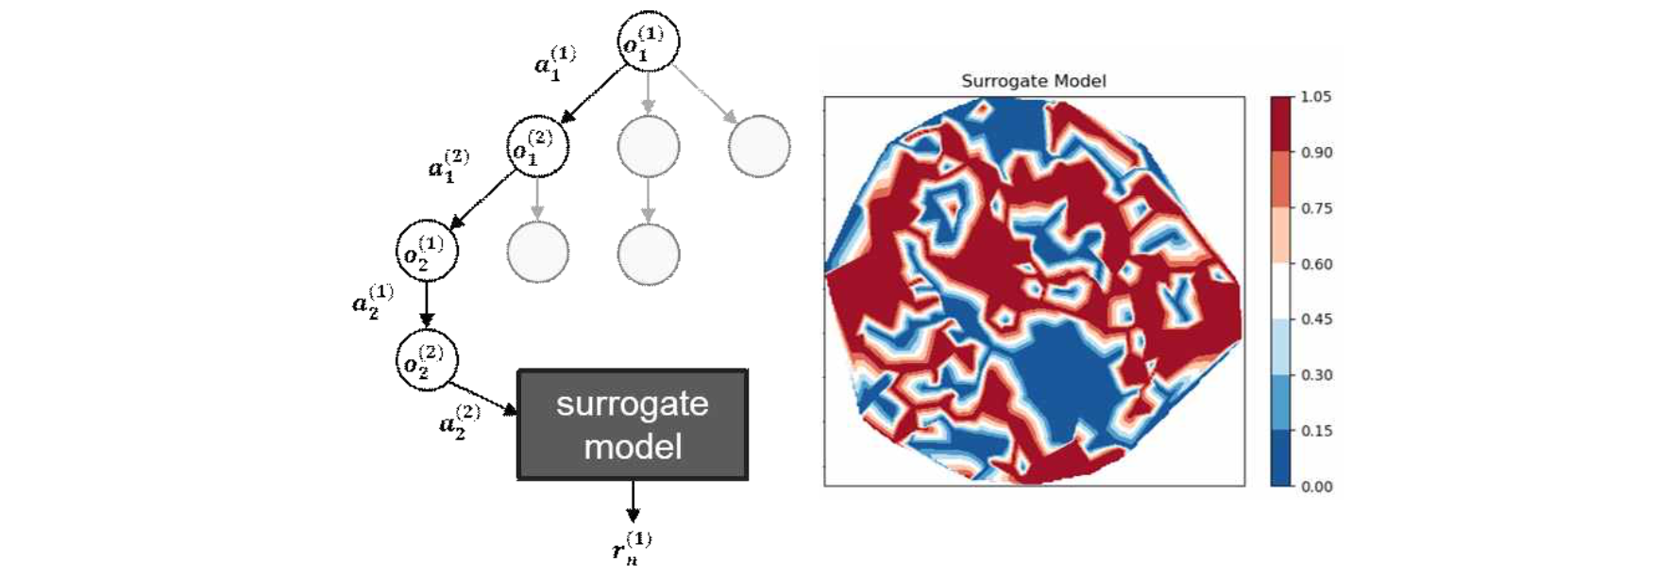▲ Conceptual diagram of MCTS behavior based on alternative models: An alternative model is utilized during simulation for tree traversal to estimate state expectations and make optimal real-time decisions (left), and a schematic of the predicted expectation distribution of an alternative model built by learning from collected data (right).

In addition, the research team succeeded in collecting data for learning alternative models and implementing its own software for data analysis in StarCraft II to increase the scalability and reproducibility of the research.

As a result of learning and applying an alternative model based on the collected data, the game's progress was predicted 10,000 (10⁴) times faster than the existing MCTS.

Professor Chang Wook Ahn said, "The significance of this research outcome is that it made it possible to determine the real-time behavior (e.g., attack, retreat, etc.) of each entity in a real-time game environment where the use of Monte Carlo tree search techniques was not possible. It is expected that in the future it can be used to make real-time decisions in real-world application problems with conflicting interests (autonomous driving, stock trading, etc.)."

This research was conducted with support from the National Research Foundation of Korea's Mid-career Researcher Support Project and the Institute for Information and Communication Technology Planning and Evaluation (IITP) Artificial Intelligence Graduate School Project. The research results were published on July 1, 2024, in 《Engineering Applications of Artificial Intelligence》, an international journal ranked among the top 2.5% in the multidisciplinary engineering field.



