GIST solves ‘109-year difficult problem’ in physics... Reveals angular momentum transfer mechanism in micro-macro world

- Professor Jong Seok Lee’s team from the Department of Physics and Photon Science made the world’s first direct observation of ‘chiral thermal phonons’ through an artificial structure... After the discovery of the ‘Einstein–de Haas effect’ (1915), the principle of angular momentum transfer from the microscopic to the macroscopic world remains a difficult problem
- “By proving that phonons can directly contribute to magnetic transport, it lays the foundation for future convergence research in phonon engineering and spin engineering”... published in the international academic journal 《Nature Nanotechnology》

▲ (From the right) Professor Jong Seok Lee and doctoral student In Hyeok Choi of the Department of Physics and Optical Science

The Gwangju Institute of Science and Technology (GIST, President Kichul Lim) announced that Professor Jong Seok Lee’s team from the Department of Physics and Photon Science succeeded in confirming the creation of chiral thermal phonons* with angular momentum in a magnetic-non-magnetic superlattice* artificial structure.

* superlattice: A structure made up of periodic layers of two or more types of materials, and the thickness of each layer is usually several nanometers.

* chiral thermal phonon: Chiral phonon is a phonon that propagates in a material as the lattice collectively rotates and moves. It has chirality, which is the property of being mirror images of each other but not overlapping. Chiral phonons that follow thermal statistics are called chiral thermal phonons.

The law of conservation of angular momentum* is one of the three most fundamental laws that explain physical phenomena, along with the law of conservation of energy and the law of conservation of momentum. It applies to both the macro world described by classical mechanics and the micro world described by quantum mechanics.

When a figure skater turns, the action of shrinking the body and closing the arms simultaneously reduces the rotational inertia and regulates the rotational speed, and helicopters using their tail blades to balance themselves are real-world examples of the law of conservation of angular momentum.

* law of conservation of angular momentum: This means that the angular momentum of a rotating body is conserved at a constant level unless a rotational force acts from the outside. Since the mass of a rotating object is constant, its rotational speed is inversely proportional. Angular momentum is defined as mass X velocity X radius.

In 1915, Albert Einstein and Wander Johannes de Hass experimentally confirmed through the Einstein-der Haas effect* that angular momentum is conserved from the microscopic world to the macroscopic world, but there was no principle. The transfer of angular momentum from the microscopic world to the macroscopic world has not been known for over 100 years since 1915 due to limitations in ultra-high-speed measurement technology.

* Einstein-de Hass effect: Magnetic dipoles in the microscopic world, randomly aligned within magnetic materials, can be aligned in one direction through external magnetic fields and temperature changes, and the spin angular momentum changes. At this time, the magnetic object in the macroscopic world rotates to satisfy the law of conservation of angular momentum, which is one of the representative effects showing angular momentum transfer between the microscopic and macroscopic worlds.

However, with the rapid development of science and technology, the fact that angular momentum can be transferred from spin in the microscopic world to phonon*, the collective movement of lattices, through spin-lattice interaction* was discovered by a research team at the Universität Konstanz in Germany in 2022. It was experimentally revealed in [Nature 602, 73 (2022)]. At this time, the phonon that receives angular momentum is called a chiral phonon, and it is a key angular momentum transfer medium that connects the microscopic world and the macroscopic world.

* spin-lattice interaction: A phenomenon in which spin, one of the basic physical quantities of particles, and repeatedly arranged lattice inside a solid are strongly influenced by each other.

* phonon: The collective movement of a lattice, a structure repeatedly arranged according to the rules of symmetry.

Nevertheless, there is a vast temporal gap between the generation of chiral phonons (a few picoseconds*) and the Einstein-der Haas effect (a few milliseconds*), and what happens in between remains a mystery to this day.

* Picosecond: trillionth of a second = 10⁻¹² seconds

* Millisecond: 1/1000th of a second = 10⁻³ seconds

The research team created an artificial heterostructure in the form of a superlattice combining magnetic oxide SrRuO3 and non-magnetic oxide SrTiO3. By directly observing the generation of chiral thermal phonons that follow Bose-Einstein statistics* for the first time in the world, they succeeded in solving the mystery of angular momentum transfer between trillionths of a second and one thousandth of a second.

* Bose-Einstein statistics: statistical distribution that boson particles such as phonons follow in thermal equilibrium

The research team induced ultrafast demagnetization* from the magnetic oxide strontium rutherate (SrRuO3)* through photoexcitation* and generated chiral thermal phonons. The chiral thermal phonon generated in this way is transferred to the adjacent non-magnetic strontium titanate (SrTiO3)* layer and forms a large magnetic moment through the dynamic multiferroic effect*.

* photoexcitation: A method of irradiating high energy light to electrons in the ground state to make them excited.

* strontium rutherate (SrRuO3): A perovskite transition metal oxide that has both conductivity and magnetism. It shows strong spin-lattice interaction and is widely used in research in various spintronics fields, such as ‘spin-orbit torque (SOT)’ research.

* strontium titanate (SrTiO3): A perovskite transition metal oxide like SrRuO3. Unlike SrRuO3, it is an insulator and has no magnetism. In addition, strontium titanate has been known as a material with relatively weak electron-to-electron interaction or electron-to-lattice bonding because it has the fewest electrons occupying the d orbital of titanium, a transition metal, compared to other transition metals.

* ultra-fast demagnetization: A phenomenon in which magnetization in a magnetic material is reduced ultra-fast (several picoseconds) by light energy.

* dynamical mutiferroicity: A phenomenon in which a current loop is formed by rotating charged ions and a magnetic moment is formed according to Ampere's law.

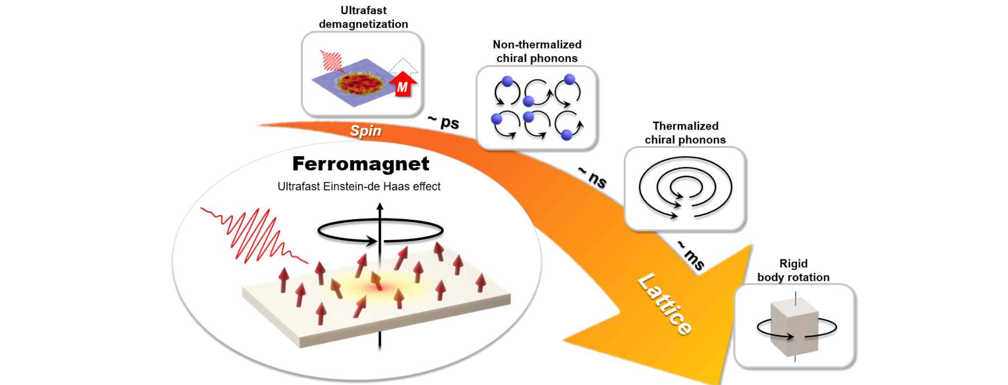▲ The process of angular momentum transfer within a magnetic material from the microscopic world (spin) to the macroscopic world (material rotation). Induces ultrafast demagnetization through photoexcitation. At this time, the process in which the reduced angular momentum of the spin is transferred to the chiral phonon can be observed in real time through the SrRuO3/SrTiO3 superlattice and the time-resolved magneto-optical Kerr effect.

The research team succeeded in observing the magnetic moment generated by chiral thermal phonons in the SrRuO3/SrTiO3 superlattice in real time through time-resolved magneto-optic Kerr effect measurement* using a femtosecond laser. It was experimentally revealed that chiral thermal phonons play an important role immediately after chiral phonons are generated until rotation of the material occurs.

* time-resolved magneto-optical Kerr effect measurement: A technology that can track the magnetic properties of photoexcited materials in femtoseconds (one trillionth of a second) using the path difference between the pump beam and the probe beam.

Professor Jong Seok Lee said, "This study demonstrates that phonons can directly contribute to magnetic transport, and shows the possibility that a point of contact between spin engineering and phonon engineering may exist, and it can be evaluated as presenting an important stepping stone for the development of multifunctional nanodevices combining magnetic and thermal functionality in the future."

This research, led by Professor Jong Seok Lee of GIST's Department of Physics and Photon Science and conducted by doctoral student In Hyeok Choi as the first author, was supported by the National Research Foundation of Korea's mid-career researcher project, new researcher project, and nano and materials technology development project. The research results were published online on July 12, 2024, in Nature Nanotechnology, a world-renowned academic journal in the field of basic and applied research in materials science.



