GIST develops a film-type nanoreactor that can be cut to the desired size and shape and used repeatedly

- Professor Ji-Woong Park's team in the School of Materials Science and Engineering has overcome the shortcomings of existing nanoreactors with a new three-dimensional nanoporous polymer film manufacturing method and technology to evenly form metal nanoparticles at a constant density along the inner wall of the pores
- Pioneering the field of membrane catalytic reactor materials that can improve yield and selectivity by causing chemical reactions in a limited nanospace... Selected as a cover paper for the international academic journal 「Small」

▲ (From the right) Professor Ji-Woong Park and doctoral student Dawoon Jeong of the School of Materials Science and Engineering

Recently, research is being actively conducted to increase yield or selectivity by placing a catalyst in a structure with nanopores and causing a chemical reaction within this space.

The Gwangju Institute of Science and Technology (GIST, President Kichul Lim) announced that Professor Ji-Woong Park's team in the School of Materials Science and Engineering has developed a film-type nanoreactor* that can be cut to the desired size and shape and reused repeatedly.

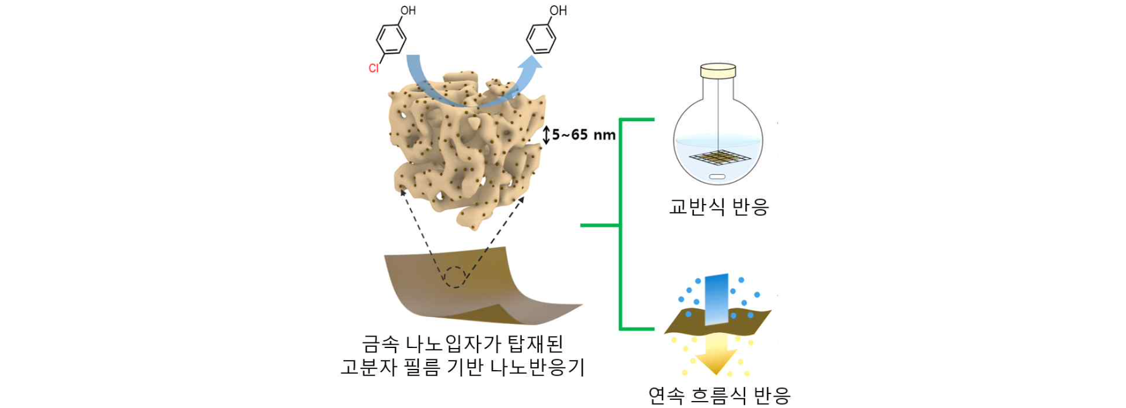▲ Polymer film-based nanoreactor loaded with metal nanoparticles. The synthesized nanoreactor can be effectively applied to stirred as well as continuous flow reaction systems.

The results of this research are expected to be utilized in the fields of pharmaceuticals and fine chemistry, as well as devices that use chemical reactions as a medium.

* nanoreactor: A nanostructure that contains a catalyst in a space with a size ranging from several nanometers to hundreds of nanometers, and allows reactants to flow in from the outside to cause a chemical reaction and then release the product.

The 'porous membrane film-type nanoreactor' developed by the research team has the function of converting reactants into products as they pass through the nanoporous film, and has the characteristics of a nanoreactor that can increase yield and selectivity by allowing chemical reactions to occur in the nanospace containing the catalyst. It solves the disadvantages of existing nanoreactors such as ▴ complex manufacturing method ▴ difficult to control catalyst amount and particle size ▴ difficulty in post-use recovery and reuse, and it has the advantage of being easy to scale up and can be effectively applied to continuous flow reaction systems as well as stirred reactions.

Nanoreactors can mainly be divided into a colloid type made by dispersing porous particles containing a catalyst in a reaction solution and a solid support type made by forming a porous structure containing a catalyst on a solid substrate.

The colloidal form is difficult to recover and reuse, and the solid support form is immersed in an excessive amount of metal precursor solution to form a catalyst, so expensive metal raw materials are inevitably wasted, and performance is reduced due to catalyst leaching, making repeated use difficult.

Therefore, it is necessary to develop a nanoreactor structure that can be quantitatively loaded with catalysts without using excessive precursors, manufactured in a way that can control the size and distribution of catalyst particles, and is easy to recover and use repeatedly.

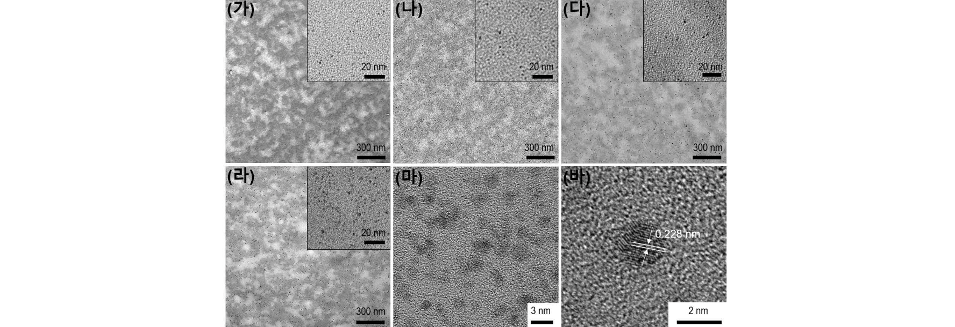▲ Transmission electron micrograph of the cross-sectional area of ​​the film according to the amount of metal nanoparticles loaded in the polymer film. (가-라) As the amount of supported metal increases, the number can be adjusted while maintaining the size (1~2nm) of nanoparticles uniformly. (마,바) Enlarged picture of (라). Nanoparticles of precise size are evenly distributed.

The ‘porous membrane nanoreactor’ has a channel structure in which pores with a width ranging from a few nanometers to tens of nanometers are connected like a three-dimensional maze, and it is well maintained without being deformed or depressed at high temperatures or in organic solvents.

When this membrane is immersed in a solution of metal precursor*, the amount and density of metal nanoparticles formed in the nanoreactor are precisely controlled by using the characteristic that the amount of metal precursor adsorbed on the surface of the inner wall of the nanopore is precisely controlled depending on the concentration.

At this time, the metal nanoparticles evenly formed on the inner wall of the nanopore act as a catalyst for the chemical reaction of the reactant flowing into the pore. Chemical reactions that occur in an environment where the diffusion of molecules or the inflow of external substances are restricted by nanopores may result in improved yields or different compositions of reaction products than in large reaction vessels.

* precursor: a compound at the stage before being transformed into a substance through a chemical reaction

The research team synthesized a nanoporous polymer film with three-dimensionally connected pore channels coated with chemical functional groups friendly to palladium precursors, and it quantitatively and uniformly adsorbed palladium precursors to the inner walls of the pores. Through reduction, a nanoreactor loaded with palladium nanoparticles was manufactured.

In a stirred reactor, when the film-type nanoreactor is immersed in a container and the reaction solution is stirred, the reactants/products easily move in and out along the three-dimensional channel and a chemical reaction occurs. When the reaction is complete, the film can be picked up and placed in a new reaction solution for repeated use.

In a continuous flow reactor, the reaction solution is pressed through one side of the nanoreactor film and the product solution flows out the other side. In this case, the reaction yield and selectivity can be controlled by controlling the concentration and flow rate of the solution.

As a result of conducting a dechlorination reaction* of organic chlorine compounds, which are water pollutants, the research team confirmed that the activity of the catalyst was maintained without decreasing even if it was reused in a stirred reaction more than 10 times or continued in a continuous flow reaction for more than 200 hours.

* dechlorination reaction: A catalytic reaction that removes chlorine from organic compounds containing chlorine (Cl).

The characteristic of this synthesis method is that it can precisely control the amount of metal precursor adsorbed along the pore inner wall of the polymer film. By reducing the adsorbed precursor, the metal nanoparticles produced can be uniformly distributed on the inner wall of the pore while maintaining the size of 1 to 2 nanometers.

In addition, unlike existing synthesis methods, the precursor solution remaining after adsorbing the precursor can be reused, preventing metal waste, making it environmentally friendly.

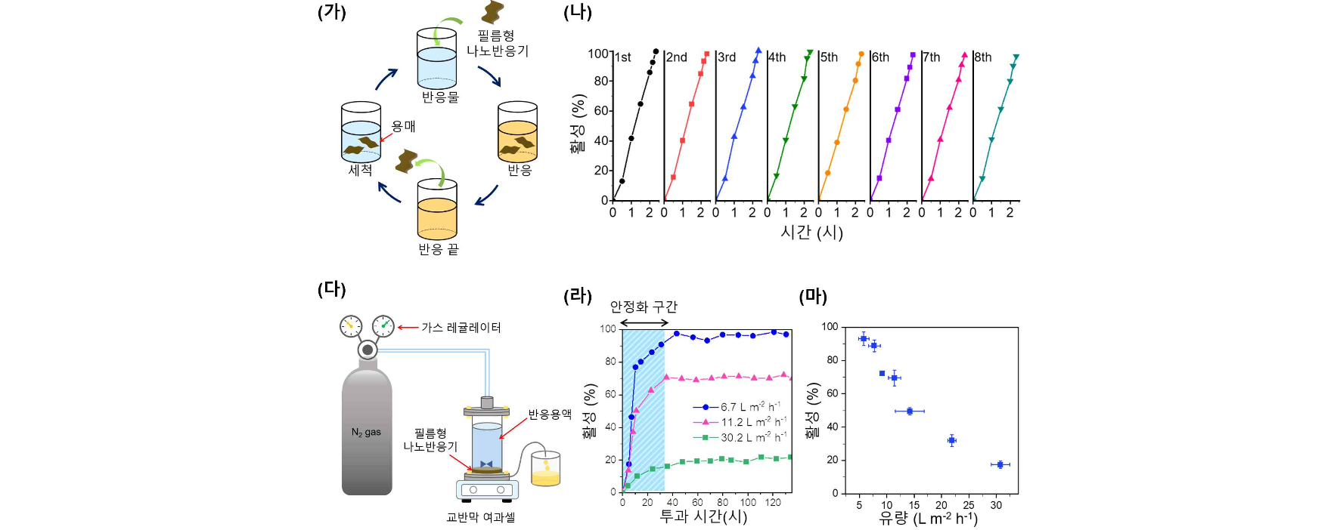▲ Catalytic performance test of a film-type nanoreactor loaded with metal nanoparticles. (가,나) Catalyst performance was maintained even after the reuse test process and eight reuse tests in the stirred reaction. (다-마) (다) Continuous flow reaction model diagram and (라,마) Activity change according to fluid flow rate control and long-term reaction test results of about 100 hours.

Professor Ji-Woong Park said, "The film-type nanoreactor can easily load other types of metal catalysts or enzymes, and it can be used to develop efficient and eco-friendly compound manufacturing methods or to create desired shapes and to be embedded in portable devices as chemical sensors or reactors."

This research, led by Professor Ji-Woong Park's team in the School of Materials Science and Engineering and conducted by doctoral student Dawoon Jeong and Dr. Wangsuk Oh, was supported by the Basic Research Project (Mid-career Research) of the National Research Foundation of Korea and was published as the back cover in ‘Small’, a top 10% international academic journal in the materials science field, on July 18, 2024.

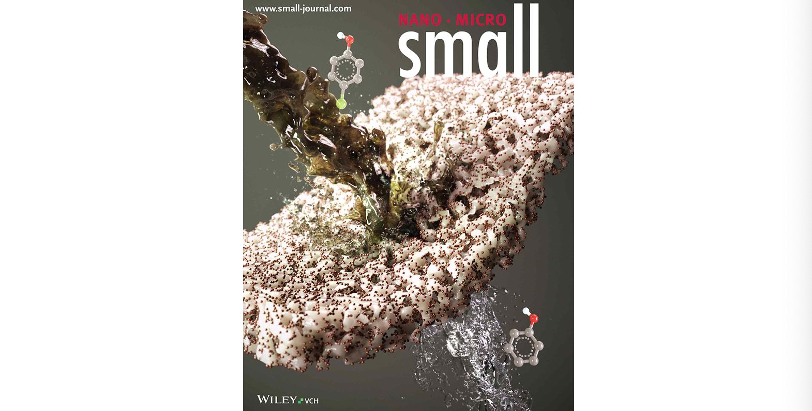
▲ Selected as ‘Small’ back cover in recognition of its excellence



