Korea-Switzerland joint research team develops new perovskite defect control technology that significantly improves solar cell efficiency and stability

- GIST Professor Hobeom Kim’s team – Swiss Federal Institute of Technology Lausanne – Korea Research Institute of Chemical Technology joint research team developed new perovskite defect control technology by introducing ‘6H perovskite crystal polymorph’
- Effective defect control is possible while maintaining material uniformity and crystallinity, so it is expected to be applied to various optoelectronic devices... Perovskite solar module achieved the world's highest level of efficiency of 21.92% (officially certified by Newport, USA)
- Published in the international academic journal 「Nature Communications」... Selected as one of the Editor’s Highlights, which selects the 50 best papers in the field recently published

▲ (From left) GIST Professor Hobeom Kim, Swiss Federal Institute of Technology Lausanne Professor Nazeeruddin, Professor Paul Dyson, Korea Research Institute of Chemical Technology Senior Researcher Nam Joong Jeon and Dr. So-Min Yoo

At the Gwangju Institute of Science and Technology (GIST, President Lim Ki-cheol), announced that Professor Hobeom Kim's team from the School of Materials Science and Engineering and a joint research team from the Swiss Federal Institute of Technology Lausanne (EPFL) and the Korea Research Institute of Chemical Technology (KRICT) have dramatically improved the efficiency and stability of perovskite solar cells*by developing a defect control technology.

By utilizing '6H perovskite crystal polymorph*', they overcame the limitations of existing perovskite defect control technology in terms of perovskite material uniformity and crystallinity preservation and opened a new paradigm in perovskite defect control research.

* perovskite solar cell: A solar cell that uses metal halide perovskite material as a photoactive layer to absorb sunlight. Recently, an efficiency level equivalent to that of silicon solar cells was reported. Due to its advantages such as low manufacturing cost, easy production process, and flexibility, it is receiving great attention as a next-generation solar cell that will succeed silicon solar cells.

* defect: A part of the crystal structure that deviates from the ideal atomic arrangement. Defects in perovskite deteriorate the material's optoelectronic properties and structural stability.

* crystal polymorph: Refers to a substance that has the same chemical composition but has a different crystal structure due to a different stacking order. In the case of FAPbI3, a perovskite material typically used in perovskite solar cells, various perovskite crystal polymorphs such as 3C, 2H, and 6H exist depending on the stacking order of the [PbI6]4- octahedron. Here, the number refers to the number of octahedral layers within the stacking unit, and the letters refers to the crystal structure (C: cubic, H: hexagonal).

Based on its excellent optoelectronic properties, perovskite is attracting attention as a light absorption material for next-generation solar cells, but crystal defects are known to be a factor that hinders the efficiency and stability of perovskite solar cells.

Therefore, defect control is essential to realize high-efficiency and high-stability perovskite solar cells for commercialization, and so far, the method of introducing external chemical species* and low-dimensional perovskite* has been mainly chosen.

However, the defect control method through the introduction of heterogeneous molecules has the limitation of lowering the material uniformity and crystallinity of perovskite, and the development of new defect control technology to overcome these limitations is required.

* external chemical species: Refers to other chemical additives excluding perovskite precursors. Research on introducing external chemical species such as Lewis-base agents, alkali metals, and polymers to control perovskite defects is continuously reported.

* low-dimensional perovskite: It has a perovskite structure, but has a reduced dimension and refers to a two-dimensional or quasi-two-dimensional (quasi-2D) perovskite. Based on its high formation energy, it has excellent thermodynamic stability and can be used as a perovskite defect control element.

Through joint research with Professor Nazeeruddin's team at the Swiss Federal Institute of Technology Lausanne, Professor Dyson's team, and the Korea Research Institute of Chemical Technology's Senior Researcher Nam Joong Jeon's research team, GIST School of Materials Science and Engineering Professor Hobeom Kim's team has developed a new technology for controlling perovskite defects using '6H perovskite crystal polymorphs containing vertex covalent components' and realized high-efficiency and highly stable perovskite solar cell devices and modules.

FAPbI3, a perovskite material commonly used in perovskite solar cells, exists in a variety of crystal polymorphs, most notably 3C (composed of 100% corner-sharing), which exhibits superior optoelectronic properties, and 2H (composed of 100% face-sharing), which has inferior optoelectronic properties.

The 6H polymorph has a high lattice coherency with the 3C polymorph for the photoactive layer because it contains 66% of the vertex sharing component. Therefore, the 6H polymorph can be used as an effective defect control element of the 3C polymorph, and since it has the exact same chemical composition as the 3C polymorph, it can maintain the material uniformity and crystallinity of the perovskite.

Using X-ray diffractometer (XRD) analysis and molecular dynamics simulations, the researchers demonstrated the coherent intervention* of halides at vertex-sharing sites between the two phases, 3C and 6H, and confirmed the formation of a 3C/6H hetero-polytype.

* Correlative intervention of halide: Based on the high lattice correlation between 3C and 6H, sharing and intervention of halides located at the vertices of the [PbI6]4- octahedron between the two phases are possible.

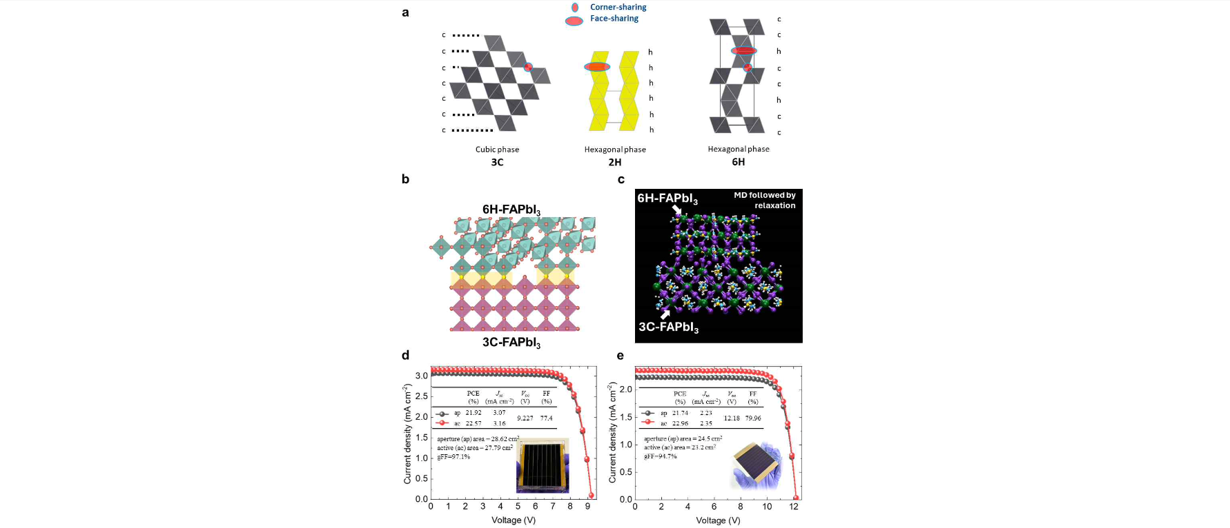[Figure 1] 3C/6H heterocrystalline polymorphs and their application in perovskite solar cells
(a) Crystal structures of 3C-, 2H-, and 6H perovskite crystal polymorphs (b) Structure of the developed 3C/6H heterocrystalline polymorph (c) Molecular dynamics simulation showing the 3C crystal polymorph stabilized by the introduction of 6H crystal polymorphs
(d) Performance and photographs of perovskite solar modules with 3C/6H heterocrystalline polymorphs and surface passivation (e) Performance and photographs of low-temperature process perovskite solar modules with 3C/6H heterocrystalline polymorphs and surface passivation

It was confirmed that this 3C/6H heterocrystalline polymorph perovskite exhibits much better optoelectronic properties than 3C perovskite based on the defect control effect of 6H.

By applying 3C/6H heterocrystalline polymorphic perovskite and surface passivation (covering a protective film), a module efficiency of 21.92% (area: 28.62 cm2) and a low-temperature process module efficiency of 21.74% (area: 24.5 cm2) were achieved. This is the world's highest level among perovskite modules of similar area, and received official certification (certified efficiency: 21.44%) from Newport, a U.S. solar cell efficiency certification agency.

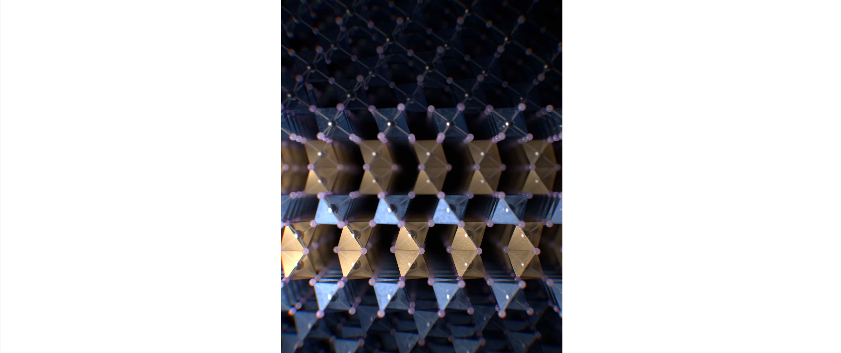▲ 3C/6H heterocrystal polymorph illustration

Professor Hobeom Kim said, "Unlike existing perovskite defect control technologies, this research result enables effective perovskite defect control while maintaining material uniformity and crystallinity. While opening a new chapter in perovskite defect control research in the future, it is also expected to be applied to various perovskite optoelectronic devices such as perovskite light emitting diodes and photodetectors.

This research, conducted by GIST Professor Hobeom Kim's team, was carried out with support from the National Research Foundation of Korea (NRF), National Research Council of Science and Technology (NST), Korea Research Institute of Chemical Technology, Swiss National Science Foundation (SNSF), and the European Union's Horizon 2020 research and innovation program.

The research results, published online on July 4, 2024, in the international academic journal ‘Nature Communications’, were selected as one of the Editors' Highlights, which selects the 50 best recently published papers in the field.



