Developing a human-scale magnetic particle imaging (MPI) device using superconducting coils could lead to personalized brain disease treatment

- GIST Professor Jungwon Yoon's team developed a human-scale MPI device that was previously used only for small animals, costing billions of won, and applied it to the human body by fusing it with a superconductor coil
- Reduces the risk of peripheral nerve stimulation and maximizes safe treatment effects through targeting within the human body, “Expected to utilize nanoparticle medical imaging as a next-generation technology for patient-tailored intractable brain diseases.”
- Published in the international academic journal 「IEEE Transactions on Medical Imaging」

▲ (From left) Professor Jungwon Yoon, postdoctoral researcher Tuan-Anh Le

A human-scale magnetic particle imaging (MPI) device that can acquire high-resolution biomedical images of the human body and a technology that can pinpoint the amount and site of drugs needed to treat brain diseases to maximize treatment effects while remaining safe has been developed through joint research between industry and academia in Korea.

This research is expected to be used for patient-tailored treatment of incurable brain diseases using nanoparticles as a next-generation medical imaging technology that is safe and can maximize effectiveness.

* magnetic particle imaging (MPI): A non-invasive molecular imaging device that can image the concentration and location of only iron oxide nanoparticles that are harmless to living organisms. It can operate without radiation and can capture 3D distribution images in real time, so it can be used in various medical fields such as diagnosis of cardiovascular and cerebrovascular diseases, cell labeling and tracking, and targeted drug delivery. Nanoparticles used as tracers in MPI are not only able to pass through the blood-brain barrier (BBB), but also provide therapeutic functions such as targeting and diagnosis of brain lesions, fever, etc., thereby providing treatment for existing brain diseases. limitations can be overcome.

The Gwangju Institute of Science and Technology (GIST, President Kichul Lim) announced a research team led by Professor Jungwon Yoon (Director of the Brain Nanorobot Research Center) in the School of Integrated Technology has succeeded in developing the world's first human-scale three-dimensional magnetic particle imaging (MPI) device based on superconductor coils that can capture nanoparticle distributions in real time by using superconductor coils instead of conventional electromagnetic coils.

This device is a human-scale MPI system that uses magnetic nanoparticles as tracers to obtain high-resolution high-gradient magnetic fields necessary for imaging the human brain region.

MPI technology is a next-generation medical imaging technology that has been developed only by a few companies in advanced medical imaging countries such as the United States, Germany, and Japan, and preclinical (clinical testing on animals) equipment with an aperture of 12 cm is sold for billions of won. Existing MPI devices have been used only for high-resolution medical imaging in small animals due to their physical properties that cause peripheral nerve stimulation.

In order to take images of the human body, a wide viewing angle must be secured, and for this purpose, if the size of the bore is increased, the gradient magnetic field* decreases rapidly, resulting in low-resolution images. Therefore, the key is to develop technology that provides high resolution while securing a wide field of view (FOV).

* magnetic gradient field (unit: T/m): It can be defined as the change in magnetic field (ΔB) divided by the change in distance (Δs). In MPI, through the generation of a gradient magnetic field, a field free point (FFP) can be created where magnetic nanoparticles react to the excitation field and generate an electric signal. As the gradient magnetic field is turned on, the field free point becomes more active. As the size of (FFP) becomes smaller, image precision can be improved.

Currently, human-scale magnetic particle imaging (MPI) devices developed globally can only generate gradient magnetic fields of 0.5T/m or less when they have similar bore sizes. Due to the limitations of image restoration techniques and magnetic nanoparticles, a gradient magnetic field of 2T/m or more is required for application to humans.

The research team developed an MPI system that can be used on the human body while maintaining high resolution with a high gradient magnetic field of up to 2.5T/m, which is increased by 5 times using a superconducting coil in a bore size of 200mm.

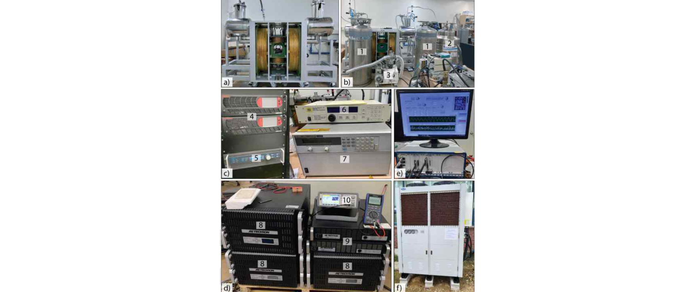▲ AM-MPI20 device based on superconducting coils applicable to the human body: a) MPI front view, b) overall configuration of MPI device and cooling equipment, c) DC power supply device (for concentrated coil, superconducting coil charging), d) waveform generator (Function generator) and power amplification device, e) computer interface device, f) cooling device: cools the superconductor coil through equipment 1, 2, and 3, and maintains a vacuum state in the process. The electromagnetic coil is charged through devices 4, 5, 8, and 9, and the superconductor coil is charged through devices 6 and 7. The entire process is monitored through e, 10 equipment, and the electromagnetic coil is cooled through f equipment.

The amplitude modulation MPI method developed by the team separates the coil required for imaging scanning from the excitation coil that generates the signal from the nanoparticles, minimizing the size, weight, and power requirements of MPI and providing a high gradient magnetic field while reducing the risk of peripheral nerve stimulation (PNS).

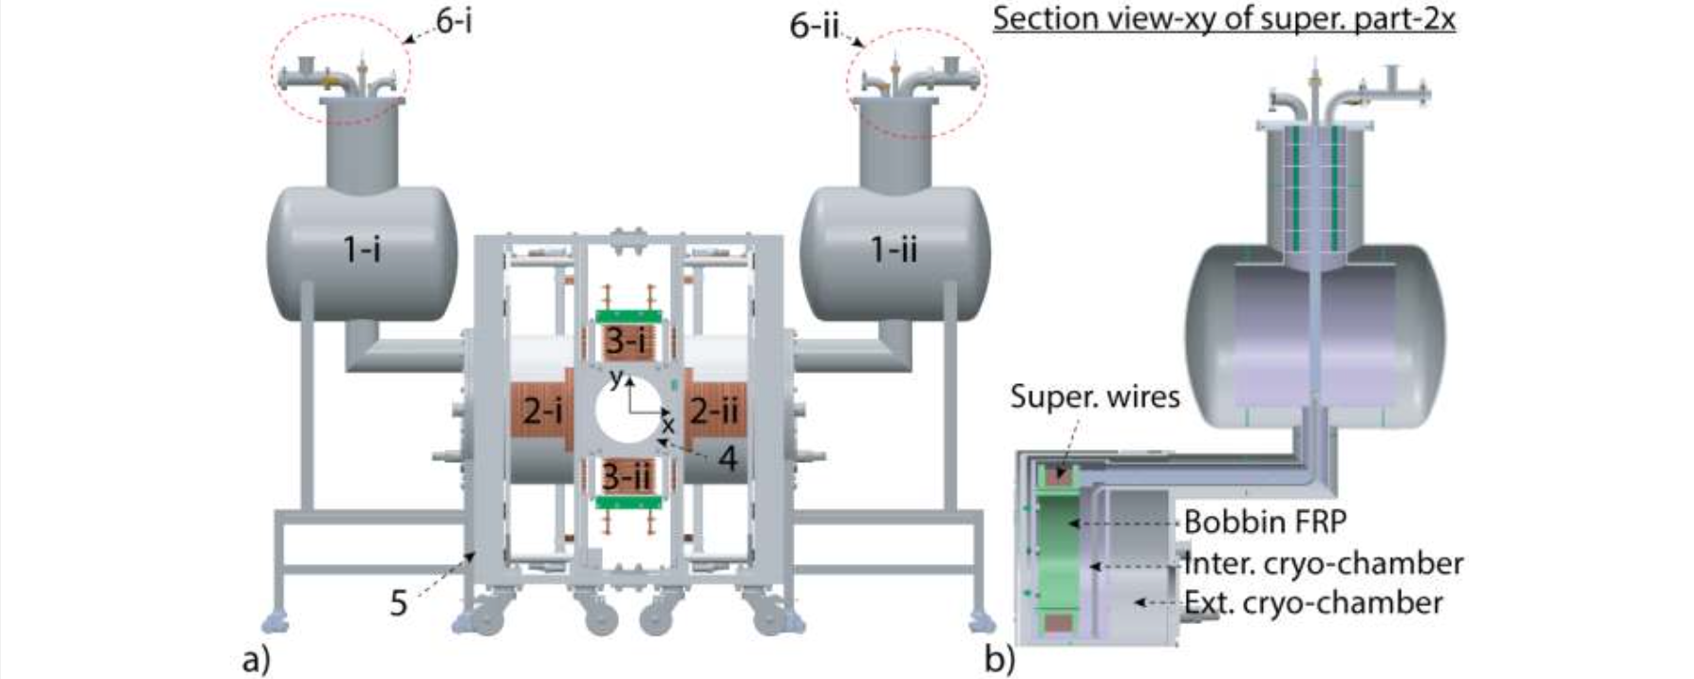▲ Human-scale MPI overall configuration diagram: (a) overall MPI system structure, (b) cross-sectional view of superconductor coil and cooling chamber: liquid helium and nitrogen to cool the superconductor coil are injected through hole 6. Position 2 contains a superconducting coil and an electromagnetic coil of MPI configuration, and as in structure (b), the superconducting coil is separated from the external electromagnetic coil.

The research team produced a generating coil using a wire containing NbTi superconductor (copper:NbTi=4.5:1). Superconductors have an electrical resistance close to zero, which can minimize power loss and greatly increase power efficiency.

It is very difficult to use superconducting coils in magnetic particle imaging (MPI) devices because the high magnetic field and frequency of the scanning coil to secure a wide viewing angle causes vibration in the system, so there is no actual case of using it on a human scale.

The team stabilized the system by using a focus coil that divides the entire field of view (wFOV) into nine smaller partial fields of view (pFOV), which reduces the amplitude of the scanning coil to significantly reduce the likelihood of quenching*.

In addition, the power loss due to the high-frequency magnetic field of the scanning coil was verified through COMSOL (multi-physics phenomenon analysis software) and ANSYS (structural analysis software), and the heat distribution was calculated to design a stable system that does not exceed the critical temperature of superconducting materials (4.2K = -268.95°C).

* quenching: A phenomenon in which a large amount of liquid helium is vaporized and released to the outside due to loss of superconductivity.

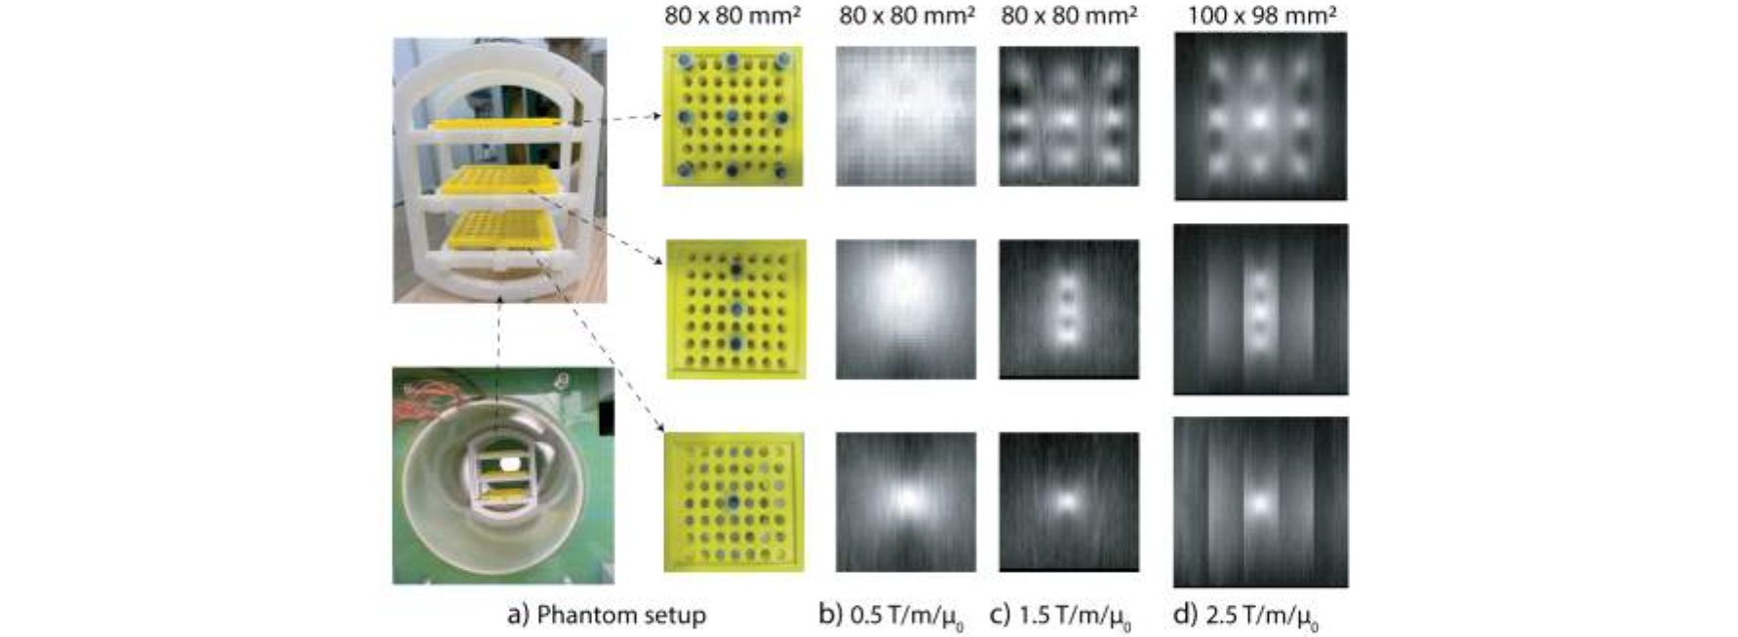▲ 3D image measured with human-scale MPI: a) Actual 3D phantom, b-d) 2D MPI image: The white shining part is the image of magnetic nanoparticles, and it can be seen that the higher the gradient magnetic field, the clearer the image. Looking at the measurement results of 9 samples, it is impossible to identify each sample with the 0.5T/m level gradient magnetic field provided by the existing Human Scale MPI.

Professor Jungwon Yoon said, "MPI technology, which is difficult to expand to human scale due to the limitations of electromagnetic coils, can be used on humans by fusing it with superconductor technology. This can further safely maximize the treatment effect through targeting of nanoparticles within the human body. It is expected that it will contribute to the groundbreaking development of patient-tailored treatments for incurable brain diseases in the future."

This study was led by Professor Jungwon Yoon and postdoctoral researcher Tuan-Anh Le of the GIST School of Integrated Technology and conducted joint research with the Seoul National University research team. In addition, it was carried out with support from the Robot Industry Core Technology Development Project of the Ministry of Trade, Industry and Energy, in which Hanmi Techwin Co., Ltd. participated as a joint research institute.

The research results were published online on June 26, 2024, in ‘IEEE Transactions on Medical Imaging,’ an international academic journal in the field of medical imaging.



