“New battery technology significantly increases the driving range of electric vehicles” GIST and Hyundai Motor Company develop technology to improve the stability of high-energy density lithium metal batteries using a three-dimensional polymer structure

- Joint research between Professor KwangSup Eom's team in the School of Materials Science and Engineering and the Hyundai Motor Company's battery research team... Implementation of a lithium metal battery with double the energy density and lifespan by introducing a three-dimensional polymer structure to the copper current collector of the existing lithium metal negative electrode
- “Proposing a new alternative to solve the instability that occurs during charging and discharging of existing lithium metal batteries” Expected to be used in next-generation electric vehicles... Published in the international academic journal 「Chemical Engineering Journal」

▲ (From the left) Professor KwangSup Eom and doctoral student Jinhyeon Jo

As sales of electric vehicles continue to continue in the global automobile market, interest in next-generation secondary batteries with larger capacity and faster charging and discharging than commercially available lithium-ion batteries is increasing.

Graphite, the anode material* for existing lithium-ion batteries, has almost reached its theoretical limit, and the development of anode materials with higher capacity is needed to increase energy density.

* anode material: Plays an important role in the charging speed and lifespan of the battery by storing and releasing lithium ions from the anode and allowing current to flow.

At the Gwangju Institute of Science and Technology (GIST, President Kichul Lim), Professor KwangSup Eom's team in the School of Materials Science and Engineering, together with the Hyundai Motor Company's battery research team, announced that they have developed technology to improve charging and discharging durability by creating a polymer-coated three-dimensional insulating structure to the cathode to solve the chronic volume expansion problem of high-energy lithium metal batteries.

Lithium metal batteries, which replace graphite with lithium metal as the cathode material, are attracting attention because they can theoretically achieve a cathode capacity 10 times higher than that of lithium-ion batteries.

However, during charging and discharging of a lithium metal battery, dendritic crystals* of lithium grow, penetrating the separator*, causing a short circuit in the battery, and as lithium is plated, volume expansion occurs, causing the battery to swell and damage the inside of the battery. Safety and durability issues, such as increased pressure, are becoming obstacles to commercialization.

* lithium dendrite: During the charging process of a lithium metal battery, lithium is unevenly deposited on the electrode and grows into dendrite. Please refer to the attached glossary.

* separator: A thin film of insulating material that prevents the positive and negative electrodes inside the battery from contacting each other. Related to battery safety.

The researchers designed a rational porous structure using polytetrafluoro ethylene from lithium metal batteries and coated the surface of the three-dimensional structure with polydopamine through a simple autopolymerization reaction to create a three-dimensional structure rich in polar functional groups*.

* polar functional group: This refers to a functional group that has polarity because elements with high electronegativity, such as N, O, and F, are covalently bonded with substances with low electronegativity, and the electrons are relatively shifted to one side.

The insulating properties of the developed three-dimensional structure plated lithium from the inside, and the abundant polarity function homogenized the flow rate of lithium ions, showing the effect of suppressing dendritic crystal growth.

By using the developed three-dimensional polymer structure as a lithium metal anode, the research team succeeded in creating a lithium metal battery with more than twice the energy density and twice the lifespan of the existing copper current collector-based lithium metal anode.

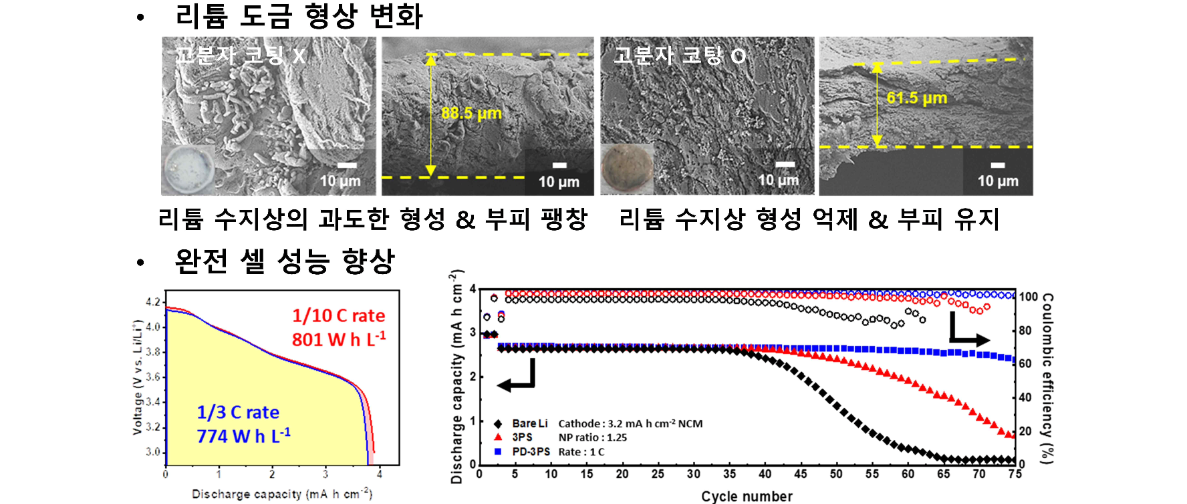▲ Comparison of lithium metal plating shape and full cell performance with and without polydopamine coating: The picture above shows lithium growth formation and volume expansion inhibition in the polymer-coated three-dimensional structure and the improved performance in the full cell.

The capacity of the existing copper current collector decreases rapidly after about 35 charge/discharge cycles, and the developed capacity approaches almost 0 after 60 charge/discharge cycles. The lithium metal anode using the newly developed three-dimensional polymer structure showed exceptionally stable performance of more than 90% of the initial capacity even after more than 75 charge and discharge cycles.

Furthermore, since polymer coating can be performed through a simple self-polymerization process, it is expected to be applicable to all types of porous structures.

In particular, the research team's NCM (nickel, cobalt, manganese) anode-based lithium metal battery (highly integrated NCM anode, NP ratio (cathode/anode capacity ratio): 1.0) using a polymer structure is more than twice as large as the existing lithium ion battery. It showed a discharge-based energy density of up to 801 Wh/L.

Therefore, when a battery of the same size is installed in the same electric vehicle, the lithium metal battery developed in this study can significantly improve driving distance by storing more than twice the energy.

Professor KwangSup Eom said, "The results of this research suggest a new alternative that can solve the problem of imbalanced protrusion formation (dendrite) and resulting volume expansion that occurs during charging and discharging, which are chronic problems of existing lithium metal batteries. If high-energy lithium metal batteries with guaranteed stability become available for next-generation electric vehicles in the future, the driving range of electric vehicles on a single charge will be able to be greatly improved."

This research, led by Professor KwangSup Eom of the GIST School of Materials Science and Engineering and led by doctoral student Jinhyeon Jo, was conducted in collaboration with the Hyundai Motor Company's battery research team and was supported by the National Research Foundation of Korea and the GIST Advanced Institute of Instrumental Analysis (GAIA) in addition to Hyundai NGV, and the research results were published online on June 22, 2024, in ‘Chemical Engineering Journal’, a world-renowned academic journal in the top 3.7% in the field of chemical engineering.



