“Spray on damaged muscles to promote regeneration” GIST Professor Jae Young Lee's team develops powder-type hydrogel

- Confirmed recovery of lost muscle function twice after treatment with ‘powdered hydrating gel’
- High therapeutic effect expected due to hemostasis effect and muscle regeneration promotion with excellent adhesiveness... Published in the international academic journal 「Bioactive Materials」

▲ (From the left) Professor Jae Young Lee, Dr. Mingyu Lee, and doctoral student Daun Seo in the School of Materials Science and Engineering

The Gwangju Institute of Science and Technology (GIST, President Kichul Lim) announced that Professor Jae Young Lee’s research team in the School of Materials Science and Engineering has developed a ‘powder-type hydrogel’ that can promote muscle regeneration.

It is in powder form and forms a hydrogel when it comes into contact with water or body fluids. It is easy to store and transport, and its advantage is that it maintains strong adhesion even in high-moisture environments.

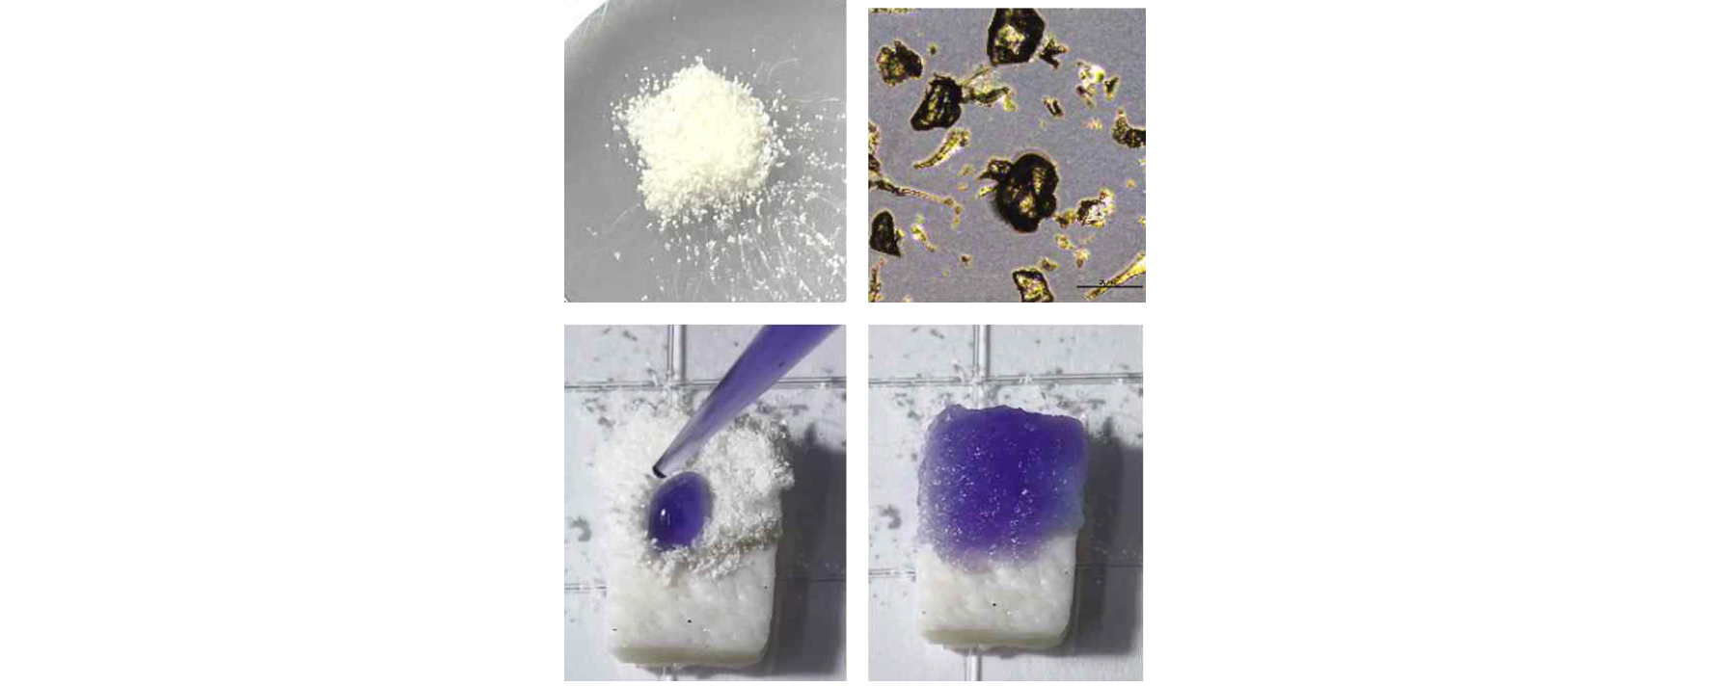▲ Actual appearance and usage process of powdered hydrogel

Traumatic accidents such as collisions and falls cause volumetric muscle loss (VML). Skeletal muscle, which accounts for approximately 30-40% of body weight, is the tissue primarily responsible for movement and force generation in the body. Once loss occurs, caution is needed as it can lead to functional and long-term disability.

Currently, autologous muscle flap transplantation is mainly used as a clinical treatment for skeletal muscle loss, but it is a complex surgical procedure. Not only can it be used in limited areas, but it also has side effects such as incomplete functional recovery, so new research based on biomaterials is urgently needed.

Hydrogels are used in regenerative research due to their many beneficial properties, including mechanical properties similar to those of body tissue.

However, existing hydrogels have a limitation in that their adhesive strength drops significantly in a moist environment. Most biological tissues have high moisture, and it is necessary to develop a hydrogel that can maintain adhesiveness in such environments when bleeding, etc. occurs.

The research team succeeded in producing a ‘powder-type hydrogel’ that can be sprayed and used on damaged muscle tissue with excellent adhesive properties even in a high-moisture environment.

After mixing the biocompatible natural polymer oxidized dextran and gelatin, it was pulverized into particles less than 300 μm in size and designed to have fast and high adhesion even in a high moisture environment.

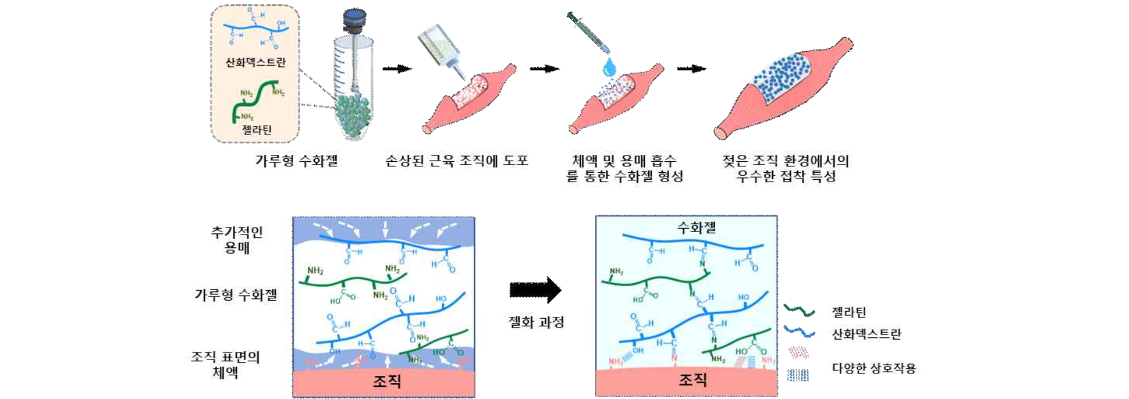▲ Schematic diagram of a powder-type hydrogel that maintains adhesion in a wet environment: A powder-type hydrogel that can form a hydrogel within 5 minutes after absorption of body fluids and solvents, showing excellent adhesion even in a wet tissue environment. It has excellent hemostatic effects due to mechanical properties similar to those of tissue and high adhesion, thereby promoting the regeneration of skeletal muscle when skeletal muscle is lost.

This hydrogel absorbs blood and body fluids on the surface of damaged muscle tissue, spontaneously forming a hydrogel, and exhibits strong adhesive properties with tissue through various molecular interactions.

After absorption of solvent and body fluids, it not only formed a hydrogel within 5 minutes at the application site, but also showed mechanical properties similar to body tissue, promoted regeneration of damaged muscles, and had stable adhesive properties that could sufficiently withstand physical shock. In addition, it was confirmed to have excellent hemostatic effects in the early stages of injury and to be effective in skeletal muscle recovery in damaged muscle areas.

This hydrogel exhibits an adhesion of 10 kPa to skin tissue, and compared to fibrin glue (2 kPa), a bioadhesive currently used for medical purposes, it showed an adhesion approximately 5 times higher.

In addition, it maintains excellent adhesion stably even in a humid environment or in water, and has been confirmed to have excellent biocompatibility with muscle cells and blood.

Therefore, the research team explained that this powder-type hydrogel has a strong hemostatic effect and is effective in regenerating the function and structure of damaged skeletal muscles after muscle loss.

Skeletal muscle regeneration requires hemostatic substances that enable rapid blood absorption and coagulation, strong tissue adhesion, and physical protection of damaged muscles. The hemostatic effect of the ‘powder-type hydrogel’ developed by the research team was confirmed to be 15 times more effective than the group that did not take any measures, and 5 times more effective than fibrin glue.

When this powdered hydrogel was applied to the damaged muscles of experimental rats that had suffered skeletal muscle loss, muscle fibrosis* was reduced, new blood vessels within muscle tissue increased, and inflammatory responses decreased after 3 weeks. As a result, it was confirmed that the strength of the muscle tissue was recovered to about twice that of the group treated with fibrin glue.

* fibrosis: A phenomenon in which fibrous connective tissue accumulates excessively. In the case of fibrous muscle tissue, the muscles become stiff and stiff, and the contractile ability of the muscles decreases, resulting in loss of muscle strength.

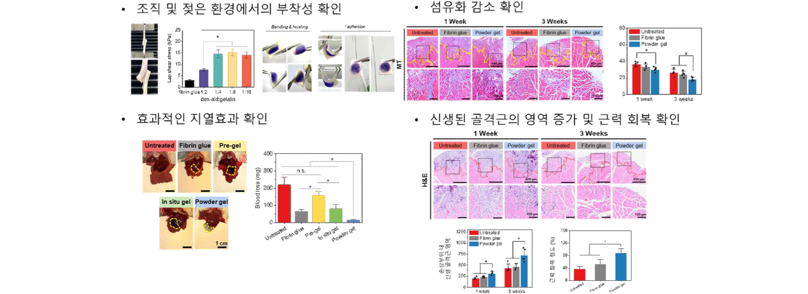▲ Characteristics analysis results of powdered hydrogel: Confirmation of tissue adhesion of powdered hydrogel, excellent adhesion even in a wet environment, reduction of fibrosis, and confirmation of skeletal muscle regeneration and strength recovery.

Professor Jae Young Lee said, "We went beyond the limitations of existing hydrogel treatments and created a powder-type hydrogel that can be easily applied even in a moist environment and exhibits strong and stable adhesion. It has mechanical properties similar to body tissues and is expected to be applied to various biomaterial fields such as scaffolds for tissue engineering and tissue regeneration."

This research, led by Professor Jae Young Lee of GIST's School of Materials Science and Engineering and conducted by Dr. Mingyu Lee and doctoral student Daun Seo, was supported by the National Research Foundation of Korea's Mid-career Researcher Support Project and the Nano and Materials Technology Development Project, and was published on June 14, 2024, in 'Bioactive Materials,' a top 1% journal in the field of biomaterials.



