GIST developed a bioelectrode with improved performance and durability by introducing powerful antioxidant substances

- School of Materials Science and Engineering Professors Jae Young Lee and Giyoong Tae's joint research team developed a bioimplantable electrode that effectively alleviates immune foreign body reactions and maintains stable performance over a long period of time using ‘hemin’, an antioxidant derived from hemoglobin
- Shows antioxidant efficacy at the level of antioxidant enzymes in the body and effectively removes reactive oxygen species... “High versatility for various implantable electronic medical devices”, published in the international academic journal 「Chemical Engineering Journal」

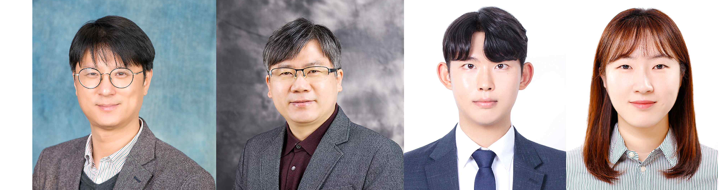▲ (From left) School of Materials Science and Engineering Professor Jae Young Lee, Professor Giyoong Tae, Dr. Sanghun Lee, and Dr. Kiyoon Min

A Korean research team has developed a high-performance bioelectrode that is excellent for effectively alleviating inflammatory reactions that can occur when medical electronic devices are implanted into the body and maintaining long-term stability.

The Gwangju Institute of Science and Technology (GIST, President Kichul Lim) announced that the joint research team of Professors Jae Young Lee and Giyoong Tae of the School of Materials Science and Engineering has developed a technology to effectively reduce foreign body immune response* by introducing antioxidant* substances into implantable bioelectrodes.

* antioxidation: Refers to the inhibition of oxidation, and is a mechanism that protects the human body from oxidative stress by mainly removing free radicals.

* foreign body immune response: It is the body's immune system's own defense response, and it is a series of immune responses that recognize an implanted foreign substance as a foreign body and attempt to separate it from surrounding cell tissue.

Implantable bioelectrodes are a core component of medical electronic devices that record biosignals such as electrocardiograms and electroencephalograms or apply electrical stimulation to muscles and nerves to diagnose health conditions and treat diseases.

However, the immune foreign body reaction that inevitably occurs due to materials implanted in the body forms thick scar tissue around the implanted bioelectrode, interfering with the transmission of electrical signals and acting as the biggest factor in impeding the performance of the electrode.

Therefore, in order to reduce this immune foreign body reaction, research focusing on controlling the response of macrophages*, which control inflammation occurring in the human body, has been actively conducted.

* macrophage: A major immune cell responsible for innate immunity. Depending on the biological environment, it exhibits conflicting characteristics of inflammatory (M1), which promotes inflammation, or anti-inflammatory (M2), which resolves inflammation. The change in their phenotype is called polarization of macrophages.

The research team designed the development of a bioelectrode with strong antioxidant capacity based on the fact that oxidative stress accumulating around implants is one of the main causes of inflammatory responses in macrophages.

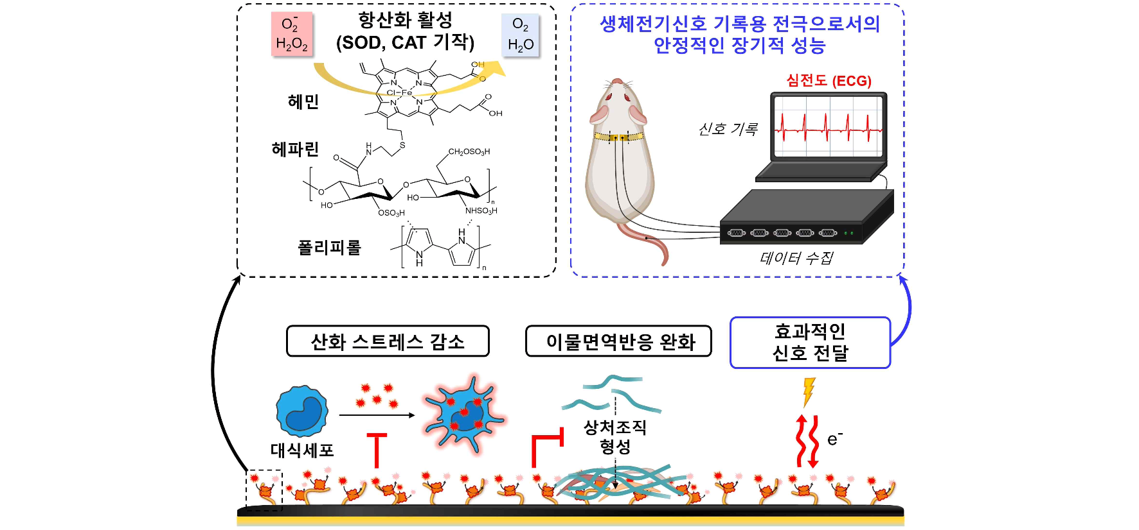▲ Schematic diagram of a polypyrrole/hemin-heparin electrode with antioxidant properties. Electrodes incorporating the antioxidant ability of hemin effectively remove reactive oxygen species, reducing oxidative stress in macrophages and alleviating foreign body immune responses, and ensuring the stability of implantable bioelectrodes.

The direction of the research was to introduce hemin, a powerful antioxidant derived from hemoglobin, into bioelectrode materials. However, hemin has low hydrophilicity, so in order to use it by itself, an organic solvent-based process rather than an aqueous solution is required.

To overcome this limitation, the research team chemically bonded hemin to heparin*, a hydrophilic biopolymer. The synthesized hemin-conjugated heparin is easily soluble in water and can be used as a dopant* in thin films of polypyrrole*, an electrically conductive polymer.

* heparin: A biopolymer that exists in the human body and has anticoagulant and anti-inflammatory effects.

* dopant: An impurity added to make a semiconductor p-type or n-type, or to compensate for the effect of already existing impurities.

Furthermore, representative reactive oxygen species, hydrogen peroxide and superoxide anion, were effectively removed. In addition, as a result of culturing macrophages on polypyrrole/hemin-heparin electrodes, the amount of reactive oxygen species inside macrophages decreased by 27% compared to the gold electrode*, and the resulting production of inflammatory cytokines (IL-6) decreased to 9%.

* gold electrode: An electrode plated with gold that is chemically inert, biocompatible, and highly electrically conductive.

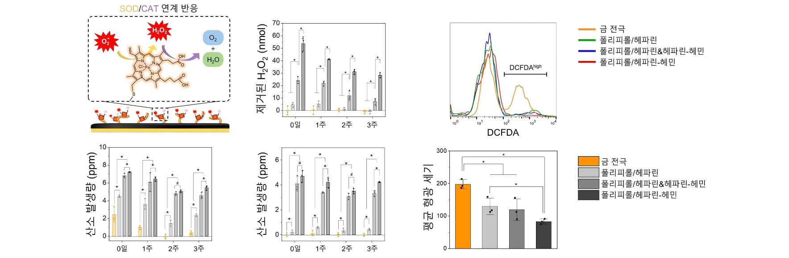▲ Evaluating the efficiency of removing active oxygen and confirming the effect of reducing the concentration of active oxygen in cells. It was confirmed that hydrogen peroxide and superoxide anion were effectively removed to generate oxygen and that the intracellular concentration of active oxygen in macrophages cultured on the electrode was reduced.

When the developed bioelectrode was implanted subcutaneously in a mouse experimental model, the proportion of macrophages polarized into an inflammatory phenotype decreased to 80% compared to the gold electrode.

In addition, the thickness of the scar tissue formed around the electrode was reduced to 53%, and real-time ECG signals could be measured while maintaining high signal sensitivity without loss of signal sensitivity for 20 days.

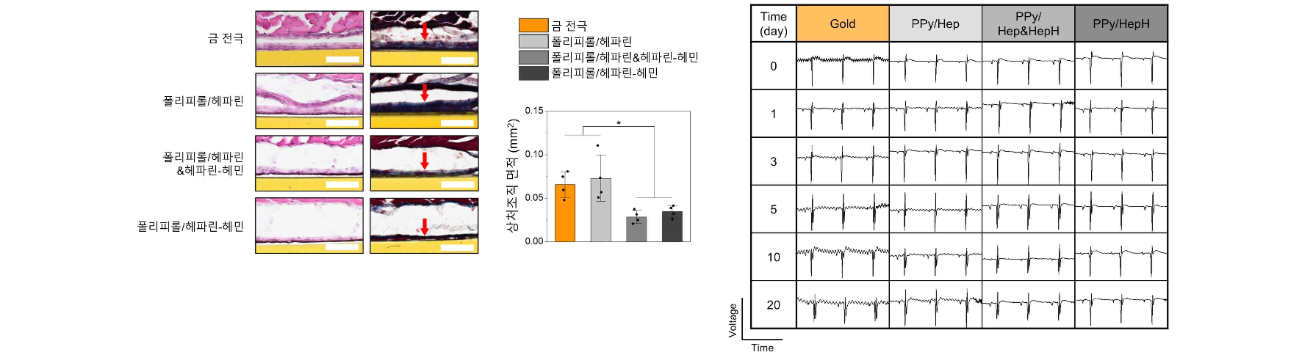▲ Effective alleviation of foreign body immune response and securing long-term stable electrocardiogram recording performance. It was confirmed that scar tissue formation, a major cause of electrode performance deterioration, was greatly alleviated, and that electrocardiograms could be recorded with high sensitivity for up to 20 days.

Professor Jae Young Lee said, "It has high versatility applicable to various types of implantable electronic medical devices by improving the performance sustainability of bioelectrodes by introducing antioxidant ability. It is expected that it can be commercialized in the future through continuous research to enhance safety and stability in the body."

This research, co-led by Professors Jae Young Lee and Giyoong Tae of the School of Materials Science and Engineering and conducted by Dr. Sanghun Lee and Dr. Kiyoon Min, received support from the Ministry of Science and ICT, the National Research Foundation of Korea's Mid-career Researcher Support Project and Basic Laboratory Support Project and was published on June 5, 2024, in 'Chemical Engineering Journal', an international academic journal in the engineering field.



