"Full-scale domestic production of hemodialysis filters" GIST developed a high-performance hollow fiber membrane for hemodialysis with 150% improved uremic removal performance

- Professor In S. Kim’s team developed a high-performance hollow fiber membrane for hemodialysis using a co-extrusion spinning process
- Optimization of hollow fiber membrane pore size and structure, expected to improve treatment efficiency for end-stage renal failure patients upon commercialization... Published in 「Chemical Engineering Journal」, a renowned international journal in the field of chemical engineering

▲ Photo:(From left) Professor In S. Kim, Thanh-Tin Nguyen (first author)

The Gwangju Institute of Science and Technology (GIST, President Kichul Lim) announced that a research team led by Professor In S. Kim of the School of Environment and Energy Engineering has successfully developed a high-performance hollow fiber separation membrane for hemodialysis (hereinafter referred to as hollow fiber membrane**) through a process of fibering polymers by pneumatic spinning*.

* co-extrusion: A technology that extrudes two or more different materials simultaneously.

** hollow fiber membrane: refers to a separation membrane molded into a thin cylindrical shape and separates impurities through microscopic holes on the surface of the thread-shaped inner or outer membrane

Compared to the existing general double spinning nozzle, 'pure water permeability' increases by 400% and 'uremic substance removal efficiency' increases by 150%, while protein loss in the blood is reduced to less than 50%, dramatically improving hemodialysis performance if commercialized in the future.

Professor In S. Kim is conducting research on the development of high-performance hollow fiber membranes for hemodialysis in order to domestically produce hollow fiber membranes for hemodialysis, which are entirely dependent on imports. In 2021, he founded InnoSep Co., Ltd., a hollow fiber membrane manufacturing company for hemodialysis, and currently serves as Chief Technology Officer (CTO). He also serves as a scholar member of the Korean Academy of Science and Technology and the International Water Association (IWA).

Patients with end-stage renal failure require treatment such as hemodialysis, peritoneal dialysis, and kidney transplantation due to the normal excretion of uremic substances in the blood due to decreased kidney function, of which hemodialysis patients account for about 80%.

Hemodialysis is a treatment that replaces kidney function by removing uremic substances from the blood using a hollow fiber membrane. The patient's blood circulates to the inside (bore-side)* of the hollow fiber membrane, and dialysate flows to the outside (shell-side**). Because it circulates and removes uremic substances in the blood, the performance of the hollow fiber membrane for hemodialysis used during hemodialysis is the most important factor in determining the efficiency of hemodialysis.

* bore-side: The side through which blood flows during hemodialysis inside the hollow fiber membrane.

* shell-side: The side on which dialysate flows during hemodialysis to the outside of the hollow fiber membrane.

When manufacturing hollow fiber membranes, the research team introduced a co-extrusion spinning process that simultaneously spins organic solvents on the outside while spinning polymer solutions using a triple spinning nozzle to create pores on the inside (bore-side) and outside (shell-side) of the hollow fiber membrane. They succeeded in simultaneously controlling the structure, which greatly improved the efficiency of removing uremic substances.

▲ Schematic diagram of the development of a hollow fiber membrane for hemodialysis using the coextrusion process. The pore structure and thickness of the hollow fiber membrane for hemodialysis are optimized by controlling the composition of the solution flowing in the center and outermost layer of the nozzle using a triple spinning nozzle.

In order to simultaneously control the pore structure on the inside and outside of the hollow fiber membrane, the research team used a triple spinning nozzle when manufacturing the hollow fiber membrane to control the composition of the solution flowing in the center of the nozzle and the outermost layer. The average pore size on the inside (the part that touches the blood) of the hollow fiber membrane for hemodialysis was adjusted to about 8.4 nanometers, and the average pore size on the outside (the part that touches the dialysate) was adjusted to 1.9 micrometers, which is about 230 times the size of the inner pores. The cross section of the hollow fiber membrane was optimized to have a single finger-like* structure that is advantageous for transporting uremic substances.

* finger-like: A finger-shaped cross-sectional structure. A typical hollow fiber membrane has a finger-like or sponge-like cross-sectional structure.

The membrane developed by the team exhibited a pure water permeability of 130 mL/m2.h.mmHg*, a removal efficiency of 124,865 mg/m2 for urea, the main uremic toxin in blood, and a protein loss of 146 mg/session**, compared to the pure water permeability (32 mL/m2. h.mmHg), uremia removal efficiency (77,133 mg/m2), and protein loss (320 mg/session), representing a 400%, 150% increase and 54% decrease, respectively.

* pure water permeability: The amount of ultrapure water passed by applying a certain pressure to a unit area.

** mg/session: Unit representing the amount of protein in the blood lost during 4 hours of hemodialysis

In addition, the separation membrane developed by the research team showed excellent hemodialysis performance in terms of uremic removal efficiency and reduction of protein loss in the blood compared to commercial hollow fiber membranes for hemodialysis that show the best performance from overseas global companies.

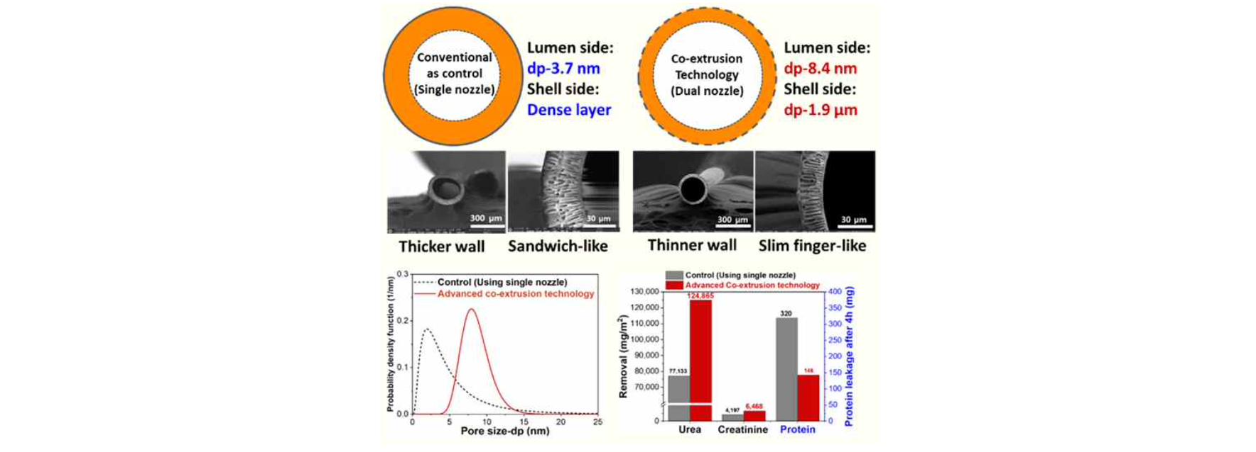▲ Characteristics and uremic removal performance of hollow fiber membrane for hemodialysis using coextrusion process. The separation membrane manufactured through the coextrusion spinning process has a pore size and cross-sectional structure suitable for hemodialysis compared to the separation membrane manufactured through the existing spinning process, and exhibits excellent uremic removal performance and a low protein loss rate.

Professor In S. Kim said, "We developed a hollow fiber membrane for hemodialysis that can significantly improve hemodialysis efficiency by precisely controlling the pore structure of the hollow fiber membrane through a coextrusion process. If the hollow fiber membrane for hemodialysis is commercialized in the future, it is expected to not only replace the heavy hollow fiber membrane for hemodialysis, which was previously entirely dependent on imports, but also contribute to improving the quality of life by significantly improving the treatment efficiency of kidney disease patients."

The research was supported by the Regional Innovation Leading Research Center (RLRC) of the Ministry of Science and ICT, the Future Promising Fusion Machine Technology Pioneer, and the Private Investment-led Technology Startup Support Project (TIPS Program) of the Ministry of SMEs and Startups, and was published on May 29, 2024, in the Chemical Engineering Journal, a top 3.5% international journal in the field of chemical engineering.



