GIST develops an innovative electrolyte additive that survives 5,000 charging and discharging of large-area zinc-bromine batteries

- Solves the instability of the zinc metal cathode with an electrolyte additive that ‘simultaneously expresses positive and negative ions’... maintains high discharge capacity (407 mAh) and klong efficiency (92.3%) even after 5,000 charge and discharge cycles
- Expected use of high-capacity energy storage system (ESS) without risk of explosion as it can secure high stability and energy density... Published in ‘Small’, a renowned international academic journal in the field of materials science and chemistry

▲ (From the left) Professor Sangryun Kim and master’s student Jeonghyun Kim

The Gwangju Institute of Science and Technology (GIST, President Kichul Lim) announced that Professor Sangryun Kim's research team at the Graduate School of Energy Convergence has developed cerium and chlorine-based electrolyte additive technology.

The results of this research overcome the problems of existing zinc-bromine batteries, such as side reactions such as dendrite growth and hydrogen evolution occurring in the zinc metal cathode, and it is expected to be able to provide high stability and energy density for large-scale energy storage systems.

* dendrite: A crystal that grows like a tree branch on the surface of a metal electrode, which reduces the efficiency of the battery and causes a short circuit, leading to performance degradation and stability problems.

* side reaction: When several reactions occur together, a reaction other than the main reaction

Zinc-bromine batteries, which use zinc and bromine as active materials, are attracting attention as next-generation secondary batteries for energy storage devices due to their high stability and high energy density.

However, like other batteries that use a metal electrode as the cathode, this battery has difficulty maintaining stable operation and long-term stable cycles due to side reactions such as dendritic growth and hydrogen evolution at the cathode.

The research team solved the instability of the zinc metal cathode by using an electrolyte additive that acts simultaneously on cerium cations (Ce³⁺) and chlorine anions (Cl⁻) in cerium chloride (CeCl₃).

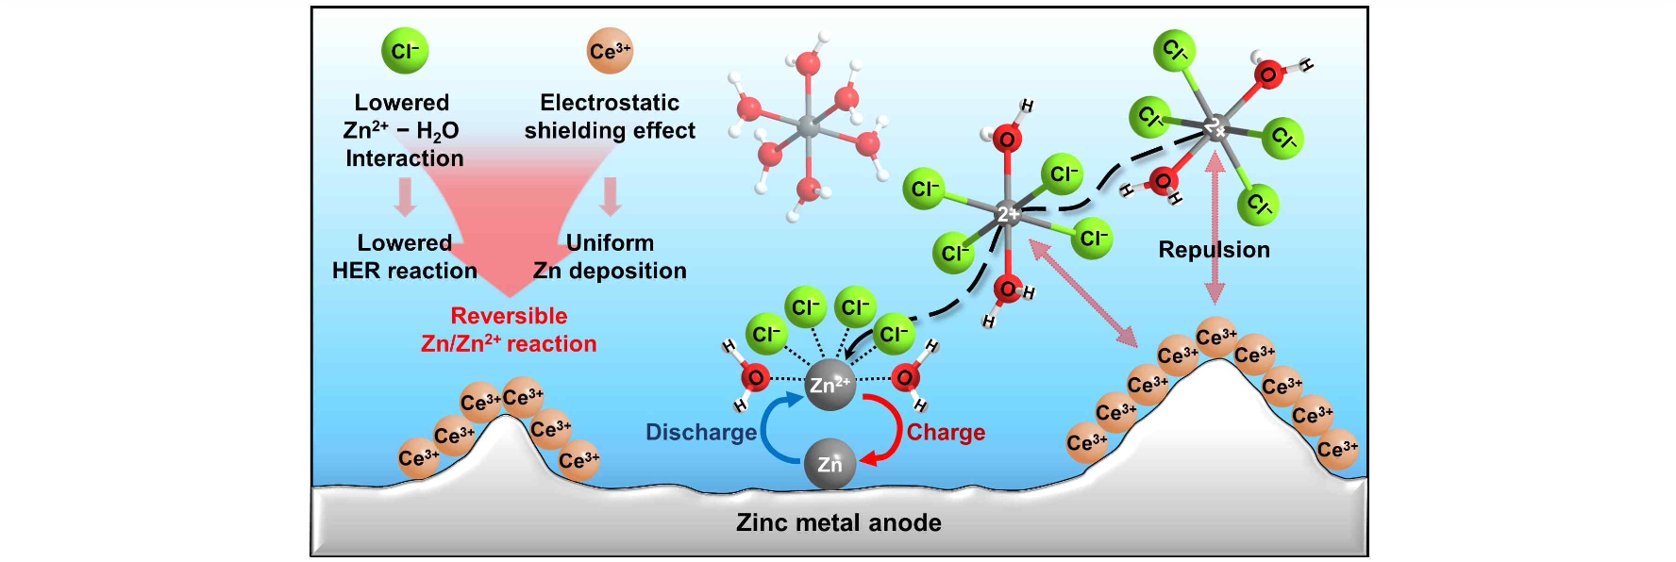▲ Image summarizing the research: This is the effect of cerium chloride (CeCl3) on the zinc electrode reaction.

Specifically, during the charging process, cerium cations (Ce³⁺) formed an electrostatic protective layer on the protrusions of the zinc metal cathode with a strong electric field, suppressing dendritic growth. At the same time, chlorine anions (Cl⁻), which have excellent electron donating properties, participated in the solvation structure* of zinc ions and suppressed water decomposition.

* solvation structure: Generally, in an electrolyte solution with a low salt (ionic compound) concentration, it means that positive ions are surrounded by an uncharged solvent and form a concentric shell.

When the developed electrolyte additive was applied to a small zinc-bromine battery in which both the anode and cathode were made of graphite, the coulombic efficiency of 94.9%* and the energy efficiency of 70.3% were maintained, respectively, even after 2,000 charge and discharge cycles. These are improvements of 73.8% and 52.9%, respectively, compared to the electrolyte without additives.

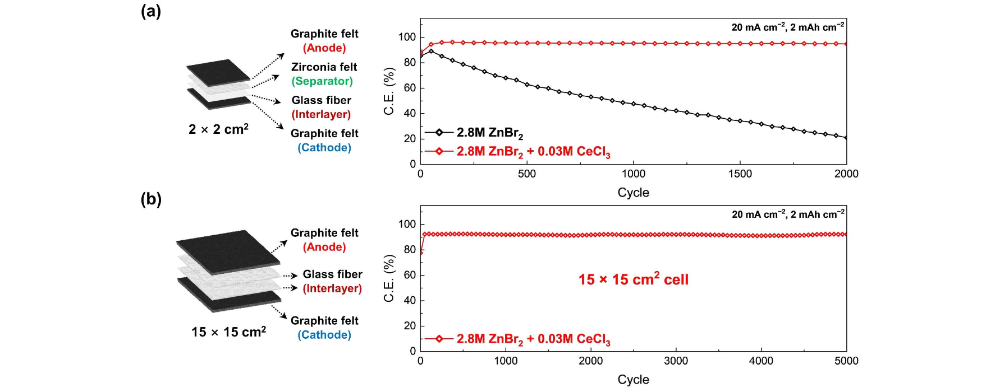▲ Comparison of electrochemical performance with and without electrolyte additives in small and large area zinc-bromine batteries: Results of applying electrolyte additives to small zinc-bromine batteries in which both the anode and cathode are composed of graphite. Even after charging and discharging 2,000 times, a high coulomb efficiency of 94.9% was maintained. This is a 73.8% improvement compared to the electrolyte without additives. Additionally, as a result of applying the electrolyte additive to a large-area zinc-bromine battery, a high coulomb efficiency of 92.3% was maintained even after 5,000 charge and discharge cycles.

Additionally, as a result of applying the electrolyte additive to a large-area zinc-bromine battery, high discharge capacity (407 mAh) and coulomb efficiency (92.3%) were maintained even after 5,000 charge and discharge cycles.

* coulombic efficiency (CE): This is the single most important indicator when predicting the future performance of a battery. A battery with a coulombic efficiency (CE) of 1.00000 (the ideal battery) means the battery will last forever, and a change in CE of as little as 0.0001 can equate to a difference in cycle life of more than 1000 cycles.

Professor Sangryun Kim said, "The results of this research help provide practical guidelines for zinc-bromine battery electrolyte design and improve understanding of electrode stabilization strategies in aqueous battery systems. In the future, it is expected to be applied to the development of high-performance and highly stable energy storage technologies such as lithium-ion batteries and all-solid-state batteries as well as water-based batteries."

This research, led by Professor Sangryun Kim of the GIST Graduate School of Energy Convergence and conducted by master's student Jeonghyun Kim, was supported by the National Research Foundation of Korea, the National Institute of Science and Technology of the Ministry of Science and ICT, and the Korea Institute of Energy Technology Evaluation and Planning and was published online on May 7, 2024, in the renowned international journal 'Small' in the field of materials science and chemistry .



