“Understanding the onset and recovery of Alzheimer’s through the movement of proteins” GIST-Chung-Ang University reveals correlation between tau protein and motor protein linked to Alzheimer’s disease

- GIST Professor Kang Taek Lee's team and Professor Jaeyoung Sung's team at Chung-Ang University developed a new theoretical model to quantify the correlation between Alzheimer's disease and changes in motor protein speed through hyperphosphorylation of tau protein in nerve cells.
- Expected to be used as an important indicator to evaluate the onset and progression of Alzheimer's and recovery to normal through treatment... Published in the international academic journal 「Chemical & Biomedical Imaging」

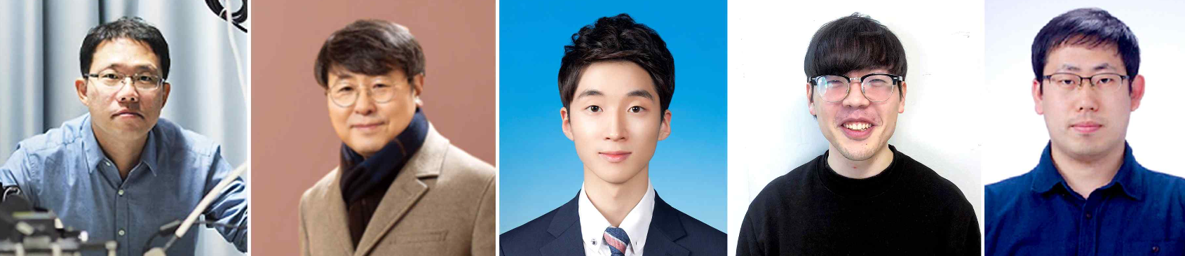▲ (From left) GIST Department of Chemistry Professor Kang Taek Lee, Professor Jaeyoung Sung of Department of Chemistry at Chung-Ang University, GIST Department of Chemistry Dr. Eunsang Lee, doctoral student Donghee Kim at Department of Chemistry at Chung-Ang University, and GIST Department of Chemistry Dr. Yo Han Song

The Gwangju Institute of Science and Technology (GIST, President Kichul Lim) announced that GIST Department of Chemistry Professor Kang Taek Lee's research team together with Professor Professor Jaeyoung Sung's research team at Chung-Ang University has identified the correlation between the movement patterns of motor proteins* in nerve cells and the hyperphosphorylation of tau protein* related to the development of Alzheimer's disease.

As a new mechanism in the study of Alzheimer's disease, the observation and analysis of intracellular motor proteins at a single molecular level is expected to be important for the diagnosis, drug development, and efficacy evaluation of Alzheimer's disease in the future.

* motor protein: A protein that propels itself along protein fibers or polymer molecules, and the energy for movement is obtained by hydrolyzing ATP.

* tau protein: It is a protein produced from MAPT (microtubule-associated protein tau), a gene that produces various proteins in relation to microtubules within cells.

Professor Kang Taek Lee's research team has been conducting research to track the movement of nanoparticles within living cells using upconverting nanoparticles (UCNP)* containing lanthanide. By focusing on the study of chemical dynamics that occur inside cells, he is currently conducting active joint research with Professor Jaeyoung Sung's research team at Chung-Ang University, known as a 'theoretical chemist who solves the mysteries of life phenomena through chemistry.'

* lanthanide-doped upconverting nanoparticles (UCNP): Nanoparticles doped with rare earth lanthanide-based elements, they have the property of absorbing near-infrared light as a light source and emitting visible light (up-converting effect).

Physiological research on hyperphosphorylation and aggregation of tau protein present inside nerve cells, which has been pointed out as a cause of Alzheimer's disease, has been actively conducted.

Tau protein is involved in the stability of microtubules, which are used as ‘roads’ to transport various substances inside cells. However, it is known that when tau protein is abnormally hyperphosphorylated due to various factors, it destabilizes microtubules, hinders material transport, and aggregates within cells to act as a toxic substance, ultimately causing Alzheimer's disease.

When tau protein aggregates and Alzheimer's disease develops, it is difficult to detect any special signs until the abnormal hyperphosphorylation and aggregation of tau protein progresses significantly because normal, non-aggregated tau protein performs its function through phosphorylation.

Accordingly, existing research focused on developing drug treatments to remove abnormal tau aggregates.

However, recently, as research using various bio-imaging technologies to observe living cells over a long period of time has become possible, understanding of diseases at the cellular level and new diagnosis and treatment methods based on this are being developed.

Professor Kang Taek Lee's research team injected up-converting nanoparticles that enable long-term imaging and tracking within living cells into nerve cells. By analyzing the change in speed of nanoparticles moved by motor proteins along with the endoplasmic reticulum, they compared the movement in normal cells with the movement in cells with hyperphosphorylated tau protein.

Professor Kang Taek Lee's team has previously developed a theoretical analysis model for changes in the speed of motor proteins within nerve cells through joint research with Professor Jaeyoung Sung's team. In this study, a new theoretical model was developed to identify the correlation between Alzheimer's disease and changes in the speed of motor proteins by hyperphosphorylating tau protein.

The average value of the squared displacement of the endoplasmic reticulum-motor protein complex showed hyperdiffusion within a few seconds in normal cells, and a non-Gaussian tail* was seen in the position distribution.

On the other hand, in cells in which hyperphosphorylation of tau protein was induced, a superdiffusion pattern and a non-Gaussian tail in the position distribution were not observed in the average value of the square of the movement distance. By analyzing the results of this experiment, it was revealed that in nerve cells where tau protein is hyperphosphorylated, the unidirectional movement of motor proteins is restricted, and the transport function of motor proteins that move quickly over long distances is greatly reduced.

* Non-Gaussian tail: Unlike the Gaussian distribution, the distribution does not decrease exponentially in the tail but decreases slowly.

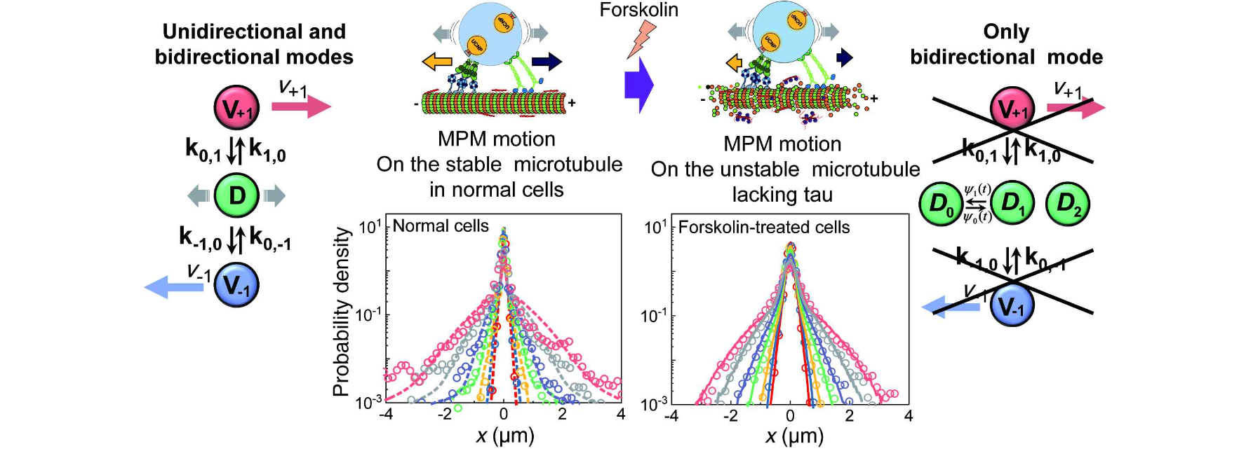▲ Changes in the characteristic transport dynamics of the endoplasmic reticulum-motor protein complex in normal neurons and neurons with hyperphosphorylated tau protein: When tau protein is hyperphosphorylated through Forskolin drug treatment, the unidirectional movement of the motor protein is inhibited. Therefore, rapid and long-distance transport in the direction of microtubules is limited.

Another characteristic of cells with hyperphosphorylated tau protein is that the non-Gaussian factor, which means that the probability distribution for displacement of the endoplasmic reticulum-motor protein complex deviates from the normal distribution, was maintained at a constant value after several seconds within the observation time.

Through time-dependent changes in this non-Gaussian factor, the research team obtained the time-correlation function of the microtubule diffusion coefficient* fluctuations of the endoplasmic reticulum-motor protein complex. By analyzing this, it was confirmed that the motility of the endoplasmic reticulum-motor protein complex differs for each microtubule and that some fluctuate depending on time. (37% fluctuated over time, and 63% showed no change in diffusion coefficient conversion within the observation time.)

In conclusion, the research team confirmed that in nerve cells where tau protein is hyperphosphorylated, the unidirectional movement of the endoplasmic reticulum-motor protein complex on microtubules is restricted, resulting in greatly slowed endoplasmic reticulum transport, and that the speed of endoplasmic reticulum transport also varies greatly depending on the microtubule. This suggests a new mechanism for neurodegenerative diseases caused by protein hyperphosphorylation.

* Diffusion coefficient: A physical quantity that represents the speed at which a molecule or molecular complex diffuses in space.

Professor Kang Taek Lee said, "Through this study, we were able to quantify the degree to which changes in the movement pattern and speed of motor proteins occur due to hyperphosphorylation of tau protein in nerve cells. In the future, it is expected that it can be used as an important indicator to evaluate the degree of hyperphosphorylation of tau protein, the degree of onset and progression of Alzheimer's, and even recovery to normal state through treatment."

This study, led by Professor Kang Taek Lee of GIST and Professor Jaeyoung Sung of Chung-Ang University and conducted by Dr. Eunsang Lee of GIST and Donghee Kim, a doctoral student at Chung-Ang University as the first author, was supported by the National Research Foundation of Korea's mid-career research project and leader researcher support project and was published online on April 23, 2024, in the journal ‘Chemical & Biomedical Imaging’, which was recently published by the American Chemical Society.



