GIST-MIT continues research results on ‘human-centered’ AI system created through close collaboration

- Professor SeungJun Kim's research team in the School of Integrated Technology and MIT CSAIL (Computer Science and Artificial Intelligence Research Institute) has produced research results such as papers, dataset construction, and patents through joint research, while also maintaining active exchanges.
- Following the first phase (2021-23) of research cooperation with MIT, the second phase (2024-25) has started, focusing on research in the fields of ‘soft robotics’ and ‘sensory intelligence’... ‘UbiComp 2024 Workshop’ hosted by GIST is scheduled to be held in October

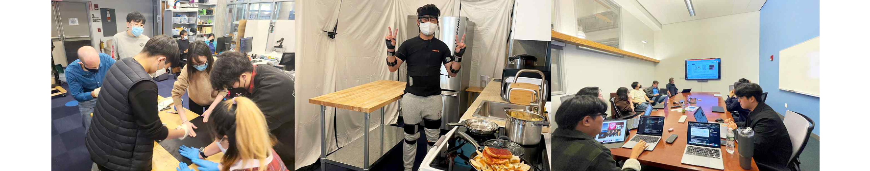▲ MIT offline visit and exchange activities: (from the left) Tactile sensor production work when visiting MIT in 2021, collection of multimodal-based wearable sensor data sets in 2022, and joint research discussion in 2023.

The Gwangju Institute of Science and Technology (GIST, President Kichul Lim) announced that the artificial intelligence (AI) joint research project being carried out with the Massachusetts Institute of Technology (MIT) in the United States is producing notable results and is leading to active international exchanges between GIST and MIT.

The GIST-MIT joint research project, which is underway as part of the GIST-MIT AI international cooperation project starting in 2021 and running until 2025, is under the theme of ‘HCI + AI for Human‐Centered Physical System Design’. This year started the second phase of research cooperation (2024-2025).

In the second stage of research cooperation, research focusing on ‘Soft Robotics’ and ‘Sensory Intelligence’ is being conducted, and GIST is expanding its global network by holding workshops with MIT.

During the second phase of the collaborative research project with MIT, the research team of Professor SeungJun Kim of GIST's School of Integrated Technology was recognized for its excellent research performance by publishing two papers in SCI(E)-listed international journals ▴ 2 papers in 'Scientific Data', three papers in 'Virtual Reality' ▴ 1 paper in 'IMWUT (Interactive, Mobile, Wearable and Ubiquitous Technologies)', and 1 paper in 'Nature Communications'.

In particular, they presented four papers at CHI (Conference on Human Factors in Computing Systems), one of the most prestigious academic conferences in the field of Human-Computer Interaction (HCI), and two of these received ‘Honorable Mention’ awards.

Additionally, the GIST-MIT joint research team built an extensive data set for ‘Badminton Artificial Intelligence Coach Development’ this year.

The 'ActionSense' project, in which Professor Daniela Rus's research team at MIT's Computer Science and Artificial Intelligence Laboratory (CSAIL) collected data on everyday tasks such as chopping vegetables in the kitchen, and Professor SeungJun Kim's team at GIST applied it to badminton.

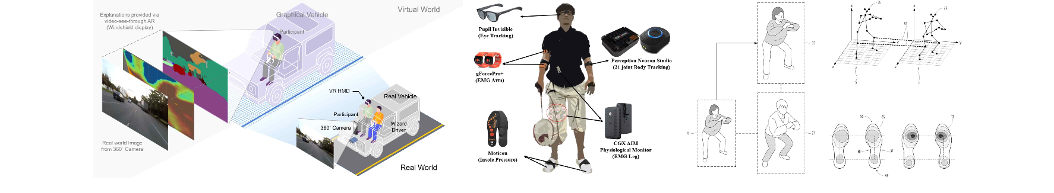▲ Joint research results of the GIST-MIT team: (from the left) self-driving vehicle description system schematic, badminton data set sensor photo, physical training multimodal feedback system

GIST researchers laid the foundation for the development of an ‘AI badminton coach’ by ​​collecting a large amount of badminton players’ movement and biosignal data through MIT’s integrated sensor collection framework. The research results were published on April 5 in the international academic journal ‘Scientific Data’.

In the second stage of research cooperation, overseas patent applications are also actively underway. This patent concerns a motion feedback system using a sensing platform consisting of a tactile sensor developed by MIT. Through this platform, each user's exercise status can be analyzed and personalized exercise feedback desired by the user can be created and provided.

In addition to papers and patents, exchange activities between GIST and MIT have become more active starting this year. At the ‘International Conference on Robotic Automation (IEEE ICRA 2024)’ held on May 17, 7 GIST researchers and 6 MIT researchers participated, and many joint research results related to GIST-MIT projects were announced.

Among the GIST researchers, Professors Kyung-Joong Kim and Jung Won Yoon from the School of Integrated Technology participated as invited speakers, and among the four papers published by the GIST researchers, two papers in which the GIST-MIT researchers participated as co-authors (“MIT’s Tactile Sensor”) “Proposal of an artificial intelligence-based walker for people with walking difficulties” and “Badminton guide motion generation technology using counterfactual explanation technology” were included.

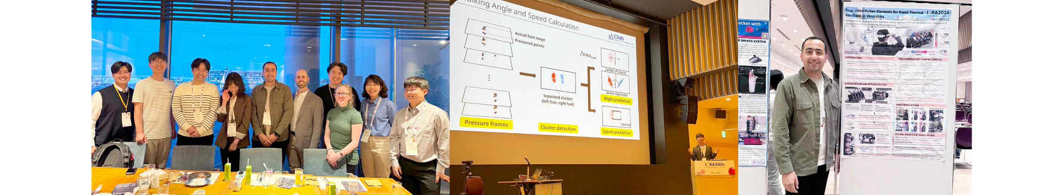▲ ICRA workshop held: (from the left) photos of the GIST-MIT collaborative research team, photos of GIST researchers’ invited talks presentation, photos of GIST researchers’ poster session presentations.

GIST Professor SeungJun Kim said, "GIST and MIT researchers continue to produce research results through international joint research, establishing themselves as exemplary examples of global research cooperation. In the future, together with MIT, we will innovate human-centered physical system design through the convergence of HCI and AI technologies and expand application possibilities in various fields."

Meanwhile, in the second half of this year (scheduled for October), the 'UbiComp 2024 Workshop' will be held hosted by GIST to announce the results of collaborative research between the two universities (topic: Interpretable, Inclusive, and Immersive Interaction for Ubiquitous AI-infused Physical Systems) and promote research cooperation. In the second stage, GIST plans to conduct a case study in the future AI environment based on the basic technology established in the first stage.



