GIST develops innovative 2D covalent organic framework (COF) synthesis technology utilizing light and fluid flow... Opening the possibility of groundbreaking development in optoelectronic devices

- Professor Hyunseob Lim's team in the Department of Chemistry maintained the flow of fluid during the synthesis process and selectively incident light to improve film quality and simplify the process to solve the shortcomings of the existing 2D COF film synthesis method
- “High-quality 2D COF film with adjustable thickness. Accurate and scalable
Opening up new possibilities”... published in ‘Small Methods’, a renowned international academic journal in the field of materials science and chemistry

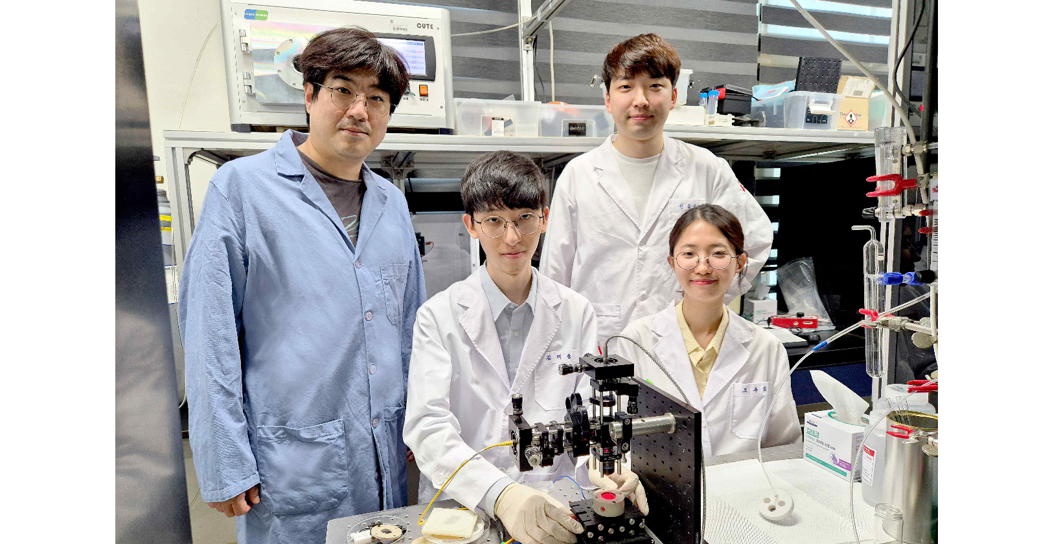▲ (Counterclockwise from left) Department of Chemistry Professor Hyunseob Lim, Taewoong Kim, a combined master's and doctoral student, Joohee Oh, a combined master's and doctoral student, and Jong-Guk Ahn, a doctoral student

Recently, there has been increasing interest in the design and synthesis of covalent organic frameworks (COFs) by covalent bonding of organic substances. COF is a metal-free organic environment with high chemical stability, biocompatibility, low density, permanent porosity, and large surface area, so it is expected to be used in electrochemical applications such as bio-imaging, drug delivery, and therapeutics.

A Korean research team has developed an innovative two-dimensional COF synthesis technology that utilizes light and fluid flow, opening up the possibility of dramatically improving the performance of optoelectronic devices and organic field effect transistors.

The Gwangju Institute of Science and Technology (GIST, President Kichul Lim) announced that Professor Hyunseob Lim's research team in the Department of Chemistry developed a new synthesis method that overcomes the problems of the existing 2D COF synthesis method and succeeded in synthesizing a high-quality patterned film with a smooth surface.

* covalent organic framework (COF): A porous crystalline polymer in which organic substances are linked by covalent bonds and have a regular arrangement at the atomic level and has excellent crystallinity and a porous structure.

COFs, which are attracting considerable attention in electrochemical applications, exhibit high chemical stability and biocompatibility due to strong covalent bonds and a metal-free organic environment and have wide application potential due to their low density, permanent porosity, and large surface area.

On the other hand, in the existing two-dimensional COF film synthesis method, a method of selectively improving the reactivity between organic building blocks at the solid surface, liquid/liquid interface, or liquid/gas interface is mainly used, thereby reducing the adsorption of contamination in the film. Various problems, such as adsorption of unreacted chemical species and physical damage, have been pointed out as disadvantages.

To solve this problem, the research team adopted a new method of maintaining fluid flow during the synthesis process at the solid/liquid interface, which does not require a transfer process.

Through this method, they succeeded in preventing contamination that may occur during synthesis and producing a high-quality two-dimensional COF film with an atomically smooth surface.

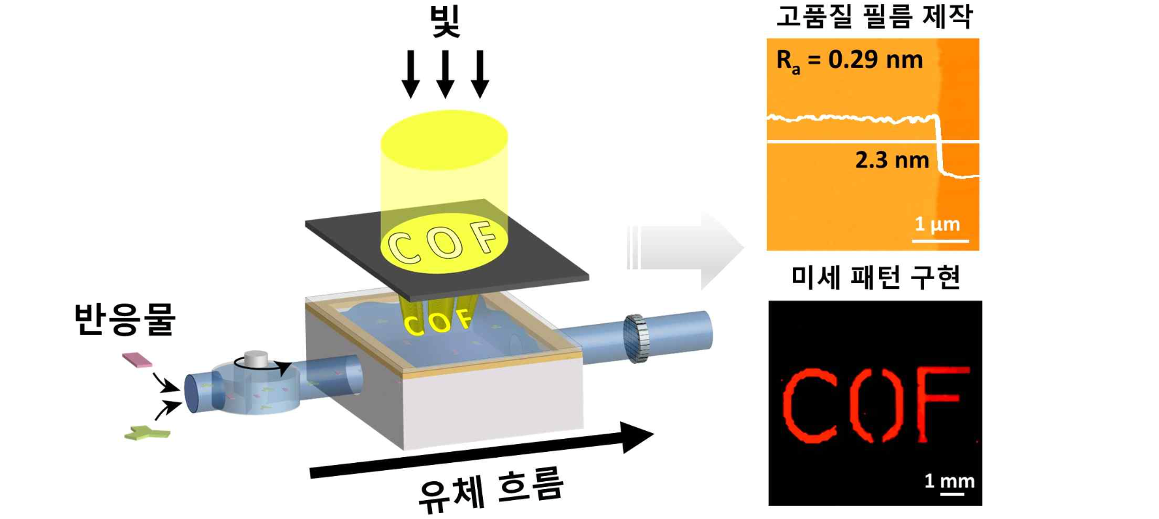▲ COF film with a smooth surface: By utilizing the flow of fluid at the solid/liquid interface, a high-quality COF film with a smooth surface can be obtained.

In particular, the research team synthesized a patterned two-dimensional COF film by selectively irradiating the light used as the energy source for synthesis using a mask. This method simplifies the device manufacturing process by eliminating the need for a complex lithography process, making it easier to utilize it as an optoelectronic device.

The lithography process is a complex process that uses light to transfer fine patterns to semiconductor or electronic device substrates, and the development of a new method that can replace this is of great significance.

The research team also found through crystallographic analysis that the two-dimensional COF film on hexagonal boron nitride (h-BN) preferred frontal orientation.

As a result, it was found that 2D COF films on hexagonal boron nitride have improved crystallinity and exhibit potential advantages in optical and electrical properties. This is expected to play an important role in the development of high-performance optoelectronic devices.

Professor Hyunseob Lim said, "This research outcome opens up the possibility of accurate production of high-quality two-dimensional COF films with adjustable thickness. In the future, it is expected to be widely applied across various fields, including the development of optoelectronic devices and effective imaging and treatment."

This research, conducted by Professor Hyunseob Lim's team in the GIST Department of Chemistry, was conducted with support from the National Research Foundation of Korea's Outstanding Young Research Support Project, Basic Science Research Laboratory, and Future Materials Discovery Project, and was published online on May 9, 2024, in 'Small Method', a renowned international journal in the fields of materials science and chemistry.



