QS World University Rankings 'Number of paper citations per professor' GIST ranked 4th in the world (1st in Korea for 17 consecutive years)

- GIST has maintained the top ranking in the world for 17 years since 2008, when it was first ranked in the ‘QS World University Rankings’... An indicator that counts the number of paper citations to quantitatively evaluate research capabilities
- The secret is to create an optimal ‘research immersion’ environment... “We will aim for a university that fosters those who can find a path to the future and ultimately contributes to national development and human happiness.”

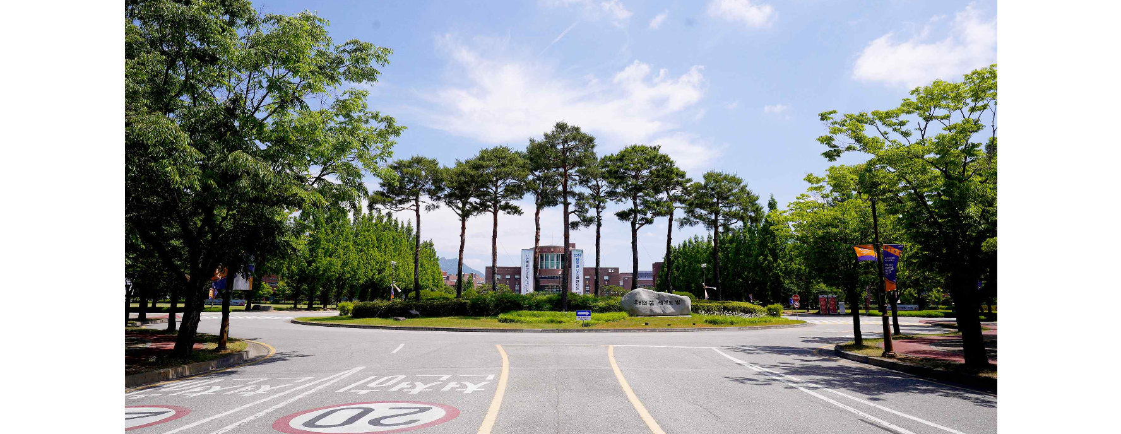▲ Panoramic view of the GIST campus entrance

The Gwangju Institute of Science and Technology (GIST, President Kichul Lim) ranks 4th in the world in the 'Citations per Faculty' category in the 'QS World University Rankings 2025' (1st place is Harvard University in the U.S.) and ranked first in the country.

The QS World University Rankings are rankings published every June by QS (Quacquarelli Symonds), a British global university evaluation agency. This year, it was announced at 5 am on the 5th, Korean time.

GIST has been ranked first in Korea in the ‘Citations per Faculty’ category for 17 consecutive years since 2008, and it has consistently maintained the top rank between 2nd and 6th among world universities.

This year, domestic research-oriented science and technology-specialized universities, including GIST, were ranked among the top 40 in the world in this category, demonstrating that strategic support for science and technology and fostering future talent at the national level is crucial to enhancing the research competitiveness of universities.

‘Number of paper citations per professor’ is an indicator of how many papers of researchers affiliated with the university have been cited by other researchers, and it is an item that can evaluate both the quantity and quality of the university’s research capabilities.

This year’s ‘number of paper citations per professor’ is a tally of the number of citations from 2018-23 (6 years) for papers published by the university during 2018-22 (5 years).

In particular, this indicator is different from indicators such as ‘academic reputation’ or ‘graduate reputation’ where the respondent’s subjective opinion greatly influences the results because it is considered a highly reliable evaluation item in that it calculates research performance and influence on other research with objective data.

GIST, which celebrates its 31st anniversary this year, has been able to maintain world-class research capabilities thanks to the fact that it has set internationalization and excellence as its operating philosophy from the beginning of its establishment and has created an optimal environment for immersion in research.

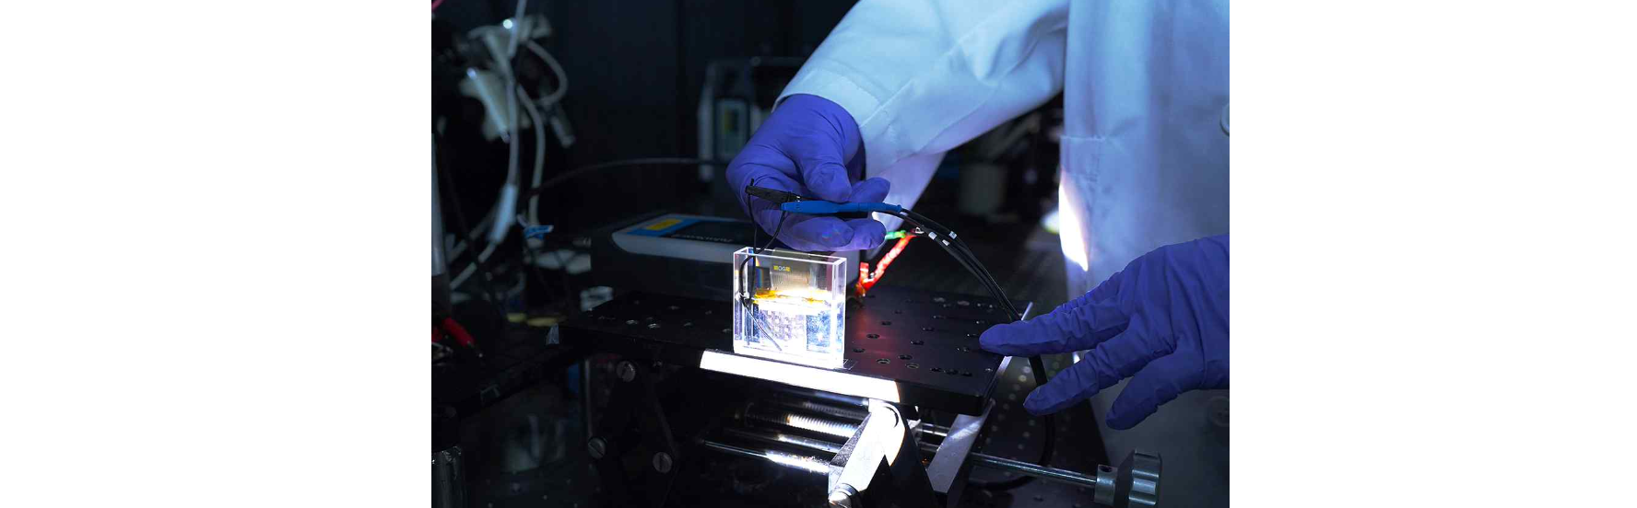▲ GIST Professor Young Min Song's research team is developing an optical modulation device with a high-efficiency optical signal modulation efficiency of close to 99% that dramatically changes the interaction between light and materials at a very small voltage of 1V or less.

GIST actively supports joint research with world-class science and technology research institutions such as MIT in the United States, and encourages convergence research centered on research groups comprised of researchers from various fields by breaking down the walls between research fields and disciplines.

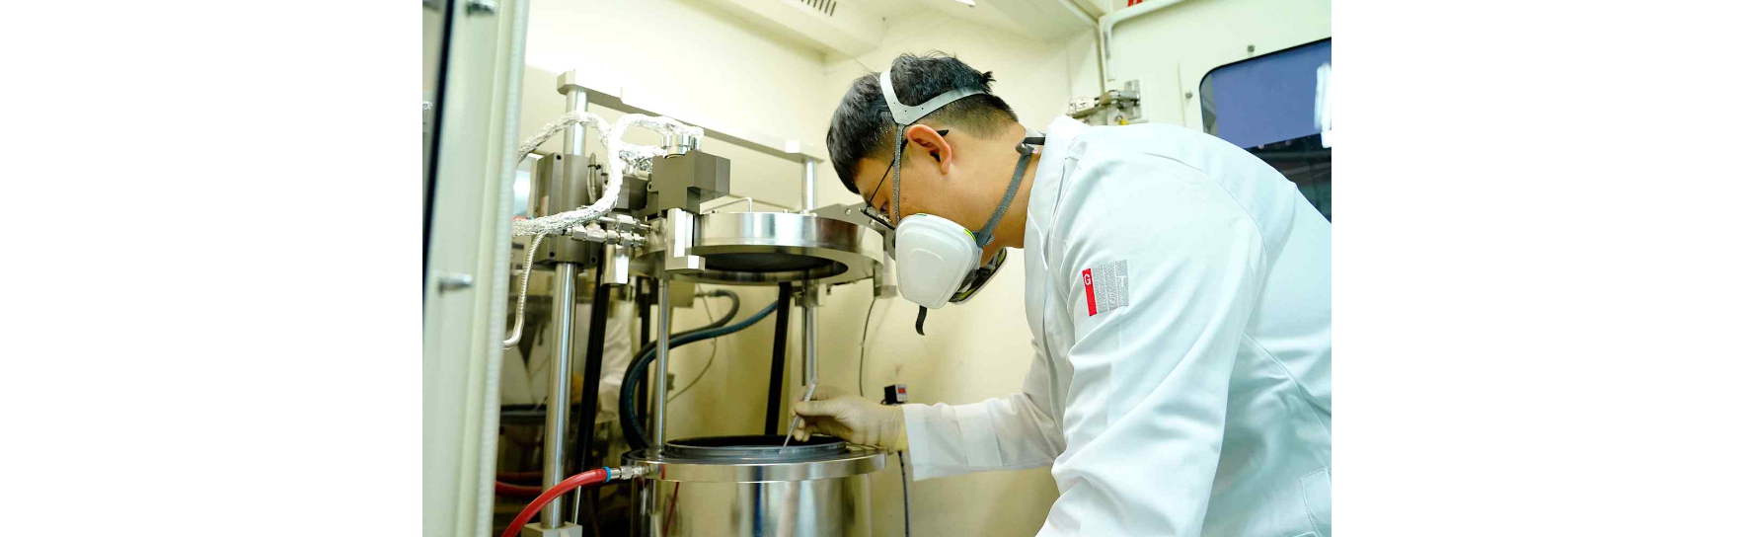▲ GIST Professor Dong-Seon Lee's research team is testing samples for gallium nitride remote epitaxy experiments on metal-organic chemical vapor deposition equipment.

In addition, GIST provides an environment where faculty and students can focus on research and operate a strategic personnel system that provides various incentives and rewards to researchers who produce excellent results.

President Kichul Lim commented on the results of this evaluation, saying, "GIST has once again proven its world-class research capabilities. GIST, which has begun a new leap forward for the next 30 years, is training path finders to brighten the future through innovative research and education that aims to be the world's first and best. Ultimately, we will aim to be a university that contributes to national development and human happiness."



