GIST-Severance Hospital joint research team develops a pituitary tumor model for the treatment of acromegaly... Laying the foundation for research on non-surgical drug treatments

- Porous hydrogel fiber-based 3D pituitary tumor model, sensitivity to ‘somatostatin derivatives’ and ‘Sstr2’ and ‘Sstr5’ gene expression are significantly higher than existing 2D culture models
- Drug treatment prognosis and resistance development mechanism revealed in vitro, follow-up research to discover new drug candidates expected... The world's first test tube model for acromegaly research was published in the international academic journal "Smart Materials in Medicine"

▲ (From the left) Professor Chang-Myung Oh of the Department of Biomedical Science and Engineering, Professor Myeong-han Yoon of the School of Materials Science and Engineering, student Wooju Jeong, and student Sungrok Wang

A test tube model for studying acromegaly, a chronic disease in which the extremities of the body enlarge due to excessive secretion of growth hormone, has been developed by Korean researchers.

Until now, surgery or administration of growth hormone inhibitors have been mainly used to treat acromegaly, but the results of this study are expected to advance research on non-surgical drug treatments.

* Acromegaly: A phenomenon in which excessive growth of the extremities of the body, such as hands or feet, occurs due to abnormalities in the secretion of growth hormone from the pituitary gland. It is generally treated through surgical treatment of the pituitary gland.

The Gwangju Institute of Science and Technology (GIST, President Kichul Lim) announced that a research team led by Professor Professor Chang-Myung Oh of the Department of Biomedical Science and Engineering and Professor Myeong-han Yoon of the School of Materials Science and Engineering, together with the research team of Professor Cheol Ryong Ku (endocrinology) of Severance Hospital, has developed a porous hydrated gel fiber-based three-dimensional pituitary tumor model for the study of acromegaly.

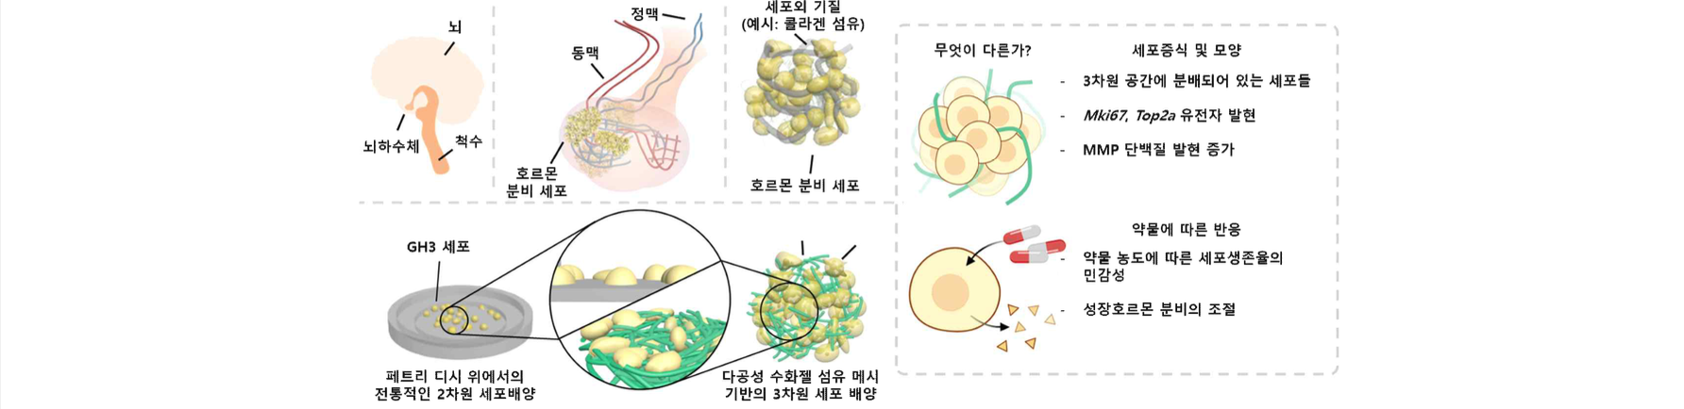▲ Illustration summarizing the research content: The pituitary gland is composed of cells that secrete hormones and fibrous extracellular matrix, and this was simulated by three-dimensionally culturing cells on a porous hydrogel fiber mesh.

The results of this research are expected to be actively applied to understanding the mechanism of drug resistance in acromegaly and to the development and screening of therapeutic drugs.

Because acromegaly is often treated through surgical procedures, it has been difficult to identify the cause of resistance to non-surgical drug treatment.

To overcome the limitation that existing pituitary tumor cell models show significant differences from the behavior of actual biological tissues, the research team cultured tumor cells on porous hydrogel fibers* with a three-dimensional structure. It was confirmed that when this model is treated with drugs, growth hormone secretion inhibition and cell death occur more sensitively than in the existing two-dimensional cell culture model.

* porous hydrogel fiber: A support in the form of nano-micro fibers developed by the research team to facilitate cell penetration and attachment by mimicking the collagen fiber network in human tissue.

The most common treatment method for acromegaly is surgical removal of the tumor, but there has not been sufficient research on the administration of somatostatin or somatostatin analog, a drug treatment method that inhibits growth hormone secretion. And because the pituitary gland is located deep in the brain, there were limitations in identifying the cause of drug resistance.

Therefore, it is necessary to develop a pituitary model at the in vitro level that secretes growth hormone and responds to drugs that inhibit growth hormone secretion.

The 3D pituitary tumor model developed by the research team has the advantage of controlling the secretion of growth hormones through drug treatment at the test tube level instead of drug administration to actual patients.

The team based their research on GH3 cells, a pituitary tumor cell derived from a mouse model. In conventional two-dimensional cell culture, GH3 cells have poor adhesion and divide at a slow rate, which limits their ability to mimic real pituitary tissue, so the researchers used a polyvinyl alcohol (PVA)-based porous hydrogel fiber mesh as a three-dimensional cell culture support.

▲ Manufacturing process and photos of porous hydrogel fiber mesh: The top shows the process of manufacturing porous hydrogel fiber mesh from PVA nanofibers through concentrated sulfuric acid treatment, and the bottom shows (i): no treatment; (ii): In the case of hydration without treatment with concentrated sulfuric acid, (iii): A photo of a porous hydrogel fiber mesh washed and hydrated after treatment with concentrated sulfuric acid. The enlarged photo is an electron micrograph (i) and a confocal micrograph (ii and iii).

PVA nanofibers have the advantage of not being cytotoxic, but they have the disadvantage of low cell adhesion and narrow spacing between fibers, making it difficult for cells to pass through.

To overcome these shortcomings, the research team formed cellulose acetate microparticles by electrospraying* during the electrospinning* process of a PVA solution and then selectively removed them through simple acid treatment* to create 3D hydrogel fibers. While dramatically increasing the pores within the structure, the cell adhesion ability of PVA fibers was greatly improved.

* electrospinning: A process of manufacturing polymer nano/micro fibers by applying an electric field during the process of spraying a polymer solution.

* electrospray: Same as electrospinning, but a process of producing nano/micrometer-sized particles by controlling the concentration of the polymer solution.

* acid treatment: A process using concentrated sulfuric acid to selectively remove cellulose acetate.

The research team developed a 3D pituitary tumor model by culturing GH3 cells, pituitary tumor cells, on this porous hydrogel fiber mesh, and found that Sstr2, Sstr3, Sstr5* gene expression and growth hormone secretion were significantly higher than in 2D cell culture. It was confirmed that the drug effect appears more quickly due to the large surface area when treated with somatostatin derivative (octreotide).

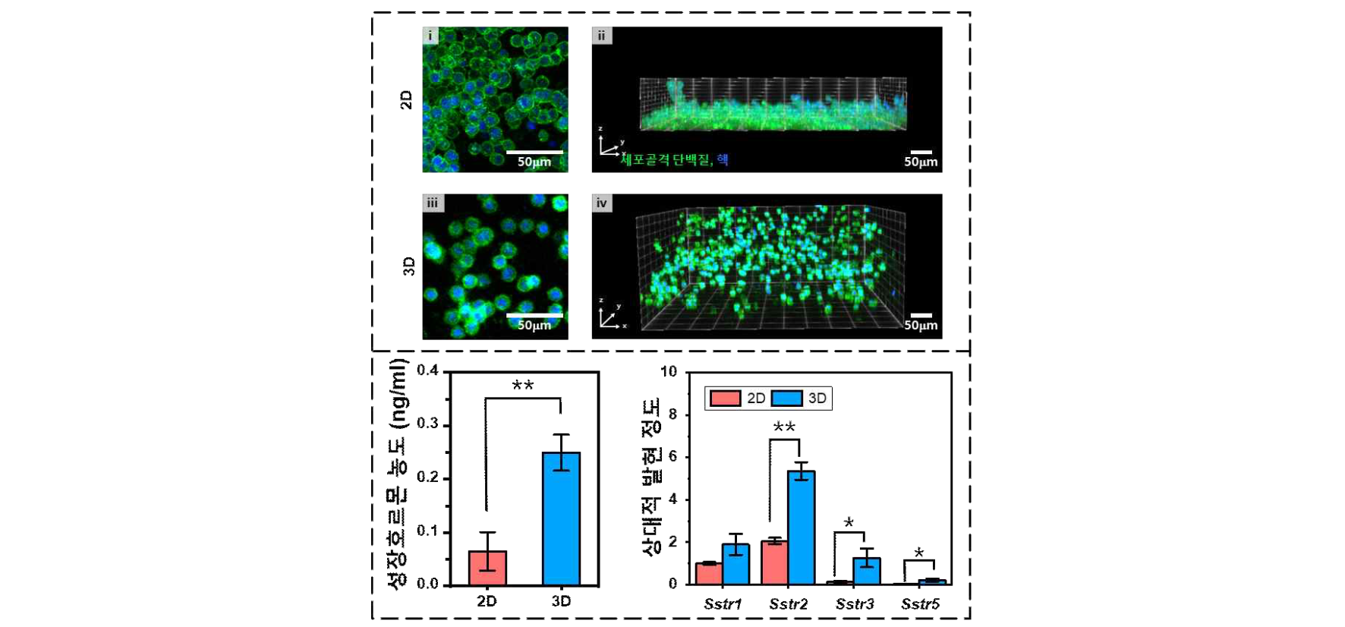[Figure 3] Comparison of 2D cell culture and 3D cell culture: The top is a confocal microscope image, viewed from above (i, iii) and from the side (ii, iv). The bottom is a graph comparing the level of secretion of growth hormone and the level of expression of somatostatin receptors according to each culture condition.

Furthermore, using a bioinformatics approach, we confirmed that the three-dimensional tumor model developed in this study, compared to two-dimensional cell cultures, had two- to fourfold higher gene expression of cell division biomarkers Mki67, Top2a, and Pomc, and consequently more closely resembled actual pituitary tumors.

* Sstr2, Sstr3, Sstr5: Abbreviation for somatostatin receptor. Each protein exists in the cell membrane and plays a role in controlling the secretion of growth hormone when combined with somatostatin.

Professor Chang-Myung Oh said, "The results of this research opened up the possibility of predicting the prognosis of drug treatment for the treatment of acromegaly, which had previously been approached primarily through surgery, and understanding the mechanisms by which resistance occurs. In the future, follow-up research such as discovery of new drug candidates through drug screening is expected."

Professor Myeong-han Yoon said, "More than just developing a new cell culture support and culturing cells in three dimensions, this research is significant because it has enabled a practical three-dimensional tumor model in vitro to validate drug response."

This research was led by Professor Chang-Myung Oh of GIST's Department of Biomedical Science and Engineering and Professor Myeong-han Yoon of the School of Materials Science and Engineering and conducted by master's student Wooju Jeong (currently a researcher at Prestige BioPharma IDC) and doctoral student Sungrok Wang (currently a postdoctoral researcher at the University of California, Irvine) at Yonsei University in collaboration with Professor Cheol Ryong Ku’s research team with support from the GIST Research Institute IIBR grants and the KHIDI-AZ Diabetes Research Program.

The research results were recently published in ‘Smart Materials in Medicine’, an international academic journal ranked in the top 10% in the field of biomedical engineering registered in SCOPUS.



